Version Date: October 23, 2018

DRAFT
Loudoun 2040 Countywide Transportation Plan

Preface – Introduction to the Loudoun 2040 Countywide Transportation Plan (CTP)
Loudoun County is one of the fastest growing counties in the nation and is the fastest growing county in the Commonwealth of Virginia. The unprecedented growth the County has experienced over the last several decades has resulted in continued and ever-increasing strain on its transportation network. Transportation continues to be one of the most important services provided by government, fulfilling the crucial role of linking people to their jobs, schools, recreation and shopping. As such, and in light of this environment of rapid growth, careful transportation planning must be undertaken to ensure that the mobility needs of the County’s citizens continue to be met over the long-term.

Initiated in the summer of 2016, this edition of the Countywide Transportation Plan (CTP) builds upon the strong foundation provided by the 2010 CTP. It has been developed to accommodate planned land use and development through the horizon year of 2040 and includes a revised and enhanced arterial and collector road network, including facilities for motor vehicles, bicyclists, pedestrians, and transit riders. The CTP also includes policies and strategies to address the connections between land uses, the built environment, the transportation network, air travel, development impacts, environmental and heritage resources, coordination with outside agencies, prioritization and funding of transportation infrastructure, and plan implementation. This plan also identifies strategies and opportunities for the protection and enhancement of neighborhood collector streets, to promote development of complete streets and safety throughout residential and community activity centers. This plan for the transportation network was developed and evaluated using criteria such as multimodal safety, forecasted facility demands (volume and capacity), potential impacts on the environment, heritage resources, quality of life, and concurrent land use plans and policies.

This plan has been reviewed by the Virginia Department of Transportation (VDOT) pursuant to Section §15.2-2222.1 of the Virginia Code and VDOT’s Traffic Impact Analysis Regulations Administrative Guidelines and conforms to of Section §15.2-2222.3 of the Virginia Code.

Plan Purpose and Relation to Other Planning Documents
The CTP provides the policy foundation for the County’s transportation network. The Comprehensive Plan provides policy guidance on land and infrastructure development. The CTP is a volume of the County’s Comprehensive Plan, alongside other volumes such as the General Plan. The Comprehensive Plan forms the policy foundation for standards and regulations within the Zoning Ordinance, Land and Subdivision Ordinance, and Facilities Standards Manual, as well as amendments and updates to these regulatory documents.

Transportation Planning History in Loudoun County
Loudoun County has a long history of transportation planning. Following decades of small area plans for specific portions of the County beginning in the 1960s, the first Countywide Transportation Plan was adopted in 1995. This plan focused heavily on creating mobility to support planned suburban development. The 1995 CTP created the framework for each of the subsequent countywide and small area transportation plans and the results of this initial plan can

be seen through today’s roadway network.

The 2001 CTP built upon the plans developed in 1995, while placing greater emphasis on protections for the environment, historic towns and villages, and quality of life in the newly- designated Rural Policy Area. It also incorporated the Dulles Corridor Metrorail Project and included language encouraging the development of mixed-used urban-style developments, particularly in the vicinity of the planned Metrorail Stations.

The 2010 CTP served as a forward-looking planning document that addressed the needs of Loudoun County by establishing a long-range vision for the County’s transportation network and defining policies that provide for the successful implementation of that network. The transportation network included major roads, public transit services, bicycle and pedestrian accommodations, and airports, making this plan far more multimodal than previous iterations. The 2010 CTP also reconsidered appropriate capacity needs for roads, identifying the impacts of wide, high-speed corridors throughout the Suburban and Transition Policy Areas and included changes to ultimate planned conditions of roads to lower-capacity facilities where forecasted demand could be accommodated by fewer travel lanes.

The Loudoun 2040 CTP seeks to provide access and mobility for residents, workers, and visitors; protect and enhance health and safety through design and construction, and; promote quality of life by protecting the integrity of the various policy areas and incorporated towns as they relate to the transportation network.

Chapter 1 – Vision for Transportation
This plan is guided by a set of goals developed based upon public input and affirmed by the Board of Supervisors, providing the foundation for the entire document and ensuring that the public is the guiding force behind this vision. From those goals, the plan identifies the overarching objectives that this plan will seek to meet through implementation of the planned transportation network and policies.

The Foundation
The 2010 CTP provided a strong framework for modern multimodal transportation planning in the County. Due to its robust and actionable policies, in coordination with previous editions and localized transportation plans, the County has facilitated development of its roadway, bicycle and pedestrian, and transit networks. Throughout the County, new corridors have been completed and projects are underway through engagement of available public funding and private contributions to expand and complete planned networks. Through the policies of the 2010 CTP and 2003 Bicycle and Pedestrian Master Plan, County policy states that:

- Connectivity and multimodal access are prioritized
- Road design considers complete streets elements
- Sidewalks and asphalt trails are constructed along both sides of all roads (except in the Rural Policy Area)
- Transit systems are enhanced and sustained

Through these policies, the County has completed more than 2,000 lane miles of planned arterial and collector roads, many featuring bicycle and pedestrian connectivity, expanded park and ride and transit options, and coordinated plans with Dulles Airport, Towns, and surrounding jurisdictions.

This plan builds upon the previous policies, seeking opportunities to strengthen areas previously limited in scope while encouraging enhanced transportation choices and design strategies.

Public Input
The Envision Loudoun public outreach process encompassed three sets of multiple public meetings at different stages throughout the process. The Board of Supervisors also appointed a Stakeholders Committee with representation from each election district and an array of impacted advocacy groups from across Loudoun County. Detailed information about public feedback, including transportation comments, can be found in the General Plan document.

Overall, feedback on the transportation planning effort focused on several key topics:

- Improving access, mobility, and transportation options
- Reducing traffic congestion
- Enhancing options for access to the County’s Metrorail Stations, including expanded local bus service options between residential neighborhoods and Metrorail Stations

- Encouraging urban and suburban development programs around Metrorail to enhance quality of life
- Protecting the character and aesthetic of rural transportation options
- Ensuring that transition area aesthetics provide an appropriate visual connection to the rural landscape
- Providing adequate and complete network of sidewalks, asphalt trails, and on-street bicycle lanes
- Creating better connections across major roadways and natural barriers for pedestrians and cyclists
- Introducing more off-road regional trails to allow for greater mobility and recreational opportunities and encouraging connections to existing regional trails
- Calming traffic on neighborhood streets where people should feel comfortable walking or riding a bicycle
- Enhancing connectivity to regional amenities, such as entertainment centers, Dulles Airport, regional parks, and surrounding jurisdictions
- Improve streetscapes
- Ensuring that transportation facilities are adequate to support redevelopment and new development

This plan was developed with the intent to provide policies, guidelines, and implementation steps to achieve these community concerns and interests, and is driven by the following vision and goals:

The Vision

Efficient infrastructure networks that safely connect people to places within the community, to the region, and to the world.

Transportation Network Goals
- Enhanced multi-modal safety for all system users.

- A reliable and efficient multi-modal transportation network that manages the travel demands of the County while maintaining fiscal and environmental sustainability.

- Transportation choices that connect people to their communities, employment centers, educational institutions, activity centers, and other amenities.

- Integration with neighboring jurisdictions to improve regional and statewide connectivity and to attract residents and businesses to Loudoun County.

- Support the growth and potential of enhanced national and international connectivity including consideration of Washington Dulles International Airport and the Silver Line Metrorail Stations.

- Context-sensitive planning and design that addresses the different characteristics and needs of the urban, suburban, transition, Towns, JLMA, and rural environments.

- A transportation network supportive of the County’s overall vision to support economic development, create vibrant, safe communities and public spaces, and protect natural and heritage resources.

Objectives of this Plan
With deference to and inspiration from the Transportation Network Goals, this document seeks to:

  - Provide comprehensive access and mobility for residents, workers, and visitors throughout Loudoun County.
  - Protect and enhance health and safety through design, construction, and improvement of quality transportation networks.
  - Promote high quality of life by protecting the integrity and opportunities provided within the County’s urban, suburban, transition, and rural areas, and supporting each of the incorporated towns within Loudoun County during planning, design, and construction of the transportation network.

Access and Mobility
Access and mobility are the two key indicators of success when evaluating a transportation system. Access describes the availability of practical connections between origins and destinations, while mobility describes the potential travel opportunities from a given place. This plan supports both high access and high mobility through a hierarchical and integrated roadway network that supports multi-modal transportation.

Health and Safety
Health and safety are the most critical factors in evaluating the usability of the transportation network and the supportive role the transportation network has in promoting community and economic development. By emphasizing health and safety throughout every component of this plan, this objective seeks to ensure that multi-modal access is integrated into design and development, impacts from the transportation network to residences, schools, and businesses are mitigated, and that safety is of paramount concern throughout each stage of design and construction.

Quality of Life
The purpose of providing transportation facilities is to enhance quality of life. The transportation network and policies in this plan ensure that people and goods can reach their destinations, whether commuting to a job, visiting friends and family, enjoying leisure activities, or returning home. In this way, transportation ensures access to the elements that make for high quality of life, with quality of life enhanced through transportation improvements that decrease congestion, provide alternative routes and travel options, and make it easier to get to selected destinations.

Chapter 2 – The Countywide Transportation Network
This plan carries forward the County’s commitment to coordinate road network plans with land use, environmental policies, heritage preservation plans, and other policies of the General Plan. The transportation vision, composed of a network and associated policies to accommodate motor vehicles, cyclists, pedestrians, and transit riders, is intended to support the County’s proposed land use by ensuring that adequate transportation facilities exist to serve the mobility needs of residents, visitors, and businesses throughout the County.

Four core sections are provided in this chapter to provide an overview of the Countywide Transportation Network. The Motor Vehicle Plan (MVP) provides a network of roadway travel lanes to accommodate the movement of passenger cars, light trucks and motorcycles, freight and delivery vehicles, transit service vehicles, and emergency vehicles. The Bicycle and Pedestrian Plan (BPP) provides a network of on-street and off-street facilities to accommodate cyclists and an off-street network of sidewalks and trails to accommodate pedestrians (unpaved trails are discussed in the General Plan). The Transit Infrastructure Plan (TIP) provides a plan for infrastructure, including transit stations and shelters, transit-priority corridors, and park-and-ride lots to facilitate growth and development of transit systems. The Characteristics of Planned Roadways section brings these plans together to define how each planned corridor in the County will facilitate travel for each mode. These four sections, along with the specific geographic area policies in Chapter 3, are the foundation of the Countywide Transportation Plan, while policies provided throughout the other chapters of this document serve to guide for implementation of the planned roadways defined in this chapter.

This chapter also includes two “Design Toolkits” at the end of the chapter. The first toolkit is a Roadway Design Toolkit which applies to the Suburban, Transition, Rural, and Joint Land Management Areas. Design standards for the Urban Policy Areas are provided in Chapter 3. The second toolkit is a Transit Infrastructure Toolkit, which is applicable for all areas of the County. These toolkits serve to provide policy-driven guidance to localized planning and implementation, while also serving as the standards for every applicable public and private transportation project.

Motor Vehicle Plan (MVP)
Loudoun County’s roads form the backbone of its transportation network. This chapter outlines the vision and associated policies that govern the planning, design and operation of Loudoun County’s road system. It features a road network that attempts to address future congestion concerns for motor vehicles, access and connectivity for cyclists and pedestrians, and accommodations for transit, reflecting travel needs through 2040. This plan also considers the importance of ensuring that roads serving each of the unique policy areas are designed and constructed in a manner consistent with the character of adjoining communities and land uses.

The County recognizes the limitations of the standard functional classification system, which traditionally emphasized operating speed and carrying capacity over other factors. By balancing mobility with access and by utilizing context-sensitive design techniques, the County is committed to achieving a complete and multimodal transportation network. Central to this commitment are Complete Streets. Complete Streets are safe for motorists, bicyclists, transit vehicles, and pedestrians of all ages and abilities. The complete street focuses not just on individual roads, but

on the decision-making and design process so that all users are routinely considered during the planning, design, construction and operation of all roadways. This chapter identifies roadways as principal arterials, minor arterials, major collectors, minor collectors, and neighborhood collectors, with consideration for complete street components for each roadway type. Local streets policies are provided in Chapter 3 of this document.

In order to plan the road network, County staff employed a combination of considerations, including public input, professional experience, institutional knowledge, and travel demand modeling to forecast future travel demands. These forecasts are based on observed local and regional travel patterns and behaviors, anticipated growth in population, households and employment both inside and outside of the County, and the characteristics of the existing and planned roadway network.

Road Capacity
The extent of improvements needed within the network and along particular corridors was guided in large part by the adequacy of a given road facility’s projected capacity needs. These capacity needs are evaluated based upon forecasted traffic volumes under peak conditions on weekday mornings and weekday afternoons. When volumes approach or exceed the capacity of a road segment, the operational efficiency of the road quickly deteriorates, leading to congestion, delays, and potentially unsafe conditions. The travel demand model forecasts the preference of traffic for certain road corridors to assign future trip demand. While the travel demand model serves as an estimate of future conditions, regular reevaluation of the road network is needed as new development is completed and land use plans are revisited and revised over time. If a particular road segment was forecasted to have an inadequate capacity based on proposed land uses, improvements were considered and evaluated for effectiveness in improving operations, either along the corridor or along parallel corridors, and incorporated into the network. Conversely, in locations where excess planned capacity was identified based on forecasted traffic volumes, rightsizing of the network was considered. Under either scenario, retesting was completed to ensure that the ultimate planned road network serves the anticipated needs of the County through 2040.

While these forecasts played a significant role in appraising potential network improvement locations, the need to enhance the roadway network was also balanced with contextual considerations by staff and County leadership as to whether such improvements were deemed practical, possible (given environmental or other physical constraints) and appropriate. Further consideration for the planned network is provided in the policies of this document that inform and support the implementation of the planned network.

The results of this analysis are provided in Appendix XX.

Level of Service
Another indicator that is considered in transportation planning is Level of Service (LOS). LOS is measured on a scale of A through F, with A representing the least amount of forecasted delay at intersections, and F representing a substantial amount of delay. Given the travel demand in an urbanized region, a certain threshold is established by policy to define acceptable levels of delay

relative to the conditions of the surrounding area. This ensures that an efficient roadway network can be planned without overcompensating to accommodate for only the highest demand during a few minutes each day, which would require substantially more travel lanes and road corridors than are envisioned by this plan. In order to account for the diversity of places that benefit Loudoun County, this plan defined adequate LOS differently in different Policy Areas, understanding that reasonable delay in planned urban centers may be different than that in auto-oriented suburban neighborhoods or rural areas. Since LOS is an indicator of intersection operations, this level of analysis was not completed with this high-level plan, but would be considered as part of public and private roadway improvement projects, and may be considered during subsequent small area planning efforts.

Maintenance
Roads are generally maintained either by VDOT or through private associations, such as homeowners associations. VDOT’s Road Design Manual, Road and Bridge Standards, and Secondary Street Acceptance Requirements (SSAR) contain design and construction standards required for roads to be incorporated into the State Highway System and for road improvements for those facilities already a part of the State Highway System. VDOT has design standards for the wide variety of secondary roads that exist in Loudoun County, ranging from rural local roads to subdivision streets and collector roads. However, as the County adopted policies to encourage creative forms of residential development and for preservation of the character of the County’s rural roads grew, so has the need grown for greater flexibility in the application of VDOT standards. Since the adoption of the 2010 CTP, the VDOT Road Design Manual was amended to include new standards for multimodal facilities in mixed-use urban centers. This provides an excellent opportunity for the County to work with VDOT to ensure that the planned land uses in the Urban Policy Areas are supported by compatible transportation facilities. As the entity responsible for maintenance and operation of all public roads in the County (with limited exceptions), VDOT is responsible for the operational integration of the roadway network. Therefore, it is critical to ensure that all road design, engineering, and construction in the County has a positive impact on VDOT’s ability to maintain an efficient network.

Private Streets
Many local streets in the County are privately maintained and are therefore not in the VDOT maintenance system. The use of private streets in Loudoun County is only permissible for certain types of development as permitted by County Ordinance, usually requiring parcels to have frontage on a public road (except when part of an historic district or residential subdivision). During the rezoning process, modifications may be needed to permit private streets. In certain cases, private streets are needed to support the planned development. Developments that include perpendicular or angled parking along streets must be private, as this feature is not permitted by VDOT design standards. Regardless, all private streets must meet the design and construction standards of the County’s Facilities Standards Manual.

VDOT continues to advise against the use of private streets for new development because of concerns related to maintenance, connectivity of the road network, and consistent design standards. County and VDOT policies call for provision and use of interparcel connections within and between developments in order to promote connectivity and options for local traffic. Additionally,

road maintenance is an expensive commitment as it includes repair and upkeep of roadways, curbs, accessible curb ramps, and stormwater management, as well as snow removal, landscape care, and street cleaning. In residential communities, the maintenance responsibility for private streets generally falls upon a property-owners association, such as a homeowners association (HOA).

In order to ensure successful maintenance of private streets, it is important that road maintenance be adequately funded for current needs and that a fund is established for future maintenance and emergency repairs. The maintenance program must ensure a state of good repair and be capable of providing access as soon as possible after snows or other emergency situations.

Traffic Calming
Following construction of a road, observations and data may indicate that vehicles are traveling at a rate of speed that is higher than was intended or is desired. Traffic calming is intended to modify driver behavior, reduce vehicle speed to legal limits, increase safety for all users of the roadway, and improve the quality of life through minimizing the negative effects of motor vehicles on neighborhoods. By slowing vehicles, it encourages the use of other modes of transportation such as walking and cycling. Traffic calming is typically implemented on residential streets, but can also be applied in activity centers with high pedestrian activity.

Common techniques for implementing traffic calming on residential streets include vertical changes to the street (speed tables, raised intersections), lateral changes to the travel way (chicanes, offset intersections, lateral shifts), constrictions to the travel way (narrowed pavement widths, pinch points, islands, traffic circles or roundabouts, entrance features, small corner radii), and streetscape improvements (surface textures, edge treatments, colors, landscaping, street trees and street furniture). Traffic calming may also include measures such as community education and enforcement. The County works closely with VDOT to implement traffic calming measures where needed.

COUNTYWIDE MOTOR VEHICLE PLAN POLICIES (SEE CHAPTER 3 FOR POLICIES RELATED TO GEOGRAPHIC POLICY AREAS)
2-1.1 Road Standards Roads will be built to the standards and conditions described in this plan.
2-1.2 Land Development Plans Planned roads will be incorporated into every stage of the land development process, including planning, design, and construction, including provision of necessary rights-of-way or easements to accommodate the facility, as determined in this plan.
2-1.3 Missing Segments It is a priority of this plan that safety concerns, gaps in the existing road system, and connections to collector and arterial roads be addressed to serve neighborhoods and employment centers already in place.
2-1.4 Focus Areas The County will prioritize transportation funding to the Urban and Suburban Policy Areas where planned land uses and population densities warrant the expansion of roadway capacity and the implementation and expansion of transit services.
2-1.5 Parallel Roads Suitable alternative access to existing uses, including parallel roads where planned, shall be constructed prior to establishment of limited access freeways.

2-1.6 Dulles Loop The County will work to implement the “Dulles Loop” as a system of limited access roads that encircle Dulles Airport in Loudoun and Fairfax Counties consisting of limited access conditions for VA Route 28, VA Route 606, and a southern connector (either US Route 50 or an extension of Air and Space Museum Parkway), in order to improve travel in the vicinity of the airport.
2-1.7 Managed Lanes The County will study opportunities for implementation of managed lanes, including HOV, HOT, and Transit-Only Lanes along planned limited access corridors and other major commuting routes, when these facilities are considered for expansion to their ultimate planned conditions.
2-1.8 Spot Improvements Intersection and safety improvements on primary roads are considered to be part of this planning document throughout the County.
2-1.9 Natural Features The County will maintain vegetation and woodlands along roadways and incorporate landscaped medians using native species where possible.
2-1.10 Electric Vehicles To promote the use of electric vehicles, this plan supports provision of electric vehicle charging stations, recognizing that this emerging technology will need to be revisited as new innovations impact public demand for alternative fuel vehicles.
2-1.11 Plan Coordination Roadway design characteristics will conform to the standards of the applicable road design toolkit and associated policies for the associated Geographic Policy Area and will complement the streetscape design guidelines and other policies of the Comprehensive Plan.
2-1.12 VDOT Coordination The County will coordinate with VDOT to seek changes in VDOT policies and standards to ensure conformity with the land use, environmental, heritage preservation and other policies of this plan while providing a safe, efficient, and cost-effective transportation network.
2-1.13 Public Roads All new public roads will be planned and constructed to VDOT standards for acceptance into the State Highway System. As appropriate, the County will seek waivers and exceptions to these standards when warranted as part of planning or design.
2-1.14 VDOT Standards Roads shall be constructed in accordance with VDOT and County design standards, as appropriate based upon future maintenance responsibilities, and shall be subject to review and comment by County and VDOT
2-1.15 Complete Streets All road construction will strive to provide all of the elements of a Complete Street, with consideration of context-sensitive design, to create roads that are safe for all users.
2-1.16 VDOT Improvements The County will work with VDOT to continue and enhance maintenance of public roads by supporting repaving efforts, encouraging construction of spot safety improvements, and coordinating to identify opportunities for optimizing use of existing pavement.
2-1.17 Pavement, Marking, and Signage DTCI shall be provided with opportunity to review and comment on all PMS (Pavement Marking and Signage) Plans and all construction plans for Arterial and Collector roadways within the County to ensure coordination with this plan.
2-1.18 Functional Classifications The County shall work with VDOT to determine appropriate

functional classifications for roadways and work to correlate these classification for all roads in the County to ensure consistency between County and VDOT classifications for roadways.
2-1.19 Primary Routes As major cross-county secondary road corridors are completed, VDOT reclassification of these corridors to primary routes should be pursued.
2-1.20 Arterial Preservation Significant arterial roadways, including all primary corridors and principal arterial roadways in the County, will be designed and maintained to support the flow of traffic through the County and the region, limiting local access points, and minimizing the use of traffic controls and allowances for cross-traffic. Preservation of these corridors will be coordinated with VDOT for acceptance into the VDOT Arterial Preservation Program as Mobility Enhancement Segments, and design of these corridors will be evaluated based upon the standards set forth for improving mobility in the VDOT Road Design Manual and Traffic Signal Justification Report Requirements.
2-1.21 Permissibility of Private Streets The County will encourage public streets while allowing private streets where needed to support alternative solutions for a proposed development pattern that would better address plan policy and would be unsupported by VDOT SSAR standards. This determination will be made by the County and VDOT based upon applicable County ordinances.
2-1.22 Responsibility for Private Streets Maintenance of private streets will be the sole responsibility of the identified private sector entity in perpetuity. Such streets are not eligible for acceptance into the public street system. Neither VDOT nor the County will accept maintenance responsibility for any private street.
2-1.23 Private Street Improvements All street improvement projects along private streets, including traffic calming measures, will be the sole responsibility of the private maintenance entity.
2-1.24 Public Road Access For lots accessed from private roads or easements, demonstration of safe access to the public road network will be provided.
2-1.25 Financial Responsibility for Private Streets The maintenance responsibility for private streets will be insured by a bond or other long-term surety approved by the County before approval of the private road. In each case where County ordinances allow private streets, there will be language specifying the entity that will provide for maintenance of the road and that neither VDOT nor the County have, or will have, responsibility for the maintenance, repairs, or improvements.
2-1.26 Community Traffic Calming Measures The County will promote and implement traffic calming measures in all policy areas through community-based and supported programs, small area plans, development applications, geometric design elements, and collaboration with VDOT.
2-1.27 Types of Traffic Calming The County will work collaboratively with VDOT and the community in identifying appropriate traffic calming measures within the context of the surrounding area. Measures will be analyzed to determine the most effective tool for each project in coordination with surrounding residents and businesses. The use of geometric design elements, such as roadway curvature, should be considered as part of the initial design and construction of roadways to minimize the need for future traffic calming

measures.
2-1.28 Cut-Through Traffic Opportunities to mitigate cut-through traffic shall be evaluated with consideration of alternative routes and continuity of the network.
2-1.29 Widening Existing Divided Roadways Existing divided roadways should be widened to the inside wherever feasible in an effort to minimize the impact on adjacent properties.
2-1.30 Planned Divided Roadways The County promotes establishing the ultimate right-of-way for planned divided roadways at the time of the initial right-of-way dedication or acquisition to allow for turn-lanes, bicycle and pedestrian facilities, and drainage systems to be established in their ultimate condition in an effort to minimize the impact on adjacent properties.

Bicycle and Pedestrian Plan (BPP)
Loudoun County aspires to be a place where pedestrians and bicyclists of all abilities have a safe, secure and convenient transportation network of walkways and bikeways that enable efficient movement to and from home, work, school, shopping, libraries, parks and community centers. To accomplish this, effective planning for the cyclist and pedestrian is integrated within each stage of planning, design, and implementation.
Buildout of planned bicycle and pedestrian networks will lead to enhanced quality of life by providing: mobility, connections, and increased options for bicycle travel; improved access to public transportation, employment, and other activity centers; a cleaner environment through reduction of air pollution caused by single-occupancy vehicle trips; expansion of the rural economy by providing the opportunity for visitors to experience the County’s beauty through biking; and preservation of cultural and natural resource corridors for public enjoyment through the designation of shared use paths, bicycle routes, and improved signage.
Bicycle Network
This plan sets forth a vision of a comprehensive bicycling network, with on-street bicycle lanes, asphalt trails, marked bicycle routes, and other accommodations to improve the viability of bicycle commuting, recreation, and tourism. The spine of the County’s bicycle network is the Washington & Old Dominion (W&OD) Trail that provides an east-west route through the central parts of both eastern and western Loudoun County. The County is working to improve safety and connectivity along the W&OD Trail, studying and implementing grade-separated crossings at high-traffic corridors and improved at-grade crossings at others. Connections to the W&OD Trail provide access from nearby locations, allowing opportunities for trips to and from major transit hubs such as Metrorail Stations, commercial and entertainment centers, residential neighborhoods, and rural economy uses. Through the land development review process, the County will implement the improvements detailed in this plan along new and existing roads. In built-up areas, including developed areas near Metrorail stations, public efforts are envisioned to complete bicycle network development.
The County recognizes that a variety of facility types are needed based on the context of the built environment and roadways in different areas of the County. Accommodations for bicyclists along roadways include on-street bike lanes, buffered on-street bike lanes, off-road asphalt trails, wide curb lanes, and paved shoulders. Along existing roads, variations in traffic volumes, traffic patterns, and roadway designs, are of paramount consideration when considering facility types.

Along new roads, design constraints due to topography, available right-of-way, design speed, anticipated traffic volumes, and historic and natural resources are also considered as part of facility design.
Furthermore, the needs of different user groups vary from experienced bicyclists who often prefer on-street facilities to the less-experienced riders who find off-road shared use paths more conducive to comfortable travel. The complete reliance on an off-road shared use path system is not possible or desirable due to costs and funding constraints, as well as diverse public preferences. Within a suburban street setting, off-street trails may create dangerous conditions at intersections, where drivers are less aware to the presence of cyclists. By bringing bicycle facilities onto the road, the awareness of drivers and cyclists to each mode of travel is increased, leading to greater attentiveness to multimodal safety. However, on higher speed, wider auto-oriented facilities, the difference in anticipated speed and driving habits may make greater separation of these modes more preferable.
Pedestrian Network
Pedestrian-friendly communities are a key component of an effective multimodal transportation system. Not only does every trip begin with walking, but safe, logical, and efficient pedestrian connections can significantly decrease the need to drive for short trips. Walking is the only form of transportation that is completely free and has positive impacts for personal health and no negative environmental impacts. The County has a substantial pedestrian network, but significant work still needs to be done to provide comprehensive pedestrian opportunities for all residents, workers, and visitors. Generally, such needs include additional sidewalks along roads and between subdivisions where missing, better lighting, safer and appropriately wide sidewalks, and improved road crossings, especially along wider and higher-speed roads, through installation of more and better marked crosswalks.

Countywide Bicycle and Pedestrian Policies
2-2.1 Purpose Bicycle and pedestrian facilities will be built to the standards and conditions described in this plan and in accordance with the Roadway Design Toolkit.
2-2.2 Road Projects Contextually-appropriate bicycle and pedestrian facilities will be included as part of all public and private secondary road construction and improvement projects.
2-2.3 Prioritization Priority shall be given to construction of bicycle and pedestrian accommodations and connections associated with arterial and collector roadways with emphasis on the completion of connections between existing facilities in an effect to provide regional connections, and to the provision of safe walking and bicycling routes to new and existing public schools.
2-2.4 Design Standards All bicycle facilities will be designed in accordance with VDOT standards and with considerations of the American Association of State Highway and Transportation Officials (AASHTO) and National Association of City Transportation Officials (NACTO) guidelines, the Americans with Disabilities Act (ADA), and the policies within this plan.
2-2.5 Land Development Plans Bicycle and pedestrian facilities will be incorporated into every stage of planning, design, and construction, including necessary rights-of-way or easements to accommodate the appropriate facility types, as determined in this plan. Such

facilities will be provided regardless of the existence of connecting facilities. This full integration will reduce the cost of designing the facilities into a project at later stages of design and engineering and ensure that the needs of bicyclists and pedestrians are met.
2-2.6 Timing Bicycle and pedestrian facilities along existing or proposed CTP roads will be provided at the commencement of a project, or the associated phase of the project, regardless of whether connections from adjacent properties are already in place.
2-2.7 Site Connections All land development applications shall provide internal bicycle and pedestrian circulation systems connecting building entrances, parking areas, and other bicycle and pedestrian destinations within the site, and will demonstrate that the facilities are designed to be safe, direct and barrier-free. These systems will also address connections to existing and planned bicycle and pedestrian facilities along the public road network and adjacent properties through direct, safe, and logical routes.
2-2.8 Site Access Child care centers, schools, and similar uses will provide safe and uninhibited pedestrian access between entrances, parking lots, play areas, adjacent roadways, and auxiliary buildings.
2-2.9 Community Access Public schools and other community facilities and uses shall be designed to encourage students and patrons to walk or bike to school through provision of connections to adjoining roads and subdivisions in all directions and implementing safe routes to school programs to improve access and educate students.
2-2.10 Trail Crossings The County shall actively seek to create grade-separated crossings for major bicycle and pedestrian corridors, such as the W&OD Trail, Broad Run Linear Park, and Goose Creek Trail. Grade-separated crossings of the W&OD Trail will be required for all roadway improvement projects at trail crossings at no cost to the Northern Virginia Regional Park Authority (NVRPA).
2-2.11 Crossings Safe, convenient, and visually attractive crossing options will be considered at each stage of development and planning to enable pedestrians and bicyclists to comfortably cross major thoroughfares. Alternatives may include new intersection designs, pedestrian and bicycle overpasses and underpasses, and other options that separate or limit exposure to vehicular traffic.
2-2.12 Public Outreach The County shall engage the public to prioritize and identify funding and alignments for bicycle and pedestrian improvements.
2-2.13 Connectivity The County shall actively seek to establish connections to local and regional trail networks including but not limited to, the Appalachian National Scenic Trail, Chesapeake and Ohio Canal Towpath, Potomac Heritage Trail, and Washington & Old Dominion Trail.

Transit Infrastructure Plan (TIP)
Loudoun County has a long history of transit planning and operations, including decades of support and planning for the Dulles Corridor Metrorail Project (Silver Line) from Falls Church through Tysons and Reston and into Loudoun County. With revenue service to station stops at Dulles Airport and in the Ashburn area anticipated to begin shortly after adoption of this plan, a new and expanded approach to transit services is underway. This plan provides a guide for general and

targeted transit infrastructure. Service plans can be found in the County’s Transit Development Plan (TDP).
Currently, the County operates three distinctly branded bus transit services, each serving different destinations and rider bases, and provides support to the Washington Metropolitan Area Transit Authority (WMATA) as a member jurisdiction.
    - Premium Commuter Bus Service (Long-Haul) travels between County park-and-ride lots and major job centers in Arlington County and Washington, DC. This service provides 112 weekday trips with 987,000 annual rides (FY 2016).
    - Metro Connection Service operates seven routes between County park-and-ride lots and Metrorail Stations in Reston and Falls Church. This service provides 274,000 annual rides (FY 2016).
    - Local Fixed-Route Service provides intra-jurisdictional curbside bus services on 15 routes throughout Eastern Loudoun County. This service provides 445,000 annual rides (FY 2016).
The County also provides demand-response services to qualifying individuals in the vicinity of its local fixed route bus services. In Western Loudoun County and the unserved areas of Eastern Loudoun County, Virginia Regional Transit (VRT) operates demand-response services to support these communities. VRT also operates a local fixed-route service between Purcellville and Leesburg.
Metrorail Planning
The completion of the Silver Line represents a commitment of significant County resources, as well as a need to change the focus of the County’s public transportation strategies. The most recent iteration of the TDP recommends a complete transition from a pre-Metrorail transit system to a transit system that incorporates and considers the Silver Line as the spine of transit services for the entire County. With this change, the County envisions an integration of Metro Connection and Local Fixed-Route services into a singular combined service plan. The benefits of this service include:
      - Improved scheduling and connectivity
      - Increased access to jobs and entertainment, driving opportunities for ridership growth
      - Expanded integration with Metrorail and Long-Haul Services
      - Better customer experiences through unified technological and service systems
In order to minimize system redundancies and ensure optimal use of public funds, Long-Haul is planned to continue its operations as a premium service, with an aim of maintaining cost neutrality, meaning that revenue from fares and advertising support the cost of services. It is anticipated that the dependability and comparative value of Metrorail with considerations of cost and travel time will highly impact the future viability of Long-Haul. Therefore, the County will continue to evaluate all options on a regular basis following the opening of Metrorail revenue service.

Transit Infrastructure Goals
- Provide a safe, affordable, convenient, efficient and sustainable multi-modal transportation system to serve the County.
- Provide an integrated transit system to connect regional centers, neighborhoods, attractions and employment and retail centers.
- Ensure the transportation system and land use policies foster greater transit use through incentives or management of parking, supportive services, and other public/private initiatives.
- Utilize investments in the transit system to enhance and promote economic development in the County.
Improving Transit Infrastructure
As a service-based mode, transit is as dependent on the quality of the service as it is on the infrastructure placed to support utilization and ridership. Transit infrastructure can best be defined as the physical attributes of transit, such as vehicle type and design, stations and stops, rails and lanes, transit signal priority (TSP), and even branding. The other characteristics of transit, such as frequencies, routing, fleet sizes, financial planning, operations and maintenance, and anything else that would be a component of the TDP would fall under the auspices of transit operations.

In order to build a more robust core network structure atop the Silver Line “spine”, this plan includes identification of transit corridors. These corridors have been identified through a combination of considerations of existing routes, existing and planned population densities, street functions, and planned service changes in the TDP. Above all, this plan emphases utilization of Silver Line stations and attempts to link both regional and community activity centers in a way that supports mutual interaction between residents and workers in those areas. Transit Corridors may include but are not limited to segments of the following roadways:

  - Ashburn Village Boulevard
  - Atlantic Boulevard
  - Belmont Ridge Road
  - Croson Lane
  - Davis Drive
  - Dulles Greenway
  - Gloucester Parkway
  - Harry Byrd Highway (Route 7)
  - Innovation Avenue
  - Loudoun County Parkway
  - Mooreview Parkway
  - Nokes Boulevard
  - Northstar Boulevard
  - Old Ox Road
  - Pacific Boulevard
  - Potomac View Road
  - Riverside Parkway
  - Russell Branch Parkway
  - Ryan Road
  - Shellhorn Road
  - Sterling Boulevard
  - Sully Road (Route 28)
  - Tall Cedars Parkway
  - Waxpool Road

This network of transit corridors serves as a starting point for countywide improvements. It creates a transit infrastructure supportive of greater densities and growth at activity centers, establishes

highly visible and managed transit corridors capable of linking multiple activity centers through the use of multiple routes, shifts transportation mode shares in the denser and more congested eastern portion of the county, introduces logical feeder service to Metrorail and commuter bus service in currently unserved areas, provides opportunities to reassess present and future importance of activity centers as development occurs, and allows consideration of the role of the Dulles Greenway and nearby park-and-ride facilities in providing express services for riders from central and western portions of the County.
Conversely, as a framework, this network is limited. It does not add significantly enhanced coverage to currently underserved areas, requires additional consideration of transit-only lanes, transit-priority lanes, and more robust facility investments as part of corridor improvements, and needs further study of the best locations for investments in additional base or premium services while maintaining reasonable service levels along existing routes.
Key Components of Transit Infrastructure Planning
There are several components to planning a robust network of transit infrastructure. The list below provides options related to some of the ways that a complete network can be achieved. Each corridor and location is different and may require different design standards.
  - Branding: Unified color and font schemes on vehicles, at station stops, schedules and brochures, websites, and signage.
  - Vehicle Type and Design: Clean and functional service vehicles with appropriate capacity, accessibility, and design to be visible and convenient for all riders.
  - Stations and Stops: Comfortable places to board and alight vehicles, including amenities that may include shelters, seating, lighting, trash, heating, restrooms, retail, and service information. These should be designed commensurate with anticipated usage and surrounding development patterns. Where intended to remove drivers from the roadway network, these should be designed with parking that is coordinated to ensure safe bicycle and pedestrian access as well as economic development opportunities. As possible, these should be located at or near the actual stop location of the transit vehicle. These facilities can provide opportunities for marketing and other business partnerships.
  - Rails and Lanes: Dedicated space for operation of transit vehicles to improve travel times and dependability. May encompass an entire transit line or may be provided for a portion of service area.
  - Transit Signal Priority: Sensor-activated traffic signals that provide extended green time to facilitate movement of buses or allow buses to “jump” a signal via special signals that allow buses to utilize a right-turn lane to advance through an intersection ahead of other traffic.
  - Land Use Planning: Quality features will achieve the greatest results when paired with transit-friendly land use planning and development, including connectivity to other modes, activity centers, and population densities that can support robust services along a corridor.
Park and Ride Lots
Park and ride lots are a critical component of the County’s transportation system. They provide space for commuters to park their cars and commute via carpool, vanpool, or transit. Park and ride lots help reduce traffic congestion and pollution, assisting the region in meeting Clean Air Act

requirements. Park and ride lots also provide an effective means for residents to manage travel costs by sharing the ride with others. In certain locations, successful park-and-ride lots can transition to become successful transit-oriented development sites, reserving and making use of land that can later be used for more intensive development. This long-range strategy may be appropriate in the Urban Policy Areas and in the Transit Corridors. As demand for Park and ride spaces continue to grow, the County will need to identify strategies to make efficient use of available land and transit operations opportunities.

Countywide Transit Infrastructure Policies
2-3.1 Transit Toolkit Transit infrastructure shall be designed to meet minimum standards as outlined in this chapter’s Transit Toolkit.
2-3.2 Planning Studies of transit infrastructure improvements will evaluate and identify system priorities that will provide the greatest benefit to all users, enhancing transit infrastructure in response to population growth and congestion.
2-3.3 Amenities Transit amenities will be provided consistent with standards described in the transit toolkit with consideration of forecasted demand for transit service based upon development patterns and service frequencies.
2-3.4 Information Signage Boarding locations for all transit and shuttle services will be designated and signed with schedules, service and fare information posted at boarding locations.
2-3.5 Barriers At all planned and existing transit facilities, projects shall identify and rectify barriers to transit station or stop access for cyclists and pedestrians, including built and natural features, lacking sidewalk and trails, and lacking transit shelters and pads.
2-3.6 ADA Accessibility Transit stations and stops and adjoining public and publically- accessible spaces will be made accessible to persons with disabilities in accordance with the Americans with Disabilities Act (ADA) and other applicable requirements.
2-3.7 Land Use The County will support opportunities and investments in transit infrastructure by planning and implementing land uses that will facilitate increased levels of transit ridership in the Urban and Suburban Policy Areas.
2-3.8 Transit-Oriented Development The County will direct new development to the Urban Policy Areas and Transit Corridors to improve the viability and cost-effectiveness of the future transit services and reduce traffic congestion in these areas.
2-3.9 Transit Access The County will require design features to improve transit accessibility and efficiency, such as grid street patterns and streetscapes that accommodate pedestrians and bus stops. County review of applications along Transit Corridors will consider station or stop access, transit vehicle stop location, pedestrian and bicycle circulation, and other features related to transit-oriented design.
2-3.10 Interim Densities The County may permit interim development along transit corridors at densities lower than those needed to support viable services so long as the proposed development patterns do not inhibit the ability of the site to reach its planned development potential as part of future development program.

2-3.11 Mode Split Development applications along Transit Corridors are anticipated to achieve a minimum 10% mode split via transit through incorporation of TDM policies.
2-3.12 Park and Ride Locations Park and ride lot locations will be strategically identified and will be located along or proximate to arterial roads and connected by sidewalks or asphalt trails to public bicycle and pedestrian networks.
2-3.13 Existing Park and Ride Lots As feasible, the County will evaluate opportunities to expand existing park-and-ride lots prior to acquiring land and constructing new lots in the same general vicinity. This will allow improved service frequencies and increased opportunities for local transit service connectivity.
2-3.14 Park and Ride Lots by Policy Area Park and ride lots, which do not include Metrorail parking garages, shall not be constructed or expanded in the Urban Policy Areas. Existing park and ride lots in the Urban Policy Areas shall be evaluated for relocation into the Suburban Policy Area as development within these areas provides opportunities for more robust uses of available land.
2-3.15 Park and Ride Shared Lots Park and ride lots may be co-located with other complimentary uses, so long as it can be demonstrated that the park-and-ride lot and the adjoining use will not impact the safe and efficient operations of the other use.
2-3.16 Park and Ride Access Park and ride lots will be designated to provide convenient and safe access, meeting ADA requirements, between the bus stopping location and the parking areas.
2-3.17 Park and Ride Calculations Park and ride lot facility needs will be calculated on the basis of one commuter park and ride space for every 30 households approved for development in the Suburban, Transition, and Rural Policy Areas.
2-3.18 Park and Ride Amenities At minimum, park-and-ride lots will include adequate lighting and waste receptacles. Lots will also include amenities such as seating, bicycle parking, indoor waiting areas, retail amenities, restrooms, recreational trails, and informational kiosks. Installation of electric vehicle charging stations is encouraged where possible.
2-3.19 Private Bus Shelters Bus shelters erected on private property will be provided within a public access easement and will be maintained by the property owner for service of public transit vehicles and private shuttles, with the following guidelines: trash is to be removed at minimum twice a week, all graffiti to be removed immediately from shelter, landscaping is to be maintained regularly, lighting will be in working order, and the shelter structure will be repaired and replaced as needed.
2-3.20 Funding The County will pursue funding opportunities to improve and enhance transit infrastructure through development applications, special tax districts, public-private partnerships, bond referendums, and other identified funding sources.
2-3.21 Public Outreach Throughout the planning and development of transit infrastructure, the County will seek the input of the Transit Advisory Board and general public concerning locations, funding, and implementation of improvements.
2-3.22 Plan Coordination Transit Infrastructure Plan implementation will meet the policies and intent of this document as well as other policies of the Comprehensive Plan.

Characteristics of Planned Roadways
Planned roadway corridors in this plan consider the needs of all system users, including drivers, cyclists, pedestrians, and transit riders. In order to accommodate this spectrum of travelers, road corridors shown on the maps provided in this chapter are further defined by typical sections provided below. It is understood that road improvement projects each feature unique challenges related to environmental preservation, public input, and the surrounding built environment. Therefore, modifications to the assigned section for each roadway segment in this plan may be necessary for implementation. However, all reasonable efforts should be made to accommodate safe and efficient multimodal mobility and operation through each stage of the planning, design, and construction processes.
There are several characteristics that help inform and describe the section and purpose of a given road segment. The most prominent characteristic is modal accommodation, which are the physical attributes, such as travel lanes, bike lanes, asphalt trails, sidewalks, and transit shelters that together comprise the roadway. Other important physical characteristics include the widths of these facilities, the presence of intersection improvements such as turn lanes and traffic controls, and accommodations for bicycle and pedestrian crossings. Other attributes that impact the design and character of a roadway include functional classification, which identifies the intent and purpose of a segment and attempts to inform design accordingly, and design speed, which impacts how the road is intended to operate. In order to standardize these factors, this plan provides a set of typical street sections that apply to each corridor identified to provide greater guidance to transportation improvement projects.
Functional Classification
A planned roadway network includes consideration of hierarchy to ensure that each corridor and segment is designed to appropriately address the needs of the traveling public. These functional classifications determine or relate several characteristics of a roadway, including anticipated design speeds, requirements for turn lanes, the prominence and significance of the road within the network, and the types and designs of bicycle and pedestrian facilities that are appropriate for the corridor. The following functional classifications relate roadway classifications that exist within Loudoun County. (The highest functional classification level – Principal Arterial – Interstate (Level 1) does not exist within Loudoun County).

Principal Arterial – Freeway (Level 2)
This classification relates planned limited access freeways and parkways where at-grade and local access is not anticipated. These corridors provide the highest level of mobility and promote long-distance travel in to, across, and out of the County. Examples include Route 28, the Dulles Greenway, and significant portions of Route 7 and US Route 50. Principal Arterial – Freeways are intended to feature the following standards:
    - 60 MPH Design Speed
    - All at-grade access terminated, with access provided via interchanges at identified locations
    - Local access will be provided via other public roads along the corridor, which will be provided prior to any closure of access.

    - Under interim conditions, will be designed with 60 MPH design speed and other standards based on the Principal Arterial – Expressway (Level 3) classification.

Principal Arterial – Non-Freeway (Level 3)
This classification relates to planned at-grade arterials (non-freeway) where at-grade access is highly controlled, preferred only at major intersections. Such facilities are intended to serve large amounts of traffic traveling relatively long distances at higher speeds. Direct property access requires careful management to preserve traffic mobility and avoid creating unsafe and congested traffic operations. Examples include Loudoun County Parkway, Route 7 in Sterling, and Route 15 north of Leesburg. Principal Arterial – Non-Freeways are intended to feature the following standards:
    - 50 MPH design speed
    - Highly-Controlled at-grade access, with local access provided via other roads or, where alternative access is not available, via consolidated multi-parcel access points.
    - Left- and right- turn lanes at all intersections

Minor Arterial (Level 4)
This classification relates to planned at-grade arterial roadways where design is focused on intra-county mobility and connections to Principal Arterial corridors. Examples include Algonkian Parkway, Belmont Ridge Road, Northstar Boulevard, and Route 9. Minor Arterials are intended to feature the following standards:
    - 50 MPH design speed
    - Moderately controlled at-grade access, with local access provided via consolidated multi-parcel access points.
    - Left- and right- turn lanes at all intersections

Major Collector (Level 5)
This classification relates to planned at-grade collector roadways that serve to provide connections between communities and arterial corridors. These seek to balance access and mobility by providing equitable measures for all travel modes, while also providing separated areas between each type of roadway user. Major Collectors are intended to feature the following standards:
    - 40 MPH design speed.
    - Somewhat controlled at-grade access, with local access provided via a single access point and consolidation of access highly preferred.
    - Left-turn lanes at all intersections. Right turn lanes at major intersections and where warranted.

Minor Collector (Level 6)
This classification relates to planned at-grade collector roadways that serve to provide connections within communities. These corridors are designed to promote multimodal access by emphasizing the needs of bicyclists and pedestrians with consideration of the needs of motor vehicles, including transit vehicles. Minor Collectors are intended to feature the following standards:
    - 35 MPH design speed
    - Access must meet VDOT requirements for collector roadways.
    - Left-turn lanes at major intersections and where warranted. Right-turn lanes where warranted.

Neighborhood Collector (Level 7)
This classification relates to planned at-grade collector roads that serve to provide access within a neighborhood. These roads are generally built with a development and serve as major gateways within and through neighborhoods and often feature limited numbers of direct driveway access points. Therefore, these streets serve greater amounts of traffic than a typical neighborhood street and require special consideration to ensure safety and multimodal access. Neighborhood Collectors are intended to feature the following standards:
    - 25 MPH design speed
    - Local access permitted.
    - Left-turn lanes at major intersections when warranted.
    - Traffic calming measures anticipated.

Local Secondary Road (Level 8)
The remainder of streets in the County are functionally classified at Local Secondary Roads. These facilities are meant to provide local access within subdivisions and other developments. Local Secondary Roads are intended to feature the following standards:
    - 25 MPH design speed
    - Local access permitted
    - Bicycles share the road
    - Five-foot wide pedestrian facilities along both sides of the road

Arterial and Collector Roadway Identification and Cross-Sections
The sections below relate motor vehicle, bicycle, and pedestrian accommodations for planned roadways including:
  - Cross-sectional elements (i.e. shoulder and ditch or curb and gutter)
  - Functional classification
  - Number of travel lanes
  - Turn lane requirements
  - Provision of on-street parking
  - Asphalt trail width
  - Concrete sidewalk width
  - Pedestrian refuge requirements
The purpose of these typical roadway cross-sections is to provide County staff, the development community and the general public with a guide for the planning, design, and coordination of improvements to the major roadways within Loudoun County. The County understands that in order for the actual roadway improvement or construction to be accepted into the state system, VDOT must approve the roadway design; therefore, VDOT standards must be utilized in conjunction with these guidelines. If any differences occur between this document and the adopted transportation maps, the maps govern.
The ultimate condition for each roadway or roadway segment stated in this document is foreseen by the County as the ultimate condition. Also, the ultimate condition may include roadway link improvements, such as increasing the number of lanes, and intersection improvements, such as turn lanes and/or interchanges. These improvements may or may not occur at the same time. For new road construction on new alignments, construction of the four outside lanes in the interim condition will be required in the design of ultimate U6M (TT), U8M (TT), and U8M roads. The planning guidelines are not intended to propose roadway improvements within the incorporated towns beyond those identified in the town plans.
Provisions for bicycle and pedestrian accommodations will vary depending on the type of facility and location; refer to Appendix XX (to be included in the next draft version) for planning guidelines for specific roadway segments. Each roadway segment will have information regarding its location, end points, policy area, functional classification, number of travel lanes, right-of-way, bicycle and pedestrian facilities, and typical cross-section.
Appendix XX will be updated as necessary and may be modified by resolution of the Board of Supervisors through land development applications or as otherwise deemed appropriate by the Board.

Road Type Descriptions, Typical Sections, and Planning Guidelines
ROAD TYPE DESCRIPTIONS
R2 Rural two-lane undivided section with shoulder and ditch
U2 (SS) Urban two-lane undivided section with curb and gutter and a sidewalk on each side of the road
R2 (T) Rural two-lane undivided section with shoulder and ditch and a trail on one side of the road
U2P (SS) Urban two-lane undivided section with curb and gutter, on-street parking, and a sidewalk on each side of the road
U2b (SS) Urban two-lane undivided section with curb and gutter, striped bicycle lanes, and a sidewalk on each side of the road
U2bP (SS) Urban two-lane undivided section with curb and gutter, striped bicycle lanes, on-street parking, and a sidewalk on each side of the road
U2B (SS) Urban two-lane undivided section with curb and gutter, buffered bicycle lanes, and a sidewalk on each side of the road
U2C (SS) Urban two-lane undivided section with curb and gutter, center turn lane, and a sidewalk on each side of the road
U2CP (SS) Urban two-lane undivided section with curb and gutter, center turn lane, on-street parking, and a sidewalk on each side of the road
U2Cb (SS) Urban two-lane undivided section with curb and gutter, center turn lane, striped bicycle lanes, and a sidewalk on each side of the road
U2CbP (SS) Urban two-lane undivided section with curb and gutter, center turn lane, striped bicycle lanes, on- street parking, and a sidewalk on each side of the road
U2CB (SS) Urban two-lane undivided section with curb and gutter, center turn lane, buffered bicycle lanes, and a sidewalk on each side of the road
R4M Rural four-lane median divided section with shoulder and ditch
U4M (TT) Urban four-lane median divided section with curb and gutter and a trail on each side of the road R4M (T) Rural four-lane median divided section with shoulder and ditch and a trail on one side of the road R4M (TT) Rural four-lane median divided section with shoulder and ditch and a trail on each side of the road
U4MB (SS) Urban four-lane median divided section with curb and gutter, buffered bicycle lanes, and a sidewalk on each side of the road
U4M (ST) Urban four-lane median divided section with curb and gutter and a sidewalk on one side of the road and a trail on the other side of the road
R6M Rural six-lane median divided section with shoulder and ditch
R6F Rural six-lane freeway
U6F Urban six-lane freeway
U6M (TT) Urban six-lane median divided section with curb and gutter and a trail on each side of the road R6M (TT) Rural six-lane median divided section with shoulder and ditch and a trail on each side of the road R8M Rural eight-lane median divided section with shoulder and ditch
U8M Urban eight-lane median divided section with curb and gutter
U8F Urban eight-lane freeway
U8M (TT) Urban eight-lane median divided section with curb and gutter and a trail on each side of the road
U10M Urban ten-lane median divided section with curb and gutter
U10F Urban ten-lane freeway

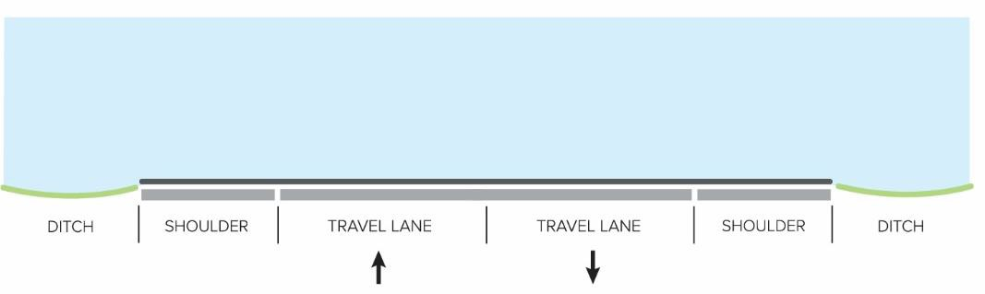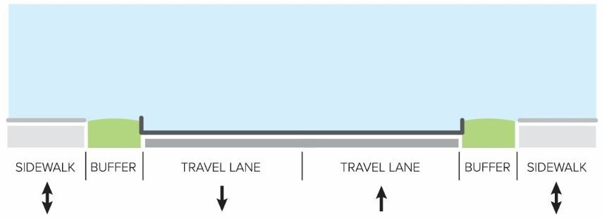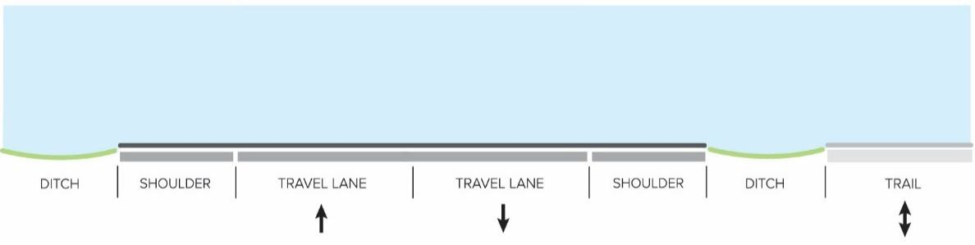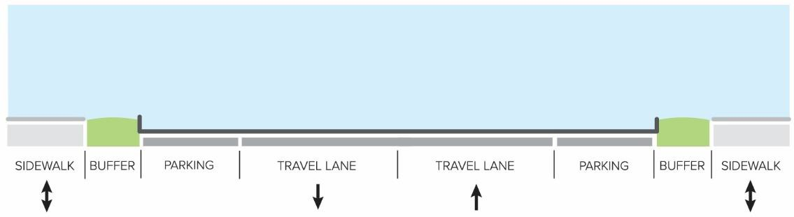TYPICAL CROSS-SECTIONS
R2

Rural two-lane undivided section with shoulder and ditch
U2 (SS)

Urban two-lane undivided section with curb and gutter and a sidewalk on each side of the road
R2 (T)

Rural two-lane undivided section with shoulder and ditch and a trail on one side of the road
U2P (SS)

Urban two-lane undivided section with curb and gutter, on-street parking, and a sidewalk on each side of the road

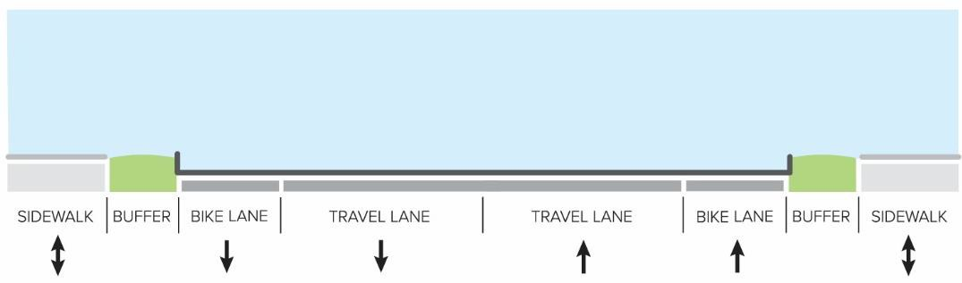
U2b (SS)

Urban two-lane undivided section with curb and gutter, striped bicycle lanes, and a sidewalk on each side of the road
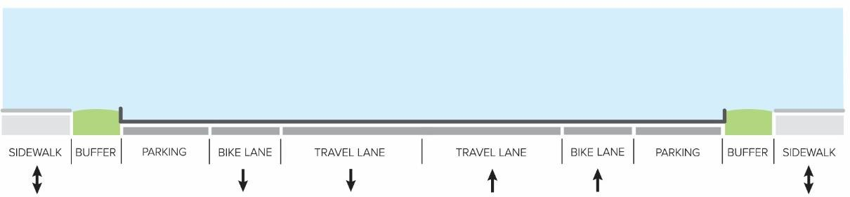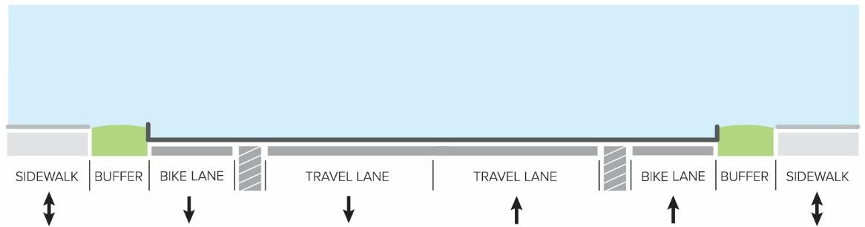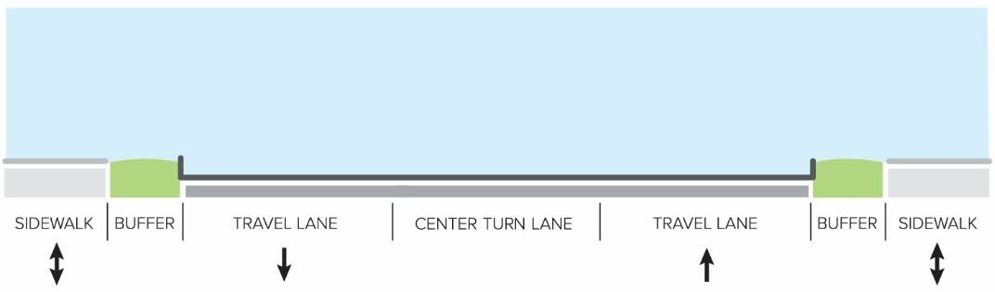
U2bP (SS)

Urban two-lane undivided section with curb and gutter,
striped bicycle lanes, on-street parking, and a sidewalk on each side of the road
U2B (SS)

Urban two-lane undivided section with curb and gutter, buffered bicycle lanes, and a sidewalk on each side of the road
U2C (SS)

Urban two-lane undivided section with curb and gutter, center turn lane, and a sidewalk on each side of the road

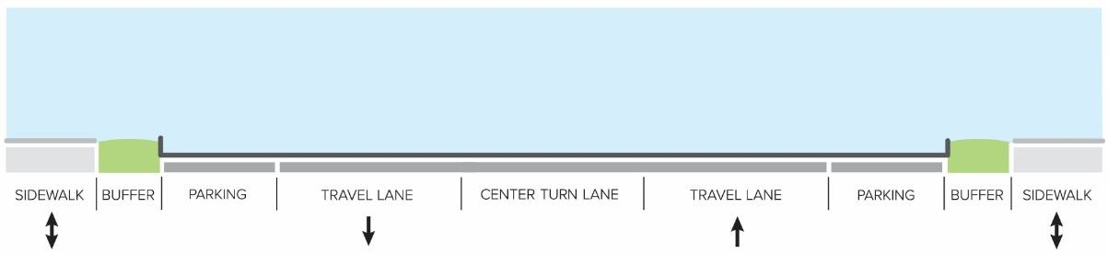
U2CP (SS)

Urban two-lane undivided section with curb and gutter,
center turn lane, on-street parking, and a sidewalk on each side of the road
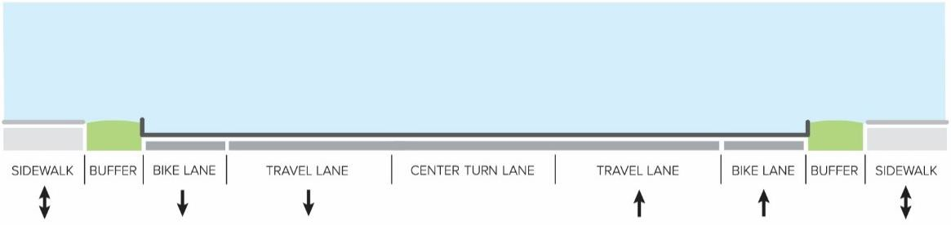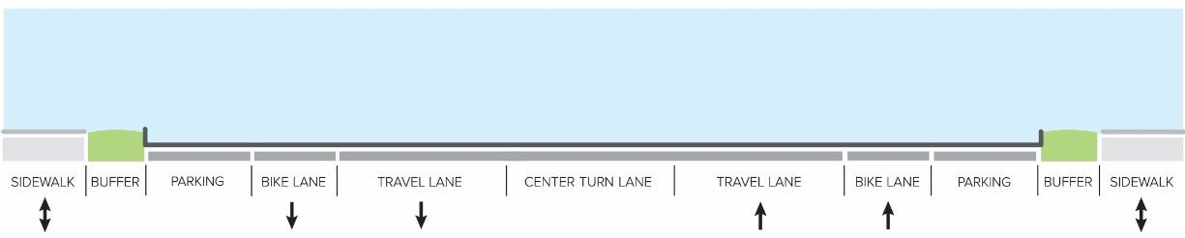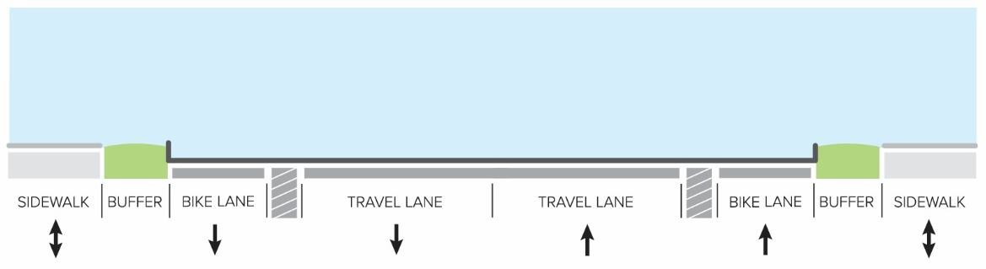
U2Cb (SS)

Urban two-lane undivided section with curb and gutter,
center turn lane, striped bicycle lanes, and a sidewalk on each side of the road
U2CbP (SS)

Urban two-lane undivided section with curb and gutter,
center turn lane, striped bicycle lanes, on-street parking, and a sidewalk on each side of the road
U2CB (SS)

Urban two-lane undivided section with curb and gutter,
center turn lane, buffered bicycle lanes, and a sidewalk on each side of the road

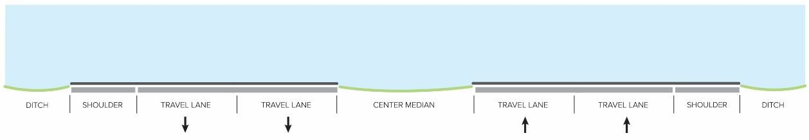
R4M

Rural four-lane median divided section with shoulder and ditch
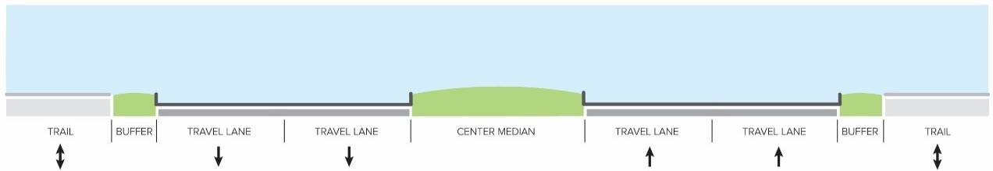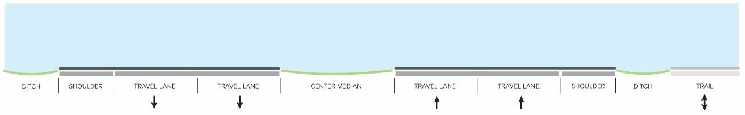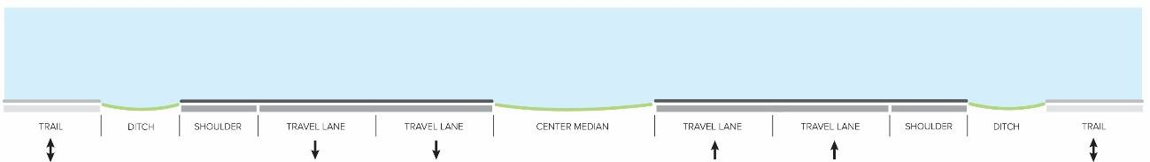
U4M (TT)

Urban four-lane median divided section with curb and gutter and a trail on each side of the road
R4M (T)

Rural four-lane median divided section with shoulder and ditch and a trail on one side of the road
R4M (TT)

Rural four-lane median divided section with shoulder and ditch and a trail on each side of the road

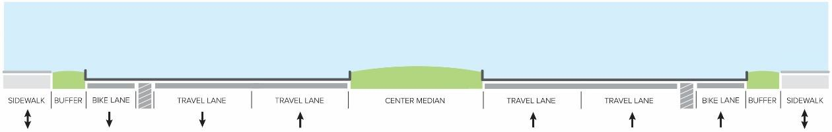
U4MB (SS)

Urban four-lane median divided section with curb and gutter, buffered bicycle lanes, and a sidewalk on each side of the road
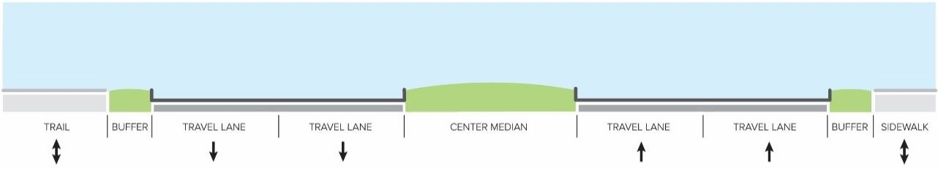
U4M (ST)

Urban four-lane median divided section with curb and gutter
and a sidewalk on one side of the road and a trail on the other side of the road

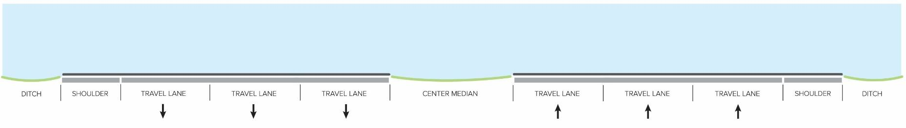
R6M

Rural six-lane median divided section with shoulder and ditch
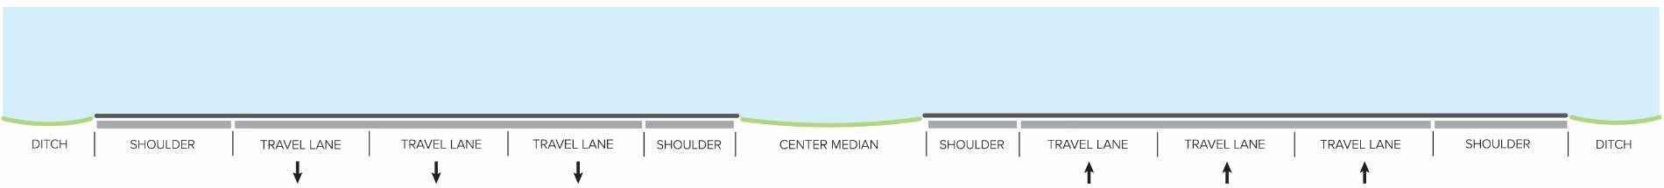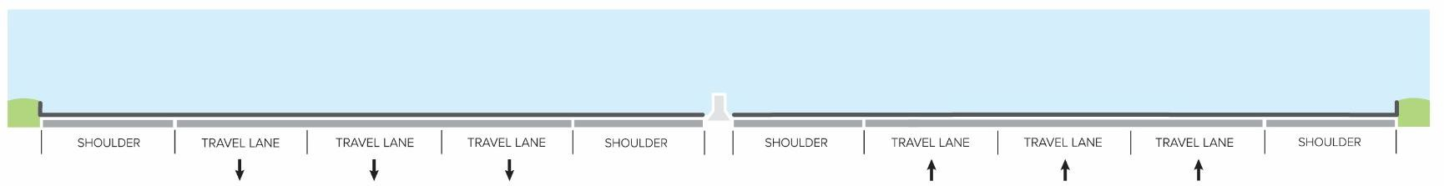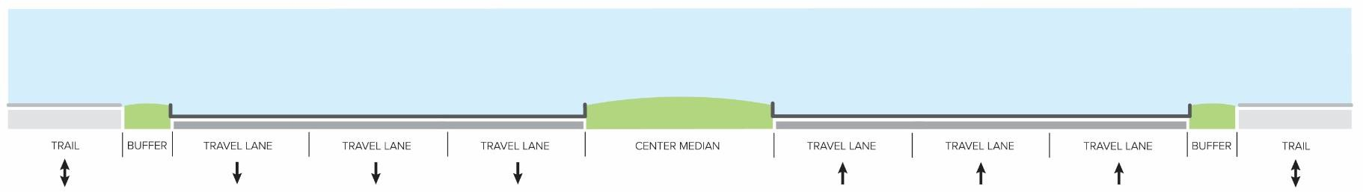
R6F

Rural six-lane freeway
U6F

Urban six-lane freeway
U6M (TT)

Urban six-lane median divided section with curb and gutter and a trail on each side of the road

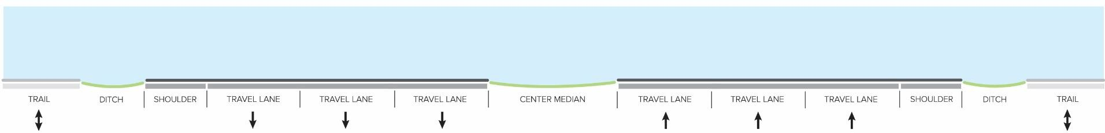
R6M (TT)

Rural six-lane median divided section with shoulder and ditch and a trail on each side of the road
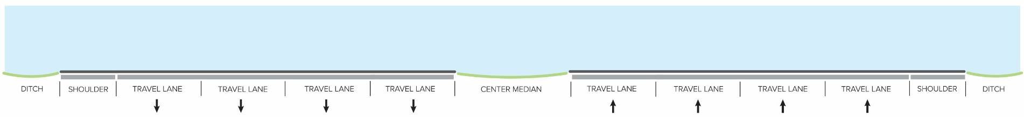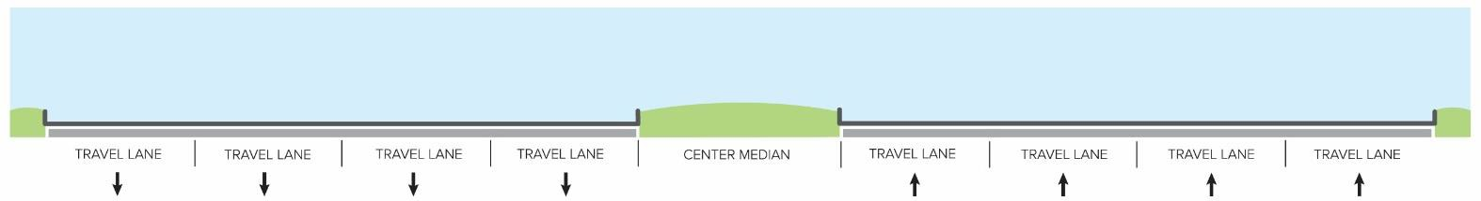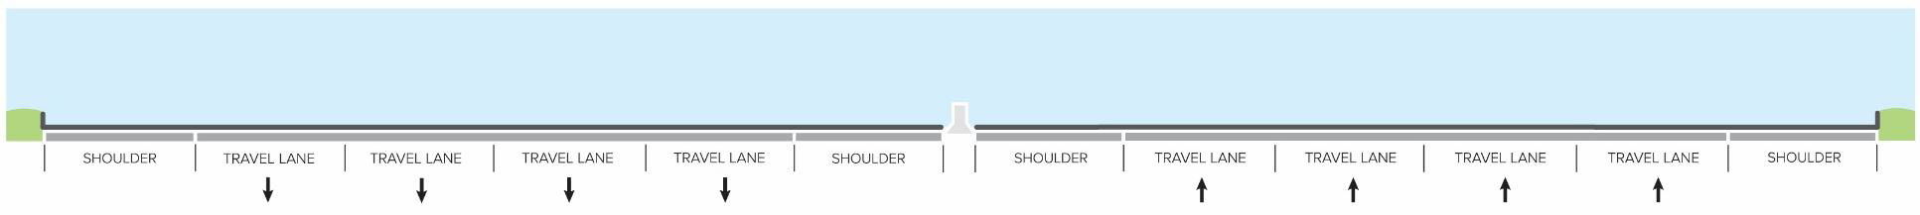
R8M

Rural eight-lane median divided section with shoulder and ditch
U8M

Urban eight-lane median divided section with curb and gutter
U8F

Urban eight-lane freeway

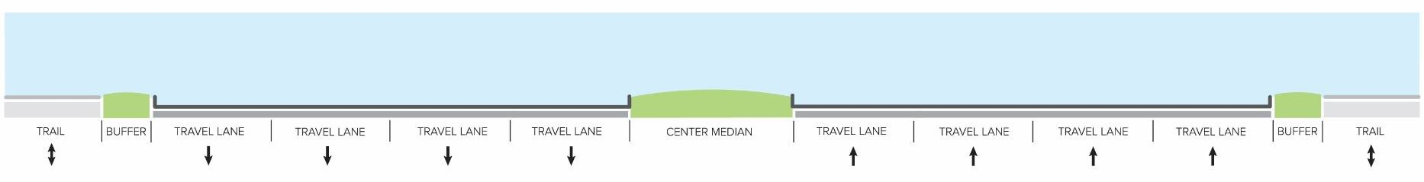
U8M (TT)

Urban eight-lane median divided section with curb and gutter and a trail on each side of the road
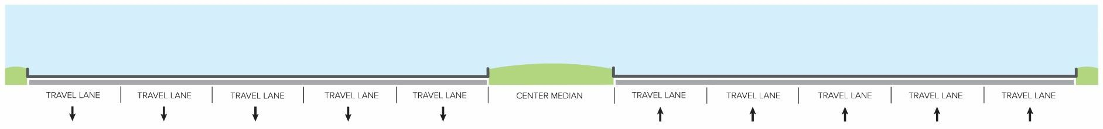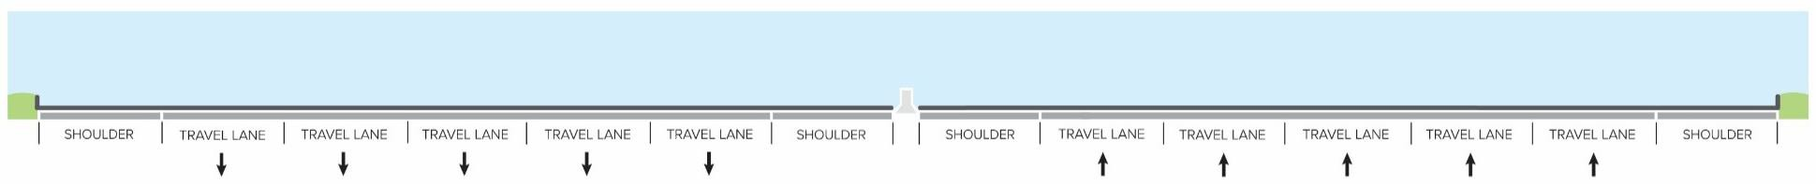
U10M

Urban ten-lane median divided section with curb and gutter
U10F

Urban ten-lane freeway

Roadway Design Toolkit for Suburban, Transition, Rural and Joint Land Management Areas
As outlined, design of streets with appropriate accommodations for motor vehicles, cyclists, and pedestrians can highly impact the reality of multimodal use and preference along any corridor. In order to achieve the vision of this plan, implementation of design elements that support the vision is essential. This toolkit provides guidance and standards for design of roadway elements, in conjunction with streetscape-related policies in the General Plan. For roadway design specifications in the Urban Policy Areas, refer to the Urban Policy Areas section of this plan.

Roadway Guidelines
Vehicular travel lanes are the core elements of roadway design. Most users will at some point use travel lanes, whether in a private vehicle, transportation service vehicle, or transit vehicle to reach a destination. Therefore, several features need to be considered when designing roads. All roads will need to meet the design standards of VDOT or the County, depending on whether the road will be maintained publically or privately. The following is an overview of guidelines for road design.

- Typically, travel lanes should be 12 feet in width. In activity centers and along planned lower speed roadways, narrower lanes should be considered to encourage reduced vehicular travel speeds and shorter crossing distances for pedestrians.
- Striping should be provided along both sides of travel lanes, and is highly desired when separating through traffic from turning traffic, on-street parking spaces, or on-street bicycle lanes
- Local streets should be designed to slow vehicles through contextually-appropriate elements such as narrow widths, tight corner radii, roundabouts, chicanes and islands, traffic controls, intersection tables, raised crosswalks, striping, and heavy landscaping.
- A striped buffer area or other barrier meeting VDOT standards between the vehicle lane and bicycle lane is preferred to strengthen the indication of a bicycle lane for drivers and cyclists, and prevent misuse of the bicycle lane for parking or turning vehicles
- During public road repaving and restriping projects, provision of on-street bicycle lanes should be evaluated based on this plan and in coordination with VDOT as part of the effort to create a complete and comprehensive bicycling network. Additional opportunities to maximize multimodal utility along existing roadways should be considered, including striping of on-street parking spaces, center turning lanes, right-sizing travel lanes, and traffic calming.
- Along rural area secondary roads, consideration will be given to opportunities to construct bicycle lanes by widening shoulders and adding signage or markings to accommodate bicycles
Off-Road Bicycle and Pedestrian Facility Guidelines
Due to their physical placement to the side of the travel ways and their relative narrow width compared to the road, off-road facilities for cyclists and pedestrians need to be designed

appropriately to accommodate safe and comfortable travel. This includes sufficient sizing, prominence, sightlines, and construction materials to make these facilities dependable and desirable to travelers. The following is an overview of guidelines for off-road facilities.

- In the Urban Policy Areas, Suburban Policy Area, and JLMAs, sidewalks are to be constructed of an impervious surface such as concrete or asphalt that will permit safe and dependable use in varying weather conditions. In the Transition Policy Area and Rural Policy Area, sidewalks are preferred to be constructed using asphalt in lieu of concrete due to the more natural aesthetic of asphalt. Where an asphalt trail is provided in place of a sidewalk, width standards for a pedestrian sidewalk may be applied.
- The following minimum standards will be applied to off-road bicycle and pedestrian facilities, with wider facilities preferred:
  - Regional Trails – 16 feet
  - Asphalt Bicycle and Pedestrian Trails along Planned Roadways – 10 feet
  - Sidewalks along Planned Roadways – 6 feet
  - Sidewalks along Local Streets – 5 feet
- Sidewalks and trails located along public roads will need to be entirely located either within the public right-of-way or within a public access easement.
- Connections between bicycle and pedestrian facilities and surrounding neighborhoods should be considered and supported through public and private planning processes, particularly along regional trail corridors including the W&OD Trail.
- Bicycle and pedestrian facilities will be designed with consideration for safe travel along and across high speed multilane roadways with consideration of the diversity of user groups who are anticipated to use these facilities.
- Bicycle and Pedestrian facilities should feature designs consistent with the natural topography of the area, especially in the transition and rural areas, minimizing impacts to existing natural and manmade features while providing for safe and efficient travel.
- Asphalt trails along roadways should be designed to follow the roadway in a direct and efficient manner, meeting AASHTO and VDOT guidelines for vertical and horizontal shifts to ensure useful and accessible bicycling routes
Intersection Design Guidelines
The integration and connection of transportation facilities provides opportunities for access and mobility as well as the need for route decisions and concerns for traveler safety. To this end, intersections, whether between two roads or a road and an off-road bicycle and pedestrian facility, need to consider multimodal safety and positive design to provide comprehensive opportunities for travel. The following is an overview of guidelines for intersections.

- Opportunities for installation of roundabouts should be considered when developing public and private projects as a safer, cost-effective alternative to a traditional signalized or stop- controlled intersection designs.
- Right-In / Right-Out intersections, and other modified intersections, will be designed in order to physically prevent non-permitted turning movements.

- Pedestrian refuge islands will be provided at crossings of median divided roadways with four or more through travel lanes to shorten individual crossing distances and improve pedestrian safety.
- Grade-separated bicycle and pedestrian crossings should be considered for major roads and rivers where anticipated demand or distance to alternative crossing locations may necessitate such an improvement.
- Crosswalks should be evaluated and provided across all four legs of signalized intersections, at stop controlled intersections, at roundabouts, and where needed to facilitate safe and efficient bicycle and pedestrian mobility, as well as between opposing curb ramps along two lane roads.
- Along primary roads and within villages in the rural area, crosswalks should be provided at pedestrian crossing locations.
- Curb ramps will need to be provided at all intersections where crosswalks are planned or anticipated.
Amenities and Natural Features
Aside from the core transportation facilities, other elements can have significant impact on travel and route preference. Natural features, such as trees, waterways, mountains, and landscaping can improve both the roadside experience and the surrounding vistas. Manmade improvements, such as buildings, public art, or erected barriers can also impact the quality of the journey. To create the best possible travel experience, useful amenities, wayfinding signage, aesthetic improvements, and safety features can be incorporated into the corridor. Additionally, natural features, such as plantings and natural barriers, can be installed to improve the design. The following is an overview of guidelines for amenities and natural features.

- Plantings are encouraged along roadways and within roadway medians where feasible.
- Plantings should make use of native plants and shrubs where possible to reduce maintenance and increase sustainability.
- Consideration will be given to accommodations for public art, place-making elements, and other aesthetic improvements along roadway corridors.
- Pedestrian plazas, pocket parks, and seating areas should be considered to provide opportunities for pedestrians to congregate and enjoy outdoor areas.
- Provision of bicycle parking for multifamily residential, commercial, and institutional uses, as well as at transit centers, park and ride lots, and other public facilities will help encourage bicycle trips. These should be located in the vicinity of primary building entrances to provide safety and convenience for cyclists.
- Where noise mitigation or other barriers to access - whether natural or artificial – are proposed between a major thoroughfare and an adjacent use, it is preferable to locate the shared-use paths and sidewalks on the side of the barrier with access to proposed uses. This will provide for better access to adjacent uses.
- Bike route signage should be considered along regional trails and along major cycling corridors following study to ensure the corridors are generally safe for bicycle travel.

- Bicycle and pedestrian wayfinding signage will be designed in a context-sensitive manner, matching the existing and planned surrounding aesthetic.
- Wayfinding signage should be provided to direct travelers to destinations such as public parks and other tourism areas
- Lighting for roads, sidewalks, and trails encourages use and promotes safety.

Transit Infrastructure Design Toolkit
In order to provide a safe, affordable, convenient, efficient and sustainable multi-modal transportation system to serve the County as outlined in the goals, distinct guidance for transit infrastructure amenities is essential. The following transit toolkit provides guidelines to create a systematic approach for the County and developers to build out a consistent and unified transit system and serves as the County’s policy foundation for the development of transit infrastructure.
Stop Placement Guidelines
Bus stops are a critical component of the transit system. On a single round trip a bus rider will typically use at least four different bus stops for boarding and alighting, and any one of those stops may create a significant barrier if not designed well. Being able to get to a bus stop easily and wait for the bus in a comfortable environment are important elements of every transit customer’s experience. These bus stop design guidelines are intended for bus stops used by full-size transit buses on fixed-route service.
Location Choice
Existing conditions such as roadway type and width, transit service characteristics, and land use affect the way that bus stops should be spaced and designed to ensure comfort, short travel times, and overall network efficiency. Additional considerations that impact the safety, convenience, and accessibility of a stop, such as placement relative to street intersections must also be considered. The following is an overview of several factors that influence the placement of bus stops.
- Bus stops should be placed near activity centers, such as shopping areas, civic buildings, schools, medical centers, or residential communities to attract ridership by enhancing the convenience of transit service. In areas where there are several activity centers in close proximity, such as an area with several popular shopping destinations, bus stop placement should consider additional factors, such as spacing and logical routing.
- For major activity generators, such as special event centers, stops should be located as close as possible to the entrance of the destination.
- Roadway speed, width, and vertical alignments should be considered when siting and designing a bus stop and stops. A bus stop’s adjoining roadway can impact both design and operation of bus service and stops. For example, wider streets may allow for curb extensions at bus stops, which would create more space for amenities and reduce the pedestrian crossing distance. However, wider streets also typically have higher travel speeds, which increase the sight distance needed for pedestrians to feel comfortable crossing the roadway as well as distance needed for drivers to see passengers at the stop as they approach.
- Conditions of the sidewalk and connections with the surrounding area are important and affect the prioritization of bus stop improvements. At minimum, a stop should be accessed

by a sidewalk in safe and ADA-accessible condition between the bus stop and the closest intersection.
- As almost all riders will need to make round trips using a pair of bus stops on opposite sides of a street, safe, nearby crosswalks with curb cuts for wheelchairs, are required. When a stop is intended to serve a singular destination, a logical path between that destination and the bus stop shall be provided as well.
- Bus stops will be designed with lighting, either as part of the stop or via nearby street lights. Passenger security (real and perceived) can positively or negatively affect customer perceptions of the bus stop. Therefore, landscaping, walls, and solid structures should be designed to CPTED (Crime Prevention Through Environmental Design) standards so as not to provide hiding spaces or restrict sight lines for passengers.
Bus Stop Zones
Determining the proper location of bus stops involves choosing between near-side, far-side and mid-block stops. The location of the stop relative to the intersection is an important consideration. If all other factors were similar, far-side stops would be preferable, since they encourage people to cross behind the bus and not in front. However, there are almost always complicating factors.
The size of the bus stop zone—where other vehicle parking is not allowed—varies based on the type of vehicle used. If the County adds articulated buses to its future fleet, 20 feet should be added to the length of all bus stop zones described in stop siting alternative. Additionally, the length of the bus stop zone should be increased by 50 feet per additional bus at locations where multiple buses may stop to board/alight passengers simultaneously.
NEAR-SIDE STOP
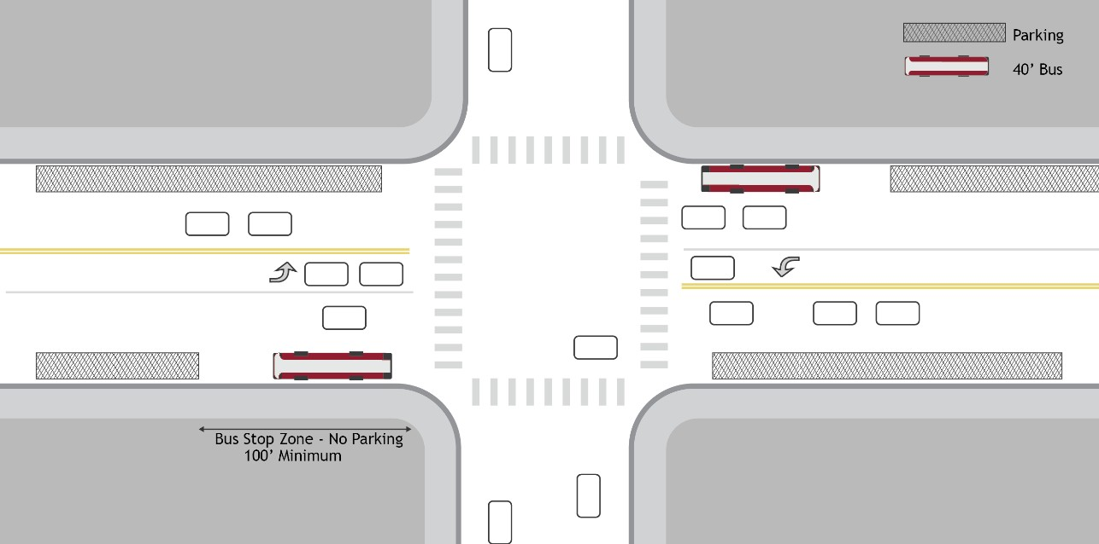
Near-side bus stops are located at the approach to an intersection, allowing passengers to load and unload while the vehicle is stopped at a red light or stop sign. Bus stops located at the near side of the intersection should be placed at least 5’ behind the crosswalk to prevent the bus from straddling the crosswalk while it is stopped to serve the stop.
Near-side stops have several advantages, depending on various intersection factors. They minimize interference with heavier traffic on the far side of the intersection, provide more

convenient access to crosswalks (if existing), allows riders to board and alight simultaneously with the red light, avoids being forced to stop for a red light and then again at the bus stop, and provides space for the bus to “jump” traffic when the traffic signal turns green.
However, there are several potential drawbacks to a near-side stop as well, including increased vehicle and control device sightline problems for crossing pedestrians, sightline problems for drivers approaching the intersection, conflicts with passing and right-turning vehicles, blockage of through travel lanes, and disruption of traffic flows. A bus may also find itself stuck on a red light after dropping passengers at the stop during the traffic signal’s green phase.
Near-side stops are recommended in locations where:
- Vehicular traffic is heavier on the far side of an intersection
- Pedestrian facilities are more readily available on the near-side of the intersection
- The bus will be turning right at the intersection, where curb extensions protect the bus from turning traffic
- Stacking of buses at far-side stops may lead to gridlock within the intersection
FAR-SIDE STOP
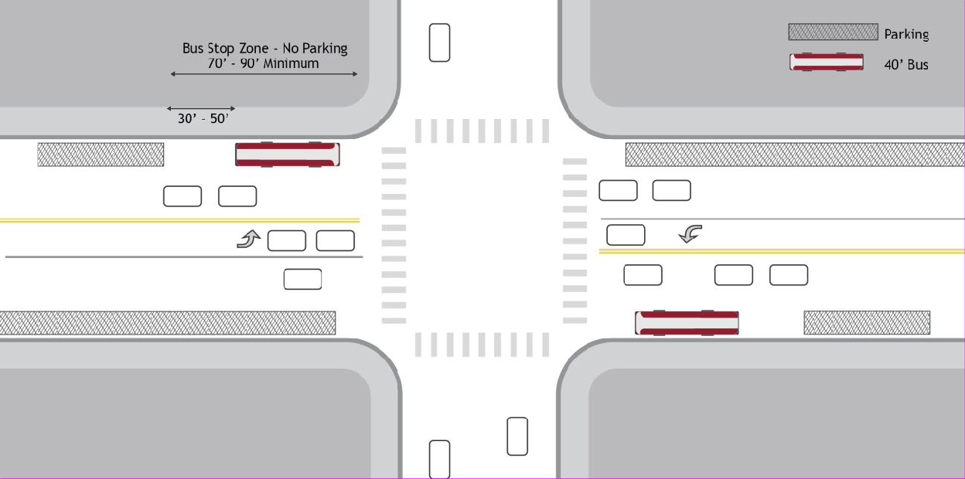
Far-side bus stops are located after an intersection, allowing the bus to travel through the intersection before stopping to load and unload passengers. For a standard 40’ transit bus, the bus stop should be located at least 50’ after the intersection to ensure that the rear of the bus does not extend into the intersection and/or straddle the pedestrian crosswalk.
Advantages to far-side stops include minimized potential conflicts with turning vehicles, the ability of buses to take full advantage of the gaps in traffic flow created at signalized intersections behind the stop, additional right-turn capacity by making curb lane available for traffic, longer deceleration distances for buses, smaller area needed for curbside bus zone (when considering space needed to pull in to the stop area), and opportunities for pedestrians to cross behind the bus.

The disadvantages to far-side stops include the potential for traffic to queue into the intersection when a bus is stopped in travel lane, obscured sight distance at the far-side crosswalk and for side streets, pedestrian conflicts as the bus approaches the stop while seeking to move past the intersection, and may result in the bus being required to stop at both the red light and the far side stop.
Far-side stops are recommended in locations where:
- Vehicular traffic is heavier on the near-side of an intersection
- At heavy right turns on major approach (or where the near side approach includes a right- turn lane), or heavy left and through movements from side street
- Existing pedestrian facilities are greater and movements safer than on the near side
- At complex intersections with multiphase signals or dual turn lanes, this removes buses from the area of complicated traffic movements
- Intersections that have transit signal priority or queue jump lanes
MID-BLOCK STOP
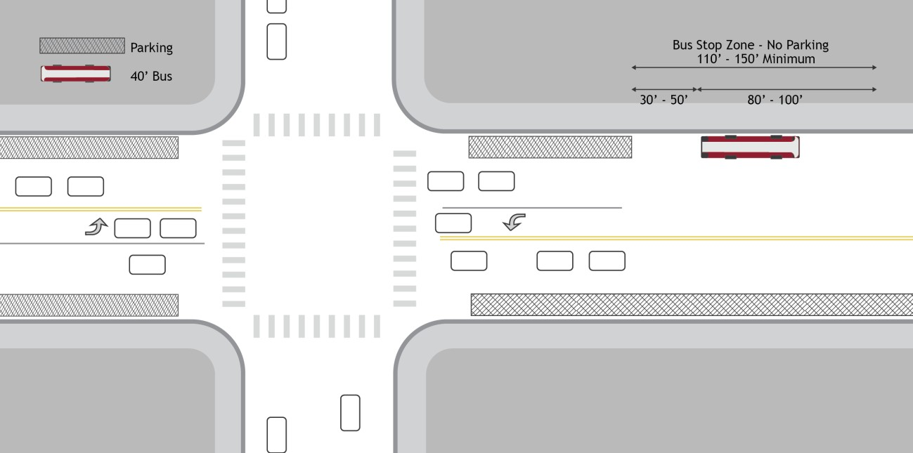
Midblock bus stops are located between intersections. Mid-block stops should generally only be used under special circumstances, such as where major trip generators/attractors justify high- volume access and that generator/attractor cannot be served at the nearest intersection, or when the distance between adjacent intersections exceeds stop spacing recommendations and a midblock crossing is available for use.
Midblock stops, while generally not preferred, provide some advantages, including the likelihood of less pedestrian congestion near customer waiting areas, improved sightlines for pedestrians and vehicles, and limited conflicts with traffic flows. However, the drawbacks of mid-block stops include the need for more significant on-street space for the bus to pull in and out of the stop zone, increased potential for unsafe midblock crossings, and increased walking distance to nearby intersections and associated destinations.

Therefore, midblock crossing should only be considered under limited circumstances where:
- Traffic or street/sidewalk conditions at the intersection are not conducive to a near or far- side stop
- Customer traffic generators are located mid-block and/or adjacent intersections are too far apart
- A queue jump lane conflicts with a potential near side or a far-side stop

Bus Stop Spacing
Stop spacing refers to the distance between bus stops along a route. Stop spacing affects overall travel time and, therefore, demand for transit. In general, the tradeoff is between close stops, which result in short walking distances but more frequent stops and longer bus trips, and stops farther apart, which result in longer walking distances but less frequent stops, higher speeds, more reliable bus service, and a shorter bus trip.
- Generally, a distance of about 1,000 feet between bus stops is recommended while up to 1,300 feet may be more appropriate for low density areas. This distance is a reasonable balance of the conflicting goals. However, finding suitable sites for bus stops may necessitate altering the spacing significantly. In addition, there may be reasons for bus stops to be closer together, such as major transfer points and/or activity centers. And there may be places where bus stops should be further apart, particularly if there would be not be any boarding or alighting anticipated based upon adjacent land uses. In high density areas, such as the Urban Policy Areas, stops along a route should occur generally no less than once every 3,000 feet.
- Whenever possible, bus stop locations should be paired, so that people are able to board and alight on opposite sides of the same roadway in the same vicinity when making a round trip. This allows the transit service to be more intuitive, and maximizes convenience for the greatest number of users.
In many cases, there are certain existing or planned locations for bus stops which stand out as particularly important. This can be due to existing use, activity centers, transfer opportunities, or other conditions. Once these critical locations are determined, the remaining stops can be planned for optimal spacing.
- At locations where transfer activity between routes is heavy, bus stops for the intersecting routes should be located as close to each other as possible in order to shorten travel for passengers traveling between routes. Additionally, stops with high transfer activity should have a high level of passenger amenities since transferring passengers have less control over the amount of time they wait at the bus stop for a transfer.

Loading Area Type
On-street bus stops each include a stop zone which may be located in a travel lane, a parking lane, or along the shoulder depending on the characteristics of the roadway. Although on‐street bus stops are the most common and the easiest to establish, each location has site constraints that should be considered when evaluating a location for an on‐street stop.

- Posted speed limits should not exceed 40 miles per hour.
- Parked cars must not block bus access to acceleration/deceleration areas or the curb, rendering the stop inaccessible to customers who use wheelchairs. Alternative configurations such as curb extensions, and bus bays may address some of these issues while accomplishing other service goals.
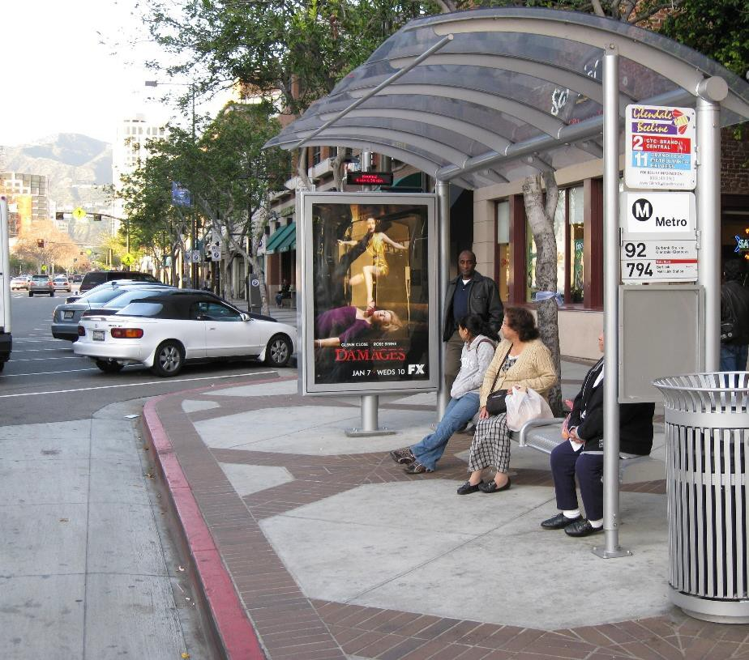
- CURBSIDE STOPS
The most common stop location, these are designed for the bus to pull up along the existing curb edge to board and alight passengers. When installing amenities at these locations, such as seating or a shelter, it is preferable to locate the amenities between the sidewalk and street edge so that riders waiting for a bus are not required to cross the sidewalk to reach the curb. These stop locations placed at least 60 feet from the edge of
the curb radius of the nearest intersection to ensure safe boarding and alighting for transit riders and safe turning movements for vehicular traffic.
- CURB EXTENSIONS
A curb extension, also known as a bulb-out, is a widening of the sidewalk to extend the bus stop loading and waiting area into the parking lane, bring it directly adjacent to the travel lane. Curb extensions are most effective in denser environments with high pedestrian activity or areas where the sidewalk is too narrow to accommodate a bus stop. In these locations, curb extensions provide a larger bus stop footprint that can accommodate shelters, benches, and other transit customer improvements while reducing interference with pedestrian activity on the sidewalk. Curb extensions also reduce the need to displace parking spaces since a bus serving a stop on a curb extension will stop in the traffic lane instead of traveling into the parking lane as they do at curbside bus stops. Finally, curb extensions work well in conjunction with crosswalks by reducing the crossing distance for pedestrians.
Curb extensions should be considered at sites with the following characteristics: High pedestrian activity
Crowded and/or narrow sidewalks
A need to reduce pedestrian crossing distances

Bus already stops in travel lane
The need to minimize loss of street parking
There are multiple travel lanes, enabling vehicles to bypass a stopped bus
Since a bus serving a stop on a curb extension will now stop in the traffic lane instead of traveling into the parking lane, a shorter bus stop length (50-feet) is required.
Stops located along a curb extension should be designed to the following minimum dimensions: 50-foot bus stop length (70-foot bus stop length for stops served by articulated buses)
5-foot by 8-foot concrete landing pad
4-foot by 10-foot rear door clear zone
BUS BAYS
A bus bay is a stop with a pull-out for buses that is constructed as an inset into the curb. The bus bay allows buses to pull out of traffic for loading and unloading, allowing general traffic to pass the loading bus. Bus bays are most effective in areas where the impact of a bus blocking a travel
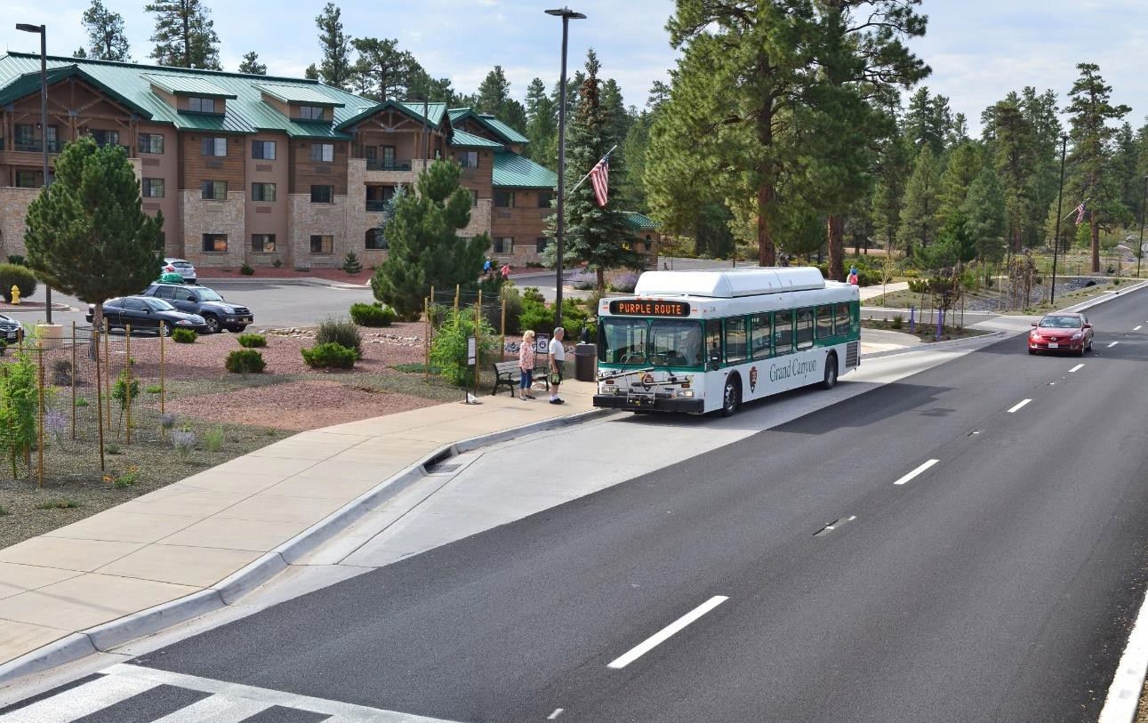
lane creates significant traffic delays, where traffic speeds are more than 40 MPH, or where long dwell times are common. In these locations, bus bays allow buses to service the stop while minimizing traffic delays and conflicts with traffic. Bus bays also clearly define the bus stop and allow customer loading and unloading to be conducted in a more relaxed manner.
However, bus bays can also make it difficult for buses to reenter traffic, which can increase bus delays, decrease service reliability, and increase average bus travel time. Bus bays may also require right-of-way acquisition. Additionally, bus bays may reduce sidewalk width and impact pedestrian traffic if sufficient right-of-way is not available.

Bus bays should be considered where street traffic averages 40 mph or more and any of the following conditions exist:
- Average peak period dwell time exceeds 30 seconds per bus
- There is a high frequency of collisions involving buses and/or pedestrians
- Bus volumes exceed 10 or more buses per hour
- Where stops in the curb lane are prohibited
- Where sight distances prevent traffic from stopping safely behind a stopped bus
- At stops where there are frequent wheelchair passengers boarding
- Where buses are expected to layover at the end of a trip

Bus stops located along bus bays require slightly different footprints than typical curbside bus stops. Since a bus serving a stop in a bay will pull out of the general traffic lane into a curved pull- out lane, a shorter bus stop length (60’) is required, as the bus will use the curved pull-out lane for its approach.
Stops located in a bus bay should be designed to the following minimum dimensions:
- 60-foot bus stop length
- 5-foot by 8-foot concrete landing pad
- 4-foot by 10-foot rear door clear zone

Bus Stop Elements and Amenities
Well-designed bus stops enhance the rider experience, decrease perceptions of extended wait times for transit services, and can contribute to increased ridership. Conversely, poorly designed bus stops can decrease customer satisfaction, make transit less attractive to potential new customers, and potentially make waiting at stops unsafe and uncomfortable for riders. Investing in high quality bus stops is often a low-cost, high-reward strategy for improving transit operations.
Developing clear and practical guidelines for amenities at bus stops can provide the structure and process needed to improve overall transit system quality. No matter how many riders use a bus stop on a given day, each stop requires certain key design elements to be safe, accessible, reliable, and comfortable for passengers. By formalizing the amenity installation process, the County can set clear goals for stop quality and provide justification for how and when bus stop upgrades occur. Bus stop amenities are profiled below.

BUS STOP SIGN
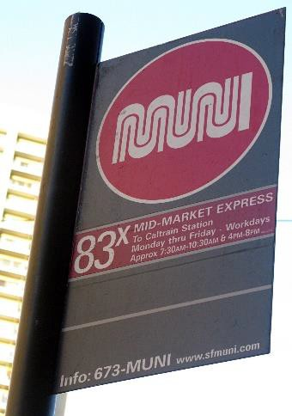
Bus stops should all include consistently updated and attractive signage conveying essential information to increase customer satisfaction and understanding of the bus system.
- Basic information includes route numbers and names, stop ID number, the direction of the routes, a phone number and website for additional assistance, and often destination(s) and service hours. A stop ID number is often used to access real-time schedule information via text message, internet, or an automated phone system. These details help to reduce confusion and increase rider comfort at stops.
- All bus stops should have a consistently maintained bus stop sign
on the far side of the boarding area and be placed on a pole at a height that conforms to ADA standards while avoiding impacts to pedestrian movement on the sidewalk.
SEATING
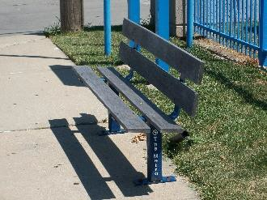
Benches can be either freestanding or part of a shelter design and provide seating for passengers waiting for the bus or near sites that attract riders who may have difficulty walking and standing.
- Seating should be provided wherever possible and designed so as not to compromise safety or obstruct sidewalk access or access to customer information.
- Benches should be fabricated of durable materials resistant to vandalism and weather conditions.
LIGHTING
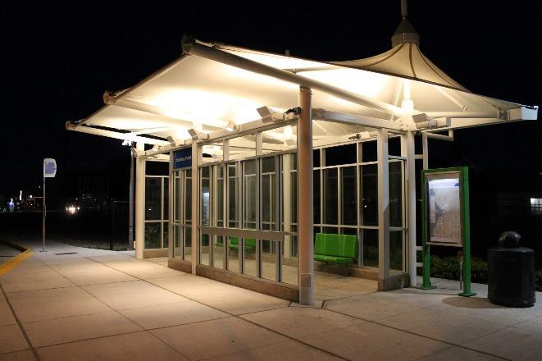
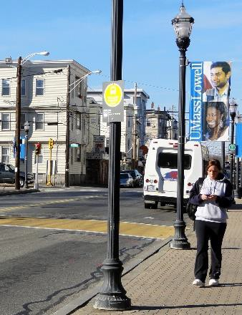
Adequate lighting at bus stop facilities allows bus drivers and approaching traffic to see waiting passengers at night. Lighting also provides added security for those waiting at the stop, in addition to illuminating route and schedule information for patrons.
- Lighting can be provided by a nearby streetlight, lighting installed within the shelter, or a stand‐alone light pole. Transit stops should either be located within 30 feet of an overhead street light or include lighting within the shelter.
- Lights installed within the shelter should be designed with appropriate brightness to provide visibility, while not being so bright as to create a spotlight effect that makes it difficult for waiting passengers to see outside.

SHELTER
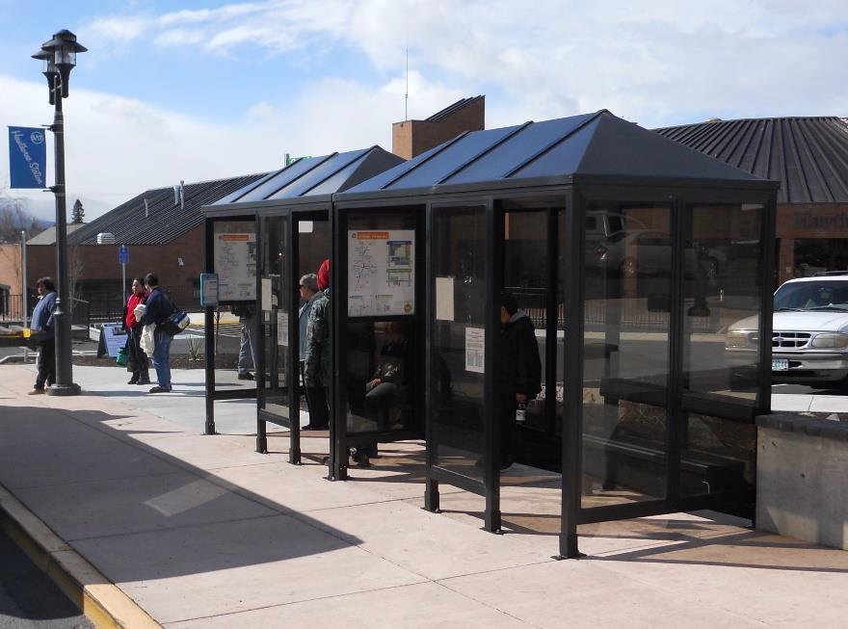
Shelters offer a prominent and safe protective waiting area for bus passengers, traditionally including informational signage about the bus service or surrounding land uses. Shelters protect transit riders from the elements and help to identify stop locations by defining a sense of place along a roadway or at a transit center.
Numerous suppliers provide off- the-shelf bus stop shelter designs. The County also has a standard design, which may be updated from time to time. This is a minimum standard and can be provided by DTCI upon request.
- Shelters should include at least two walls, a roof, seating, and a clear space for customers using a wheelchair.
- Bus shelters should provide a clear line of sight to approaching buses. Many shelter designs incorporate glass or plastic walls in order to provide multiple lines of sight.
- Bus shelters shall be a minimum of 16-feet in width in the Urban Policy Areas and a minimum of 12-feet in width elsewhere in the County. At existing or planned transfer points, at stop locations central to activity centers, and at locations where high ridership is anticipated, a minimum of 16-feet in width shall be required. All bus shelters will be designed to include lighting, which may be on a motion detector or timer, and shall be solar-powered as feasible.
WASTE AND RECYCLING
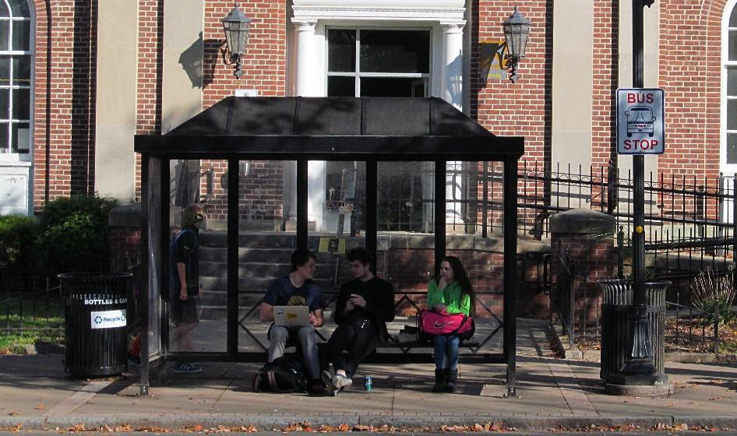
Bus stops, both those with and without shelters, can offer both trash and recycling receptacles to help keep the stop area free of debris, food scraps, or other refuse generated by waiting bus passengers on a daily basis.
- Receptacles should be durable, visible, and placed conveniently without blocking major pedestrian movements.

- Bus stops that have a problem with litter and those in proximity to fast food establishments should have trash receptacles.
- Receptacles should be of a standard type, closed at the top to prevent rain, snow, or other precipitation from entering, and easy for maintenance workers to access and empty.
- Maintenance may be completed through a private maintenance agreement. Design should be consistent for easy identification by travelers, but receptacles can be customized with artwork or advertising specific to stop locations.
BICYCLE PARKING
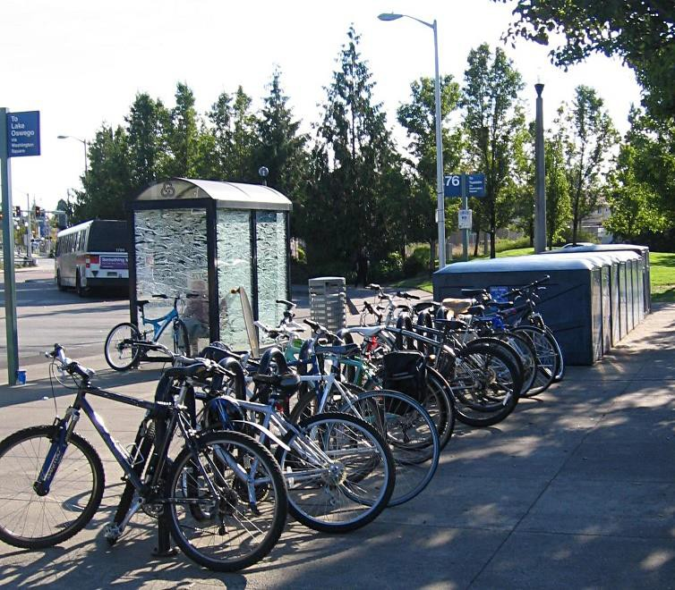
Permanently and individually installed bicycle racks provide an opportunity for bus passengers arriving by bicycle to securely park their bike during the length of their bus trip. Groups of bicycle racks may be covered and secured in lockers or a shelter with gated access to provide an additional benefit to long-term bicycle parkers by protecting bicycles and related gear from weather or theft.
- Bicycle parking should be provided at all park-and-ride lots and at transfer stations.
- Lockers should be clearly labeled as bicycle parking and signs should be posted with directions for use. Larger
bicycle parking stations can have vertical hanging racks and typically require a unique maintenance plan and are often operated as a concession or contract service.
- Sufficient spacing between racks enables a comfortable and intended fit of two bicycles to each rack. To be consistent with the Association of Pedestrian and Bicycle Professionals (APBP) Bicycle Parking Guidelines, racks aligned parallel to each other should be at least 36 inches apart. Those aligned end-to-end should be 96-inches apart. Racks perpendicular to a wall must be at least 48-inches from the wall and at least 48-inches from the curb. Racks parallel to a wall should be at least 36-inches from the wall and 24-inches from the curb.
Additional Amenities
The following amenities will be considered as part of bus stop design but are not anticipated at all stop locations at this time:

REAL TIME INFORMATION DISPLAYS
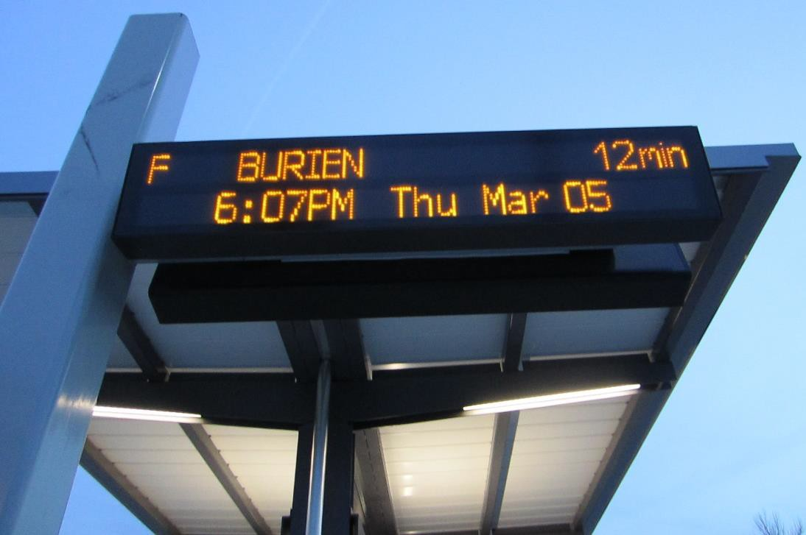
An electronic display at bus stops showing the number of minutes until the next arrival of each operating bus route at that very stop can help improve the passenger experience.
Especially at stops where bus route frequencies are less than every 10-15 minutes, knowledge of how long a passenger must wait until the next bus is
important for rider comfort.
OFFBOARD FARE VENDING EQUIPMENT
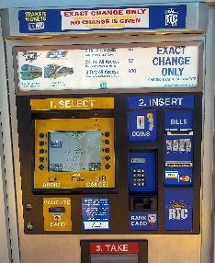
At major bus stops and transfer stations, the installation of fare payment/purchase equipment at bus stops can improve customer convenience and service reliability by reducing on-board cash transactions and bus stop dwell times. Off-board fare payment vending machines and associated instructional signage typically require a 10’ by 10’ footprint for two machines and should be semi-enclosed. The potential need for wired connections for power or communications can restrict the number of potential deployment sites
PUBLICATION VENDING
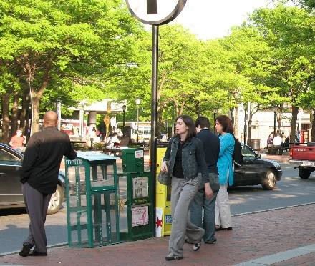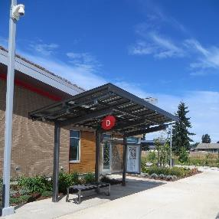Newspaper boxes and other literature vending machines can be an added convenience to passengers and should be placed at locations where there is a high level of pedestrian activity or bus ridership. Corrals can be used to designate a location for newspaper boxes. As with other bus stop elements, boxes should not obstruct pedestrian movement and should comply with ADA requirements.
SECURITY CAMERAS
Bus stops and transit centers see large numbers of users each day, not always under employee supervision. A
security surveillance system both on-board buses and at select facilities can help to ensure a safe and secure environment for customers and employees alike. Video surveillance also allows the transit operator to monitor facilities remotely at any time of the day and may have operational benefits from an arrival/departure/loading time perspective.

Bus Stop Hierarchy
Resources for providing and improving passenger facilities must be prioritized in terms of what improvements will be made and where they will be applied. The table below provides a guide for the provision of the previously described bus stop elements for each class of bus stop.
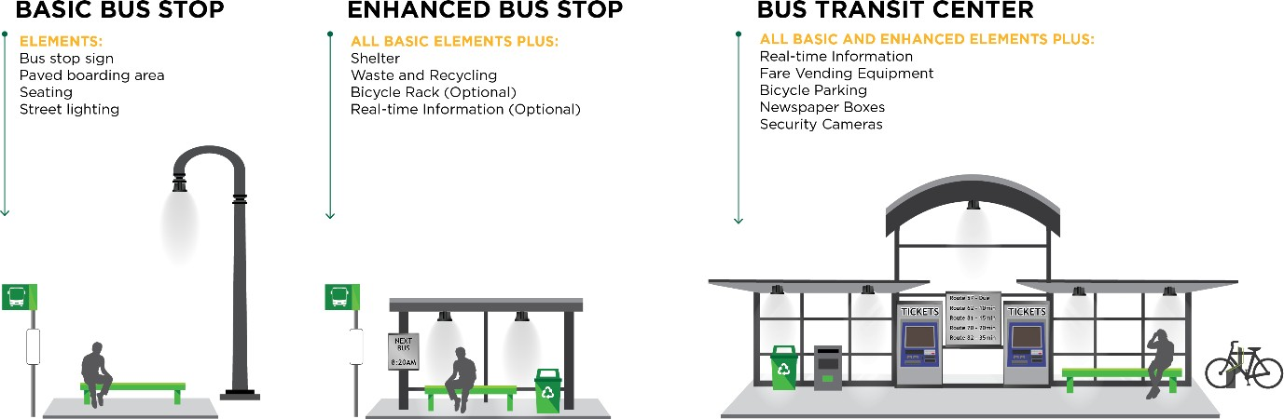

Conceptual Ideas of Basic, Enhanced, and Transit Center Bus Stops

Note that the Park & Ride is not in and of itself a typology. The bus stop located proximate to any size parking facility may be configured as a basic stop, an enhanced stop, or a transit center, although anticipated high ridership at these locations are more likely to lend themselves to the Transit Center category. Considerations on the choice of stop class should consider total daily trips, number and type of routes serving the stop, and any the customer based served.

Bus Stop Element | Basic Stop | Enhanced Stop | Transit Center
Bus Stop Sign | Yes | Yes | Yes
Seating | Yes | Yes | Yes
Lighting | Yes | Yes | Yes
Shelter | No | Yes | Yes
Waste and Recycling | No | Yes | Yes
Bicycle Parking | No | Optional | Yes
Real-Time Information | No | No | Yes
Fare Vending Equipment | No | No | Optional
Literature Vending | No | No | Optional
Security Cameras | No | No | Optional

Operational Network Features/Improvements
In addition to stops, there are improvements that can be made to the transit system through management of travel lanes along identified transit corridors. These improvements attempt to prioritize transit as a more efficient way to move more people through a transportation corridor, understanding the people trips as being different than the traditional vehicle trips metric.
DEDICATED TRANSIT LANES
Dedicated transit lanes are used to prioritize and improve frequent bus services on busy streets. Owing to the high passenger capacity of transit, a dedicated transit lane can drastically increase the amount of people that can be transported along a corridor during the highest demand travel periods. Since dedicated transit lanes encourage people to shift to transit, reducing vehicle demand, they are an important part of maximizing the utility of the transportation system by making travel faster, more reliable, and more enjoyable. Pavement markings, signage, and enforcement are important to maintain the integrity of dedicated lanes.
Dedicated lanes can be located along the curb, which work best on streets with a parking lane that can be designated as no parking during peak travel hours, few driveways, and limited right-turning traffic. They can also be located within the median, operating in full-time dedicated lanes with median islands for boarding. For short connections, they can use transit plazas that prohibit other vehicle traffic and reserve the entire right of way for buses.
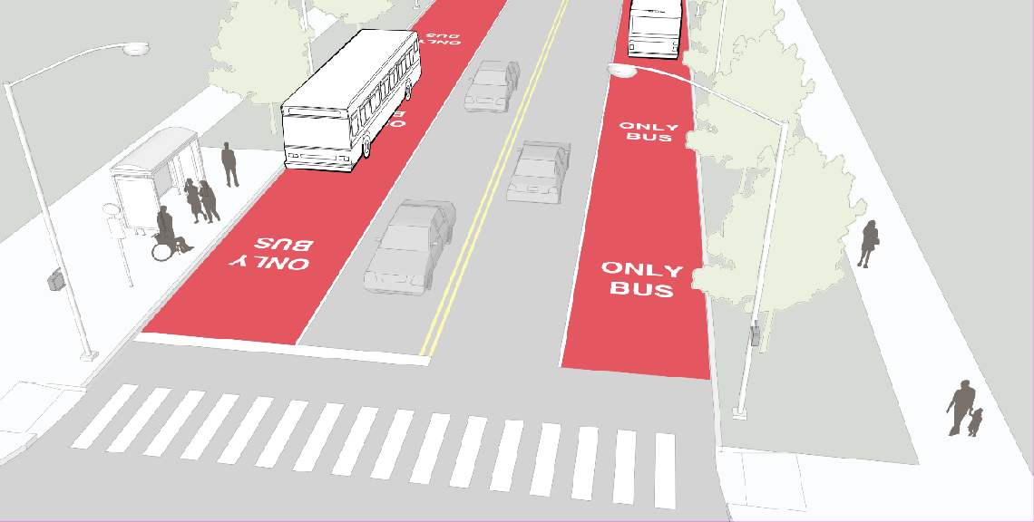
Transit lanes are used only on corridors where transit service is very frequent, ridership is high, and traffic congestion significantly and routinely impedes transit operations. Transit lanes may be permanent or time restricted—reserved for transit vehicles only at peak hours of the day and permitted for other uses at other times. Transit lanes may also be considered for future implementation where planned densities may result in the need for such facilities in the future.
Example of Dedicated Transit Lanes

SHARED TRANSIT LANES
A shared lane reserved for transit vehicles and bicyclists can provide improved accommodation for both road users to maneuver together as transit vehicles start and stop along a corridor. Shared

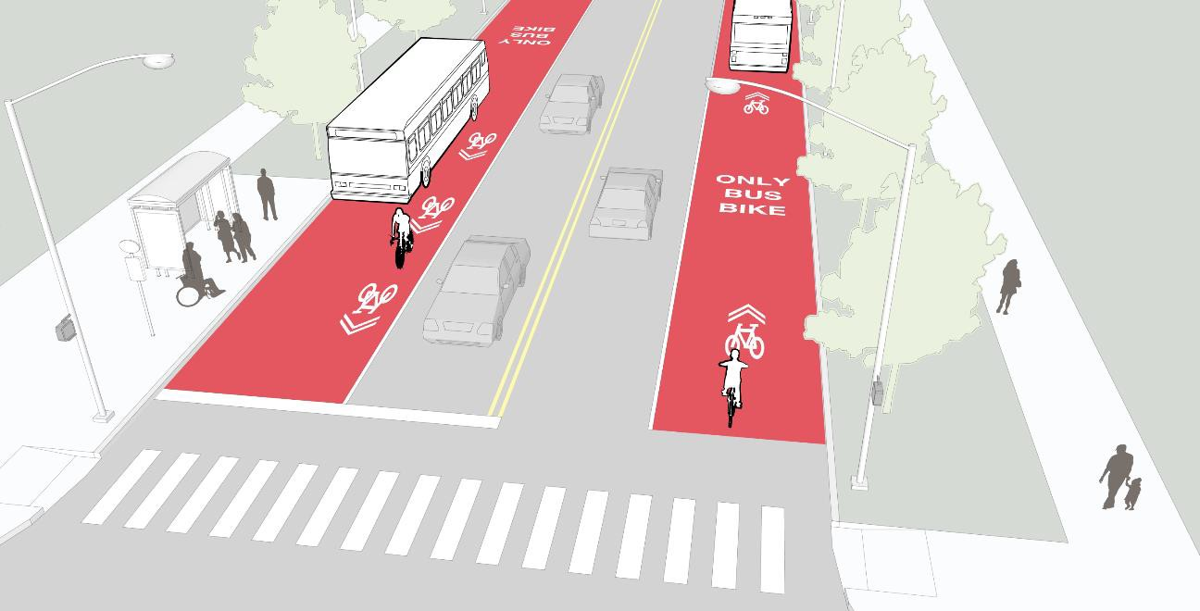
lanes are appropriate on streets where bus headways are at most every five minutes, traffic speeds are less than 30-miles per hour, bike volumes are not very high, and space constraints preclude exclusive facilities for each mode. The shared lane is typically wider than a dedicated transit lane. They should be located in the outermost lane adjacent to a curb to reduce conflict.
Example of Shared Transit Lanes

BUS QUEUE JUMP LANES
- A short bus lane located at the approach to a traffic signal allows buses to bypass waiting traffic, significantly improving transit travel time. They are best used at congested intersections on primary transit routes and where stops can be placed at the far-side of an intersection. Space on the far side of an intersection should exist for the bus to reenter traffic. Bus queue jumps may be:
- Transit Exemption for Right-Turn Lanes: The bus queue jump lane shares space with a right-turn lane, but transit vehicles are allowed to proceed straight through the intersection.
- Shared Right-Turn/Bus Lane: The entire curbside lane is reserved for transit vehicles, but drivers are allowed to enter the lane when approaching an intersection for right turns.
- Advanced Stop Bar: The main stop bar is pushed back several car lengths and a transit- only or “right and transit” lane is placed along the curb at least two car lengths ahead of the stop line, so that transit vehicle can pull ahead of other traffic.

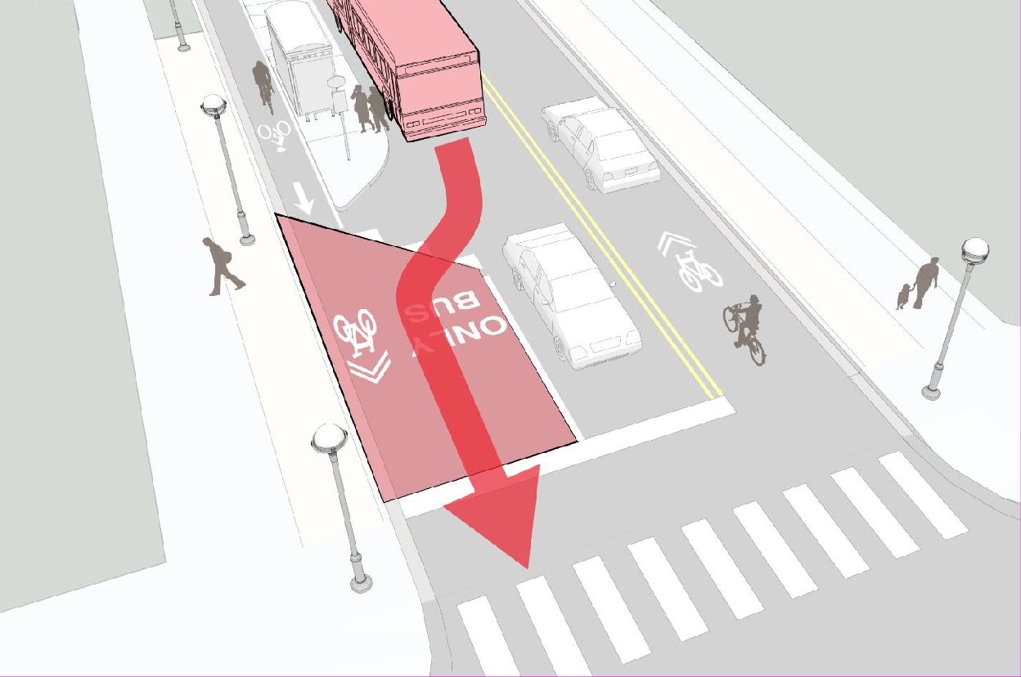
Example of Bus Queue Jump Lanes

Maximum Allowable Walkshed Mode Shifts for Site Analysis
When evaluating the breakdown of transit trip generation, realistic assumptions should be made by considering the type of available transit service nearby, the frequency of the service, the distance to the service area, and the uses proposed. Mode shifts to transit may not exceed the following rates subject urban orientation of the proposed use and the allowable mode shift rates described below:

Transit Inner Core (Generally ¼ Mile or less from a Transit Center)
40% Rapid Transit | 25% Local Transit

Transit Outer Core (Generally ¼ Mile to ½ Mile from a Transit Center)
20% Rapid Transit | 10% Local Transit

Transit-Supportive Area (Generally ½ Mile to 1 Mile from a Transit Center)
5% Rapid Transit | 0% Local Transit

(These may be applied at the weighted rates for proposed developments as described below based upon walkshed and transit service in the vicinity).

Retail Uses 100% of the allowable walkshed mode shift for all pedestrian-oriented retail uses. Reductions may not be applied for any auto-oriented retail use, including drive-through

restaurants, drive-through banks, drive-through pharmacies, car washes, gas stations, automobile service stations, or convenience stores (if fronted by gas pumps).

Commercial (Non-Retail) Uses 100% of the walkshed reduction for office uses, artistic studios, educational institutions, research and development campuses, and technology campuses. Reductions may not be applied for any auto-oriented or industrial/manufacturing use such as warehouses, data centers, vehicle rental businesses, manufacturing, breweries (non-retail), and moving/shipping/storage businesses, including any related office components.

Residential Uses 100% for the allowable walkshed mode shift for multi-family residential units under 1,500 SF and urban single-family attached residential units under 1,800 SF; 80% for multi- family residential units over 1,500 SF and urban single-family attached residential units between 1,800 SF and 2,400 SF; 50% for single-family attached residential units over 2,400 SF and all single-family detached residential units.

Chapter 3 – The Built Environment – Transportation and Land Use
Our collective desire to travel and explore is generated by our interest not in the journey, but the destination. Without places to go, be they homes, businesses, schools, entertainment venues, or recreational options, there would be no need for roads. Therefore, the demand for mobility and access is dependent on the built environment, and he built environment has a substantial impact on how the transportation system operates. Distances between uses, connectivity and integration of places, building design, and environmental features can all impact how the traveling public perceives a particular location. Addition, alteration, or removal of a seemingly trivial structure or other feature, such as landscaping, signage, entryways, or windows may deeply impact the way people feel about their safety and security in that areas, as well as about the aesthetic quality of the environment.

If places are the reason people travel at all, the spaces between the places can impact experiences just as significantly. Low speed roads may deter drivers, while high speed roads may deter cyclists and pedestrians. Narrow, winding two-lane roads may fit perfectly in a rural environment, but feel out of place and insufficient in a suburban environment. The transportation network connects people to places within every part of Loudoun County, but to achieve planned connections while supporting the goals and intended outcomes of the entire Comprehensive Plan, the context of the built environment must be of paramount consideration. Therefore, design of the transportation system must consider not only facilities needs but appropriate design for the surrounding planned environment. This chapter provides policies to support the creation of a comprehensively multimodal transportation system that accommodates all transportation modes with strong consideration of enhancement opportunities in the Urban and Suburban Policy Areas, creation a visual transition in the Transition Policy Area, preservation of the landscape in the Rural Policy Area, and coordination and integration with Towns through the Joint Land Management Areas.

To accommodate travel options along every route to incorporate the needs of different users within these differing contexts, this plan incorporates roads, sidewalks, bike lanes, asphalt trails, and transit infrastructure policies to ensure that multimodal connectivity can be realized. Effective implementation of a context-sensitive multimodal transportation system requires implementation of several key planning principles to ensure that facilities are designed to fit the natural and built environment in which they currently or are planned to exist. These principles include:

- The development of local and regional street connections providing redundant routes and multiple access options appropriate based upon the existing and planned environment.
- Human-scaled connections to ensure that every system user has logical routes throughout the area.
- Design of roadways that accommodate drivers, cyclists, and pedestrians.
- Amenities that encourage and provide adequate access to all travelers.
The following sections provide a framework for context-sensitive transportation system design for the Urban, Suburban, Transition, and Rural Policy Areas, as well as for the Towns and Joint Land Management Areas.

Urban Policy Areas
The Urban Policy Areas transportation network focuses on the concept of choices. If a transportation network is designed appropriately, no resident, worker, or visitor to the area is limited to a single transportation mode in order to travel, allowing for choice depending on distance, weather conditions, trip purpose, or personal preference. For others, such as those who are too young to drive, those who do not feel comfortable driving, those who cannot afford a personal vehicle, or those who are unable to drive, multimodal systems provide safe and dependable travel options to ensure convenient access to goods, services, employment opportunities and entertainment.

Creating a Multimodal System
The Urban Policy Areas plan and policies are critical because development of a multimodal system cannot happen haphazardly or through piecemeal efforts. Just as a comprehensive street network is necessary to allow cars and traffic to move efficiently, so are the networks intended for transit riders, cyclists, and pedestrians necessary to encourage people to take advantages of these different mode choices. This is comparable to a two-lane road with stop signs every block that intentionally slows traffic, and is therefore not as preferable to drivers as a freeway. Transit, automobile, bicycle, and pedestrian networks that account for the mobility needs of these different modal users are required for each mode choice to be viable.
  - For Automobiles, this means ensuring development of a system of higher-capacity roadways in order to move traffic through and into the area.
  - For Transit Riders, this means identifying and building streets that feature elements to support premium transit services, including frequent but practically-spaced transit stops, to allow for direct routing and high-frequency transit services that provide logical connections throughout the County and to the rest of the region via Metrorail.
  - For Cyclists, this means ensuring development of on-street bicycle lanes into a network that serves bicycle commuters by providing higher speed, traffic-signal controlled routes through the Urban Policy Areas. Meanwhile, this also means developing a comprehensive on- and off-road trail network that serves recreational cyclists.
  - For Pedestrians, this means completing a sidewalk system that provides continuous routes along both sides of every street in the corridor for maximum mobility and access. It further means providing sidewalks that are free of bicycles, delivery loading and unloading, and limits the frequency of driveways to provide limited interruptions and conflict points in the pedestrian network.
Urban Policy Areas – Built Environment
General policies for these facilities are outlined below. Chapter 2 of the Countywide Transportation Plan provides specific descriptions of the street section typology for each roadway identified in the plan. Along planned limited access roadways, trail systems along parallel roadways have been incorporated into the plan to provide non-motorized access in these corridors.

Urban Areas Built Environment Policies
3-1.1 Multimodal Design Every street within the Urban Policy Areas will include design elements for vehicles, pedestrians, and bicycles to ensure multimodality. These elements should incorporate all prominent modes, including:
    - Bicycling through on-street bike lanes, trails, and shared travel lanes
    - Walking through sidewalks and jogging paths
    - Driving and Riding Transit through innovative street designs
    - Modal Transfers through bicycle parking, transit shelters, and transit stations
3-1.2 Block Size Small urban block sizes are a critical component to maximizing access and walkability. Development in the Urban Policy Areas will provide connected internal streets (including Local Streets, Avenues, Boulevards, and Multimodal Through Corridors) placed at an interval of no more 660 feet (1/8th mile). This interval is not inclusive of alleyways or service roads. Exceptions for interruptions to the street grid, resulting in a Superblock (a block larger than 660 feet by 660 feet), shall be allowed where necessary to provide for public parks, public facilities, cultural institutions, or other uses deemed appropriate by the County requiring a large uninterrupted swath of land, or where natural and fixed manmade features (e.g., floodplains, bridges, utility substations) would not permit development of an optimally-connected network. Where feasible, pedestrian connections through this Superblock shall be provided to ensure ample pedestrian connectivity.
3-1.3 Off-Street Parking Areas Parking lots should be oriented to the rear of buildings to ensure safe and convenient access to Boulevards and Avenues for pedestrians and cyclists in order that conflicts with vehicle drive aisles are reasonably minimized.
3-1.4 Inter-parcel Connectivity New, expanded, or significantly renovated development plans will seek to maximize the number of logical street connections to adjacent properties and to CTP roadways for all modes so that seamless connectivity can be achieved between developments. Development proposals in the Urban Policy Areas shall provide for or reserve inter-parcel connections meeting the block criteria above to both undeveloped and underdeveloped adjacent sites so that future developments may connect seamlessly into the proposed development in accordance with land use policies of this plan.
3-1.5 Landscaped Buffers The buffer area between sidewalks and roadways is an important element of transportation system design. Buffer widths should depend on the speed of a roadway and the character of the surrounding development and will conform to VDOT Design Guidelines.
3-1.6 Street and Driveway Alignments As feasible, streets and driveways shall be constructed to align with existing streets and driveways in order to facilitate development of a grid of streets.

3-1.7 Connectivity Land development applications will include connected and unified road, bicycle, and pedestrian networks where feasible in order to promote connectivity within a development and between neighboring developments.
3-1.8 Public Roads Internal roads within a development site shall be public, unless meeting the definition of alleys or service roads. Public Roads shall be designed to meet the standards of VDOT Road Design Manual Appendix B (2) and DRPT Multimodal System Design Guidelines.
3-1.9 Meeting the Intent of the Typology Development applicants will define how the proposed roadways within the proposed development meet the intent of either a commuter route, commercial mixed-use street, residential street, or industrial street, and demonstrate compliance with the policies and sections for each roadway.
3-1.10 Pedestrian Corridors All Multimodal Through Corridors, Boulevards, and Avenues shown in this plan shall be considered pedestrian corridors. In order to maintain the integrity of these corridors, service uses such as loading docks and trash collection should face service driveways internal to the site. Service driveways and parking lots shall not be placed immediately parallel to pedestrian corridors, unless it can be demonstrated that the proposed layout enhances or complements the pedestrian streetscape.
3-1.11 Planned Roadways, Sidewalks, and Trails Any roadway or trail indicated within this plan shall be constructed in the location shown on this plan as described in this plan, whether built by the County or as part of a land development application.
3-1.12 Plan Coordination Transportation Improvements in the Urban Policy Areas will meet the policies and intent of this document as well as other policies of the Comprehensive Plan.
Urban Policy Areas Roadway Network
The transportation network established herein seeks to meet all of the objectives described above, creating a regional grid to facilitate the development of an urban grid of local streets throughout. Corridors run generally east-west or north-south, providing multiple redundant travel ways through the area. This allows traffic to divide onto parallel roads, similar to the County’s transportation system plan for other parts of the County. This plan also includes several new components in regard to transportation. Roads are more specifically defined to ensure coordination with all modes. This allows for creation of a network that serves drivers, cyclists, walkers, and transit riders all within the same system. This network allows developments to retain and create their own identities, while ensuring that development can be designed to fit seamlessly into the greater network. This network features high-speed highways and low-speed local streets, recognizing the importance of each type of roadway in the overall network, and integrates access to Metrorail as a key component of the overall concept.

The Urban Policy Areas road network provides ample mobility and access for drivers, transit users, cyclists, and pedestrians, regardless of age or ability. The transportation network provides for true mode choice, ensuring that users are not limited in the options, whether they choose to drive a personal vehicle, ride transit, ride a bicycle, or walk. The Urban Policy Areas transportation network facilitates the development of the envisioned high-density urban environment detailed

within this plan, and improves and increases connectivity to places throughout Northern Virginia and the region for people throughout Loudoun County.

In a suburban roadway network, grid connectivity is replaced by funneling traffic onto arterial roadways. Traffic in a traditional suburban subdivisions travel along local roads, funneling to one or two entrances along collector roads. From there, traffic funnels from the collector onto an arterial with traffic from other subdivisions. This system therefore requires wide collector roads and even wider arterial roads to act as the ribs and spine of the network, respectively. An urban network, comparatively, has several sets of ribs and spines, more evenly dispersing traffic through the network and allowing for more direct travel routes.

Urban multimodal streets feature many elements already found in Loudoun County. In the Urban Policy Areas, these elements include:

  - Parallel Roads With redundant travel options, multiple routes allow travelers to disperse more evenly and efficiently throughout the system.
  - Frequent Intersections Long blocks limit pedestrian access and opportunities to reach key corridors. Human-scaled block sizes ensure greater mobility for all system users.
  - Crosswalks and Midblock Crossings While traveling an additional ¼ mile during a trip may be nearly imperceptible when driving, pedestrians travel approximately three miles per hour. This means that if someone wants to get across the street and the nearest crossing is ¼ mile in either direction, that person has to travel an additional 10 minutes simply to complete this crossing. Therefore, frequent and well-marked crosswalks make a substantial difference for pedestrians. Along main streets, midblock crossings should also be considered for additional convenience.
  - Sidewalks Wide sidewalks facilitate pedestrian activity and make streets welcoming to pedestrians. On slower streets, sidewalks may be built adjacent to the curb, while on higher-speed roadways, a buffer area may be appropriate.
  - Bike Lanes These striped bike-only zones create a safe and dependable route for cyclists, not blocked by pedestrians and not sharing the travel lane with cars. They encourage bicycle commutes and increase comfort for cyclists and drivers.
  - Transit Shelters Enhanced transit shelters are critical in making transit a choice mode during the heat of the summer, cold of the winter, and in the evening. These shelters can include information such as schedules, live next bus screens, and provide access for all users, including those with physical disabilities. By placing shelters between the sidewalk and the street, transit users can move seamlessly from the shelter onto the bus without conflicting with pedestrians or being exposed to the elements.
DRPT Definitions and Concepts
In 2013, the Virginia Department of Rail and Public Transportation (DRPT) released the Multimodal System Design Guidelines, which provide a transportation system design manual alternative to the Virginia Department of Transportation’s (VDOT) Road Design Manual. In order

to permit these guidelines to be applied in certain areas, VDOT amended its Road Design Manual in 2014, adding Appendix B (2), which includes guidelines for implementation of the DRPT standards within a designated urban area. In order to facilitate the County’s visions of the Urban Policy Areas as an urban, multimodal center, the County has incorporated these guidelines into the plans within this document.
Streets within the Urban Policy Areas will be identified by a hierarchy as defined by the Virginia Department of Rail and Public Transportation. Descriptions of roadway typologies as defined in the DRPT Multimodal System Design Guidelines are provided below:
Multimodal Through Corridor
The Multimodal Through Corridor (MTC) is a higher speed corridor that connects multiple activity centers. It is intended for longer distance, higher speed automobile, bus, or rail travel and ideally has limited at-grade intersections with other roadway types. MTCs are good candidates for high speed commuter transit having few impediments to traffic flow. Higher speeds limit pedestrian and bicycle modes and hence the corridor design should provide separated facilities for these modes if they are needed. The design of the adjacent buildings should be oriented away from MTCs and towards place-making corridors on the other side of the buildings, providing more desirable pedestrian facilities and pedestrian-oriented land uses on the place-making corridors, while still accommodating pedestrian travel along the MTCs. Design speeds for MTCs range from 35 to 55 mph.
Transit Boulevard
The Transit Boulevard is the highest capacity and most transit supportive Multimodal Corridor in the typology. It would typically only be found in dense urban centers that have sufficient density and market for premium transit. A Transit Boulevard is a multi-lane and multimodal boulevard with a dedicated lane or right-of-way for transit. Transit technologies could be bus service with a bus only lane (BRT or express bus), light rail, or other transit technologies with a separate right- of-way. Other transit types that share lanes with general traffic, such as streetcar or local bus service, could be accommodated on a Boulevard, Major Avenue, or Avenue, but the dedicated transit-only right-of-way defines the Transit Boulevard corridor type. Design speeds for Transit Boulevards range from 30 to 35 mph.
Boulevard
A Boulevard is the corridor type of highest multimodal capacity that accommodates multiple motorized and non-motorized modes. Boulevards allow for higher traffic volumes and greater efficiency of vehicular movements than Major Avenues, Avenues, and Local Streets, and typically have four to six lanes of traffic but may be up to eight lanes in particularly dense centers, such as Tysons (in Fairfax County). Boulevards provide safe and convenient pedestrian and bicycle access to adjacent land uses. Boulevards feature a median, landscaped amenity elements, street trees, and wider sidewalks. Design speeds for Boulevards range from 30 to 35 mph.
Major Avenue
Major Avenues contain the highest density of destinations, intensity of activity, and mix of modes. Because of the close proximity of destinations, pedestrians and street activity are common on Major Avenues. Major Avenues have wide sidewalks to accommodate high numbers of pedestrians and a variety of outdoor activities, including sidewalk cafes, kiosks, vendors, and other street activities. Major Avenues can be areas of high transit ridership for local bus routes. Traffic

is low speed and localized. Due to the intensity of destinations, longer regional trips do not use Major Avenues; rather such trips would typically utilize Boulevards or Multimodal Through Corridors. Autos and buses on Major Avenues travel at slow speeds because pedestrian crossings and on-road bicyclists are frequent. Major Avenues typically have four or fewer lanes for motor vehicle travel while providing adequate facilities for bicycling and typically providing roadway space dedicated to on-street parking. Design speeds for Major Avenues range from 30 to 35 mph.
Avenue
Avenues provide a balance between access to the businesses and residences that front upon them and the collection of vehicular and pedestrian traffic. While having fewer destinations than Major Avenues, pedestrian and bicycle activity is very common, as Avenues serve as critical links in the non-motorized network. Avenues are low speed roadways that facilitate shorter trips, but still contain a fair amount of destinations. Avenues typically have three travel lanes or fewer, and do not exceed four lanes. Avenues may have roadway space dedicated for on-street parking and provide adequate bicycle facilities. Avenues have a 25-30 mph design speed.
Local Street
Local Streets see the lowest amount of activity and have the slowest speeds and the highest access. Bicyclists typically can share the road with autos, because speeds are slow and auto traffic is sparse, although they have separate sidewalks and trails for pedestrian accommodation. Local Streets are primarily in more residential areas and are intended to serve only trips that originate or end along them. They connect to Avenues, Boulevards or Major Avenues, funneling longer trips to these higher capacity corridor types. Local Streets are characterized by slow design speeds, wider setbacks; they may not have lane striping and emphasize on-street parking. Local Streets have a 25 mph design speed.
Roadway Features
Good design for the multimodal transportation system in the Urban Policy Areas needs to integrate all of the modal demands outlined above. Therefore, consideration of design standards, traffic controls, roundabouts, and other traffic operations and traffic calming measures must be considered in relation to their impacts to each of the modes desired along the corridor. The decisions made in pursuit of these goals will impact traffic patterns, development potential and design, and mode splits for the transportation system through the area.

While it is commonly understood that the number of travel lanes on a roadway determines roadway capacity, the width of those lanes can have a significant impact as well. Lane width impacts travel speed, and pedestrian crossing distance. For example, on a four-lane median-divided roadway, suburban standards can call for the two-lane section in each direction to be 27 feet from curb to curb, exclusive of turn lanes. Comparatively, in a more urban environment, that width could be limited to 22 feet. While this difference may seem minimal to drivers, it can make a significant difference for pedestrians.

On-street parking is another factor that can help drivers find parking easily and can slow traffic, make drivers more aware of bicyclists, and protect pedestrians. This is because the cars parked next to the roadway make drivers in the right-lane more cognizant of the potential for movement on their right side, thereby making them more aware of bicyclists. Further, it provides a physical barrier between the roadway and the sidewalk, separating pedestrians from vehicle traffic.

Multimodal streets can serve the needs of drivers, transit uses, cyclists, and walkers all at the same time. The pictures below demonstrate designs conducive to a multimodal environment, such as pedestrian refuges at wide crossings that provide pedestrians a safe place to wait if they cannot make it all the way across the street, and peak hour bus/HOV lanes can encourage transit ridership and carpooling when congestion is heaviest, removing single-occupancy vehicle trips from the road. Meanwhile, in order to protect the pedestrian-oriented character of local streets, traffic calming measures integrated into street design, such as roundabouts, road diets, chicanes, and raised crosswalks can create an environment where traffic feels the need to travel at slower speeds. These are preferable to other types of retrofits, such as speed bumps, median dividers, and retrofitted cul-de-sacs, which breakup neighborhoods and reduce accessibility and mobility.
Roadway System Policies
3-1.13 DRPT Implementation All roadways within the Urban Policy Areas will be built or redesigned in accordance with VDOT Road Design Manual Appendix B (2) and DRPT Multimodal System Design Guideline standards and policies and descriptions provided in this plan. Streets internal to a development site should be classified as local secondary roads (VDOT Functional Classification) and local streets (DRPT Multimodal System Classification).
3-1.14 Design to Meet the Typology Based upon the DRPT Multimodal System Design Guidelines, roadways within the Urban Policy Areas will be defined according to the DRPT Multimodal System Classification. The descriptions provided below are derived from the DRPT Multimodal System Design Guidelines as they are intended to be applied within the Urban Policy Areas:
3-1.15 Grid of Streets Streets within the Urban Policy Areas will be developed in a grid pattern corresponding to the alignment of at least one Avenue or Boulevard adjacent to or within the site, or to an existing grid of local streets immediately adjacent to the site.
3-1.16 Connectivity Road and pedestrian connectivity will be maximized within the Urban Policy Areas through connections between Local Streets, Avenues, and Boulevards at regular intervals, and sidewalks along all public and private streets and commercial driveways.
3-1.17 Roadway Widths Streets shall be designed to minimum widths required by the standards of the Virginia Department of Transportation, in accordance with an appropriate multimodal street section type approved with this document.
3-1.18 Curb Radii Corners at intersections along Boulevards, Avenues, and Local Streets in the Urban Policy Areas shall be designed to shorten the crossing distance for pedestrians and slow turning traffic in order to increase safety for all system users. Corners at the intersection of two Multimodal Through Corridors shall be designed to facilitate both traffic flow and pedestrian safety.
3-1.19 Turn Lanes Turns lanes will be provided along Multimodal Through Corridors. Turn lanes will be provided along Boulevards, Avenues, and along commercial driveways only where warranted and needed for safety. Turn lanes are prohibited along local streets as defined in this plan. Free-flow turn lanes are prohibited to or from Boulevards, Avenues, or Local Streets. Dual left-turn lanes are prohibited along Avenues, and Local Streets.

Dual left-turn lanes are permitted on Boulevards only at intersections with Multimodal Through Corridors.
3-1.20 Cul-de-Sacs Cul-de-sacs and dead-end streets are prohibited in the Urban Policy Area, except where specific environmental constraints, road design minimum standards, or public amenities exist that would prohibit a connection, and reasonable development alternatives are not feasible. Service driveways and parking access driveways are not subject to this policy.
3-1.21 On-Street Parking On-street parallel parking shall be provided where feasible along all Avenues and is encouraged along all Boulevards in commercial, industrial, and residential districts, except where the proposed adjacent use will generate minimal travel and occupies an area greater than 660 feet in length. On-street parking will be clearly striped and indicated by signage along the street. On-street parking is recommended along local streets in commercial, industrial, and residential districts. Angled or perpendicular on-street parking spaces are prohibited along all public and private streets within the Urban Policy Areas.
3-1.22 Lane Striping Roadway lanes should be striped at a width appropriate to the DRPT Multimodal System classification, even if they have a wider curb-to-curb width.
3-1.23 Traffic Controls All intersections within the Urban Policy Areas shall include traffic control signs or signals so as to clearly indicate right-of-way for all system users.
3-1.24 Roundabouts Roundabouts should be considered as an alternative to traffic signals and stop controls along Avenues and Local Streets, particularly at entrance gateways to commercial or residential districts. Roundabouts are not preferred along Transit Corridors.
3-1.25 Traffic Calming on Boulevards and Avenues Boulevards and Avenues shall be designed to permit traffic to operate efficiently at speeds appropriate for the area. As such, measures should be taken during the initial design phase to incorporate elements that will provide a safe environment for all users. On-street parking, roundabouts, textured crosswalks, curb extensions, median islands, and pavement markings that indicate a reduced travel-way width should be incorporated into land development and construction plans.
3-1.26 Traffic Calming on Local Streets Local streets should be designed to prioritize pedestrians. As such, raised crosswalks and intersections, miniature roundabouts, striped chicanes with parking bays, and curb extensions should be employed to maintain appropriate vehicular traffic speeds and provide for safe pedestrian crossings.
Urban Policy Areas Bicycle and Pedestrian Transportation
Often paired, cycling and walking are two distinctive transportation options that can be made possible with incorporation of infrastructure to support these travel modes. Generally, people will choose cycling or walking for shorter trips as well as for recreation. In the Urban Policy Areas, the development patterns outlined in Chapter 2 of this document support walking and cycling by establishing a mix of uses, residential density to support these uses, and street design elements to make these non-motorized modes not only an option, but a preferable alternative to driving or taking transit. A bicyclist and pedestrian-friendly development pattern may also help to remove

potential vehicle trips from the roadway as people may choose to shop locally and seek employment locally, rather than driving to these destinations and adding cars to the area’s roadways. Below is a discussion of how to facilitate development that considers accommodations for bicyclists and pedestrians.

Bicycle mobility is important for the success of the Urban Policy Areas. Cycling has become a primary mode of travel in urban areas throughout the United States, allowing for short- to medium- range trips with no per-mile transportation cost to the commuter. A multimodal urban center must accommodate bicycles in a safe and inviting manner through buffered, connected, and logical bike lanes, and ample bicycle parking. The proliferation of bicycles is possible when safe, convenient, and abundant networks are put into place to provide real mobility. A comprehensive network will not only lead to a significant increase in bicycling for commutes and errands, but these trips directly reduce automobile trips and help to alleviate vehicular congestion on roads by making these other modes of travel more feasible. This will also ease demand for limited parking spaces, which are costly to construct and maintain in an urban environment where land values are high. The more comprehensive the bicycle network, the exponentially greater the impact. In many American cities, investments in bicycling infrastructure has helped to draw young professionals and dynamic businesses, further growing their local economies.
For commuter cyclists, real mobility exists when a combination of shared low-speed travel lanes, dedicated bicycle lanes on medium-speed roadways, and buffered bike lanes on higher-speed roadways are provided in a complete and practical form to create a network that caters to commuter cyclists. This plan includes a detailed plan for on-road bicycle lanes in the Urban Policy Areas, with an overall goal of creating a bicycle-friendly environment for residents, workers, and visitors.
On-road bicycle facilities exist in many form based upon the roadway characteristics. On low- speed local roads, bicycles may be able to safely share the travel lanes with vehicles. To facilitate this multimodal operation, signage, such as “Share the Road” signs, and striping, such as “Sharrow” markings can be used to alert drivers to the presence of cyclists. On slightly more prominent roads with more traffic, striped bike lanes, which create an additional, narrow travel lane intended only for bicycles, may be suitable. Often, these types of lanes are best located on streets with moderate traffic speeds, where other moderate-speed elements, such as on-street parking and frequent pedestrian crossings can be accommodated. For higher-speed roads, providing a dedicated bicycle lane is crucial, as is ensuring its separation from vehicular traffic. This can be accomplished by adding a striped-out area between the bike lane and the vehicle lane, providing a buffer between modes. This buffered bike lane helps ensure that errant drivers and cyclists will be less likely to cross paths, just as a highway shoulder helps ensure that errant drivers have some ability to regain control of a vehicle before departing the roadway altogether. On the highest-speed roads, however, accommodating cyclists in a safe and comfortable manner on the roadway may not be possible. While regular cyclists tend to prefer the roadway where traffic is of a low-to-moderate speed (35 MPH or under), higher speed corridors are often incompatible with on-road bicycling, instead requiring a trail adjacent to the roadway. In these cases, it becomes critical that the trail is arranged to accommodate cyclists, limiting tight curves and providing clear sightlines for safety.

Off-road trails can further improve this network, with well-placed and well-designed paths providing an additional layer of connectivity for cyclists. This, however, depends on these trails becoming an integrated part of the network, with adequate space for cyclists and pedestrians, manageable curves, protected roadway crossings, and frequent, bicycle-friendly access points. These trails can serve a dual purpose: providing commuter routes during weekday peak travel periods while providing recreational opportunities during early-mornings, evenings, and weekends. In order to facilitate demand for these trails for either use, it is critical that these pathways are pleasant, with good maintenance and natural features, and safe, with adequate sightlines, trail markings, and wayfinding. This plan includes a detailed plan for off-road trails in the Urban Policy Areas in order to create commuting routes and family-friendly amenities that serve to promote and enliven the outdoor environment. While road-adjacent trails can also provide useful connectivity along major corridors outside of the development core, they are not appropriate in high-density urban areas due to the pedestrian activity in these locations. As such, in these areas, sidewalks and on-road bicycling are more compatible with the Urban Policy Area’s mobility and development goals.
Asphalt trails, or shared-use paths, in the Urban Policy Areas serve two important and distinct purposes. They provide recreational opportunities through their role as linear parks, allowing families to ride bicycles together or hike through nature, and allowing opportunities to experience a natural environment interwoven into one that is markedly urban. However, they are also a key component of a multimodal transportation system. While a trail may serve as a recreational amenity on Saturday afternoon, come Monday morning, it can also become a commuting route for those walking or riding a bicycle to work. Loudoun County already has a transportation corridor of this nature: the Washington & Old Dominion Regional Park Trail. Well used by commuters and leisurely travelers alike, this route is often over-capacity, with pedestrians, joggers, recreational cyclists, and commuter cyclists all in conflict with one another. The popularity of this facility speaks to the need for more trail systems in the County, as well as to the importance of these trails not only as parks but as part of the transportation system.
Bicycle Amenities
An important part of a comprehensive bicycle network, stationary amenities such as bicycle parking are necessary components of a complete system. Similar to a road network without traffic signals or adequate parking, a good bicycle network requires quality bicycle parking, including bike racks and bike storage that are provided with a high level of access to major destinations. Additionally, with a complete network comes opportunities for services such as bike share, allowing tourists and workers access to bicycles away from their homes, and providing opportunities for “last mile” travel, so that people living or working within bicycling distance – but not walking distance – of a transit center can reach their destinations without requiring a personal vehicle or waiting for the bus.

Comprehensive Vision for Bicycling
Creating a comprehensive bicycle network means developing a system that serves bicycle commuters, those shopping and making local trips by bicycle, and those cycling for recreation and/or exercise. The network proposed within this plan provides ample options for all of these users, ensuring travel options for current and future residents, workers, and visitors.

Pedestrian Connectivity
A comprehensively connected pedestrian network is integral to the success of the Urban Policy Areas. The promise and economic success of the Urban Policy Areas is dependent on providing an inviting, accommodating, and safe environment, encouraging pedestrian activity within the urban core. Pedestrians are not only a critical transportation component, but also act as a magnet, attracting economic growth and development. Achieving the goals of a walkable and vibrant urban center is only possible with human-scaled transportation system development, including street sections at a scale narrow enough for all pedestrians to cross comfortably with elements such as curb extensions to shorten crossing distances, crosswalks at frequent intervals, direct routes between key destinations within the urban center, and grade separation where pedestrian and/or vehicular traffic volumes and/or road widths make at-grade crossings impractical.

Pedestrians depend on many factors to make travel comfortable and easy. Like roadways, sidewalks that are too narrow may feel constricted, especially if located along a wide roadway or tall buildings. Also like roadways, wider sidewalks can encourage pedestrian activity, as the sidewalks become more accommodating to large groups and conversations. Human-scaled transportation elements also include analysis and consideration focused on the pedestrian experience. A mile-long journey that may take 4 minutes for a driver in a climate-controlled vehicle within a moderately-dense environment takes approximately 20 minutes for a pedestrian in the elements, assuming a safe and direct pathway is available. Therefore, considering the needs of pedestrians means thinking at a pedestrian scale, understanding that a short travel distance for a driver may be significant for a pedestrian, and that the amenities offered by a personal vehicle cannot be provided in the same way for a pedestrian. Therefore, improving conditions for pedestrian travel must be accommodated in other ways, such as creation of an attractive streetscape, development of awnings and inlets to provide temporary shelter, provision of benches and tree for sitting and shade, and allotment crosswalks, signs, and signals that can ensure safe interaction with vehicular travel ways.

The most prominent conflict for pedestrians in a suburban environment is often the barrier of wide and intimidating roadways that can feature up to 150-foot wide crossing distances. That distance requires more than 30 seconds for a typical pedestrian to cross, and far longer than that if the pedestrian is unable to move at a rapid pace.

Additionally, these types of roadway promote automobile travel, with drivers often unprepared for the presence of pedestrians, making collisions between vehicles and pedestrians, especially when vehicles are turning, particularly common. While ground-level pedestrian activity is always preferred, and visually-appealing crosswalks are encouraged, high-volume, wide thoroughfares may require more extensive crossing infrastructure, including grade-separation, in order to ensure that system users, including children, senior citizens, and disabled individuals can cross safely.
The vision for the Urban Policy Areas is a highly-connected pedestrian-friendly network that supports and encourages pedestrian activity and makes walking a preferred mode of travel. This can be achieved through construction of a comprehensive system, development of pedestrian- oriented neighborhoods, and a focus on pedestrian nodes.

Bicycle and Pedestrian Connectivity Policies
3-1.27 Bicycle Lanes Marked on-street bike lanes (minimum 5 feet in width) shall be provided where called for by the Bicycle Facilities Plan. On roads with speed limits of 30+ MPH or roads with at least four through travel lanes, bicycle lanes shall be buffered from traffic by striping at least 3 additional feet in width. Buffer zones are recommended, but not required, where on-street parking spaces are provided adjacent to the bicycle lanes as they help provide additional space between both open doors from parked cars and moving traffic.
3-1.28 Trails Off-street asphalt trails shall be constructed in accordance with the Urban Policy Areas Trails Plan. Where parallel and adjacent to a roadway, these trails shall be at least 10 feet in width and shall provide a direct route (without overly meandering deviations) to allow for moderate bicycle speeds. Where routed independently from a roadway, the trails shall be at least 16 feet in width and feature a separating stripe down the center of the path to indicate the bi-directional nature of the trail.
3-1.29 Intersection Crossings At intersections, curb ramps shall be placed in the direction of the bicycle path to facilitate through movements. Where both sidewalks and trails intersect with a roadway in the same direction, separate crosswalks should be marked for trail users (bicyclists) and for those on the sidewalk (pedestrians), as permitted by VDOT.
3-1.30 Trail Construction Development proposals shall include construction of trails, or at minimum, reservation or dedication of trail easements where indicated by the plan. Unless specifically indicated otherwise by the plan, all trails shall be paved for ease of use and access for all system users. Trails included in the Bicycle Facilities Plan shall include a public access easement along their entire length or be dedicated to the County as a linear park in order to ensure public right of access along throughout the trail network.
3-1.31 Dedicated Roadway Crossings For roadway crossings as part of the off-road trail network, the County shall seek public and private opportunities to construct grade- separated crossings. As an interim condition, traffic signals may be sought to provide a safe crossing of roadways with four or more vehicular travel lanes.
3-1.32 Bicycles on Roadways without Bicycle Lanes and Trails On two-lane Avenues and Local Streets without on-street bicycle lanes or adjacent trails, travel lanes shall be designed for use by vehicles and bicycles through pavement markings and/or “Share the Road” signs to convey awareness of the presence of bicyclists in the vehicular travel lanes.
3-1.33 Bicycle Parking Secure bicycle parking (bike racks) for at least four bicycles shall be provided at average intervals of once every 660 feet (1/8th of a mile) within commercial districts and once every 1,320 feet (1/4th of a mile) within residential districts. Bicycle parking will be provided in public parks and near primary entrances to public facilities.
3-1.34 On-Site Bicycle Facilities Secure bicycle rooms are encouraged within high-density residential and commercial buildings proposed within the Urban Policy Areas to encourage bicycling among residents and employees.
3-1.35 Bicycle and Pedestrian Connectivity Plan Land development applications within the Urban Policy Areas shall demonstrate conformance with the Urban Policy Areas Bicycle

and Pedestrian Plans and, for legislative applications, shall include a bicycle and pedestrian connectivity plan, clearly indicating on-road and off-road mobility options proposed with the application.
3-1.36 Sidewalks Minimum eight-foot sidewalks are required along both sides of all Multimodal Through Corridors, Boulevards, and Avenues, and are encouraged along all Local Streets, within the Urban Policy Areas, regardless of use or location, except where specific provisions are described for the roadway in Chapter 2 of this plan. Minimum six-foot wide sidewalks are required along both sides of any Local Street in the Urban Policy Areas, regardless of use or location.
3-1.37 At-Grade Pedestrian Crossings Safe pedestrian crossings shall be incorporated into all intersections within the Urban Policy Areas for all pedestrian approaches.
3-1.38 Grade-Separated Pedestrian Crossings Grade-separated crossings may be provided in lieu of an at-grade crossing if such a crossing meets the grade-level sidewalk within 660 feet (1/8th of a mile) of the subject intersection. Grade-separated crossings are preferred to connect dense developments on either side of Multimodal Through Corridors and other higher-speed and wide roadways where the street typology is not conducive to a pedestrian environment.
3-1.39 Crossing Accessibility and Safety Grade-separated and at-grade pedestrian crossings shall be fully-accessible for all users, complying with all local, state, and federal regulations, and shall be, at minimum, 16 feet in width. Tunneled and skyway crossings shall include lighting throughout for pedestrian safety and clear sightlines from end to end, including at approaches. Signing shall be provided directing pedestrians and cyclists to use the grade-separated crossing in order to reach the opposite side of the roadway. Pedestrian refuge islands should be considered for at-grade crossings of wider roads where space allows.
3-1.40 Pedestrian walkability In order to maximize pedestrian access and mobility, pedestrian networks should provide direct routes to major destinations within the grid, as possible. When trip reductions are applied as part of traffic study for a development application, transit walksheds are required to provide a high-level of pedestrian access in coordination with plan policies.
3-1.41 Curb extensions In order to narrow the travel width of an intersection, curb extensions should be constructed at all crossings along streets with on-street parking, unless a right- turn lane is required per policy at the intersection.
3-1.42 Crosswalks Crosswalks shall be provided at all intersections within the Urban Policy Areas. Crosswalks shall be provided along avenues and boulevards a least once every 1,320 feet (1/4th of a mile), shall be designed to VDOT standards, and shall include appropriate signage and/or signaling to alert drivers to presence of pedestrians. Along Multimodal Through Corridors, Boulevards, and Avenues, crosswalks will be marked in an enhanced style, such as Solid, Continental, Zebra, Ladder, or another similar style

acceptable by VDOT that provides a highly visible indication of the potential for pedestrians to be crossing at that location.
Urban Policy Areas Transit Infrastructure
A critical element of an urban area, public transportation serves as most efficient way to move people along popular commuter routes and between activity centers. This is because far more people can be transported comfortably in a railcar or bus than in a personal vehicle and no dedicated space is needed to park that transit vehicle. Within the Urban Policy Areas, transit services are planned to include Metrorail, commuter, limited-stop, express, and local buses, and shuttles and circulators. Together, these services provide accessibility, convenient, and affordable access for people both inside and outside of Loudoun County.

Metrorail
Transit service in the Urban Policy Areas is centered around Metrorail. The Dulles Corridor Metrorail Project (Silver Line) will include stations at Ashburn, Loudoun Gateway, and Dulles Airport in Loudoun County and Innovation Center in Fairfax County on the Loudoun County border with frequent service to the commercial centers at Herndon, Reston, Tysons, Arlington, and Washington, DC. Though not part of the current project, the Town of Leesburg envisions in its Town Plan an extension of Metrorail to Leesburg, following the Dulles Greenway corridor. With the arrival of Metrorail service to Loudoun County, existing bus transit service will be altered to serve changing commuter patterns.

Countywide (local and express) Transit Network
Metrorail is complemented by a comprehensive and dependable local fixed-route bus service connecting people to places throughout Loudoun County. To create and enhance a high-quality transit system, frequent, fast, and dependable service, as well as clean and comfortable vehicles and stops are provided. These routes run both express service to important locations throughout the County and more locally to neighborhoods and communities. Within the Urban Policy Areas, a limited number of routings between the Metrorail stations and the fringes of the Urban Policy Areas will increase service on key roadways and provide opportunities for easy transfers. Every local bus route provides access to a Metrorail station or a Transit Center. Optimal service for local fixed-route bus services are at least every 15 minutes in the peak periods, with, at minimum, 30 minutes in the off-peak. Fares should be commensurate with surrounding jurisdictions, and discounts for transfers to/from Metrorail should be studied.

Several major corridors within the Urban Policy Areas are designated as Transit Corridors. These streets will serve as the primary routes for the countywide transit network through the Urban Policy Areas, providing efficient and logical routes between locations throughout the County and the Metrorail Stations. Located primarily along four-lane roads, these streets are designed to facilitate travel of transit and private vehicles alike. In order to facilitate dependable and logical transit routes, stop locations will be placed strategically at key locations along the corridor, at distances that provide access to the surrounding area without unnecessarily frequent and underutilized stops. Bus stop locations should face the Transit Corridor when possible, rather than an intersecting or adjacent street, to provide dependability and clarity of route to riders. For this system to function

properly, it is also crucial that bus stops on either side of a Transit Corridor are located at the same intersection so that riders may depart and alight a transit vehicle at the same approximate location. Features along these corridors may include enhanced bus stops and transit centers, intelligent transportation system devices (such as signal preemption), transit-friendly street elements, and frequent crosswalks. These streets should be considered for transit lanes at such time as transit ridership and projected growth within the area can justify such an improvement.

Localized Shuttles and Circulators
Private developments may choose to operate private shuttles connecting residents, employees, and visitors to locations within their site, or to Metrorail services. These private shuttles may be interim
– until public transportation service is implemented – or permanent. However, demands for public transportation services and constrained space at the Metrorail Stations for transit vehicles may limit the effectiveness of these services as substantial growth occurs.

Aside from countywide bus services and private shuttle services, circulator services localized within the Urban Policy Areas can efficiently move people in high-density areas with all-day demands for service between the Metro Stations and the core developments within the Urban Policy Areas. This circulator is different from countywide local routes in both its character and route, using smaller buses and preferring denser, busier, and often slower streets that bring people to the most popular centers in the area, even at the expense of slightly increased travel times. Fares on circulator routes are usually lower than local fixed-route services, if not free altogether. Circulators, unlike traditional buses, are considered to be economic incubators and tend to run at all times, with the greatest demand and frequently in the evening and on weekends, when tourism to the area is most prominent. A conceptual map of potential circulator routes is shown below. These routes are intended for conceptual purposes only and would be further planned in coordination with the entity that would be operating the service. In the long term, circulator routes should comprehensively cover residential and employment centers within the Urban Policy Areas, ensuring that all residents and most employees are within a five minute walk of a shuttle stop. As the below concepts indicate, at least four shuttles are envisioned:

- A Moorefield Station Shuttle providing a connection between Moorefield Station and the Ashburn Metrorail Station South Transit Center.
- An Ashburn Station Shuttle providing a connection between areas north and south of the Ashburn Metrorail Station and the Ashburn Metrorail Station South Transit Center.
- A Loudoun Gateway Station Shuttle providing a connection between the Route 28 Business District and the Loudoun Gateway Metrorail Station Transit Center; and
- A Silver Line Loop Circulator providing a connection between the Ashburn North, Ashburn South, and Loudoun Gateway Transit Centers and the surrounding areas.
These shuttles will provide direct routes between development areas and the Metrorail Stations in order to ensure convenient and reliable access to all parts of the Urban Policy Areas.

Transit Amenities
Bus shelters are an important element at stop locations, with stops and associated shelters placed at intervals relative to the surrounding development density. In higher density areas, more frequent stops are assigned, with frequencies declining as dictated by housing and commercial density. Regardless of spacing, well-lit and signed shelters placed at the bus stop locations should be easily identifiable and include service information where feasible. In the central core of highly dense areas, more prominent and inclusive amenities are constructed to provide for modal transfers, higher ridership demands, and route transfers. The transit toolkit in Chapter 2 provides guidelines for these improvements.

Urban Area Transit Infrastructure Policies
3-1.43 Transit Infrastructure Design Development and implementation of transit infrastructure will be based upon the policies of this plan and the guidelines provided in the Transit Toolkit in Chapter 2.
3-1.44 Metrorail Project Facilitation The County will facilitate the implementation of the Dulles Corridor Metrorail Project, extending to Ashburn via intermediate station stops at Innovation Center, Dulles Airport, and Loudoun Gateway.
3-1.45 Improvements Associated with Metrorail The County, in partnership with VDOT, WMATA and/or other appropriate agencies, will ensure that land needed to provide planned rail-related improvements is obtained or reserved prior during review of land development applications. Land acquisitions and reservations will consider long-range transit plans as well asshort term improvements.
3-1.46 Transit Corridor Elements Specific streets identified as Transit Corridors will be designed for transit service with special attention to transit elements including transit shelters and stations, bus bays, and bicycle and pedestrian access to transit services. Development proposals should concentrate the location of fixed transit elements along these roadways in accordance with the policies outlined below.
3-1.47 Transit Corridor Design Roundabouts and raised roadway traffic calming measures are prohibited along Transit Boulevards and other Transit-Priority Roadways, unless specifically designed to accommodate transit vehicles.
3-1.48 Intelligent Transit Systems Transit-priority elements such as traffic signal preemption and active parking information signage should be considered as part of transit system development within the Urban Policy Areas.
3-1.49 High-Capacity Transit System Development Transit Corridors should be prioritized for any future plans for transit-priority lanes through the Urban Policy Areas.
3-1.50 Private Shuttles In order to ensure residents and employees in the Urban Policy Areas have a car-free option for travel to and from Metrorail, the County will seek private shuttle services between developments within the Urban Policy Areas and at least one of the Metrorail Stations during review of legislative land development applications. These

shuttles should operate at a minimum frequency of every 15 minutes during peak hours and every 30 minutes during all other times that Metrorail is operating.
3-1.51 Land Development Applications Proposed circulator routes and stop locations should be indicated on applicable land development application materials in order to ensure integration and route connectivity with adjoining developments.
3-1.52 Provision of Service Fixed-route private shuttle services will be operated on an interim basis, ceasing operation at such time as a public circulator service is initiated that provides redundant routing and frequency.
3-1.53 Circulator Routes Circulators will be routed to provide direct access to development nodes within the Urban Policy Areas
Urban Policy Areas TDM Strategies
Urban development patterns provide ample opportunities for implementation of bold TDM strategies. Walking to work becomes a viable option for many people. High ridership transit service is made possible by increased density along major corridors. Possibilities for bike share and car share services that are dependent on integrated residential and office environments can grow in demand in order to serve the area.

Public Transit Walksheds and Trip Reductions
Trip reductions based on transit access from a proposed development are encouraged in the Urban Policy Areas. These reductions will consider several factors related to use, transit services available, access to transit service, and orientation of uses toward transit with appropriate connectivity. Scoping agreements for traffic impact studies shall be based on walksheds described herein (which could vary within the development area), and the design of the transportation network within the development site to facilitate the level of transit-use described in the scoping document and traffic impact study. Transit reductions for local transit will vary, not to exceed the rates outlined above, based upon a review of:
- The overall frequency of all existing transit services serving the site, including combined headways and hours of operation (weekday / peak / weekend).
- The type of service offered (local / limited / express).
- The scale of bus facilities existing on the site or proposed as part of the land development application (shelter / transit center / transit station).
- Estimated transit ridership based on the proposed uses and likelihood of the proposal to generate ridership at a level equitable to the requested reduction.
TDM Policies
3-1.54 Live/Work The County will provide information regarding the benefits of working in mixed-use urban center and encourage employees to consider options for living closer to their workplaces.
3-1.55 Metrorail and Transit The County will strongly encourage the use of Metrorail and other transit services, and work with companies in the Urban Policy Areas to develop strategies to encourage daily ridership, and incentives for those who do not drive alone. The County

will work with development applicants to ensure that transit is featured as a prominent component of the development proposal.
3-1.56 Traffic Scoping The trip reduction guidelines described in this section shall be applied to planning studies, traffic impact study scoping documents, and land development applications, as applicable and requested, when identifying needs and mitigating impacts of proposed transit-oriented developments. During traffic scoping, the Applicant may also request to take reductions based on ITE, ULI, or other accepted industry standard urban development impact evaluator in consultant with County staff.
3-1.57 Vehicle Trip Reductions Trip reductions shall be permitted for different uses within the Urban Policy Areas based upon walkshed and access to transit if the site is designed according to the guidelines for transit-oriented developments within this document. The primary/public building entrances claimed within the walkshed must be located within the walkshed area for the associated reduction to be utilized.
3-1.58 Minimum Parking Reductions Reductions to parking requirements will be evaluated by standards of the County’s Zoning Ordinance and policy. The policy component of this review will be based upon the trip reductions described above as well as any information provided by the Applicant as justification for the reduction.
3-1.59 Car Share and Bike Share The County will study the creation of a bike share system and encourage car sharing services to locate in the Urban Policy Areas in order to allow residents and workers to access local and regional services without the need for a private automobile. The County will request that development applicants provide opportunities for car share and bike share within their developments.
3-1.60 Carpools and Vanpools The County will work with employers in the Urban Policy Areas to encourage workers to commute by carpool and vanpool, and to incentivize those who do not drive alone.
3-1.61 High-Occupancy Vehicle and Bus Lanes The County will consider alternative travel lane typologies along roadways within the Urban Policy Areas in order to encourage alternative travel options.
3-1.62 Dynamic Parking The County will encourage the development of dynamic parking systems in public and publicly-accessible parking structures in order to guide drivers to available spaces.

Suburban Policy Area
Suburban areas are typified by networks of wide, high-speed roads and tree-lined residential local streets defined by curves and cul-de-sacs, strip center retail, and isolated office parks, while heavily oriented towards automobiles. As the County’s suburban areas have built out, plans and policies have sought to improve upon this model through encouragement of interconnectivity, strengthened pedestrian access, and integration of both commercial and community amenities into development planning. Today, these efforts have in many ways bucked many of the problems of traditional suburban development while sustaining the positive aspects of suburban living, such as access to

open space, access to goods and services, and moderate densities that provide for community integration and personal space.
Modern definitions of quality of life have reflected these trends, with consumer preference for townhomes, bicycle and pedestrian facilities, and walkable amenities driving demand. In order to accommodate these desires, the policies below are designed to facilitate safety and operation of this modern transportation system while providing flexibility to accommodate the types of uses the market demands.

Suburban Policy Area Built Environment
For the purposes of this transportation plan, the suburban built environment is best defined as the spaces between the places (trip origins and destinations), including site access, parking, and the relationship between structures and streets. In the Suburban Policy Area, this means engaging buildings into transportation system planning to ensure that placemaking can occur while support suburban mobility needs.
Suburban Built Environment Policies
3-2.1 Structure Access All buildings will be designed to accommodate safe and convenient pedestrian access between building entrances, parking areas, and adjoining streets.
3-2.2 Quality Design The County supports proposals for quality design for streets and transit shelters, including the use of enhanced materials, plantings, and wayfinding signage to enhance the aesthetic character of development.
3-2.3 Entrances Building entrances should be designed to face streets either along or internal to the development in order to provide opportunities for improved streetscape and encourage pedestrian traffic.
3-2.4 Village of Ashburn This plan supports the preservation and enhancement of the Village of Ashburn through context-sensitive transportation network design and consideration of historic structures and preservation of the village aesthetic.
3-2.5 Plan Coordination Transportation Improvements in the Suburban Policy Area will meet the policies and intent of this document as well as other policies of the Comprehensive Plan.
Suburban Policy Area Roadways
While this plan attempts to provide modal options for travelers throughout the Suburban Policy Area, the primary mode of travel in the suburban area is the automobile. Therefore, completion of the planned roadway network is critical to success of the planned suburban area. The policies below seek to create a safe, efficient, and connected road network in the suburban area, promote the suburban quality of life desired by residents within this area.
Suburban Roadway Policies
3-2.6 Design Standard All roadways in the suburban area shall be designed consistent with the Roadway Design Toolkit.
3-2.7 Grid of Streets Roadways will be designed to facilitate development of a grid of local streets with integrated bicycle and pedestrian access.
3-2.8 Integration of Uses The County will improve the planned and existing motor vehicle, bicycle, and pedestrian networks in the Suburban Policy Area by encouraging additional

connections between neighborhoods and between residential and employment areas where such connections can be made with minimal disruptions. These connections will be prioritized where it can be demonstrated that such connections will ultimately reduce congestion.
3-2.9 Level of Service For public and private transportation projects within the Suburban Policy Area, a Level of Service threshold of LOS D or better, overall and by approach, will be the standard for analyzing needed improvements.
3-2.10 Interparcel Access Interparcel access reservations will be provided via dead end streets, cul-de-sacs, or land reservations as part of development applications, including redevelopment applications, where adjacent parcels are undeveloped or could be redeveloped in the future.
3-2.11 Connectivity Development applications will connect to established interparcel access points or reservations, unless sufficient justification can be provided for abandoning such a potential connection.
3-2.12 Traffic Calming Traffic calming measures shall be considered for local and collector roadways in the Suburban Policy Area to improve multimodal safety and quality of life.
3-2.13 Roundabouts Roundabouts should be considered as an alternative to traffic signals and stop controls along Avenues and Local Streets, particularly at entrance gateways to commercial or residential districts. Roundabouts are not preferred along Transit Corridors.
Suburban Policy Area Bicycle and Pedestrian Facilities
One of the primary benefits of suburban living is the opportunity to enjoy open space while living proximate to workplace and lifestyle destinations. While the automobile is the primary mode of transportation in the suburban area, it is crucial to provide opportunities for bicycling and walking for short trips, to provide mobility to those who cannot drive, and for recreation. As in urban areas, a complete network is necessary to realize the full potential of bicycle and pedestrian systems in the suburban area.
Suburban Bicycle and Pedestrian Policies
3-2.14 Provision of Facilities Bicycle and pedestrian facilities are required along both sides of all public and private streets in the Suburban Policy Area, designed and constructed consistent with the policies and Roadway Design Toolkit of this plan.
3-2.15 Off-Road Trails Provision of publicly-accessible off-road trail networks through suburban neighborhoods is highly encouraged. Such networks will provide for greater access to natural amenities and activity centers.
3-2.16 Off-Road Trail Parking Areas Small parking areas intended to serve recreational trails in the suburban area, including the W&OD Trail, are supported by this plan. Such lots may be privately maintained by entities other than the County or VDOT. Wayfinding and informational signage will also be provided at these parking areas to direct cyclists and pedestrians to nearby destinations.
Suburban Policy Area Transit Infrastructure
The suburban policy area features suburban street grids, but in many places within the county, development densities present opportunities to expand local transit service by attracting riders through convenience and, in the coming years, access to Metrorail and planned urban centers. This

means that coordinated planning with identification of potential transit corridors can help to facilitate these ridership growth opportunities. Additionally, community park-and-ride lots can offer transit services, increasing the efficiency of the suburban road network and providing travel options to those seeking to reach major job centers.
Suburban Transit Infrastructure Policies
3-2.17 Park-and-Ride Lots Regional park and ride lots shall be considered for placement at the outskirts of communities and neighborhoods to attract nearby residents to depart the public road network and shift to transit prior to reaching the County’s most demanded arterial roads.
3-2.18 Bus Shelters Curbside bus shelters are encouraged along collector roads in the suburban policy area. This will ensure that such investments are located along pedestrian-friendly corridors that can efficiently accommodate transit services.
3-2.19 Bus Lanes Opportunities for bus-only, bus-priority, and signal-priority shall be evaluated along major corridors in the county. Such studies will consider ridership demands, potential service types and patterns, and key locations where such facilities would have the most significant impact on reducing travel time for transit riders.
3-2.20 Stop Locations It is anticipated that bus stops intended to serve specific uses will be located to provide logical and direct access for transit riders between the stop and building entrances, including placement such that the rider will not need to cross parking lots or travel a further distance than is reasonable.
Suburban Policy Area TDM Strategies
A balanced transportation system is vital to Loudoun citizens. The County supports and promotes a variety of commuting options for residents, employees and visitors. These include carpools and vanpools, rail and bus transit, bicycling, walking, teleworking and alternative work schedules. To facilitate these options, transportation demand management (TDM) strategies are implemented to encourage use of positive commuting options. TDM strategies also seek to reduce single occupant vehicle (SOV) travel, thereby increasing the efficiency of the transportation system. By providing mobility choices, air and water quality can be improved, congestion can be reduced, and citizens may enjoy a better quality of life. TDM measures also support other goals within this plan, including the creation of walkable mixed-use communities, which help to reduce the need to build as many multi-lane roadways. In addition, mobility options serve the needs of a growing and diverse population, including non-drivers, and help attract economic development to the County.

In the suburban area, TDM is key to improving utilization of existing facilities and services while accommodating growth. TDM programs help manage travel demand to make the systems more efficient with a core mission of moving more people in fewer vehicles, less demand during the peak travel period, or, in the case of teleworking, eliminate travel demand altogether. To accomplish these goals, TDM focuses on people-oriented transportation choices and efficient transportation solutions.
The benefits of enhanced investment in public transportation and TDM programs to Loudoun County and the region span a broad range. Some of the most notable benefits include improved mobility and travel choices, decreased cost of travel, reduce roadway congestion, improved air and water quality, and opportunities for improved quality of life through decreased stress, time savings, and greater opportunity for rest or work while in transit, while allowing the transportation network

to keep pace with needs of a growing population.

Specific TDM programs offered by Loudoun County include transit services, carpool and vanpool programs, employer outreach efforts, telework support services, provision of bicycle and pedestrian facilities, and planning and management of park and ride lots and HOV facilities.

Suburban Transportation Demand Management Policies
3-2.21 Land Development Strategies for TDM will be evaluated and recommended at each stage of the development process for legislative applications, including at traffic study scoping stage, to evaluate opportunities to mitigate transportation system impacts deriving from proposed land uses.
3-2.22 Trip Reductions TDM-based trip reductions included with traffic study scoping agreements will be evaluated as mode shifts and appropriate provisions will be requested during the land development review process to support such reductions. Such reductions will be reviewed taking into consideration existing and proposed surrounding land use patterns and opportunities for effective TDM implementation.
3-2.23 Recommended Improvements TDM will be facilitated through provision of facilities needs to accommodate programs, including but not limited to: transit shelters and stations, park-and-ride lots, bike racks, carpool and vanpool parking spaces, workplace TDM information displays, car sharing parking spaces, bicycle sharing stations, regional bicycle and pedestrian facilities, workplace transit commute benefit programs, private shuttle services, managed travel lanes, and financial support of County TDM programs.
3-2.24 County Efforts The County will encourage employers to support alternative travel modes by engaging employers, proving County staff support, and encouraging adoption of private TDM programs.
3-2.25 Parking Reductions The County will consider existing and proposed TDM programs as a factor when evaluating requests for modifications and reductions to parking requirements. These TDM factors will be evaluated based on demonstration of likely reductions to trip and parking generation rates commensurate with the demonstrated reduced forecasted demand for parking.
3-2.26 Shared Mobility The County shall encourage private provision of car sharing and bicycle sharing in public and private commercial and residential areas to decrease the demand for private vehicle ownership and parking.
3-2.27 Shared Rides The County shall encourage vanpooling and carpooling through public and private programs in order to encourage more efficient commuting and better use of the County's roadways.
3-2.28 Telework The County shall encourage public and private entities to provide opportunities for employees to telework, hold alternative hours, or provide opportunities for a compressed work schedule in order to improve travel along the County's roadways.
3-2.29 Metrorail Access The County supports the extension of Metrorail into Loudoun County and will continue to seek opportunities to increase ridership through improved mobility, access, and amenities in the vicinity of the station areas.

Transition Policy Area
The Transition Policy Area serves to provide a visual transition between the suburban and rural areas of the County. To achieve this goal, development in the Transition Policy Area should provide more rural features than the suburban area and more suburban features than the rural area. In the same vein, the transportation network should reflect the shifting development patterns and aesthetic between these areas. To achieve this type of built environment, the policies below reflect a combination of suburban and rural area policies.

Transition Policy Area Built Environment
The transition built environment is one that provides a defined transition between suburban and rural through changes to the aesthetic characteristics of transportation corridors. This means creating an environment that features elements of both rural and suburban design while still feeling connected, integrated, and logical to provide a sense of continuity and place.
Transition Built Environment Policies
3-3.1 Setbacks All buildings shall be sufficiently set back from roadways to create a less intensive feeling along roadways, supplemented with native landscaping to enhance the aesthetic character of development.
3-3.2 Streetscape Building entrances should be designed to face streets along the development frontage in order to provide opportunities for improved streetscape.
3-3.3 Traffic Operations Site access will be designed to limit impacts to traffic operations along arterial and collector corridors, including incorporation of design elements to limit the need for traffic signals.
3-3.4 Plan Coordination Transportation improvements in the Transition Policy Area will meet the policies and intent of this document as well as other policies of the Comprehensive Plan.
Transition Policy Area Roadways
The road network in the Transition Policy Area is planned to reflect the transitional character of the area as outlined in the General Plan. The policies below represent a combination of suburban and rural roadway policies that will facilitate development of the transition area in a way that achieves its planned purpose.
Transition Roadway Policies
3-3.5 Level of Service For public and private projects within the Transition Policy Area, a Level of Service threshold of LOS D or better will be the standard for analyzing needed improvements.
3-3.6 Interparcel Access Reservations will be provided for future interparcel access via dead end streets, cul-de-sacs, or land reservations as part of development applications, including redevelopment applications, where adjacent parcels are undeveloped or could be redeveloped in the future.
3-3.7 Connectivity Development applications will connect to established interparcel access points or reservations, unless such a connection would disrupt significant environmental or natural features, or other sufficient justification can be provided for abandoning such a potential connection.

3-3.8 Capacity Collector and arterial roads in the transition area will be planned for the necessary capacities and roadway sections to accommodate through trips and are generally not intended to accommodate development beyond that planned to occur.
3-3.9 Transition Techniques Appropriate techniques will be used to visually signal to travelers that they have left the Suburban Policy Area and entered the Transition Policy Area. Some of these techniques include a reduction in the number of through travel lanes, a change to the design of the roadway section, a change in speed limit, increased natural landscaping and wider buffers, and a transition from curb and gutter to shoulder and ditch sections. Any improvements within the transition area will also be made consistent with the Roadway Design Toolkit.
3-3.10 Roundabouts Roundabouts should be considered as an alternative to traffic signals and stop controls along Avenues and Local Streets, particularly at entrance gateways to commercial or residential districts. Roundabouts are not preferred along Transit Corridors.
Transition Policy Area Bicycle and Pedestrian Facilities
Through extensive provisions of open space, the transition area offers opportunities for recreation and enjoyment of nature. Bicycle and pedestrian connections can improve access to these amenities while also providing connectivity to residential, retail, and community centers.
Transition Bicycle and Pedestrian Policies
3-3.11 Connectivity Developments will be designed to feature internally and externally integrated bicycle and pedestrian access, with great deference to preservation of natural topographies and environmental features.
3-3.12 Off-Road Trails Provision of publicly-accessible off-road trail networks is highly encouraged in the transition area. Such networks will provide for greater utilization and access to natural amenities.
3-3.13 Recreational Parking Areas Small parking areas intended to serve recreational trails in the transition area are supported by this plan. Such lots may be privately maintained by entities other than the County or VDOT. Wayfinding and informational signage will also be provided at these locations.
Transition Policy Area Transit Infrastructure
The auto-oriented nature of the Transition Policy Area provides opportunities for commuter park- and-ride lots. Comparatively, planned densities in the Transition Policy Area are generally incompatible with higher population densities needed to support local bus service. However, planned activity nodes in the General Plan may provide opportunities for hybrid bus services with longer routes and fewer stop locations.
Transition Transit Infrastructure Policies
3-3.14 Park and Ride Lots Regional park and ride lots shall be considered for placement along arterial corridors in the transition area to provide options to local residents as well as travelers from rural areas and those traveling from outside of the County.
3-3.15 Bus Shelters Curbside bus shelters shall be evaluated in planned activity nodes, but are not envisioned in other parts of the transition area where population densities are unlikely to support local transit services.

Transition Policy Area TDM Strategies
A balanced transportation system is vital to Loudoun citizens. The County supports and promotes a variety of commuting options to residents, employees and visitors. In the transition area, these commuting options include carpools and vanpools, commuter bus, bicycling, walking, teleworking and alternative work schedules. To facilitate these options, transportation demand management (TDM) strategies are implemented to encourage use of positive commuting options. TDM strategies also seek to reduce single occupant vehicle (SOV) travel, thereby increasing the efficiency of the transportation system. By providing mobility choices, air and water quality can be improved, congestion can be reduced, and citizens may enjoy a better quality of life. In addition, mobility options serve the needs of a growing and diverse population, including non-drivers, and help attract economic development to the County.

Transition Transportation Demand Management Policies
3-3.16 Land Development Strategies for TDM will be evaluated and recommended at each stage of the development process for legislative applications, including at traffic study scoping stage to evaluate opportunities to mitigate transportation system impacts deriving from proposed uses.
3-3.17 Trip Reductions TDM-based trip reductions included with traffic study scoping agreements will be evaluated as mode shifts and appropriate provisions will be requested during the land development review process to support such reductions. Such reductions will be reasonable based upon proposed and surrounding land use patterns and opportunities for effective TDM implementation.
3-3.18 Recommended Improvements TDM will be facilitated through provision of facilities needs to accommodate programs, including but not limited to: transit shelters, park-and- ride lots, bike racks, carpool and vanpool parking spaces, workplace TDM information displays, regional bicycle and pedestrian facilities, and financial support of County TDM programs.
3-3.19 County Efforts The County will encourage employers to support alternative travel modes by engaging employers, proving County staff support, and encouraging adoption of private TDM programs.
3-3.20 Parking Reductions Parking reductions are generally not supported in the transition area due to the lower planned densities. Limited consideration of parking reductions will be considered on a case-by-case basis where it can be demonstrated that reasonable reductions in parking generation will be achievable.
3-3.21 Shared Rides The County will promote vanpooling and carpooling through public and private programs in order to encourage more efficient commuting and better use of the County's roadways.
3-3.22 Telework The County will encourage public and private entities to provide opportunities for employees to telework, hold alternative hours, or provide opportunities for a compressed work schedule in order to improve travel along the County's roadways.

Rural Policy Area
The Rural Policy Area represents the County’s goals to focus new urban and suburban development in the eastern portions of the County, thereby maintaining and supporting rural

economic uses and residential lifestyles throughout the west. As the largest policy area by geography, planning transportation capacity through this area with appropriate consideration of context, character, and preservation aesthetic is a challenging process. When planned correctly, such efforts can create opportunities sustaining the rural qualities that Western Loudoun offers for generations to come.
Rural Policy Area Built Environment
Although the “built” environment is not what comes to mind when picturing the west, development that does occur in the context of the General Plan requires consideration of access and impacts on the transportation system. The policies below seek to protect the rural area while being cognizant of the ever-increasing demands for mobility through this area by travelers to and from locations within and outside of the County.
Rural Built Environment Policies
3-4.1 Setbacks Buildings in the Villages should be located closer to the street frontage and provide a consistent streetscape, while those outside of the Villages should be sufficiently set back from roadways to create a less intensive feeling along roadways, supplemented with native landscaping to enhance the aesthetic character of development.
3-4.2 Streetscape Building entrances should be designed to face streets along the development frontage in order to provide opportunities for improved streetscape.
3-4.3 Access Points Access points will be designed to support the rural context, including shoulder and ditch sections, rustic elements, and preservation of the rural road corridor aesthetic.
3-4.4 Traffic Operations Site access will be designed to limit impacts to traffic operations along arterial and collector corridors.
3-4.5 Plan Coordination Transportation improvements in the Rural Policy Area will meet the policies and intent of this document as well as other policies of the Comprehensive Plan.
Rural Policy Area Roadways
Loudoun County has a network of over 265 miles of unpaved rural roads that reflect the County’s agricultural heritage, many of which were trail blazed in the 17th and 18th centuries. The unpaved rural road network has a natural traffic calming effect that permits their shared use for horseback riding and hiking and contributes to the quality of life sought by rural residents. They are recognized as adding to the rural character that attracts tourists. They also facilitate the safe, efficient movement of farm vehicles. The County is committed to the preservation of a safe unpaved rural road network. It is also worth noting that paving this extensive network of unpaved roads is undesirable due to the cost of completing such a task, which would require reallocation of state funds from other, more utilized, roads in the Secondary Road Improvement Program (SRIP), such as those in the Suburban and Transition Policy Areas.

In certain circumstances, unpaved roads may need to be paved. In consultation with the County, road paving occurs when VDOT can no longer provide adequate maintenance to keep the facility in operable condition due either to the geometry or traffic demands for the road. In such instances, the County supports the use of minimal-impact and context-sensitive design techniques, such as Pave-In-Place and Rural Rustic Road standards.

Rural Rustic Road Program
VDOT manages a Rural Rustic Road program that can be applied to any unpaved secondary road that carries at least 50 but no more than 1,500 vehicles per day, serve predominantly local traffic, and that has been designated by the County as a Rural Rustic Road. The design and engineering standards of this program are intended to preserve the significant historic and environmental features of these low volume roadways, while limiting the need for additional rights-of-way. The intent of this program is to improve travel conditions and dependability on the road while limiting traffic growth along the corridor by maintaining the most limited design and engineering standards necessary to maintain safe travel along the road.

Pave-In-Place Program
VDOT manages a Pave-In-Place program that can be applied to any unpaved secondary road that carries at least 50 but no more than 750 vehicles per day. These roads are paved within an existing right-of-way if possible or within a slightly wider right-of-way that is less than 40 feet wide based on considerations of safety, public input, historical and aesthetic features along the corridor, availability of land, and environmental considerations.

Rural Roads Policies
3-4.6 Intent Transportation road improvements in the Rural Policy Area will be focused on the safety of all users and will be designed to protect the rural character of the road network. Such improvements will be consistent with the Roadway Design Toolkit.
3-4.7 Traffic Calming Traffic calming measures will be incorporated into road projects in the Rural Policy Area to improve safety, with particular focus on Towns, Villages, and other historic areas. Improvements to roads in or adjacent to existing Villages will incorporate site specific design solutions to preserve the existing aesthetic and character.
3-4.8 Improvements All transportation improvements made within the Rural Policy Area will be designed to a rural standard, including use of shoulder and ditch sections, native plantings, and provision of turn lanes only where warranted and needed for safety and maintenance of traffic operations.
3-4.9 Roadway Districts The County will seek to protect the historic and scenic qualities of roads within the Rural Policy Area through the designations of Historic Roadway Districts, Virginia Scenic Byways, and Historic Access Corridors.
3-4.10 Necessary Improvements The County will seek to make only essential safety improvements on unpaved rural roads based on volumes, the nature of the road users (local vs. regional traffic), and crash data.
3-4.11 Preservation The County will coordinate with VDOT on review of planned road improvement plans for rural roads so that the County can limit potential negative impacts on rural character, including features such as:
  - Tree canopy
  - Stone walls and fences

  - Hedgerows
  - Historic and Agricultural Structures
  - Significant View Sheds
  - Limestone / Karst topography
3-4.12 Low-Impact Improvements The County supports maintaining the unpaved roads as feasible. In cases where unpaved roads must be paved, the VDOT Pave-in-Place and Rural Rustic Road programs will be used to the maximum extent possible. The County will work with VDOT to expand opportunities and refine application of these standards through legislation.
3-4.13 Unpaved Roads The County’s commitment to maintain its unpaved rural roads is a de facto recognition of the traffic calming effect of these roads on local traffic. Other traffic calming measures along rural roads will be designed with considerations of rural context and character.
3-4.14 Roundabouts Roundabouts should be considered as an alternative to traffic signals and stop controls along Avenues and Local Streets, particularly at entrance gateways to commercial or residential districts. Roundabouts are not preferred along Transit Corridors.
Rural Policy Area Bicycle and Pedestrian Facilities
This plan supports growth of a cycling network in the Rural Policy Area while promoting safety for riders. The plan also indicates the need for pedestrian facilities along primary roads and in the villages, where pedestrian activity is anticipated to occur.
Rural Bicycle and Pedestrian Policies
3-4.15 Priority Facilities along primary roads and within the Towns and Villages will be prioritized in order to provide mobility within and between rural activity centers.
3-4.16 Villages Within the villages, sidewalks will be provided along both sides of all public and private streets.
Rural Policy Area Transit Infrastructure
The County provides select long-haul commuter bus services from limited portions of the rural area. However, the County does not operate local transit services in the rural area. Instead, these services are operated by Virginia Regional Transit and include a fixed-route local bus service and on-demand services. The relatively low densities in the rural area outside of the towns are generally unable to support transit services. However, future consideration may be given to routes through the rural area that connect rural towns and villages to transportation hubs either in the eastern portions of the County or in neighboring jurisdictions.
Rural Transit Infrastructure Policies
3-4.17 Park-and-Ride Lots The County shall study and seek public input regarding opportunities for regional park and ride lots along primary road corridors in the rural area to provide options to rural communities as well as travelers from outside of the County, thereby mitigating some pressures on the County road network.
3-4.18 Commuter Bus Services The County will continue to support long-haul bus services from locations in the rural area, exploring opportunities for connections to the County’s Metrorail Stations and evaluating the ongoing demand for these services.

3-4.19 Support The County supports the continued provision of local and on-demand transit services in the rural area by Virginia Regional Transit.

Rural Policy Area TDM Strategies
In order to maintain a high quality of rural life and low traffic congestion in the County’s rural communities, transportation demand management (TDM) measures can be instituted in the context of rural opportunities and lifestyles. Due to the relatively low population densities across the rural landscape, the types of TDM measures employed in denser portions of the County may not be adaptable in the rural area. However, certain steps can be taken to minimize the need for single- occupancy vehicle travel in these areas.

In the rural area, TDM can manage travel demand to make the systems more efficient with a core mission of moving more people in fewer vehicles, less demand during the peak travel period, or, in the case of teleworking, eliminate travel demand altogether. To accomplish these goals, TDM focuses on people-oriented transportation choices and efficient transportation solutions.

The benefits of enhanced investment in public transportation and TDM programs to Loudoun County and the region span a broad range. Some of the most notable benefits include improved mobility and travel choices, decreased cost of travel, reduced roadway congestion, improved air and water quality, and opportunities for improved quality of life through decreased stress, time savings, and greater opportunity for rest or work while in transit, while allowing the transportation network to keep pace with needs of a growing population.

Specific TDM programs applicable to rural development patterns may include long-distance transit services, carpool and vanpool programs, employer outreach, telework, provision of context- sensitive bicycle and pedestrian facilities, and planning and management of park-and-ride lots.

Rural Transportation Demand Management Policies
3-4.20 Land Development Strategies for TDM will be evaluated and recommended at each stage of the development process for legislative applications, including at traffic study scoping stage to evaluate opportunities to mitigate transportation system impacts deriving from proposed uses.
3-4.21 Trip Reductions TDM-based trip reductions are not anticipated in the rural area, except in the Towns. For TDM policies within the Towns, please refer to the Town Plans.
3-4.22 Recommended Improvements TDM will be facilitated through provision of facilities needs to accommodate programs, including but not limited to: park-and-ride lots, bike racks, carpool and vanpool parking spaces, workplace TDM information displays, regional bicycle and pedestrian facilities, private shuttle services, and financial support of County TDM programs.
3-4.23 County Efforts The County will encourage employers to support alternative travel modes by engaging employers, proving County staff support, and encouraging adoption of private TDM programs.

3-4.24 Shared Rides The County will promote vanpooling and carpooling through public and private programs in order to encourage more efficient commuting and better use of the County's roadways.
3-4.25 Telework The County will encourage public and private entities to provide opportunities for employees to telework, hold alternative hours, or provide opportunities for a compressed work schedule in order to improve travel along the County's roadways.

Towns and Joint Land Management Areas (JLMAs)
Each of Loudoun County’s seven incorporated towns – Hamilton, Hillsboro, Leesburg, Lovettsville, Middleburg, Purcellville and Round Hill – control their own transportation planning functions within their corporate limits. Additionally, due to their larger populations, both the Town of Leesburg and the Town of Purcellville are responsible for the maintenance and operation of all public roads within their boundaries. However, the County works cooperatively with each Town regarding transportation matters both within the Towns and in unincorporated areas outside the Towns’ boundaries. Joint Land Management Areas (JLMAs) have been established by the County as urban growth boundaries around four of the Towns: Hamilton, Leesburg, Purcellville, and Round Hill. JLMA boundaries define the planned ultimate extent of Town municipal water and sewer systems.

Towns and JLMAs Policies
3-5.1 Coordination The County will coordinate development of plans and design of all transportation facilities within JLMA areas with the associated Town, and will seek opportunities to provide comment and coordination during Town transportation planning and design efforts.
3-5.2 Town Plans Development in the JLMAs should refer to the associated Town JLMA plan for policy and strategy related to connectivity of the transportation network. Proposed connections outside of the JLMA will be subject to the plans and policies for the associated Policy Area as defined in this plan.
3-5.3 Connectivity The County will work with the Towns to ensure seamless connections and continuous networks between the Towns and surrounding portions of the County as appropriate based upon other County policies and plans.
3-5.4 Traffic Management The County will work with the Towns to strive for completion of a functional and dependable transportation system, while respecting the historic nature and aesthetic qualities of the Towns.
3-5.5 Land Development The County will work with the Towns to complete joint evaluations of land development applications that are located near Town boundaries or that would have substantial transportation impacts on both Town and County networks.
3-5.6 Plan Coordination Town and JLMA transportation improvements will meet the policies and intent of this document as well as other policies of the Comprehensive Plan.

Chapter 4 – Air Travel
Air travel is an integral component of Loudoun County’s overall transportation system. Washington Dulles International Airport (IAD) is one of the most utilized airports in the United States. It offers connections to international destinations and provides a critical economic engine for business and cargo movement with the County and the larger Washington, DC region. Leesburg Executive Airport (JYO) is one of the largest general aviation airports in the Washington region and supports both a burgeoning corporate market and recreational fliers. Air travel also occurs from localized facilities such as helipads, which can be used for emergency services as well as to provide high-speed travel options for businesses and individuals.

Washington Dulles International Airport
Washington Dulles International Airport (Dulles Airport) is a critical component to success of the County’s entire comprehensive plan. In 2017, 265,025flights operated out of Dulles Airport serving nearly 22,800,000 passengers, including 7,744,586international travelers, each arriving and departing through the airport’s Loudoun County terminal buildings.

Access to Dulles Airport is provided by the Dulles Airport Access Road, which connects to Route 28 and the Dulles Greenway for connections to Loudoun County. Transit access is provided by WMATA via the Wiehle-Reston East Station until the completion of the Dulles Corridor Metrorail Project, at which time rail access will connect travelers to the airport, providing access to locations along the rail line within Loudoun County. At this time, bicycle and pedestrian connections are not provided to the airport. In addition, this plan calls for extension of the Air and Space Museum Parkway as an arterial corridor between Route 28 and Loudoun County Parkway, enhancing mobility for air travelers, museum visitors, and daily commuters into and out of southern Loudoun County. Any portion of the proposed arterial corridor that traverses Dulles Airport property will be coordinated with and approved by the Metropolitan Washington Airports Authority.

Dulles Airport also features the Smithsonian Institute’s Udvar-Hazy Air and Space Museum in the southeast corner of the airport. This cultural center is easily accessed from Loudoun County via Route 28 and US Route 50 via Air and Space Museum Parkway.

Leesburg Executive Airport
Leesburg Executive Airport is a general aviation facility that is owned and operated by the Town of Leesburg. The airport supports approximately 115,000 annual arrivals and departures, with nearly 300 aircraft stationed at the facility. The airport also features minimum charter operations and repair services. Its 5,500-foot long runway is planned for extension in the future to support the airport’s growth and expansion.

Private Air Travel Facilities
Aside from airports, air travel can be facilitated via heliports, helipads, and other private facilities. These facilities can support emergency safety and medical services, economic development, and decreased demand for travel along County roads. While not common, such facilities do exist throughout the County and serve a role in supporting mobility goals.

AIR TRAVEL POLICIES
4-1.1 Intent The County supports the growth and development of Washington Dulles International Airport and Leesburg Executive Airport.

4-1.2 Coordination The County will coordinate development of plans and design of transportation facilities along the boundaries of the airports with MWAA, VDOT, Fairfax County, the Town of Leesburg, and other agencies as appropriate. The County will seek opportunities to provide comment and coordination with airport officials during airport planning and design efforts.

4-1.3 Access To improve access to Washington Dulles International Airport, the County supports and will work to implement the Dulles Loop, consisting of limited access conditions for VA Route 28, VA Route 606, and a southern connector (either US Route 50 or an extension of Air and Space Museum Parkway), working to identify where airport access points would be logically located or improved along these corridors.

4-1.4 Multimodal Access The County will work to enhance access to the airports through improvements to nearby roadways, provision of transit services, and options for bicycle and pedestrian access.

4-1.5 Transit Access The County will work in coordination with the other jurisdictions surrounding Dulles Airport to conduct a joint transit study to determine if a fixed guideway transit system is feasible along the Route 606, Route 28, US Route 50, or other corridors in the vicinity of Dulles Airport.

4-1.6 Expansion The County will work with the airports to design transportation facilities that facilitate planned growth at both airports, including runway expansions and freight connectivity.

4-1. 7 Private Air Travel The County supports development of air travel facilities such as helipads for emergency services and business development, in adherence to local, state, and federal regulations. See Chapter 7 of this document for policies related to mitigation of noise impacts.

Chapter 5 – Mitigating the Impacts of Development
Successfully implementing this plan requires a concerted effort by the County government, private landowners, and developers to ensure that a coordinated and connected multimodal network is achieved. Land development applications (LDAs) consist of two types: legislative and ministerial. To the extent permitted by the Virginia Code and the applicable guidelines of the Comprehensive Plan, the CTP seeks to engage development applicants to facilitate coordination with and completion of planned transportation infrastructure.

Review of LDAs
Legislative applications seek to change or expand permitted development opportunities and are subject to review by the Planning Commission and the Board of Supervisors. Legislative applications may, or may not, request changes that conform to the planned land use, and therefore may, or may not, represent consistency with forecasted regional trip generation anticipated by this plan. Therefore, each application needs review and comment regarding transportation policy and to identify any issues that might arise in conflict with this plan following approval of the land development application. For legislative applications, concerns with conformance to existing plans can be addressed either through proffers, which are voluntary commitments made as part of rezoning application packages, or conditions, which are requirements imposed by the County as part of special exception application packages. To ensure the viability of this plan, transportation proffers and conditions seek to ensure that the policies and intent of this plan are incorporated into the final application package. All policies within this document are considered as part of this review, as appropriate based on proposed use and location of an application. The County will not in any way suggest, request, require or accept any proffered commitment unless and to the extent such proffers are consistent with County proffer policies and proffer guidelines as set forth in the General Plan.
Ministerial applications seek to authorize development of already permitted uses on a site subject to regulations and ordinances. Similarly, ministerial applications advance development of permitted uses which also may not conform with planned land use. However, since these uses are already permitted, review of these applications includes ensuring fulfillment of any associated proffers and conditions, and resolving any direct conflicts with this plan related to the planned transportation network, access management, frontage improvements, and connectivity.
LAND DEVELOPMENT REVIEW POLICIES
5-1.1 Ensuring Conformance DTCI will review land development applications to ensure conformance to the County’s transportation policies as provided in this plan and the General Plan. Requests for additional detail or commitments may be made with as part of any applications to facilitate implementation of this plan, in accordance with applicable State and local requirements.
5-1.2 Legislative Applications DTCI review of legislative applications may include comments related to traffic studies, traffic engineering, potential impacts of the proposals, ensuring that the plan set accommodates planned transportation facilities and appropriate circulation

elements, reasonable access to the public roadway network, and any other transportation- related characteristic of the development proposal as described in this plan.
5-1.3 Ministerial Applications DTCI review of ministerial applications will include comments related to conformance with this plan, adherence to any approved proffers and conditions, and assurance that development plans will accommodate the ultimate condition of the County’s planned transportation network.
5-1.4 Mitigating Impacts The Applicant will be responsible for mitigating each of the modal impacts generated by the proposed development. Trip reductions incorporated into the Applicant’s traffic analysis will be considered as modal shifts and appropriate facilities will provided to support this modal shift.
5-1.5 General Approach The County will actively seek transportation proffers, including those for roads and related infrastructure such as traffic signals, transit (including transit capital and route start-up costs), and bicycle and pedestrian facilities from rezoning applications. A case-by-case analysis of the needs for transportation improvements will be made for each development application.
5-1.6 Level of Service Standards Through legislative applications, the Applicant will be required to demonstrate that minimum level of service thresholds, as defined by the relevant policy area, will be achieved and maintained at all study intersections throughout all phases of development. Mitigation measures needed to meet the level of service standard must be in place and open for use prior to the appropriate occupancy permit that is forecasted to cause the degraded level of service.
5-1.7 Planned Roadways Any transportation facilities indicated within this plan shall be constructed in the location shown on this plan and as described in this plan, whether built by the County or as part of a land development application. Justification for exceptions to this policy require appropriate documentation, including demonstration of cause.
5-1.8 Traffic Calming Applicants will be responsible for addressing potential traffic calming concerns that may result from a proposal new development and ensuring that network design encourages low travel speeds while also providing for a logical and efficient network.
5-1.9 Access Management Proposed site entrances from public roads are subject to review by the County. The County may request limitations or additions to the total number and locations of access points in order to ensure efficient operation of the transportation system.
5-1.10 Access Design Turn lanes and other safety features shall be of primary consideration when evaluating access management to developments, especially those primarily serving children, tourism, and large vehicles.
5-1.11 Driveway Stubs Existing driveway stubs should be used when feasible as part of development, unless such access points conflicts with access management policies or standards. When a site is developed that would preclude future use of an existing stub, the stub shall be removed and the roadway and associated turn lanes and median breaks shall be fully removed and the roadway will be reconstructed to appropriate standards for the segment as described in this document.

5-1.12 Plan Coordination Transportation improvements will meet the policies and intent of this document as well as other policies of the Comprehensive Plan.
TRAFFIC STUDY POLICIES
5-2.1 Traffic Study Requirements Traffic studies are required with all legislative applications and will be scoped based upon the intensity and impacts of the proposal.
5-2.2 Pre-Application Meeting A pre-application meeting or waiver is required to occur at least one week prior to a traffic study scoping meeting.
5-2.3 Scoping Requirements In order to scope a traffic study, a completed draft traffic study scoping application form, including identification of all uses proposed for the site, trip generation table, site layout graphics, and bicycle and pedestrian accommodations will need to be submitted at least one week in advance of the meeting date. Traffic study scoping parameters and agreements will be consistent with the standards and criteria set forth by VDOT. Traffic study scoping agreements will be coordinated with VDOT as required.
5-2.4 Agreement Expiration Traffic Study Scoping Agreements will expire two years from the date of County approval. After two years, the County, at the request of an applicant, may renew the agreement only if the scoping agreement is deemed to accurately represent the current proposal and surrounding land uses and transportation network.
5-2.5 Traffic Counts Traffic counts shall be considered valid for a period of one year after collection.
5-2.6 Background Traffic If substantial changes, as determined by the County, have occurred at a study intersection more than 6 months after the scoping agreement is signed (e.g., a new road or large development opens, impacting traffic patterns), DTCI reserves the right to request a new traffic study scoping agreement be drafted and a new traffic study be completed.
5-2.7 Conformance Traffic Study submissions and CDPs should generally conform to the scoping agreement. If the County identifies substantial changes in use, character, extent, or scale at time of checklist submission, the County may deem the traffic study scoping agreement invalid and require that a new agreement be drafted.
PROFFER POLICIES
The following policies are subject to the overriding County proffer policies and proffer guidelines as set forth in the General Plan. In its consideration and acceptance of all proffers, the County will apply the standards of Virginia Code Sections 15.2-2297, 15.2-2302, and 15.2-2303.4, as applicable, to evaluate the reasonableness of proffered conditions, and for those applications subject to Section 15.2-2303.4, the County shall accept only those proffers permitted or deemed reasonable under Virginia Code Section 15.2-2297 and not deemed unreasonable under Section 15.2-2303.4.
5-3.1 Cash-In-Lieu When a proffer proposes an improvement along a public road, a cash-in- lieu provision should be included in order to allow the County or others to advance implementation of an improvement.

5-3.2 Potential Proffers Private participation in the funding and development of the transportation system may include, but need not be limited to:
- Access improvements beyond those required by County Ordinance;
- Frontage improvements beyond those required by County Ordinance;
- Appropriate right-of-way for on-site roads not required by County Ordinance;
- Appropriate cross-section of a roadway to accommodate traffic beyond that generated by the development;
- Construction of regional improvements (both on- and off-site) or cash contribution towards regional improvements;
- Traffic signal warrant studies and traffic signalization at intersections;
- Roundabouts, interchange improvements, and other alternative intersection designs;
- Development and improvement phasing;
- Interparcel connections beyond those required by County Ordinance;
- Sidewalks and asphalt trails, with accompanying public access easements and maintenance agreements for those facilities constructed outside of the public ROW;
- On-road bicycle facilities;
- Land acquisition or contributions towards eminent domain proceedings;
- Routing and scheduling of construction and industrial traffic to minimize impacts on adjoining areas;
- Travel Demand Management measures;
- Traffic calming measures;
- Contributions towards roadway, transit capital, or bicycle and pedestrian improvements, and;
- Contributions towards abandonment / vacation of public ROW.

5-3.3 Monetary Contributions Where cash proffer contributions can be accepted subject to state and local policies and ordinances, the County will seek contributions for roadways and transit in the general vicinity of a residential development site on a per-unit basis. The amounts of any such contribution will be guided by analysis of acceptable level of service standards, projected costs of improvements, and projected funding levels through the plan horizon. Regional improvements (as defined in this document) made as a part of a development can be deducted from this contribution amount. Improvements necessary to mitigate site-generated impacts shall not be considered as regional improvements.
5-3.4 Use of Monetary Contributions Cash contributions provided as part of a development application either for regional improvements or in lieu of completed improvements, funds will be utilized within the related policy or planning subarea. If requested during the land development review process, alternative geographic areas of reasonable size and

relationship to the site may be considered, such as tax district boundaries or boundaries defined by major roads.
5-3.5 Right-of-Way Valuation The County will value right-of-way dedications based on County pre-rezoned assessment values at the time of the rezoning application in accordance with Capital Facilities proffer guidelines.

Parking Standards
Parking requirements are regulated by the Zoning Ordinance. However, parking locations, standards, and safety impact the transportation system by affecting demand for parking on public streets, pedestrian routes between sidewalks and building entrances, and vehicular safety and access between parking facilities and the public road network. Therefore, parking needs to be evaluated in the broader context regarding the transportation system.
5-4.1 Parking Studies Parking studies shall be reviewed by DTCI to ensure adequate on-site and on-street parking is provided to support the proposed uses.
5-4.2 Pedestrian Routes Safe and practical pedestrian access between parking areas and proposed uses shall be considered when evaluated when analyzing proposals for shared parking.
5-4.3 Parking Reductions Proposals for reductions in minimum parking requirements for residential and commercial uses shall be supported by DTCI when existing, substantial, and reasonable peak, off-peak, and weekend local and regional travel alternatives can be demonstrated as accessible from the site when the parking reduction is proposed.
5-4.4 Parking Areas Locations of proposed parking areas shall be arranged to meet the Countywide Transportation Plan and Comprehensive Plan goals for the planning subarea and policy area where the development will be located.
5-4.5 Site Access Parking shall not be placed in conflict with site access points, and shall be arranged so as not to inhibit traffic flows into and out of the site.
5-4.6 Parking Locations As possible, parking lots and parking structures shall be located to the rear of development sites so as to bring buildings closer to the street, improving walkability and creating a sense of place.
5-4.7 Parking Signage Appropriate signage shall be provided for restricted parking spaces, including accessible spaces, day care pick-up and drop-off spaces, use-specific spaces adjacent to a shared parking area, and for visitor-specific spaces, as appropriate.
5-4.8 Parking Requirements The County will study appropriate rates of parking to ensure that sufficient parking is provided while not providing an overabundance of parking that can detract from the quality of a development.

Traffic Management and Operations
Significant development proposals may generate traffic exceeding normal conditions. Such proposals might including regional destinations such as major shopping or entertainment venues, conference centers, large religious or educational institutions, or other special event or activity centers. Such locations may warrant substantial transportation system improvements based on their peak usage, but would result in a substantially overbuilt network during most other times.

Therefore, alternative solutions could be considered to support such proposals while promoting the goals of this plan through use of Traffic Management and Operations Plans (TMOPs).
TRAFFIC MANAGEMENT AND OPERATIONS PLAN (TMOP) POLICIES
5-5.1 Use of TMOPs TMOPs shall be required only when extreme shifts to travel demand are anticipated based a proposed use.
5-5.2 Alternative Modes As feasible, alternative modes should be incorporated into TMOPs, specifically transit shuttles and general transit access.
5-5.3 Traffic Mitigation Fees To manage travel demand and encourage carpooling and use of transit shuttles, the County supports the use of parking fees as part of a TMOP.
5-5.4 Traffic Control Traffic control personnel shall be incorporated into TMOPs. Any changes to lane usage and access along public roads shall be approved in advance by the County and VDOT.
5-5.5 Hours As feasible, the County shall encourage timed events to be scheduled such that travel demand generated by the proposed use would occur outside of the normal peak commuting hours. This would promote the efficiency and effectiveness of the transportation system in the vicinity of the site and minimize impacts to regular travelers.

Chapter 6 – Regional, State, and Local Coordination
Transportation planning is a complex process, requiring coordination with decision -making bodies from all levels of government and often with the private sector. Loudoun County actively participates in transportation planning processes at the regional, state and local levels to ensure:

- Effective coordination among appropriate agencies/bodies
- Full compliance with State and Federal laws
- The ability to maximize Regional, State and Federal funding, and ultimately
- The provision of needed transportation facilities and services and implementation of the County’s vision for transportation

Regional Coordination
As part of the Washington, D.C. metropolitan region, Loudoun County coordinates with various regional agencies in order to identify, plan for and implement priority transportation improvements and ensure concerns of a regional nature are addressed. Federal and state laws form the framework of these associations. The County works cooperatively with three such regional bodies on a regular basis. They include the National Capital Region Transportation Planning Board (TPB), the Northern Virginia Transportation Authority (NVTA) and the Northern Virginia Transportation Commission (NVTC). Each of these institutions has distinct roles and is discussed in the sections that follow.

The National Capital Region Transportation Planning Board (TPB)
The National Capital Region Transportation Planning Board is the federally designated Metropolitan Planning Organization (MPO) for the entire Washington, D.C. metropolitan region. The TPB was established in 1965 in response to federal legislation that required urban areas to develop coordinated planning processes. The TPB plays an important role as the regional forum for transportation planning. MPOs prepare plans and programs that the federal government must approve in order for federal-aid transportation funds to flow to their regions. The TPB’s primary activities are the development of a 25-year Financially Constrained Long-Range Plan (CLRP) and a six-year Regional Transportation Improvement Program (TIP). At present, the TPB is in the process of developing an updated long range plan, referred to as Visualize 2045, which will contain both financially constrained and unconstrained transportation plans. Members of the TPB include representatives of local governments; state transportation agencies; the Maryland and Virginia General Assemblies; the Washington Metropolitan Area Transit Authority (WMATA); and non- voting members from the Metropolitan Washington Airports Authority (MWAA) and federal agencies. Loudoun County currently holds one seat which is filled by a member of the Board of Supervisors; a second seat will become available to Loudoun County when the County’s population surpasses 400,000 persons. The County became actively involved with the TPB in the mid-1980s during the early stages of planning for future transportation improvements to include the Dulles Corridor Metrorail Project and the Dulles Toll Road, and later the Dulles Greenway. The TPB’s activities are closely coordinated with the Metropolitan Washington Council of

Government’s (MWCOG) programs for forecasting population and employment for the region, and with the air quality planning activities of the Metropolitan Washington Air Quality Committee (MWAQC).

The CLRP responds to federal requirements that funding sources be identified for all strategies and projects included in long-range plans. Updated at least every three years, the CLRP includes only those projects and strategies that can be implemented over the planning period with funds that are “reasonably anticipated to be available.” The TIP shows how portions of the CLRP will be implemented over the first six years of the planning period. Individual projects in the CLRP and TIP are often analyzed in more detail in corridor or sub-area studies. These studies are conducted by state and local agencies in cooperation with the TPB, and in accordance with federal procedures. Loudoun County projects must be on this six-year program in order to receive federal or state funding. Because the TPB places a project in the CLRP only after a funding source is identified, the placement of a project in the CLRP and TIP creates a high probability that the project will be constructed.

One reason for the strict criteria for project placement in the CLRP and TIP is that, under federal law, metropolitan areas must demonstrate that they comply with the Clean Air Act Amendments of 1990 and with a United States Environmental Protection Agency (USEPA) memorandum of March 1995 on the phased attainment process. The Washington, D.C. metropolitan region is currently designated as a non-attainment area for the federal health standards for ozone and fine particles. As such, the region has developed a State Implementation Plan (SIP) for the attainment of clean air standards and must demonstrate that planned transportation improvements are in conformance with the SIP. Each year, the CLRP and TIP are tested for air quality conformity. In recent years, conformity for specified pollutants has consistently been obtained by the region as called for in the SIP. Air Quality issues are further discussed in Chapter 7, Environmental and Heritage Resources.

The Northern Virginia Transportation Authority (NVTA)
Established in 2002 by the Virginia General Assembly, the Northern Virginia Transportation Authority is responsible for long-range regional transportation planning for Northern Virginia. Member jurisdictions include the Counties of Arlington, Fairfax, Loudoun and Prince William, and the Cities of Alexandria, Fairfax, Falls Church, Manassas, and Manassas Park. Loudoun County has been a member of the NVTA since its inception and holds one seat which by Code is filled by the Chairman of the Board of Supervisors. In accordance with its mission, NVTA is responsible for development of the TransAction Regional Transportation Plan, most recently updated and adopted in 2017, which identifies critical transportation projects requiring funding within Northern Virginia through the year 2040. TransAction stands for “A Transportation Action Plan for Northern Virginia” and is scheduled to be updated every five years.

In 2013, NVTA’s role increased significantly with the General Assembly’s passage of HB 2313. That legislation created a dedicated revenue source for funding transportation projects through the NVTA. One of the criteria for jurisdictions to receive certain funding through the NVTA is that the transportation project for which funding is sought must be included in TransAction. Additionally, NVTA identifies priority projects for regional Congestion Mitigation and Air Quality Improvement (CMAQ) and Regional Surface Transportation Program (RSTP) funding

each year.

The Northern Virginia Transportation Commission (NVTC)
The Northern Virginia Transportation Commission is responsible for coordinating public transportation planning and funding in the Northern Virginia jurisdictions of Arlington County, Fairfax County, Loudoun County, the City of Alexandria, the City of Fairfax, and the City of Falls Church. Created by the Virginia General Assembly in 1964, NVTC consists of 21 commissioners. Fourteen commissioners are locally elected officials from the six member jurisdictions, six are from the General Assembly, and the final commissioner is a representative of the Virginia Secretary of Transportation. Loudoun County holds two of the 21 seats which are filled by members of the Board of Supervisors. Loudoun County became actively involved with NVTC when it began collecting a 2% local gasoline tax in January 1989. As part of its mission, NVTC receives and administers gasoline tax funds for member jurisdictions. NVTC also advocates for funding for public transit, provides oversight for Virginia Railway Express (VRE) and Washington Metropolitan Area Transit Authority (WMATA) services, and coordinates planning for innovative transit services in the region, among other functions. Additionally, NVTC administers the I-66 Commuter Choice Program, which awards funding from I-66 inside the Beltway tolling revenues for transit infrastructure and service as well as transportation demand management programs in the greater I-66 Corridor through a competitive process.

The Metropolitan Washington Airports Authority (MWAA)
The Metropolitan Washington Airports Authority operates Washington Dulles International Airport and Ronald Reagan Washington National Airport under a 50-year lease with the Federal Government, as authorized by the Metropolitan Washington Airports Act of 1986, Title VI of Public Law 99-500. Washington Dulles International Airport, located within both Loudoun County and Fairfax County, provides domestic and international air service for the Mid-Atlantic region. Both airports were transferred to MWAA from the Federal Government in June 1987. Prior to that date, the airports were owned and operated by the Federal Aviation Administration in the U.S. Department of Transportation. MWAA is governed by a 17-member Board of Directors, which establishes the Authority’s policy and provides direction to management. Members of the Board are appointed by the Governors of Virginia and Maryland, the Mayor of Washington, D.C., and the President of the United States. The MWAA organization includes central administration, airports management and operations, and police and fire departments.
MWAA is not taxpayer-funded but is self-supporting, using aircraft landing fees, rents and revenues from concessions to fund operating expenses. In the early 2000s, MWAA embarked on a major capital construction program at Dulles Airport, including improved facilities and additional capacity with completion of a new airport traffic control tower, expanded airline gates, a fourth runway, and a train system that provides access between terminals. Airport capital improvements are funded by bonds issued by the Airports Authority, Federal and State Airport Improvement Program funds, and Passenger Facility Charges.
In November 2008, the Commonwealth of Virginia transferred responsibility for the daily operation, maintenance and control of the Dulles Toll Road to MWAA. Tolls collected are used for operation, maintenance and improvements in the Dulles corridor, and to fund a portion of the construction of the Metrorail in the Dulles corridor. Additional construction funding is provided

by Fairfax and Loudoun Counties, the Commonwealth of Virginia, and the Federal Government. MWAA is managing the Dulles Corridor Metrorail Project; the first phase to Reston opened in July 2014, and the second phase to Dulles and Loudoun County is under construction and is anticipated to be operational in 2020.
The Washington Metropolitan Area Transit Authority (WMATA)
The Washington Metropolitan Area Transit Authority, commonly referred to as Metro, was created by an interstate compact in 1967 to plan, develop, build, finance, and operate a balanced regional transportation system in the national capital area, to include Metrorail and Metrobus. WMATA is governed by a Board of Directors consisting of eight voting and eight alternate members. Maryland, Virginia, the District of Columbia and the Federal Government appoint two voting and two alternate members each. Metro began operating the first phase of Metrorail in 1976. Today, Metrorail serves 91 stations and has 117 miles of track, with an additional six stations, including three in Loudoun County, and 12 additional miles of track to be opened with Phase 2 of the Silver Line in 2020. When Phase 2 of the Silver Line opens, MetroAccess paratransit service will also become operational within portions of Loudoun County.

Route 28 Highway Transportation Improvement District Commission and Advisory Board
The Route 28 Highway Transportation Improvement District Commission administers the Route 28 Highway Transportation Improvement District, established by Loudoun County in partnership with Fairfax County in 1987 to accelerate limited access improvements to Route 28, a key artery in the region. The Commission is made up of members of the Boards of Supervisors from both Counties and has the authority to subject the owners of industrial and commercial property within the District to a maximum additional tax assessment of 20 cents per $100 of assessed value. The funds collected are used for the road improvements and debt service on bonds issued by the state. The Route 28 Highway Transportation Improvement Advisory Board submits an annual report to the District Commission on the transportation needs of the District and activities of the Board, and presents special reports concerning the District tax as requested by the Commission or either the Fairfax or Loudoun Board of Supervisors. The Advisory Board consists of members appointed by the Boards of Supervisors and selected by landowners within the Route 28 District.

Specific Regional Coordination Topics
New Potomac River Crossing
For more than fifty years, various studies and regional plans have considered an additional roadway connection across the Potomac River between Virginia and Maryland west of Interstate
495. In September 2016, the Board of Supervisors (Board) included the concept of a new Potomac River crossing on its list of Strategic Plan initiatives and subsequently included the item on its Strategic Plan Initiatives Work Plan in January 2017. On June 29, 2017, at its annual Transportation Summit, the Board received a presentation summarizing the history of the proposed Potomac River crossing as well as data resulting from previous studies. At that time, the Board initiated a study to identify a series of potential corridors recommended for further analysis in an area bounded by Route 7 on the south, the Potomac River on the north, Fairfax County on the east and Goose Creek on the west. This study was completed in August 2018 with a report that provides an overview of the potential benefits and challenges of a new Potomac River crossing.

On September 20, 2018, the Board recognized two of the corridors identified in the August 2018 report, namely Corridor D and Corridor E, and the area between these corridors, as the County’s preferred location for a future Potomac River crossing. Both were mapped as 2,000-foot wide corridors to identify existing conditions and environmental concerns within the corridor and surrounding areas. Specific roadway alignments were not established within the identified corridors.
Corridor D Overview
Corridor D begins at the interchange of Route 7 and Route 28. From this southern terminal point, Corridor D runs northwest generally following Broad Run. Corridor D runs through the eastern portion of Bles Park and terminates on the southern bank of the Potomac River just west of the mouth of Broad Run and near Selden Island in the Potomac River.
As identified in the August 2018 report, Corridor D has potentially large impacts to existing residential properties, 100-year floodplain, and parks. Corridor D would have minor impacts to wetlands, existing transportation infrastructure, utilities, commercial properties, and regional connectivity.
Corridor E Overview
Corridor E begins at the interchange of Route 7 and Loudoun County Parkway. From this southern terminal point, Corridor E runs northwest following the existing alignment of Loudoun County Parkway to the intersection of Loudoun County Parkway and George Washington Boulevard. From that intersection, Corridor E continues north along the western edge of the University Center development just east of the Potomac Farms subdivision and into Bles Park. Corridor E terminates on the southern bank of the Potomac River near Selden Island in the Potomac River.
From the report, Corridor E has potentially large impacts to existing residential and commercial properties. Corridor E would have minor impacts to 100-year floodplain, wetlands, recognized environmental conditions, public facilities, existing transportation infrastructure, historic resources, and utilities.

Potomac River Potential Crossing: Corridor D Map Potomac River Potential Crossing: Corridor E Map

Legend

Loudoun c ounty Border Loudoun County Public School Signalized lnlel"'Sel;tions Existing lnterctlarige
Legend
- • S tu dy B oundarie s
Loudo1m Coonty 00fder LoudolJn Coonly Public Sct1ool Signalized lnterse<:tions Eidsiing Interchange
Planned Interchange

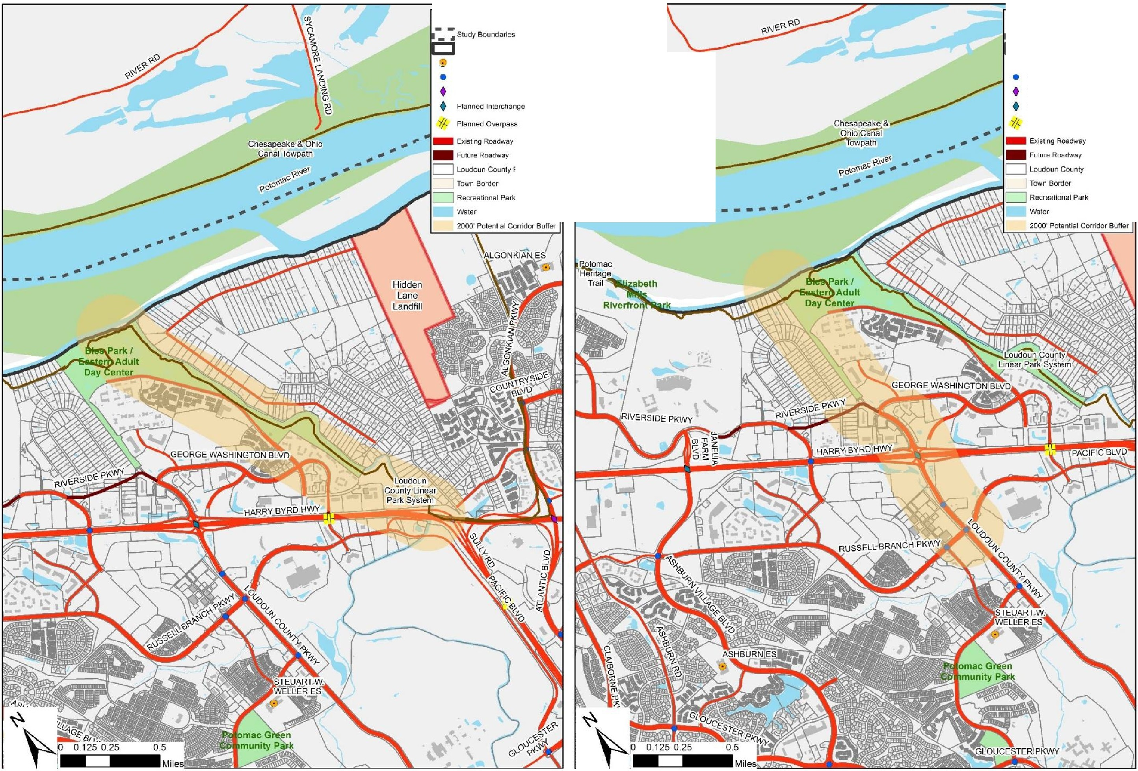

Fu ture Roadw ;ty
C:J Loudo un County ParCels
Town Border

.. ---------

Planned Overpass

11111 Future Roadway
C:J Loudoun COLmty Par cels

Regional Recreational Access
Loudoun County is situated near two major national recreational corridors just outside of its boundaries, namely the Appalachian National Scenic Trail along the Blue Ridge and the Chesapeake & Ohio (C & O) Canal Towpath along the Maryland shoreline of the Potomac River. There are limited non-motorized connections between Loudoun County and these corridors for individuals wishing to access them without the use of a motor vehicle, or conversely, for individuals hiking or biking along these corridors wishing to access points within Loudoun County. Improved connections could, for example, provide access between the Appalachian Trail at Snickers Gap and the Village of Bluemont, between the C & O Canal Towpath at Brunswick, Maryland to the Town of Lovettsville, and between the C & O Canal at White’s Ferry and the Washington and Old Dominion (W & OD) in the Town of Leesburg.
Regional Transportation Coordination Policies
6-1.1 County Participation in Regional Organizations The County will continue to participate as a member of regional transportation planning agencies to increase the County’s role and status in the regional planning arena and to generate support for transportation projects that are contained within the Loudoun 2040 Countywide Transportation Plan. Roadways and other transportation facilities identified in the Loudoun 2040 Countywide Transportation Plan represent planned or improved transportation facilities Countywide and their ultimate conditions. Transportation facilities noted in this plan are will be updated on a regular basis through the County’s transportation planning process in coordination with regional planning agencies, and by resolution of the Board of Supervisors.
6-1.2 Issues of Mutual Concern The County will continue to work with other localities on specific issues of mutual regional concern, such as the Route 28 Highway Transportation Improvement District (HTID), and to provide support for appropriate regional transportation improvements outside the County.

6-1.3 Potomac River Crossing The County is committed to the on-going study of a future Potomac River Crossing between Virginia and Montgomery County, Maryland. The County’s preferred location for such a crossing is within the boundaries identified as Corridor D and Corridor E, and the area between these identified corridors. This future crossing will take every measure to avoid the removal of any existing residential dwellings within Loudoun County.

6-1.4 Potomac River Crossing Coordination The County will develop a plan for regional coordination and collaboration with local and state jurisdictions, as well as with federal agencies, to advance the concept of a future Potomac River Crossing.

6-1.5 Regional Recreational Access The County will work with adjacent jurisdictions and agencies to identify and implement improved non-motorized access between the Appalachian Trail and the Chesapeake & Ohio Canal Towpath to points within Loudoun County.

State Coordination
Of equal importance to its coordination with regional agencies, the County must partner with state

agencies to realize its vision for transportation. Coordination with VDOT is particularly important given that the state is responsible for maintenance and operation of all public roadways in Loudoun County.

The Commonwealth Transportation Board (CTB)
At the forefront of transportation issues for the state, the Commonwealth Transportation Board is a governor-appointed 17-member body that establishes administrative policies for Virginia’s transportation systems and allocates funding for highway projects, airports, seaports and public transportation. CTB-approved programs are administered through the various transportation- related state agencies, including the Virginia Department of Transportation (VDOT), the Virginia Department of Rail and Public Transportation (DRPT), the Port of Virginia, and the Virginia Department of Aviation.

Office of Intermodal Planning and Investment (OIPI)
The Office of Intermodal Planning and Investment is located within the Office of the Secretary of Transportation and was created in 2002 to encourage the coordination of multimodal and intermodal planning across the various transportation modes within the Commonwealth. Since then, the office has produced multiple statewide planning efforts, performance reports and collaborated with multiple entities to promote a safe, strategic and seamless transportation system. OIPI is also charged with assisting the CTB in the development of the Statewide Transportation Plan, currently known as VTrans2040. VTrans2040 identifies is the long-range, statewide multimodal policy plan that lays out overarching Vision and Goals for transportation in the Commonwealth. It identifies transportation investment priorities and provides direction to transportation agencies on strategies and programs to be incorporated into their plans and programs.

VTrans2040 identifies multimodal needs across the Commonwealth. The plan focus is on the needs of the Commonwealth’s statewide network of Corridors of Statewide Significance, the multimodal regional networks that support travel within metropolitan regions, and improvements to promote locally designated Urban Development Areas. In Loudoun County, the Northstar Boulevard / Belmont Ridge Road corridor is a designated Corridor of Statewide Significance, referenced as “North-South Corridor G,” and the locally designated Urban Development Area is comprised of the Urban and Suburban Policy Areas.

VTrans2040 is divided into two components: the VTrans2040 Vision Plan (Vision Plan) and the VTrans2040 Multimodal Transportation Plan (VMTP). The VTrans2040 Vision component lays out Virginia’s Guiding Principles, Vision, Goals, and Objectives in a policy framework to guide partner agency investment decisions over the next 25 years. The VTrans2040 VTMP component includes a Statewide Transportation Needs Assessment. This needs assessment serves as a screen for state funding consideration through the SmartScale program.

The Virginia Department of Transportation (VDOT)
The Virginia Department of Transportation is responsible for the maintenance and operation of all public roads in Loudoun County (excluding incorporated towns with populations greater than 5,000 people). Included with this responsibility is the provision of transportation improvement

projects to ensure the continued mobility of the traveling public. The County works closely with VDOT in the identification and implementation of priority transportation projects through the Six- Year Improvement Program (SYIP). These projects represent a portion of the County’s priorities and are the culmination of significant programming, design and funding actions.

VDOT’s Locally Administered Projects (LAP) Program offers opportunities for the County to directly manage construction, as well as planning, environmental clearance, design, and permitting of transportation projects that include VDOT funding. This approach helps to streamline project development, saving time and money in the process and bringing projects to fruition in an abbreviated time-frame compared to past projects. In 2006, VDOT approved Loudoun County’s application to participate in a predecessor to the LAP program for the rehabilitation of historic Hibbs Bridge on Route 734. The Hibbs Bridge project was successfully completed by the County’s Office of Capital Construction in 2007. More recently, with the development of the County’s robust CIP since 2012, several other projects have been or are currently being administered under the LAP program through the County’s Department of Transportation and Capital Infrastructure (DTCI). These projects include the extension of Claiborne Parkway between Croson Lane and Ryan Road; construction of the Route 7 / Belmont Ridge Road Interchange; the widening of Belmont Ridge Road between Truro Parish Drive and Croson Lane, and Northstar Boulevard between US Route 50 and Tall Cedars Parkway.

The County also works with VDOT and the development community in the land development review process regarding road improvement issues, including through the Chapter 527 legislation initially passed by the Virginia General Assembly in 2006 and which became effective July 1, 2007. This legislation allows VDOT to review and submit comments on comprehensive plans and plan amendments and certain rezoning proposals, as well as their associated traffic impact analyses. It is intended to provide local governing bodies and their constituents with additional information to aid in the land use and transportation decision-making process. In general, comprehensive plans or plan amendments that have a substantial impact on, or cause a substantial change to, the existing transportation network or state-controlled/maintained highways, and land development applications that have a significant impact on state-controlled highways must be submitted to VDOT for review and comment. The specific criteria that are used with each type of application are contained within the VDOT Revised Traffic Impact Analysis Regulations Administrative Guidelines, 24VAC30-155.

The County intends to continue its current relationship with VDOT as the County continues to implement public transportation infrastructure improvements to design and construct roadways and bicycle and pedestrian facilities as identified in the Loudoun 2040 Countywide Transportation Plan.

The Virginia Department of Rail and Public Transportation (DRPT)
The Virginia Department of Rail and Public Transportation focuses on the movement of people and goods throughout the Commonwealth, primarily in the areas of rail, public transportation, and commuter services. DRPT works with local, regional, state, and federal governments, as well as private entities to provide support for projects and programs by:

- Assessing feasibility and environmental impacts of new and expanding services;
- Conducting statewide rail and public transportation studies;
- Planning and programming new services and capital improvement projects; and
- Providing leadership, advocacy, technical assistance and funding.

DRPT works with private railroad companies to promote freight rail and to expand access to passenger rail across Virginia, including Amtrak and Virginia Railway Express (VRE) services. DRPT supports both passenger and freight rail initiatives through funding options, expert advice, research, and advocacy, and represents the State’s interests in interstate and national rail issues. DRPT also provides advice, support and funding to local bus as well as commuter bus and rail services throughout Virginia. Commuter Services Programs, which work to promote carpools, vanpools, telework and other alternative modes of transportation to Virginia’s commuters, help to save individuals (and employers) time and money, and can also help manage traffic congestion and benefit the environment. DRPT partners with commuter service programs operating in the Commonwealth, including Loudoun County Commuter Services, to provide information, business incentives, and ridematching services.
Additionally, with regard to increased focus on multimodal transportation across the Commonwealth, DRPT in 2013 developed the Multimodal System Design Guidelines to provide a framework for multimodal planning at regional, local and corridor scales. These guidelines provided an alternative to VDOT’s Road Design Manual, and in 2014 VDOT amended its Road Design Manual to allow for the application of these guidelines in certain designated urban areas in jurisdictions were VDOT operates and maintains the public road network. Further information regarding the DRPT Multimodal System Design Guidelines is provided in Chapter 3, The Built Environment – Transportation and Land Use.

Local and Other Coordination
As an extension of its coordination with other agencies, particularly VDOT, the County works with other key entities to ensure appropriate coordination is accomplished for certain transportation issues, initiatives and projects. The most common of these are as follows:

- The County coordinates with its towns and neighboring jurisdictions as well as regional agencies.

- The County develops and pursues a legislative program with the Virginia General Assembly that includes transportation facilities and funding and also coordinates with other jurisdictions on transportation matters of mutual interest.

- The County facilitates Transportation Demand Management (TDM) programs through the County’s Transit and Commuter Services program, in coordination with DRPT, VDOT, MWCOG, and local Transportation Management Associations (TMA's). Each organization provides technical and financial support through grant programs, research, training, and marketing assistance. As part of each program, the County provides employer outreach opportunities to assist employers in developing or expanding employee transportation programs.

State, County, Local and Other Coordination Policies
6-2.1 VDOT Transportation Planning Coordination The County will continue to encourage the VDOT to participate in long-range planning processes to provide the input for the formulations of County transportation policy.
6-2.2 VDOT Funding Coordination The County will submit applications for funding to VDOT for the various funding programs managed by VDOT.
6-2.3. VDOT Land Development Coordination The County will obtain VDOT’s input into development applications through the County’s land development application referral process, and by working with VDOT and applicants to ensure that proposed public streets are accepted into the state’s system. This will include submissions of development related traffic impact analysis to VDOT for review in accordance with the Chapter 527 legislation.
6-2.4 VDOT Roadway Crossing Coordination The County will ensure multi-way stop controls, mid-block marked crosswalks, and marked crosswalks across uncontrolled approaches are not installed prior to street acceptance by VDOT; unless supported by an engineering study.
6-2.5 VDOT LAP Project Participation The County will continue to manage projects under VDOT’s LAP Program and coordinate with VDOT throughout all phases of project development and implementation.

6-2.6 Coordination with Incorporated Towns The County will work with officials and citizens of its towns to discuss transportation issues and opportunities. Participation of local citizens and associations in local road design will be encouraged as part of the process for the Primary and Secondary Road Programs.
6-2.7 Coordination with Adjacent Jurisdictions The County will work with adjoining jurisdictions to create seamless road, bicycle, and pedestrian connections across borders wherever possible.

6-2.8 DRPT Coordination The County will continue to facilitate TDM programs in coordination with the DRPT, other partner agencies, and local TMAs.

Local Control and Management Options
In Virginia, responsibility for public roads in most counties lies with the state. However, state legislation permits counties to take responsibility for road management. This local control is mandatory in incorporated towns larger than 3,500 people and in cities. The Towns of Leesburg and Purcellville presently have this responsibility. Recent indications are that the state may encourage increased local responsibility as a means of reducing costs. The terms of transferring responsibility for secondary roads from VDOT to Loudoun County, commonly referred to as devolution, would require agreement between the Commonwealth Transportation Board and the Board of Supervisors. Local management and responsibility for roads would entail significant costs to the County.

Should Loudoun choose to maintain its local roads, the County could face annual maintenance expenditures, depending on the level of state funding to the County. This figure does not include

the potentially larger costs of additional preconstruction and review staff, equipment, materials, and other costs associated with local control of secondary roads. For now, the County has chosen to continue relying on VDOT’s management and maintenance support of all primary and secondary public roads in the county.

The Public-Private Transportation Act of 1995 (PPTA) is the legislative framework enabling the Commonwealth of Virginia, qualifying local governments and certain other political entities to enter into agreements authorizing private entities to acquire, construct, improve, maintain, and/or operate qualifying transportation facilities. The public entities may either solicit or accept unsolicited proposals from private sources. Loudoun County has utilized the PPTA to fund needed transportation improvements in the Route 28 and Dulles Greenway Corridors. Planned transportation projects beyond those currently constructed in these corridors will be evaluated to assess whether application of the PPTA is appropriate.

Local Control and Management Options Policies
6-3.1 VDOT Maintenance Responsibility VDOT will continue to have responsibility over all public roads in Loudoun County, except incorporated towns with populations larger than 3,500 people.
6-3.2 Projects Consistent with County Policy The County will encourage transportation projects that minimize the fiscal impact of construction, operation, and maintenance on the County to the extent that such projects are also consistent with the County’s land use, environmental and historical preservation policies.
6-3.3 VDOT Standards All roads to be maintained by VDOT will be built to VDOT standards or VDOT permitted variations from VDOT standards for admission into the state system.
6-3.4 PPTA Project Review The County will review any transportation projects proposed for construction in Loudoun County under the provisions of the Virginia Public-Private Transportation Act of 1995 (PPTA).

Chapter 7 – Environmental and Heritage Resources
The protection of the environment in and around Loudoun County is a top priority of this plan. Consistent with state and federal legislation and the policies of the General Plan, this document supports the protection of Environmental and Heritage Resources, with specific policies to address transportation-related impacts. Additional policies on these matters can be found in the General Plan.

Environmental Resources
Air Quality
Loudoun County is actively involved in the protection of air quality through its engagement in the regional planning process. The County participates in this process as a member of the National Capital Region Transportation Planning Board (TPB) and the Metropolitan Washington Air Quality Committee (MWAQC) through the Metropolitan Washington Council of Governments (MWCOG), the Metropolitan Planning Organization (MPO) for the region. The Washington Metropolitan region is currently designated by the US Environmental Protection Agency (EPA) as a nonattainment area for federal health standards with respect to ozone and fine particles (PM2.5), which means that potentially serious health problems can be expected as a result of the levels of these pollutants in the atmosphere. In 1977, Federal clean air legislation was enacted which specified that an MPO could not approve any transportation project that did not conform to a State Implementation Plan (SIP) for attainment of clean air standards. Following in 1990, the Clean Air Act Amendments (CAAA) further defined conformity of an implementation plan as “meeting the purpose of eliminating or reducing the severity and number of violations of the national ambient air quality standards and achieving expeditious attainment of such standards.”

Each year the TPB updates two regional planning documents that make up the implementation plan. The Financially Constrained Long-Range Plan (CLRP) and the Regional Transportation Improvement Plan (TIP). The CLRP has a long-range planning horizon of 25 years while the TIP focuses on all regionally significant projects in a short-term six-year time frame. Both the CLRP and TIP are required to have an EPA finding of air quality conformity each time they are updated.

The most recent CLRP and TIP (2016 CLRP and FY 2017-2022 TIP, respectively) have been demonstrated to be in conformance with regional transportation plans according to the Air Quality Conformity Assessment. Should air quality conformity fail to be attained in the future, the region could face federal sanctions, including loss of highway funding.

It is very important that policies support lowering total vehicle emissions and meeting air quality standards. The County’s land use policies, calling for high density development at major transit nodes and implementation of transit routes are important factors. These policies promote new transit and ridesharing services—Metrorail, express inter-jurisdictional bus and local bus, and carpools and vanpools. They include bicycle and pedestrian improvements as well as travel demand management strategies such as telecommuting and flexible work hours. The County supports a comprehensive approach to implementing these measures to reduce the use and dependence on the private automobile.

Air Quality Policies
7-1.1 Clean Air Attainment The County will participate in the regional Clean Air Act Attainment Plan air quality conformity evaluation process.
7-1.2 NEPA All transportation planning will comply with the Federal Clean Air Act Amendments of 1990 through support of the State Implementation Plan (SIP).
7-1.3 Reducing Trips The County will implement land use policies that will reduce vehicular trips and vehicle miles traveled to achieve the air quality standards required by the federal, state or county government, whichever are the most stringent. Such land use measures may promote pedestrian facilities, bicycle use, ridesharing, mass-transit options, and mixed-use communities.
7-1.4 Electric Vehicle Charging Stations The County encourages the use and installation of electric vehicle charging stations at County owned facilities and County park and ride lots. Electric vehicle charging stations are encouraged to be installed at private parking lots.
Water Quality
The County seeks to preserve and protect the quality of surface water and groundwater by minimizing the intrusion of the road network on river and stream corridor resources and areas underlain by limestone. In Loudoun County, disturbances to river and stream corridors and their associated floodplains are regulated by the United States Army Corps of Engineers (the Corps) and the Virginia Department of Environmental Quality (DEQ), with regular coordination with the County’s Department of Building and Development. The Corps and DEQ call for the avoidance and minimization of impacts to the maximum extent practicable and to provide compensatory mitigation for authorized impacts exceeding established thresholds. The County supports measures that protect water quality by minimizing the intrusion of the road network on river and stream corridor resources and areas underlain by limestone. The County also seeks to protect these areas by establishing buffers to maintain stream bank stabilization, temperature moderation, flood control, and aquatic habitat as well as filtering nutrients and sediments from upland disturbances.

Water Quality Policies
7-1.5 Road Crossing Locations Road crossings of the river and stream corridor resources will avoid or, when avoidance is not feasible, minimize and mitigate disturbances within floodplains and steep slopes. Road crossings will be constructed generally perpendicular to the flow of the drainage way to minimize impacts. Road alignments designed to extend within and parallel to the floodplain will be avoided.
7-1.6 Stream Maintenance Road crossings will avoid, minimize, and compensate for filling of jurisdictional waters and wetlands in a manner consistent with requirements of the United States Army Corps of Engineers and the Virginia Department of Environmental Quality. A natural stream channel will be maintained beneath road crossings to minimize impacts on stream flow and habitat. The County supports the mitigation of stream and wetland impacts and the creation of stream and wetland mitigation banks to improve water quality within Loudoun County.

7-1.7 Riparian Buffers Forested riparian buffers are a crucial component of environmental planning. Road crossings will avoid disturbance of forested riparian buffers. Where this is not feasible, road crossing projects will include reforestation to compensate for lost forest habitat.
7-1.8 Limestone Road projects proposed in areas underlain by limestone / karst features will seek to avoid sensitive environmental features.
Noise Exposure
It is the County’s intention to protect residents from exposure to excessive noise from transportation facilities within reasonable limits by applying recognized standards. This will ensure that the County receives federal and state assistance in mitigating traffic noise problems near existing developments. Finally, the County should adopt the state standards into the Zoning Ordinance to ensure that future development protects itself from noise problems. These policies are not intended to apply to temporary noise sources such as transportation construction projects.

Noise Policies
7-1.9 Land Development All proposals for residential, institutional, or other noise sensitive uses adjacent to existing or proposed arterial and major collector roads will complete a study of predicted traffic noise to ensure that forecasted noise levels fall within acceptable levels, or can be abated to meet County standards.
7-1.10 Noise Studies Roadway noise studies will use the most recent version of the Federal Highway Administration’s Highway Traffic Noise Prediction Model (FHWA-RD-77-108, as amended). Studies will use a design year no less than 10 years after the road corridor is anticipated to be completed to its ultimate condition and open to traffic, with considerations for planned design speed, pavement type, future topography, and lane configurations. Forecasted traffic volume projections will be provided by the County upon request.
7-1.11 Noise Abatement Criteria A noise level is considered to approach the noise abatement criteria when it is 1 dBa less than the noise abatement criteria for a defined use. A noise level is considered to substantially exceed existing noise levels when noise levels increase by 10 dBa or more. Hourly A-Weighted Sound Levels in Decibels (dbA) will demonstrate future noise levels at, or below the following levels:
  - Lands on which serenity and quiet are of extraordinary significance and serve an important public need and where the preservation of those qualities is essential if the area is to continue to serve its intended purpose – 57 Leq (h) (exterior)
  - Picnic areas, recreation areas, playgrounds, active sports areas, parks, residential yards, motels, hotels, schools, churches, libraries, and hospitals. – 67 Leq (h) (exterior)
  - Commercial uses or developed lands, properties, or activities excepting those described above – 72 Leq (h) (exterior)
  - Residences, motels, hotels, public meeting rooms, schools, churches, libraries, hospitals, and auditoriums – 52 Leq (h) (interior)
Traffic noise impacts can occur below the Noise Abatement Criteria List Above. These criteria should only be used as absolute values which, when approached or exceeded,

require the consideration of traffic noise abatement measures. These do not represent federal standards or desirable noise levels and should not be used as design goals for noise barrier construction.

7-1.12 Noise Reduction Noise abatement will provide at least a 5dBA reduction in highway traffic noise levels in order to provide noticeable and effective attenuation and will be in place prior to the issuance of occupancy permits for any impacted structures.
7-1.13 Noise Abatement Types Structural noise abatement measures, such as concrete walls, shall not be used unless required noise reductions cannot be reached by other means. Passive noise abatement measures are preferred including adequate setbacks, earthen berms, wooden fences, and dense tree vegetation. When used, noise walls will include design elements such as articulated walls and gradual descents that blend with natural features in the landscape. Walls should be supplemented with appropriate landscaping and reflect the character of the surrounding natural environment.
7-1.14 Responsibility Construction and maintenance costs associated with noise abatement measures needed for land development activities will be borne by the associated development(s).

Heritage Resources
The rural character of the County is deeply associated with the County’s rich history. Stone walls and tree-lined rural roads frame great expanses of farmland dotted with historic homes, barns, and small farm structures creating a unique Loudoun landscape. In addition to these scenic resources, there are six County-administered historic districts, two town-administered historic districts and one historic district on the Virginia Register of Historic Places. Loudoun has dozens of historic sites and districts listed in the National Register of Historic Places and many historic and archeological resources yet to be evaluated for the Register, as well as five National Landmark sites. Loudoun County has most recently been recognized as part of the nationally renowned “The Journey Through Hallowed Ground” corridor, a historically and culturally significant corridor that extends outside of Loudoun County, and follows Route 15. The Journey Through Hallowed Ground National Heritage Area is a 180-mile long, 75-mile-wide historical region extending from Gettysburg, Pennsylvania to Monticello in Charlottesville, Virginia. The County Board of Supervisors joined The Journey Through Hallowed Ground Partnership in 2008 with the issuance of a resolution of support for this National Heritage Area. This corridor includes many of the sites already recognized in the County as historic treasures including the John Mosby Heritage Area. All of these sites are major tourist destinations. The impact that roads and other means of transportation have on the rural landscape must be considered during the design of road-improvement and new construction projects. These sites are closely tied to their rural settings and can be negatively affected by road projects.

The County has six designated historic and cultural conservation district, two historic site districts, and one historic roadway district. There are also three town-administered historic districts. One method used by the County to help facilitate the public awareness of scenic roads and their associated landscapes is through state-designated “Virginia Byways,” as authorized by the 1966 Scenic Highway and Virginia Byways Act. Virginia Byways are corridors with significant aesthetic and cultural value, leading to or lying within areas of historical, natural or

recreational significance. Virginia Byways designation could ensure valued heritage resources are considered as part of road improvement and maintenance projects. The designation does not guarantee the conservation and protection of roadways or their adjacent corridors. Local land use controls are still needed to preserve the unique character of the Virginia Byway corridor. Seventeen Virginia Byways are located in the County. Route 15 is also designated as a National Scenic Byway.

Seventeen Virginia Byways are located in the County. They are:

- Route 7 (Colonial Highway) from the intersection with Route 287 in Purcellville east through the Town of Hamilton to the intersection with Route 699 (Dry Mill Road);

- Route 9 (Charles Town Pike) from its intersection with the Route 7 bypass and Route 662 (Clarkes Gap Road) to the West Virginia State Line;

- Route 15 (James Monroe Highway) from the Maryland State Line south to the Prince William County Line;

- Route 662 (Clarkes Gap Road) from Waterford to Route 9 at Paeonian Springs;

- Route 665 (Loyalty Road) from Taylorstown to Waterford;

- Route 671 (Harpers Ferry Road) from its intersection with Route 9 (Charles Town Pike) to the intersection with Route 340 near the Potomac River;

- Route 673 (Milltown Road) from the intersection with Route 287 (Berlin Turnpike) in Lovettsville to the intersection with Route 681 (Milltown Road) southwest of Lovettsville;

- Route 681 (Milltown Road) from the intersection with Route 673 (Featherbed Lane) to Route 698 (Old Wheatland Road) near Waterford;

- Route 690 (Mountain Road) from Route 673 (Irish Corner Road) near Lovettsville to Hillsboro;

- Route 699 (Dry Mill Road) from the intersection of Route 7 (Colonial Highway) to the intersection of Loudoun and King Street (Route 15) in the Leesburg Historic District;

- Route 704 (Harmony Church Road) from the intersection of Route 7 (Colonial Highway) in Hamilton to Route 15;

- Route 719 (Woodgrove Road) from Round Hill to Hillsboro;

- Route 722 (Lincoln Road) from the southern boundary of Purcellville, including the JLMA, to the intersection with Route 728 (North Fork Road);

- Route 728 (North Fork Road) from the intersection of Route 722 (Lincoln Road) to the intersection of Route 731 (Watermill Road);

- Route 731 (Watermill Road) from the intersection of Route 728 (North Fork Road) to the intersection with Route 734 (Snickersville Turnpike); and

- Route 734 (Snickersville Turnpike) in its entirety from Bluemont to Aldie.

- Route 751 (Cider Mill Road) in its entirety from the intersection of Route 719 (Woodgrove Road) to the intersection with Route 9 (Charles Town Pike)

The Zoning Ordinance empowers the County to further protect historic roads through the designation of Historic Roadway Districts and Historic Access Corridor Districts. Route 50 through the Mosby Heritage Area will be considered for designation as either a Historic Roadway District or Historic Access Corridor and Route 626 will also be considered for designation as a Historic Access Corridor. The County will work with the Town of Leesburg to designate Edwards Ferry Road from Battlefield Parkway east to River Creek Parkway as a Historic Access Corridor. The Beaverdam Creek Historic Roadways District has already been established using this section of the Zoning Ordinance.

Heritage Resource Policies
7-2.1 Preservation and Protection The County supports heritage resource and archeological studies for transportation project and will implement measures to protect cultural, historic and archaeological sites which are affected by state-funded road improvement projects and supports archeological studies for state-funded improvements, including use of Section 106 and 4F processes when required.
7-2.2 National Scenic Byways The County supports The Journey Through Hallowed Ground National Scenic Byway designation of US Route 15 and will incorporate the National Scenic Byway guidelines to ensure that improvements are constructed to meet these standards, as applicable. The County will coordinate with VDOT on road improvement plans along this corridor.
7-2.3 Virginia Byways The County will work with the state to recommend and implement Virginia Scenic Byway designations along roads of significant aesthetic or historical value. The County will coordinate with VDOT on road improvement plans along these corridors.
7-2.4 Designation of Corridors and Districts The County will identify, define, and designate Historic Roadway Districts, and Historic Access Corridor Districts beneficial to preserving the rural and community character of the County. The creation of Historic Roadway Districts and Historic Access Corridors will be a community-driven process to include relevant Advisory Boards, Commissions, and Committees.
7-2.5 Middleburg The County, in coordination with the Town of Middleburg, will protect the entrance corridor to the National Register Middleburg Historic District, as well as the scenic and historic character and importance of the first paved road in the Commonwealth, the County will designate Route 50 through the Mosby Heritage Area as a Historic Access Corridor or Historic Roadway District as provided for in the Revised 1993 Zoning Ordinance. To further protect the entrances to the Middleburg Historic District, the County will designate Route 626 (Foxcroft Road and The Plains Road) as a Historic Access Corridor as provided for in the Zoning Ordinance.

7-2.6 Waterford The County will protect the Waterford National Historic Landmark, as designed by the National Park Service, as well as the scenic and historic character and importance surrounding roadways and will seek opportunities to enhance protections of this area through traffic calming measures and other efforts to encourage through traffic to use alternate routes.
7-2.7 Mosby Heritage Area The County will pursue Virginia Byways designation by the Commonwealth for Route 626 in its entirety and Route 50 in the Mosby Heritage Area.
7-2.8 Edwards Ferry Road The County will work with the Town of Leesburg to designate Edwards Ferry Road from Battlefield Parkway east to River Creek Parkway as a Historic Access Corridor and the spine of the Ball’s Bluff Battlefield National Historic Landmark.
7-2.9 Historic Towns and Villages In addition to those noted in the above policies, the County will seek opportunities to enhance and protect historic landmarks and buildings within the incorporated Towns and designated Villages.

Chapter 8 – Prioritization and Funding
It is important that the County set priorities for its planned transportation improvements in order to be able to efficiently focus public and private resources on major projects needed in both the short- and long-term. This chapter is intended to provide general guidance for the Board of Supervisors to consider in its development of the Capital Improvement Program (CIP). This six-year program, updated annually based upon real and forecasted budget allocations, provides funding for transportation infrastructure development throughout the County. Funding sources, which are outlined later in this chapter, include County revenues, as well as Regional, State and Federal funds as distributed to the County.
This chapter provides high-level guidance on prioritization of projects and provides policy to enable the County to seek funding opportunities for desired projects. It is not intended to provide a ranked listing of projects, as such rankings occur during the annual CIP development. Rather, the policies below provide broad guidance relating to completing missing links for all modes, considering functional classification, and coordinating with private project development to ensure available funding is optimized to maximize efficiency of the transportation network.

Transportation Improvement Priorities Policies
8-1.1 General Guidance Documents The County’s Capital Improvement Program (CIP) and the Virginia Department of Transportation’s Six-Year Improvement Program (SYIP) will be the key processes for prioritizing transportation improvements on a regular basis. The County will base transportation decisions in part on its land use policies contained in the Loudoun 2040 General Plan and its transportation model outputs.
8-1.2 Priority Project Considerations Road and other transportation infrastructure improvements will promote traffic, pedestrian, and bicycle safety and mobility. This shall include appropriate locations for transit stops that provide for improved vehicular and transit operations consistent with area land uses and regional demands.
8-1.3 Priority Project Types The County will place priority on transportation projects falling into one or more of the following types, in no particular order:
  - Projects that complete missing segments of arterial and major collector corridors
  - Projects within the County’s Intersection Improvement Program
  - Projects to provide connectivity in and around the County’s Metrorail stations
  - Projects that provide significant economic development benefits to the County
  - Projects within the County’s Sidewalk and Trail Program Projects that incorporate “complete streets” concepts and features Funding Sources
The planning, design, construction, operation and maintenance of a multi-modal

transportation system are completely dependent upon the availability of adequate funding. The funding of transportation infrastructure requires significant expenditure of capital, typically beyond the resources of local government. Traditionally, the County has depended on State and Federal funds for the design and construction of transportation projects, augmented by private sector contributions, known as proffers. However, as traditional sources of funding dwindled, the County was forced to increasingly rely upon private sector contributions, and to implement funding alternatives, including the sale of bonds and the use of innovative financing options.

While the County has been successful in utilizing a variety of means to finance transportation projects, the inherent uncertainty in the timing of infrastructure improvements linked to private sector projects remains a challenge. Also, key projects continue to remain unfunded or under-funded where financing is unavailable or inadequate. Finally, rising construction costs further complicate the issue. Accordingly, the County places an emphasis on setting priorities through annual project review and provides guidelines and direction for funding acquisition and management.

In November 2006, Loudoun County voters approved the County’s first ever local road bond referendum in the amount of $51.3 million. The approval allowed for the sale of bonds to pay for the construction of an interchange at the intersection of Route 7 and Loudoun County Parkway, a section of Russell Branch Parkway associated with the interchange, and the full or partial design of six additional road projects. The approval of the 2006 referendum represented a commitment by the County and its voters to ensure the provision of priority transportation improvements in an effort to promote both economic development and quality of life. Building on this effort, beginning in 2012, the Board of Supervisors embarked on a robust transportation component of the County’s Capital Improvement Program (CIP), which as of 2018 has grown to a level such that transportation comprises over 50% of all CIP funding. Loudoun’s CIP is now one of the largest transportation programs administered by a local government anywhere in the United States. Additionally, with the passage of HB 2313 in 2013, the General Assembly authorized a significant source of dedicated revenue for funding transportation projects in Northern Virginia through the NVTA.

The various sources of funding that are available to the County are summarized below. These include local, regional, state, federal, and public-private funding sources (including proffers). Each of the listed funding programs has specific criteria that must be met in order to be used. The County seeks to take advantage of all available resources, or a combination thereof, in an effort to secure adequate funding and advance its transportation initiatives. Leveraging outside, or non-local source funding, is a primary goal for the County. For specific information on planned transportation expenditures within the County, please refer to the County’s latest adopted Capital Improvement Program (CIP), as well as VDOT’s latest adopted funding programs.

Local Funding Sources
General Obligation Bonds, Lease Financing and Revenue Bonds

Many of Loudoun’s transportation projects have been financed by the sale of state bonds through the Northern Virginia Transportation Bond Act. Such improvements include the widening of Route 7 to six lanes between Route 28 and the Route 15 Bypass; the construction of the interchange at Route 7 and the Route 15 Bypass in Leesburg; and Route 15 safety improvements north of Leesburg. These bonds have been financed from different sources, such as recordation taxes, public right-of-way use fee, and the state’s general funds. Where appropriate Lease Financing and Revenue Bonds may be used to fund projects. The County’s use of bonds to fund transportation and non-transportation projects is subject to the Board’s self-imposed fiscal policies.

Local Tax Funding / Local Tax Funding for Roads
The Board has adopted a policy to fund a minimum of ten percent of the CIP using cash. Additionally, HB 2313 (2013 Session of the General Assembly), which provided funding to the NVTA, requires local jurisdictions to contribute, from their local funds, a level of funding equal to or exceeding the 30% formula distribution from the NVTA (“Maintenance of Effort”). The Board established a policy to designate $0.02 per $100 of assessed value of real estate property taxes to meet the Maintenance of Effort requirement.

Local Gasoline Tax
The County began to receive Local Gasoline Tax revenues in January 1989 with the formation of the Loudoun County Transportation District Commission (LCTDC). In January 1990, the LCTDC was dissolved, and Loudoun County became a member of the Northern Virginia Transportation Commission (NVTC). Local Gasoline Tax revenues are received by the Commonwealth and held in trust by NVTC for Loudoun County. Expenditure of Loudoun County’s Local Gasoline Tax revenue is regulated by the Interim Transportation Plan adopted by the former LCTDC on September 11, 1989, which organizes projects by category. Unlike other localities, Loudoun County can spend Local Gasoline Tax revenues for road improvements and bicycle and pedestrian improvements as called for in the Loudoun 2040 CTP as well as on transit programs. Other Northern Virginia jurisdictions use the money solely for WMATA (Metro) expenses. Per Board direction, once Phase 2 of the Dulles Corridor Metrorail Project is complete, 100 percent of the funds will be directed to fund Loudoun County’s obligations to WMATA.

The use of Local Gasoline Tax funds has been flexible. Funds have been used to leverage state Revenue Sharing Program funds and private contributions for road construction, to supplement primary and secondary road improvement projects, such as traffic signals, to improve traffic movement, to supplement the Commuter Bus operating costs and for a variety of locally oriented transportation projects that have no other funding source. Beginning in FY 2018, most Local Gasoline Tax funds were set aside to fund the upcoming expenses related to Metrorail. In FY 2019, all Local Gasoline Tax funds will be used for Metrorail-related costs.

Regional Funding Sources
Northern Virginia Transportation Authority (NVTA) Funding

In 2013, the General Assembly passed HB 2313 creating a dedicated revenue source for funding transportation projects through the NVTA. Thirty percent (30%) of the funds, referred to as local funds, are distributed annually to the qualifying jurisdictions using a formula based method. The remaining seventy percent (70%) funds are available to qualifying jurisdictions on a competitive basis to implement regional transportation projects. One of the criteria for eligibility to receive the 70 percent regional funds is that transportation projects for which funding is sought must be included in NVTA’s long range transportation plan known as TransAction. Revenues from HB 2313, funded by sales taxes, transient occupancy (lodging) taxes, and grantor’s (real estate transfer) taxes, generate an estimated $300 million annually in local and regional transportation funding to Northern Virginia.

In August 2015, NVTA embarked on a major update to TransAction, which was adopted in October 2017. TransAction provides a multi-modal guide for transportation investments in Northern Virginia and will be the mechanism through which over $1 billion will be allocated to regional transportation improvements through NVTA’s Six-Year Funding Program (SYP). The 70 percent regional NVTA funds allocated on a competitive basis will only be available to Northern Virginia jurisdictions’ projects included in TransAction, with jurisdictions to submit projects for funding consideration every two years. Updates to NVTA’s SYP will accommodate:

- Project/project phase completions
- Project schedule and budget adjustments (subject to NVTA policies)
- Fluctuations in regional revenues
- Updated NVTA regional priorities

TransAction is anticipated to be updated every five years, with the next scheduled update to be adopted by fall 2022. Consideration is underway for ad-hoc TransAction updates or amendments under exceptional circumstances, subject to NVTA approval and the identification of an acceptable funding source.

Northern Virginia Transportation Commission (NVTC) Transform I-66 Funding
In January 2016, the NVTC and the CTB signed a 40-year memorandum of agreement (MOA) allowing NVTC to use a portion of the toll revenues from the I-66 inside the Beltway project (now referred to as the 66 Commuter Plan) to fund multimodal projects in Northern Virginia. The MOA assigns VDOT, on behalf of the CTB, to control and manage tolling on I-66. Toll revenues will be used and distributed to support the tolling operations and tolling maintenance of the facility, and to fund components selected by NVTC and approved by the CTB for the project, designed to specifically attain the Improvement Goals stated in the MOA. The CTB delegates to NVTC the authority to select and administer the implementation of the components to be funded from the portion of the toll revenues of the facility as provided in the MOA. These projects, designed to benefit toll payers, will ease travel through this congested corridor. Park and ride lots, bike share stations, express bus service and high-tech transit information screens are among the types of projects eligible

for funding. The funding can be used for both capital and operating costs of the facilities, and a call for projects will be solicited on an annual basis.

State Funding Sources
VDOT Six-Year Improvement Program (SYIP) Funding
The Six-Year Improvement Program (SYIP) is the primary mechanism for state transportation funding. During the 2014 Virginia General Assembly Session, HB 2 was enacted which requires the CTB to develop and implement a quantifiable and transparent prioritization process for making funding decisions for projects funded through VDOT or DRPT using the Commonwealth’s transportation funds. The program was subsequently renamed “SmartScale: Funding the Right Transportation Projects in Virginia.” For each SmartScale cycle, projects must be submitted by September 30 of the calendar year. Once all projects have been submitted, evaluation teams work through December to screen and score all projects and provide project rankings to the CTB in January. The SYIP is updated on an annual basis.

HB 1887, which was enacted during the 2015 General Assembly Session, replaced the current $500 million annual allocation made by the CTB and corresponding formula and the old “40-30-30” allocation formula to the primary, secondary and urban highways respectively with a new funding formula. HB 1887 provided two main pathways to funding within the SYIP process—the Construction District Grant Program (CDGP) and the High- Priority Projects Program (HPPP). The CDGP is open only to localities and replaces the old “40-30-30” construction fund allocation model with a new formula that allocates funding using the following percentages:
- 45% of funds to the newly established state of good repair purposes;
- 27.5% to the newly established high-priority projects program; and
- 27.5% to the highway construction district grant programs.
The new formula takes effect beginning in FY 2021 but some unallocated dollars will flow through the new formula during a transition period before FY 2020.

The current application cycle for adding SmartScale funded projects into the SYIP follows timeline:
- July – Coordination with Jurisdictions begins for the next round of applications
- August through September – Solicitation of project applications
- September 30 – Deadline for submission of projects
- October through January – applications screened and scored
- January – Preliminary release of rankings
- February through April – CTB consideration of projects to be added to the SYIP
- April through May – CTB Public Meetings on a draft SYIP
- June – CTB adoption of the SYIP

VDOT Secondary Road Improvement Program (SRIP) Funding
The SRIP provides state and federal funds for the construction of secondary road improvements. In Loudoun, these funds have primarily been used to improve or pave unpaved roads. This funding program will expire on July 1, 2020 per HB 1887. Following the full implementation of HB 1887 in FY 2021, there will be no dedicated funds for secondary roads. Counties will have to apply to their respective VDOT district to receive the grant funds for paving of unpaved roads, and proposed projects are required to be ranked through the SmartScale process.

VDOT Revenue Sharing Program Funding
The Revenue Sharing Program is a dollar-for dollar cash match to provide additional funding for use by a county, city, or town to construct, maintain, or improve the highway systems within that locality, and for eligible additions in certain counties. Locality funds are matched with state funds with statutory limitations on the amount of state funds authorized per locality. The program is administered by VDOT in cooperation with participating localities under the authority of the Code of Virginia § 33.2-357. An annual allocation of funds for this program is designated by the CTB. Projects may be constructed by VDOT or by the locality under an agreement with VDOT.

Federal Funding Sources
Regional Surface Transportation Program (RSTP) Funding
RSTP are federal funds and any project using these funds is subject to federal requirements including NEPA, Davis-Bacon Wage Rates, Buy-American, enhanced review of plans and specifications by VDOT and the FHWA. The federal transportation appropriation established several categories of Surface Transportation Program (STP) funding. RSTP funds, which constitute 30 percent of the overall program, flow through VDOT for primary, secondary, and urban road programs and are distributed through a regional allocation process agreed to in the region. This process includes initial allocation of funds to projects through the NVTA with final endorsement by the National Capital Region Transportation Planning Board (TPB). The process to obtain funding is both competitive and complex. Projects must be recommended by the NVTA Policy Committee, and be included in the Constrained Long-Range Plan (CLRP) and Transportation Improvement Program (TIP) by the TPB.

Congestion Mitigation and Air Quality (CMAQ) Improvement Funding
CMAQ funds are federal funds and any project using these funds is subject to federal requirements including NEPA, Davis-Bacon Wage Rates, Buy-American, enhanced review of plans and specifications by VDOT and the FHWA. These funds are distributed to the Commonwealth of Virginia, through VDOT and distributed to local jurisdictions using a formula agreed to in the region. NVTA provides oversight to the CMAQ program. In order to receive CMAQ funding, a project must demonstrate a positive impact on reducing vehicle emissions and improving air quality. CMAQ funds may be used for local transit projects such as transit service start-up costs, the purchase of vehicles, or bus

shelters, as well as certain bicycle and pedestrian facility projects. Also, CMAQ funds for traffic-signal coordination or ridesharing programs require no local match. CMAQ may be used to fund improvements to existing intersections that will reduce congestion and thus lower vehicle emissions.

Additional Bicycle and Pedestrian Funding Sources
The federal government offers a number of programs that are dedicated to providing funding for most bicycle and pedestrian projects. The programs are diverse and are made available for eligible projects according to their own sets of criteria.

Private Sector Funding Sources
The Public-Private Transportation Act of 1995 (PPTA)
The PPTA is the legislative framework enabling the Commonwealth of Virginia, qualifying local governments and certain other political entities to enter into agreements authorizing private entities to acquire, construct, improve, maintain, and/or operate qualifying transportation facilities. Loudoun County, in coordination with the CTB, accepted a proposal filed under the PPTA that funded limited access improvements to Route 28, including five interchanges and several sections of the Route 28 parallel roads. The Board also used the PPTA to enter into an agreement with a private developer to design, construct and operate the North Commuter Parking Garage at the Ashburn Metrorail Station.

Cash and In-Kind Proffers
The Proffer system is a voluntary program governed by the Code of Virginia that allows a private developer to offer conditions as part of a rezoning application to offset the impacts of a proposed development. Proffers include certain in-kind improvements or cash payments to improve the public infrastructure needed to serve new residents or users of the development. In the past, many of the new roads constructed in the County were built by developers pursuant to proffer obligations. However, the County’s reliance on developers to construct road improvements resulted in roads being built in a piecemeal fashion that created missing segments and bottlenecks because one development may have met its development threshold that required road improvement to be completed while another site did not. The County has accepted cash proffer contributions that are typically designated for specific road improvements or for regional road improvements in the vicinity of the development. Code of Virginia § 15.2-2303.2 stipulates the requirements for spending cash proffer payments and includes a provision for the alternative use of cash proffer payments referred to as proffer flexing. Administratively, the County’s process for spending cash proffers requires the issuance of a proffer determination by Zoning Administration and an amendment to the CIP.

Beginning in 2017, changes to the Code of Virginia significantly impacted the County’s ability to accept proffers for residential applications in certain portions of the County. The County will not in any way suggest, request, require or accept any proffered commitment unless and to the extent such proffers are consistent with County proffer policies, contained

in Chapter 5, Mitigating the Impacts of Development, and the proffer guidelines as set forth in the Loudoun 2040 General Plan.

Impact Fees
An impact fee is an assessment or payable amount imposed on new development in order to generate revenue to fund or to recover reasonable costs of public facility improvements, the need for which are generated by new development. The Code of Virginia authorizes Counties to enact an impact fee program for roads. The fee must be based on a formula for road improvements with a specified service area or “traffic shed”. Road impact fees have not been used, in part, because transportation proffers through the rezoning process have been used successfully to construct significant road improvements. A deterrent to using the impact fee enabling legislation is a prohibition from assessing an impact fee on any development that is covered by proffered conditions for any off-site road improvements. Extensive use of proffers in Loudoun has made it difficult to use impact fees. A local jurisdiction can require impact fees from ministerial land development applications, including subdivisions. However, impact fees may not be used in conjunction with the proffer system in the same area of a locality. It is difficult and costly to develop and maintain the program.

Special Tax Districts
Route 28 was improved to a six-lane divided road through the use of a “transportation service district” authorized by the Code of Virginia. A Special Tax District may be created only by resolution of the Board of Supervisors upon the petition of landowners representing at least 51 percent of either the assessed value of land or actual land area within the proposed district that is zoned for commercial or industrial use or is used for such purposes. The Route 28 Highway Transportation Improvement District (HTID) was established by resolutions of the Loudoun and Fairfax County Boards of Supervisors in 1987.

The Route 28 HTID demonstrates that a public-private partnership can construct a major road improvement using this funding technique. The Route 28 improvements were constructed in a short time frame. The District approach allows a major road improvement to be built before development occurs, avoiding congestion and maintaining good levels of service in the corridor. The use of tax districts for future road improvements in other corridors is limited. This technique is only feasible in corridors with substantial potential for commercial and industrial growth.

Community Development Authorities (CDA)
The County may consider petitions for Community Development Authorities (CDAs) from the owners of at least 51 percent of the land area or assessed value of a given tract. CDAs are defined as “a public body politic and corporate and political subdivision of the Commonwealth” by the Virginia Code, and have the power to “finance, fund, plan, establish, construct or reconstruct, enlarge, extend, equip, operate and maintain” infrastructure improvements. These improvements may include “roads, bridges, parking facilities, curbs, gutters, sidewalks, traffic signals, stormwater management and retention

systems, gas and electric lines and street lights.” CDAs are empowered to raise funds through revenue bonds, special taxes, and special assessments on adjoining properties.

Private-Sector Toll Road Construction
The 14-mile extension of the Dulles Greenway constructed by the Toll Road Corporation of Virginia, a private corporation, opened to traffic in September 1995. The financing for the project was secured by the private sector with rights-of-way obtained through private- sector negotiations and transactions or private-sector proffers from land-development applications. Once the financing and permits were obtained for this project and construction commenced, construction proceeded very rapidly under private-sector management. However, rising toll levels have been and continue to be a public concern. These tolls are regulated by the State Corporation Commission (SCC) and are subject to their review. Ultimately, the Greenway is slated to revert to state control.

Transit-Specific Funding Sources
Virginia Department of Rail and Public Transportation (DRPT) Managed Programs DRPT manages the state and federal aid programs that are the largest sources of grant funding for public transit services in Loudoun County. The following descriptions
summarize the information about these programs.

State Operating Assistance
The program provides funding for the following eligible operating expenses:

- Administrative costs
- Fuel and lubricants
- Tires
- Maintenance parts and supplies

The financial assistance is allocated among the Virginia providers of public transportation on the basis of total operating expenses incurred during the most recent fiscal year. Typically, 12 to 23 percent of total operating costs have been paid with DRPT in formula funds.

State Capital Assistance
The program provides funding for the purchase, rehabilitation, or improvement of capital assets such as:

- Vehicles
- Safety and security equipment
- Maintenance and operations facilities
- Bus stops and shelters
- Real estate

The state match ratio for the conventional transit program is calculated by dividing the available state funding by the amount needed to support the non-federal share of all eligible projects. Typically, the state funding ratio has varied from 20 to 60 percent.

The State Paratransit (Demand Response) Program is a subset of the Capital Assistance Program. The maximum state participation is 95 percent. All projects are typically matched at the maximum participation ratio.

State Transportation Demand Management (TDM) / Commuter Assistance
The program supports the administrative costs of TDM and Commuter Assistance Programs. Typically, Loudoun County has been funded at a state participation rate of 80 percent. Funding for this program comes from the Transportation Efficiency Improvement Fund (TEIF), another state program. The TEIF funding is used to support both TEIF and TDM/Commuter Assistance projects. The amount of TEIF funding available for both programs has consistently been $4.0 million annually.

DRPT reviews and rates the applications according to a specified list of criteria. It then includes the recommended applications in the draft Six-Year Improvement Program. The Commonwealth Transportation Board (CTB) releases the draft program for public comment. The CTB then approves the Improvement Program.

Federal Transit Administration (FTA) Section 5311 Rural Areas
This FTA program provides funding for operating and capital expenses for public transportation serving non-urbanized areas or areas of less than 50,000 in population. DRPT is the designated recipient for Virginia’s Section 5311 program and is responsible for administering the funds. This is a major source of funding for Route 40, the Purcellville Connector and Loudoun’s western On-Demand services, which are operated by Virginia Regional Transit.

The financial assistance is allocated among the Virginia providers of public transportation on the basis of the latest US Census population data for areas with a population less than 50,000. DRPT typically funds 50 percent of net operating expenses and up to 80 percent of eligible capital expenses after the net operating expenses are funded.

Funding Policies
8-2.1 Funding Sources The County will seek funding for the construction of the planned transportation facilities as outlined in the Loudoun 2040 CTP through a variety of public and private funding sources, including local, regional, state, and federal funds, public-private partnership funds, private-sector proffer donations, private property owner easements, and citizen donations.
8-2.2 Funding Allocations The County will seek its fair share of funding sources, which include, local, regional, state and federal funds. The County will continue to seek innovative funding measures, such as bond financing, special taxing districts, toll road revenues, federal grants, Community Development Authorities (CDAs), and measures envisioned by the Public-Private Transportation Act (PPTA) to assist in

financing roads, bicycle and pedestrian facilities, and transit improvements.
8-2.3 Safety Improvements The funding of needed safety improvements is a County priority.
8-2.4 Regional Agencies and State Government The County will continue to work with regional agencies, the Commonwealth Transportation Board, and the General Assembly to ensure that Loudoun County receives its fair share of regional and state funding through all funding mechanisms.
8-2.5 CMAQ Funding The County will continue to pursue and use federal Congestion Mitigation and Air Quality Improvement (CMAQ) funds and state transit capital and operating funds to increase transit options in the Urban and Suburban Policy Areas. The County will also seek CMAQ funds for eligible bicycle and pedestrian facility projects, traffic signal coordination projects, and ridesharing programs.
8-2.6 Park and Ride Lots The County will seek funds from a variety of sources including regional, state, federal, and the private-sector contributions, to fund the development of park and ride lots and related transit infrastructure.
8-2.7 Pedestrian Overpasses The County will support the construction of pedestrian overpasses where needed through a variety of available public-sector funding sources as well as private-sector contributions.
8.2-8 Multiple Funding Sources Where appropriate, the County will combine funding from two or more funding sources to provide expedited construction schedules for transportation improvements.

Chapter 9 – Implementation of the Plan
The Comprehensive Plan is a component of an ongoing effort to provide transportation services. The Plan serves as the policy basis for future planning efforts, providing the criteria, objectives, and parameters for future transportation efforts by the County. This chapter provides an outline of key issues that should be addressed and future tasks that should be undertaken to fully implement the goals of this plan.
The planned transportation facilities identified in this document generally have not been engineered, funded, or fully analyzed. Therefore, many steps must be taken to reach implementation, including corridor, environmental impact and alignment studies, modifications to land use plans and ordinances, and interjurisdictional coordination. This chapter outlines major tasks that will need to be achieved as the County moves toward implementation of priority planned transportation projects.

Implementation Strategies
The County has identified a series of strategies to implement the transportation goals described in Chapter 1:

Enhanced multimodal safety for all system users.
  - Complete the build-out of the major road network while ensuring integration with the local road network, encourage connectivity between developments to reduce the overall burden on the major road network, and set tangible, achievable goals demonstrating incremental progress towards that end.
  - Ensure that all major projects accommodate travel by vehicles, cyclists, pedestrians, and transit riders as integral elements of the County’s transportation system.
  - Work with the Virginia Department of Transportation to improve and expand standards and support safety improvement programs for multimodal networks.
  - Form a Citizen Bicycle and Pedestrian Advisory Committee to review and improve planning bicycle and pedestrian facilities in the County. Committee will include specific focus on the development of a Rural Trails Plan to include both on-road facilities and off- road corridors including stream valley trails and connections to nearby regional trail networks.
  - Define multimodal improvements areas in coordination with the General Plan’s land use definitions. These areas will be targeted for small area transportation plans to identify comprehensive system improvements within these areas.
  - Develop plans for pilot projects/programs to test the viability of facility improvements.
  - Consider revisions to this plan to embrace new technologies, such as autonomously- controlled vehicles, , including opportunities for public and private enhancement of these new modes of travel.
  - Continually seek to improve safety for drivers, cyclists, and pedestrians through engineering, education, and enforcement, seeking to eliminate all fatalities and major

injuries on County roadways. To accomplish this implementation step, the County will consider becoming a Vision Zero community, acknowledging that traffic deaths and severe injuries are preventable through a modern, multidisciplinary approach to improving traveler safety.

A reliable and efficient multi-modal transportation network that manages the travel demands of the County while maintaining fiscal and environmental sustainability.
  - Identify priorities that will provide the greatest benefit.
  - Prioritize improvements and facilities to complete gaps in the Suburban Policy Area transportation system, including gaps in the bicycle and pedestrian network, to reduce trip lengths, travel times and automobile dependence.
  - Employ intelligent transportation systems (ITS) technologies in order to maximize the efficiency of the transportation network.
  - Track overall system performance.
  - Study opportunities for signed bicycle routes to encourage and facilitate longer-distance bicycle travel in the County.
  - Maintain cost estimates for common transportation improvements in the County for use by developers, staff, and elected leaders in developing funding plans and evaluating land development applications.

Transportation choices that connect people to their communities, employment centers, educational institutions, activity centers, and other amenities.
  - Integrate transportation policy with land use policy.
  - Expand public outreach and educational programs to promote and encourage the use of transit, bicycle and pedestrian transportation, and ride-sharing, carpooling and vanpooling.
  - Support bicycling by encouraging transit operators to offer bike-on-bus racks and bike- on-rail accommodations.
  - Promote bicycle safety and education in conjunction with information programs sponsored by partnering agencies.
  - Work with the School Board to increase the number of students who can safely bicycle or walk to school by prioritizing “Safe Routes to School” programs.
  - Seek opportunities to implement a comprehensive bike share network to connect originating and receiving areas within the County’s activity centers.
  - Develop rates and standards for provision of TDM measures, such as provision of dedicated parking spaces and transit service improvements.

Integration with neighboring jurisdictions to improve regional and statewide connectivity and to attract residents and businesses to Loudoun County.
  - Fully participate in regional and statewide planning efforts.
  - Engage in neighboring planning and implementation projects to increase the mutual benefit of regional investments.

Support the growth and potential of enhanced national and international connectivity including consideration of Washington Dulles International Airport and the Silver Line Metrorail Stations.
  - Coordinate plans and projects with MWAA and WMATA to provide optimal travel opportunities.
  - Focus multimodal development patterns in the areas of the Metrorail Stations to encourage use and benefits of the Metrorail system.
  - Develop transportation networks that support and encourage airport-compatible land uses in the vicinity of Dulles Airport and Leesburg Airport.
  - Educate and engage residents, workers, and visitors to encourage use of Metrorail and associated local bus, bicycling, walking, and ride-sharing options for trips within and outside of the County.

Context-sensitive planning and design that addresses the different characteristics and needs of the urban, suburban, transition, Towns, JLMA, and rural environments.
  - Employ context-sensitive design in order to respect historic and environmental features and community character.
  - Link land use and transportation decisions.
  - Respect and encourage shared use of rural roads by pedestrians, equestrians, farm vehicles, bicyclists, and automobiles by making only those improvements necessary for the safety and utility of all users.
  - Support road designs in both residential neighborhoods and commercial areas that integrate multimodal transportation options and enhance adjacent land uses.
  - Refine the transportation network and improve connectivity through the small area plan process, with input from local residents and other community stakeholders, and incorporate small area plans into this document as amendments to the Comprehensive Plan.
  - Adopt a highway noise ordinance and amend the Zoning Ordinance to implement the State Noise Abatement Policy, thereby minimizing future highway noise impacts and qualifying the County for federal and state assistance in the event noise-abatement features are needed to protect existing developments. The County will also seek the authority to require that road improvements proposed by private interests will be required to abide by the same standards.

  - Work with VDOT, and seek state enabling legislation if necessary, to provide rural road standards for safe travel by all rural road users such as farm vehicles, horses, bicycles and pedestrians. The needs of rural economy uses will be a major consideration.

A transportation network supportive of the County’s overall vision to support economic development, create vibrant, safe communities and public spaces, and protect natural and heritage resources.
  - Comply with all applicable environmental regulations.
  - Pursue proffers, special tax districts, business ventures, bonds, other funding sources, or a combination thereof as appropriate.
  - Generate and adopt cost metrics for transportation improvements related to development impacts with consideration of plan policies.
  - Identify and protect scenic byways and historic routes.
  - Present County proposals to state and federal officials.
  - Create and maintain maps showing all existing and proffered transportation facilities to use as a guide for identifying gaps and priority improvement areas.
  - Adopt a highway noise ordinance in accordance with the State Noise Abatement Policy that outlines the standards for noise abatement that comply with federal requirements.
  - Amend the Zoning Ordinance, Facilities Standards Manual, Land Development and Subdivision Ordinance, and other relevant regulations to facilitate implementation of policies within this plan.
  - Identify opportunities to amend and update County Ordinances to implement regulatory strategies in conformance with this plan.

Glossary ~
The definitions provided are not intended to and do not provide a comprehensive explanation of all criteria, factors, or regulations pertaining to any given term. The definitions are supplements to and must be used in conjunction with appropriate context.

Access – The ability of the traveler to reach desired destinations. May vary based upon travel mode or development patterns. High-level access refers to adjacency or high-proximity to desired places, while low-level access refers to undesirable travel distances or environments necessary to reach a destination. Inaccessible defines a situation in which a destination cannot reasonably be reached by a particular mode under any practical circumstance.

Accessibility: (1) The extent to which facilities are barrier free and useable by all people. (2) A measure of the ability or ease of all people to travel among various origins and destinations.

Activity Center : An area with high population and concentrated activities which generate a large number of trips (e.g., Central Business District, shopping centers, business or industrial parks, recreational facilities (also known as trip generator).

Alight: To get off a transit vehicle. Plural: “alightings”.

Alley – A private roadway serving more than three (3) private driveways, emanating from a public street or another alley. Does not serve building frontage.

AM Peak (or PM Peak): The morning or evening commute period, about three hours, in which the greatest movement of passengers occurs, generally between home and work; the portion of the morning or evening service period where the greatest level of ridership is experienced and service provided.
Synonyms: AM Rush, Early Peak, Morning Peak, Morning Rush, PM Rush, Late Peak, Evening Peak, Evening Rush, Peak Period

Americans with Disabilities Act of 1990 (ADA): The law passed by Congress in 1990 which makes it illegal to discriminate against people with disabilities in employment, services provided by state and local governments, public and private transportation, public accommodations and telecommunications.

Arterial Road: Generally, a publicly owned and maintained road, designed with restricted access and primarily intended to carry “through” traffic at 45 to 55 miles per hour.

Auto-Oriented Street – A streetscape arranged to provide convenient access primarily to automobiles. This includes frequent driveway access points, building frontages facing away from the street, speed limits greater than 30 MPH, and limited at-grade pedestrian crossing locations.

Auto-Oriented Uses – Any use more likely to draw automobile traffic than foot traffic. Includes uses primarily for cars, such as gas pumps and car wash facilities, as well as uses oriented toward drivers, such as drive-through restaurants and pharmacies, and uses developed to serve drivers more conveniently than pedestrians, such as convenient stores located to the rear of gas pumps.

Avenue – A Major Avenue or Avenue as defined by the DRPT Multimodal System Design Guidelines, Avenues are locally- oriented streets serving to provide a high degree of connectivity and access between and through an urban center.

Bike Lane, Striped – An on-street bike lane that features a single solid striped lane between the vehicular travel way and the curb or on-street parking spaces with a width of at least six (6) feet.

Bike Lane, Buffered – An on-street bike lane that features a curbside bicycle lane and striped buffer zone and two solid stripes between the bicycle lane and the vehicular travel ways. The bicycle lane is at least five (5) feet in width and the buffer zone is at least three (3) feet in width.

Board: To go onto or into a transit vehicle. Plural: “Boardings”.

Boulevard – A Transit Boulevard or Boulevard as defined by the DRPT Multimodal System Design Guidelines, Boulevards serve to provide mobility throughout the area, connecting urban development areas with other neighborhoods and regional connections.

Bus (Motorbus): A rubber-tired, self-propelled, manually-steered vehicle with fuel supply carried on board the vehicle. Types include articulated, charter, circulator, double deck, express, feeder, intercity, medium-size, sightseeing, small, standard-size, subscription, suburban, transit and van.

Bus, Commuter: A bus with front doors only, normally with high-backed seats, and with or without luggage compartments or restroom facilities for use in longer-distance service with relatively few stops.
Synonym: Commuter Coach.

Bus, Express: A bus that operates a portion of the route without stops or with a limited number of stops.

Bus, Feeder: A bus service that picks up and delivers passengers to a rail rapid transit station or express bus stop or terminal.

Bus, Subscription: A commuter bus express service operated for a guaranteed number of patrons from a given area on a prepaid, reserved-seat basis.

Bus, Transit: A bus with front and center doors, normally with a rear-mounted engine, low-back seating, and without luggage compartments or restroom facilities for use in frequent-stop service.

Bus Lane – A managed lane dedicated for use by public transit vehicles. This lane may be exclusive to transit vehicles at all times or only during certain travel periods, as signed. The lane may be incorporated into the vehicular road section or separated by buffers or barriers, or within an exclusive right-of-way.

Bus Rapid Transit (BRT): BRT is essentially transit on rubber wheels rather than rail. It combines the features of conventional buses and a rapid transit system, such as Metrorail. To save time, passengers would pay their fares when they enter the station, not when they board the bus. They would enter low-floor buses through one of several doors, the way subway riders enter a Metrorail car. Buses would run every few minutes and would stop at designated station platforms.

Bus Shelter: A building or other structure constructed near a bus stop, to provide seating and protection from the weather for the convenience of waiting passengers.

Bus Stop: A place where passengers can board or alight from the bus, usually identified by a sign.

Capital: Long-term assets, such as property, buildings, roads, rail lines, and vehicles.

Capital Assistance: Financial assistance for transit capital expenses (not operating costs); such aid may originate with federal, local or state governments.

Capital Costs: Costs of long-term assets of a public transit system such as property, buildings, vehicles, etc.

Capital Improvements Program (CIP): The County’s plan for future capital project expenditures. This plan spells out the capital facilities that the County plans to finance, including schools, libraries, parks, etc.

Capital Project: Construction and/or procurement of district assets, such as transit centers, transit vehicles and track.

Captive Rider: Someone who must use public transportation for his/her travel. Synonym: Transit Dependent

Carpool: An arrangement where people share the use and cost of a privately owned automobile in traveling to and from pre- arranged destinations.

Circulator – A public transit service that serves a small area, often traveling in a circular, rather than linear, route. Serves to connect riders within a localized area, or to a transit center where more substantial transit services are offered.

Chicane: A form of curb extensions that alternate from one side of the street to the other. A traffic calming technique.

Choice Rider: A rider who chooses to ride public transit but could otherwise take another travel mode. Commuter - A person who travels regularly between home and work or school.

Choker: Facing curb extensions that narrow the street at a particular location. A traffic calming technique.

Clean Air Attainment Area: Area with concentrations of criteria pollutants that are below the levels established by the National Ambient Air Quality Standards (NAAQS) are considered either attainment or unclassifiable areas.

Collector Road: A road into which local roads funnel and which, in turn, carries traffic to an arterial road. Ideally a collector road would have few private entrances accessing it directly.

Commuter Rail: Long-haul rail passenger service operating between metropolitan and suburban areas, whether within or across the geographical boundaries of a state, usually characterized by reduced fares for multiple rides, and commutation tickets for regular, recurring riders. Also known as “regional rail” or “suburban rail.”

Comprehensive Plan: The Loudoun 2040 General Plan for the County and its supporting components, including the Loudoun 2040 Countywide Transportation Plan. Every County in Virginia must have a Comprehensive Plan, which spells out policies for future development in order to ensure orderly growth and the protection of the public health and welfare. The Comprehensive Plan may consist of a number of components, such as local area plans, service plans, and strategic plans.

Connectivity: The provision of multiple, parallel, and redundant travel ways within a network to provide for integration, mobility, and access. High connectivity describes a high level of integration, mobility, and access, while low connectivity describes a lack of options and access, disintegration and limited mobility.

Context Sensitive Design: A project development approach that promotes the involvement of all relevant stakeholders in the development of a transportation facility that fits its physical setting and also reflects concerns for scenic, aesthetic, historic, and environmental resources while providing for transportation safety and mobility.

Controlled Access: Access onto divided roadways concentrated at median crossovers. Individual parcel access highly discouraged, with access provided through interparcel connections and consolidated access points.

Corridor: A broad geographical band that follows a general directional flow connecting major sources of trips that may contain a number of streets, highways and transit route alignments.

dB(A) Leq (h): A measurement of highway traffic noise. dB (A) is the A-weighted levels, or decibels adjusted to approximate the way that an average person hears sound. Leq is the constant, average sound level. Highways that cause noise levels to be experienced at exterior residential locations above 67 dB (A) Leq and at exterior commercial locations above 72 dB (A) Leq are considered to have a negative impact and should be mitigated as part of roadway improvement projects.

Deadhead: There are two types of deadhead or non-revenue bus travel time:
(1) Bus travel to or from the garage and a terminus point where revenue service begins or ends; (2) A bus’ travel between the end of service on one route to the beginning of another.
Synonyms: Non-Revenue Time

Demand Responsive Transportation Services: Door to door transit service, usually by a small 13-passenger shuttle bus whereby a person telephones to schedule a pickup during operating hours. Also called “Dial-a-Ride.”

Design Speed: Recommended speed, which sets the design standards for new and/or improved road sections. The design speed should be flexible to minimize the impact of the improvement on the existing corridor, while maintaining safety.

Dial-a-Ride: See "Demand Responsive Transportation Services."

Disabled: As defined by the Americans with Disabilities Act (ADA); a person who has a physical or mental impairment that substantially limits one or more major life activities, a person who has a history or record of such an impairment, or a person who is perceived by others as having such an impairment.

DRPT Multimodal System Design Guidelines – A set of transportation design standards developed by the Virginia Department of Rail and Public Transportation for implementation within urban areas and applied through approvals from the Virginia Department of Transportation.

Elevated rail: Rail that runs on a grade-separated guideway on a structure that provides overhead clearance for vehicles running on the terrain below.

Environmental Impact Statement (EIS): The document prepared as part of the National Environmental Policy Act (NEPA) process. A Draft EIS (DEIS), followed by a public hearing and final EIS (FEIS) are prepared. Occasionally, a Supplemental DEIS is prepared to address a change in circumstance. These documents are the result of a systematic, comprehensive review process designed to identify and evaluate the potential impacts of a project.

Express Service: Express service is deployed in one of two general configurations:
- A service generally connecting residential areas and activity centers via a high speed, non-stop connection, e.g., a freeway, or exclusive right-of-way such as a dedicated busway with limited stops at each end for collection and distribution. Residential collection can be exclusively or partially undertaken using park-and-ride facilities.
- Service operated non-stop over a portion of an arterial in conjunction with other local services. The need for such service arises where passenger demand between points on a corridor is high enough to separate demand and support dedicated express trips.
Synonyms: Rapids (1 or 2), Commuter Express (1), Flyers (1)

Fare: Payment in coins, bills, tickets, tokens or various electronic media (such as SmarTrip Cards) collected for transit rides.

Fare Box: A device that accepts the coins, bills, tickets and tokens given by passengers as payment for rides.

Farebox Recovery Ratio: A measure of the proportion of transit operating expenses covered by passenger fares. It is calculated by dividing a transit operator’s fare box revenue by its total operating expenses.
Synonyms: Fare Recovery Ratio

Farebox Revenue: The value of cash, tickets and pass receipts given by passengers as payment for public transit rides.

Fare Collection System: The method by which fares are collected and accounted for in a public transportation system.

Fare Structure: The system set up to determine how much is to be paid by various passengers using the system at any given time.

Federal Transit Administration (FTA, formerly UMTA, Urban Mass Transit Administration): A part of the U.S. Department of Transportation (DOT) which administers the federal program of financial assistance to public transit.

Feeder Service: Service that picks up and delivers passengers to a regional mode at a rail station, express bus stop, transit center, terminal, Park-and-Ride, or other transfer facility.

Fiscal Year (FY): The yearly accounting period for the Loudoun County and State of Virginia government which begins July 1 and ends on the following June 30. The fiscal year is designated by the calendar year in which it ends (e.g., FY 2004 is from May 1, 2003 to September 30, 2004).

Fixed Route: Transit service provided on a repetitive, fixed-schedule basis along a specific route, with vehicles stopping to pick up passengers at and deliver passengers to specific locations.

Fixed Route Transit Service: Bus service on a fixed route and fixed schedule. Loudoun Transit in Leesburg is an example of a fixed-route transit service.

Formula Funds: Funds distributed or apportioned to qualifying recipients on the basis of formulas described in law; e.g., funds in the Section 18 program for Small Urban and Rural Transit Assistance, which are distributed to each state based on the state's percentage of national rural population. See also "Section 9."

Garage: The place where revenue vehicles are stored and maintained and from where they are dispatched and recovered for the delivery of scheduled service.

Synonyms: Barn, Base, Depot, District, Division, O/M Facility (ops/maint), Yard

Grid of Streets – An interconnected roadway network with parallel and redundant streets meeting at frequent intervals, commonly featured within an urban area.

Headway: The scheduled time interval between any two revenue vehicles operating in the same direction on a route. Headways may be LOAD driven, that is, developed on the basis of demand and loading standards or, POLICY based, i.e., dictated by policy decisions such as service every 30 minutes during the peak periods and every 60 minutes during the base period.
Synonyms: Frequency, Schedule, Vehicle Spacing

Heavy Rail: High-speed, passenger rail cars operating singly or in trains of two or more cars on fixed rails in separate rights- of-way from which all other vehicular and foot traffic are excluded. Also known as “rapid rail,” “subway,” “elevated (railway),” or “metropolitan railway (metro).”

Heritage Resource: Any historic, architectural, archeological, or scenic site, structure, landscape or object that has cultural significance to the community.

High Occupancy Vehicle (HOV): Vehicles that can carry more than two persons. Examples of high occupancy vehicles are a bus, vanpool and carpool. These vehicles sometimes have exclusive traffic lanes called "HOV lanes," "busways," "transitways" or "commuter lanes."

High-Occupancy Vehicle (HOV) Lane – A managed lane dedicated for use by vehicles with two (2) or more passengers. This lane may be exclusive to qualifying vehicles at all times or only during certain travel periods, as signed. The lane may be incorporated into the vehicular road section or separated by buffers or barriers.

HOT Lane: A traffic lane in a street or highway on which vehicles with less than the criteria number of occupants is charged a toll, and vehicles at or above the criteria number of occupants is charged no toll or a reduced toll.

Induced Travel Demand: Traffic growth produced by the addition of capacity in the transportation system or a reduction in the price of travel.

Intelligent Transportation Systems: The application of current and evolving technology (particularly computer and communications technology) to transportation systems, and the careful integration of system functions, to provide efficient and effective solutions to multi-modal transportation problems.

Interchange: An intersection of two roadways where the through traffic lanes are vertically separated by grade (i.e. one roadway travels over or under the other). Turn movements between the intersecting roadways occur via ramps.

Joint Development: Ventures undertaken by the public and private sectors for development of land around transit stations or stops.

Joint Land Management Area (JLMA): The growth area surrounding an incorporated town and served by public water and sewer or projected to be served in the near future. The JLMA is planned cooperatively by the County and the Towns. The boundary of the JLMA marks the edge of utility service and distinguishes between significantly different land uses and thus is an urban growth boundary.

Landscape Buffer – A space between the roadway curb and the sidewalk that may feature grass, shrubs, and trees along with other physical with streetscape elements.

Level of Service (LOS): A qualitative measure describing operational conditions within a traffic stream, generally in terms of such factors as speed and travel time, freedom to maneuver, traffic interruptions, comfort and convenience, and safety. Traffic flow conditions are divided into six levels of service (LOS) ranging from LOS “A” (ideal, free flow) through LOS “F” (breakdown). The Northern Virginia Transportation Coordinating Council (TCC) coined a seventh LOS “G”, to describe the breakdown in travel conditions over an expanded peak period.

Light Rail: Lightweight passenger rail cars operating singly (or in short, usually two-car, trains) on fixed rails in right-of-way that is not separated from other traffic for much of the way. Light rail vehicles are driven electrically with power being drawn from an overhead electric line via a trolley or a pantograph. Also known as “streetcar,” “tramway,” or “trolley car.”

Light Rail Transit (LRT): An electric railway with a “light volume” traffic capacity compared with heavy rail. Light rail may use shared or exclusive rights-of-way, high or low platform loading and multi-car trains or single cars.
Synonyms: Streetcar, trolley car and tramway

Limited Access: Access onto roadway restricted to grade separated interchanges. No at-grade access is allowed.

Local Access: Relatively unrestricted individual parcel access directly onto roadway. Individual residential parcel access highly discouraged, with access provided through interparcel connections and consolidated access points.

Local/Secondary Road: A public, state-owned and maintained road designed for direct access from individual lots to subdivision and rural collector roads.

Local Street – As defined by the DRPT Multimodal System Design Guidelines, Local Streets serve to provide access through neighborhoods and feature traffic calming applications to enhance the pedestrian-oriented feel of the street.

Major Collector: A roadway that carries traffic through the county, provides a connection between arterials, and is accessed by minor collectors and/or rural secondary roads.

Minor Arterial: A roadway that serves commuter traffic with access from major and minor collectors.

Minor Collector: A roadway that carries traffic from local subdivision streets and rural secondary roads to major collectors and/or arterials.

Mixed-Use Development – A development with multiple uses seamlessly integrated in the design and development. In regard to transportation, features an internal street network that allows different uses to be accessed on foot, by bicycle, or via transit without easy recognition by the traveler that the uses have changed. Often features retail and/or office uses surrounded by residential uses in order to create a town center concept.

Mobility – The distance a person can reasonably travel from an origin point within a certain timeframe. Indifferent to the desired destination. May be impacted by barriers to travel, such as limited-access roadways, traffic congestion, or lack of infrastructure.

Mode: A particular form of travel (e.g., bus commuter, rail, train, bicycle, walking or automobile).

Mode Split: The proportion of people that use each of the various modes of transportation. Also describes the process of allocating the proportion of people using modes. Frequently used to describe the percentage of people using private automobiles as opposed to the percentage using public transportation.

Model: An analytical tool (often mathematical) used by transportation planners to assist in making forecasts of land use, economic activity, and travel activity.

Multimodal System – A transportation system that features primary elements for multiple travel modes, providing connectivity to destinations within the area through true travel options and related supportive development.

Multimodal Street (Complete Street) – A street that contains elements to allow multiple primary modes of travel.

Multimodal Through Corridor – As defined by the DRPT Multimodal System Design Guidelines, Multimodal Through Corridors provide higher-speed regional access to and through an area and are intended to freely move substantial traffic volumes in order to decrease congestion on other roadways.

Multimodal Transportation – A transportation system element that provides opportunities for modal transfers and use of multiple transportation modes. Examples include on-street and structured parking, transit stops and stations, bike and car share services, bike racks, and park-and-ride facilities.

National Environmental Policy Act of 1969 (NEPA): Federal law that requires that any major federal action or policy that has a significant impact on the environment will require the preparation of an EIS. The EIS must address:
  - the environmental impact of the proposed action,

  - any adverse environmental effects which cannot be avoided should the proposal be implemented,
  - alternatives to the proposed action,
  - the relationship between local short-term uses of man’s environment and the maintenance and enhancement of long- term productivity,
  - and any irreversible and irretrievable commitments of resources which would be involved in the proposed action should it be implemented.

Network: The configuration of streets or transit routes and stops that constitutes the total system.

Non-attainment area: An area designated by the EPA and federal law under the Clean Air Act that does not meet federal pollution standards. Area with concentrations of one or more criteria pollutants in a geographic area that are found to exceed the regulated or ‘threshold’ level for one or more of the NAAQS, the area may be classified as a nonattainment area.

Off-Peak: Non-rush periods of the day when travel activity is generally lower and less transit service is scheduled.

Operating: Maintaining the ongoing functions of an agency or service. “Operating expenses” include wages, benefits, supplies, fuel and services. “Operating assistance” is used to pay for the costs of providing public transit service.

Operating Assistance: Financial assistance for transit operating expenses (not capital costs); such aid may originate with federal, local or state governments.

Operating Cost/Operating Expense: The total costs to operate and maintain a transit system including labor, fuel, maintenance, wages and salaries, employee benefits, taxes, etc.

Operating Deficit: The sum of all operating expenses minus operating revenues.

Operating Revenue: Receipts derived from or for the operation of transit service, including fare box revenue, revenue from advertising, interest and charter bus service and operating assistance from governments.

Operator: An employee of a transit system who spends his or her working day in the operation of a vehicle, e.g., bus driver, streetcar motorman, trolley coach operator, cablecar gripman, rapid transit train motorman, conductor, etc.

Optimal Traffic Circulation Pattern – Roadway development scheme that optimizes and equalizes vehicular and pedestrian access throughout a site that features fluid internal connections and connections to adjacent roadways and developments to limit funneling of traffic and access limitations.

Origin: The location of the beginning of a trip or the zone in which a trip begins. Also known as a “Trip End”.

Paratransit: Comparable transportation service required by the Americans with Disabilities Act (ADA) of 1990 for individuals with disabilities who are unable to use fixed-route transportation systems.

Park-and-Ride: A parking area for automobile drivers who then board vehicles, shuttles or carpools from these locations.

Passenger: A person who rides a transportation vehicle, excluding the driver.

Passenger Miles: A measure of service utilization which represents the cumulative sum of the distances ridden by each passenger. It is normally calculated by summation of the passenger load times the distance between individual bus stops. For example, ten passengers riding in a transit vehicle for two miles equals 20 passenger miles.

Passenger Revenue: Fares paid by passenger traveling aboard transit vehicles. Synonyms: Farebox Revenue

Passenger Trips: The number of rides taken by people using a public transportation system in a given time period. Synonyms: Ridership

Pave-in-place: The Commonwealth’s pave-in-place program allows the county to pave gravel roads within a narrow, forty- foot right-of-way for those roads carrying between 50 and 750 vehicles per day, in a manner that is sensitive to the rural character of the roadway.

Peak Hour/Peak Period: The period with the highest ridership during the entire service day, generally referring to either the peak hour or peak several hours (peak period).
Synonyms: Commission Hour

Pedestrian Corridor – All controlled-access Multimodal Through Corridors, all Boulevards, and all Avenues within the Silver Line Policy Area.

Pedestrian-Oriented Street – A street typology featuring elements that encourage pedestrian activity, including wide sidewalks, continuous street frontage with primary building entrances, active plazas and parks, frequent crosswalks, and speed limits of 30 MPH or below.

Performance Criteria: Threshold measures (such as ridership, cost, cost per rider, etc.) that indicate the utilization and cost- effectiveness of proposed transit services are sufficient to justify investment.

Premium Transit – Public transit that features high-quality elements including, but not limited to, dedicated guideways, enhanced transit shelters, off-board ticketing, and special branding.

Primary Roads/Routes: Roads owned by the Virginia Department of Transportation whose construction and/or maintenance is funded through the Virginia Transportation Development Program (VTDP). Primary roads generally serve a relatively large volume of regional traffic flow and range from route numbers 1 to 599 in the VDOT Primary Road system.

Principal Arterial: A roadway that serves regional and intrastate traffic with access from minor arterials and major collectors.

Private Sector Contributions: Funds provided by private entities towards the construction of transportation improvements that serve a public purpose; examples include special tax districts, private sector toll road construction, bond financing for transportation projects and impact fees.

Proffered Condition/Proffer: A voluntary promise or commitment given in writing by a developer to construct certain improvements, to make certain donations, or to develop property subject to specified conditions to mitigate the impact of the proposed development land and to develop the property in accord with the Comprehensive Plan.

Program: (1) verb, to assign funds to a project; (2) noun, a system of funding for implementing transportation projects or policies.

The Public-Private Transportation Act of 1995 (PPTA): The legislative framework enabling the Commonwealth of Virginia, qualifying local governments and certain other political entities to enter into agreements authorizing private entities to acquire, construct, improve, maintain, and/or operate qualifying transportation facilities.

Public Street – A street maintained by the Virginia Department of Public Transportation (VDOT).

Public Transportation: Transportation by bus, rail, or other conveyance, either publicly or privately owned, which provides to the public general or special service on a regular and continuing basis. Also known as "mass transportation," "mass transit" and "transit."

Rail, Commuter: Long-haul rail passenger service operating between metropolitan and suburban areas, whether within or across the geographical boundaries of a state, usually characterized by reduced fares for multiple rides, and commutation tickets for regular, recurring riders. Also known as “regional rail” or “suburban rail.”

Raised crosswalk: A location where the crossing elevation is slightly higher than the roadway elevation. A traffic calming technique.

Rapid Transit: Rail or motorbus transit service operating completely separate from all modes of transportation on an exclusive right-of-way.

Recovery Time: Recovery time is distinct from layover, although they are usually combined together. Recovery time is a planned time allowance between the arrival time of a just completed trip and the departure time of the next trip in order to allow the route to return to schedule if traffic, loading, or other conditions have made the trip arrive late. Recovery time is considered as reserve running time and typically, the operator will remain on duty during the recovery period.

Synonyms: Layover Time

Revenue: Receipts derived from or for the operation of transit service including farebox revenue, revenue from other commercial sources, and operating assistance from governments. Farebox revenue includes all fare, transfer charges, and zone charges paid by transit passengers.

Revenue Miles: Miles operated by vehicles available for passenger service.

Revenue Vehicle Hour: The measure of scheduled hours of service available to passengers for transport on the routes, equivalent to one transit vehicle traveling in one hour in revenue service, excluding deadhead hours but including recovery/layover time. Calculated for each route.

Reverse Commute: Movement in a direction opposite to the main flow of travel, such as from the Central City to a suburb during the morning commute hour.

Ridesharing: A form of transportation, other than public transit, in which more than one person shares in the use of the vehicle, such as a van or car, to make a trip.

Ridership: Number of rides taken by people on a public transportation system in a given time period. Synonym: Passenger Trips

Right-of-Way (ROW, R/W): The land over which a public road, rail line, or bicycle/pedestrian infrastructure is built. An exclusive right-of-way is a road, lane, or other right-of-way designated exclusively for a specific purpose or for a particular group of users, such as light rail vehicles or buses.

Roundabout: An unsignalized circular intersection of two or more roadways where the entering traffic yields to circulating traffic.

Roundabout Interchange: A roundabout interchange is a freeway-to-street or a street-to-street interchange that contains at least one roundabout.

Route: A specified path taken by a transit vehicle usually designated by a number or a name, along which passengers are picked up or discharged. Synonyms: Line

Rural Provider: An entity that provides transit service outside of urbanized areas.

Secondary Roads/Routes: VDOT roads with route numbers 600 and above which include a wide variety of facilities.

Scenic Highway: A road located within a protected corridor and having recreational, historic or scenic interest.

Schedule: From the transit agency (not the public timetable), a document that, at a minimum, shows the time of each revenue trip through the designated time points. Many properties include additional information such as route descriptions, deadhead times and amounts, interline information, run numbers, block numbers, etc. Synonyms: Headway, Master Schedule, Timetable, Operating Schedule, Recap/ Supervisor’s Guide

Scheduling: The planning of vehicle arrivals and departures and the operators for these vehicles to meet consumer demand along specified routes.

Secondary Road: A road owned by VDOT whose construction and/or maintenance is funded through the Virginia Secondary Road Improvement Program (SRIP).

Service Area: A geographic area provided with transit services. Service area is now defined consistent with ADA requirements.

Service Hours: The time from the first scheduled pickup to the last scheduled drop-off; the basis of payment for contracted transit service in Loudoun County.

Service Road – A private roadway serving three (3) or fewer private driveways, emanating from a public street or an alley. Provides access to loading docks and trash collection areas. Does not serve building frontage.

Service Standards: A benchmark by which service operations performance is evaluated.

Shared Lane – A roadway travel lane shared by vehicles and bicycles, with signage and/or pavement markings to indicate this situation.

Shared-Use Path – See trails.

Shuttle: A public or private vehicle that travels back and forth over a particular route, especially a short route or one that provides connections between transportation systems, employment centers, etc.
Small Bus - See "Bus, Small."

Speed Bump: A raised hump in the paved surface of a street that extends across the street, usually not more than five inches high. A traffic calming technique.

Subsidy: Funds granted by federal, state or local government.

Trail – An asphalt trail with a minimum width of 10 feet along roadways and 16 feet away from roadways designed to serve pedestrians and cyclists.

Traffic Calming: Measures to reduce the negative effects of motor vehicle use, alter driver behavior and improve conditions for non-motorized street users. Traffic calming includes both physical measures and non-physical measures (community education and enforcement). See also choker, chicane, raised crosswalk, traffic circle or roundabouts, and speed bump.

Transfer: A slip of paper issued to a passenger that gives him or her the right to change from one transit vehicle to another according to specified limitations.

Transit: A shared mode of transportation, which often operates on a fixed route and fixed schedule, and is available to all who pay the fare; however, demand responsive transportation, which does not operate on a fixed route or fixed schedule is also a form of transit. Other examples include bus, light rail, and heavy rail. See “Public Transportation.”

Transit Center – A premium transit station featuring elements to serve multiple transit vehicles, boarding and alighting passengers, waiting passengers, and modal transfers. May feature amenities including retail space, climate control, taxi stands, or aesthetic prominence.

Transit Corridor: A broad geographic band that follows a general route alignment such as a roadway or rail right-of-way and includes a service area within that band that would be accessible to the transit system.

Transit Dependent: Someone who must use public transportation for his/her travel. Synonym: Captive Rider

Transit Friendly Design: Design of roadways and streetscapes that facilitates transit use, such as pull-off areas for buses, adequate sidewalks or shoulders for safe passenger waiting and departing, and street design that allows for turning and circulation of buses throughout the development.

Transit-Priority Street – A street designed with transit elements such as bus lanes, bus bays, bus stops and/or special traffic signals to facilitate the movement of transit vehicles and encourage transit ridership. Usually feature the highest density of transit routes and frequencies.

Transit Node: An area designated per the Loudoun County Revised General Plan as a focal point for transit service and transit- supportive land uses.

Transit-Oriented Development (TOD) – A development served by, or planned to be served by, frequent transit service that is designed in a compact and dense urban form that facilitates convenient and comfortable bicycle and pedestrian access to applicable transit stations, drawing travelers to the transit station area, and supporting the continued operation and growth of the transit system in the vicinity of the development.

Transit Station: Structures that house both passengers and transportation systems operations and equipment.

Transit Stop: A location along the street or transit line that has simple facilities such as signage and shelters.

Transit System: An organization (public or private) providing local or regional multi-occupancy-vehicle passenger service. Organizations that provide service under contract to another agency are generally not counted as separate systems.

Transportation Analysis Zones (TAZ): The geographic unit of analysis in a four-step model for travel demand. Usually, an urban area is divided into hundreds or thousands of transportation analysis zones (TAZs).

Transportation Demand Management (TDM) – Techniques and concepts applied to transportation systems to decrease congestion during peak periods, encourage more sustainable travel patterns, and educate commuters about travel options. Common methods including carpooling, transit use, flexible schedules, and telework.

Travel Demand Forecasting Model: A computer program based on a series of mathematical equations that simulates the performance of the transportation system given a set of land use conditions. It estimates trip generation (how much travel), trip distribution (who goes where), mode choice (how people travel), and route choice. It provides decision makers with information related to questions such as:
  - Which land use scenario yields the least amount of travel by private automobile?
  - Where will traffic congestion likely appear?
  - How will future traffic congestion levels be affected by various potential land use and development scenarios?
  - What types of transportation investments will most improve future mobility?
  - How many people will use public transit or car for their trip to work?

Trip: The one-way operation of a revenue vehicle between two terminal points on a route. Trips are generally noted as inbound, outbound, eastbound, westbound, etc. to identify directionality when being discussed or printed. Synonyms: Journey, One- Way Trip

Trip Reduction – A modal shift from private vehicle to public transportation, cycling, or walking assumed as part of a traffic impact analysis.

Urban Area – A higher-density area that has at least eight (8) dwelling units per acre and features urban elements such as street grids, optimized traffic circulation patterns, multimodal streets, and encouragement of transit-use, walking, and cycling.

Urbanized Area (UZA): An U.S. Bureau of Census-designated area of 50,000 or more inhabitants consisting of a central city or two adjacent cities plus surrounding densely settled territory, but excluding the rural portion of cities.

VDOT Road Design Manual Appendix B (2) – The enabling design manual for the DRPT Multimodal System Design Standards.

Vehicle Miles: The number of miles traveled by a vehicle, usually calculated by mode.

Virginia Byway: A Virginia Byway is defined as a road, designated as such by the Commonwealth Transportation Board (CTB) having relatively high aesthetic or cultural value, leading to or within areas of historical, natural or recreational significance.

Vision Zero: A commitment to eliminate all transportation related fatalities and severe injuries, while increasing safe, healthy, equitable mobility for all.

Walkshed – The walking distance from a transit station as measured by the most direct route provided. May be used to measure reductions to estimated automobile trip generation and density that may be served by transit.

Wide Curb Lane: An outside travel lane provided for bicyclists with a width of at least 14 feet; also referred to as a wide outside lane or shared lane, and typically does not include bikeway designation.

Sources:
American Public Transit Association: Glossary of Transit Terminology www.apta.com/research/info/online/glossary.cfm

Institute of Transportation Engineers www.ite.org

Metropolitan Washington Council of Governments www.mwcog.org

Sacramento Regional Transit District Transit Glossary www.sacrt.com/transitglossary.stm

  - Department of Justice
Civil Rights Division, Disability Rights Section www.ada.gov/cguide.htm

The Virginia Department of Transportation www.virginiadot.org

*##
*##

Loudoun Heights

!

D

*##

LOUDOUN 2040

*##

RD

*##
*## *##

LOVETTSVILLE
*##

COUNTYWIDE
TRANSPORTATION

*##

!

Neersville

*##
*## *##
*##
*##
*## *##
Taylorstown
LEGEND
ROADWAY ELEMENTS
2040 PLANNED
CTP ROADS # OF LANES
10 Lanes
8 Lanes
6 Lanes
4 Lanes
2 Lanes Freeway (See Note IV)
Refer to Town Plan (See Note III)
X Existing/Planned Interchange
YX# Existing/Planned Partial Interchange
)" Existing/Planned Overpass
*## Scenic Byway
*## Proposed Scenic Byway
Metrorail Silver Line
"M Metrorail Station
Village Conservation Overlay District Washington & Old Dominion Trail
Refer to Chapter 2 for Ultimate Roadway Geometry

ROADWAY PLAN MAP
*##

*##

*##
*##

*##
*##

*##

DRAFT
*## *##

##

OCTOBER 23, 2018

*##

*##

*##

*##

*##
*##
*##

*## HILLSBORO *##
*## *##

*##
*

*##

*## *##

*## *##

*## *##

#

*##

Lucketts

*##

*##

*## *## *#
*## #

*##

*##
*##
*##

*##

*##

*##
*##

*##

*##

GAP

Waterford
*#

*##

*##

WOODGROV

J L M A

*##

*##

*## *##

!

*##

G
Y X ")
")
X )" X
HAMILTON
#

RD
Paeonian *##
Springs
X
*## *##

E.
#
*##

ROUND X
HILL PURCELLVILLE
    - X )"
*## *#
*##
*## *# X
*## *##
*## X

- *##

Bluemont

*##
JL M A
*##

*##
*##

Lincoln

*##

*##
*##

*##
X
")

)"*##

*##
*##

LEESBURG

X

HOPE P

X ")A
X J L M A
X

*## *##
*##

*##

*##
*##
X ") X

*## *## X

M

*##

!

*##
*##
*## *##
*##
*##
*##

*## *##
X

XY#

LEESBURG EXECUTIVE AI RPORT

X

R

W
X

*##
*##

*##

*##
*## *##
N *## *## X

N

C

X
XY#
X

L

S U B U R B A N

*##

Philomont
*## *##

LO
*##
*##

*##
*##

*##
R U R A L

*##
*##

)"

")

MI
T R A N S I T I O N X

Old Ashburn

)"

STI X

Y

T

S
X

E

B

*## *##

*##

*##
*##

*##

C

*##

*##

*##

URN

X

L

V E
")

D ES

")

Ashburn

P X
)"

GLOUCESTER

VD

A
YX#

X ")B

A

St. Louis

*##

*##

*##

Metrorail Station

"M
X
")

J

MOO

RYAN
")C
X

*##

*##

*##

OLYM DR

C
N

*##

*##
*##

*##
*##
*##

*##

*##
*##

*##
Aldie
*##
*##

CHARITABLE ST
X
)"

CEN

DR
UR BAN

E
X
)"

"MX

E

O

RID
Loudoun
X
Gateway ")D X

OX RD

PACIFIC
Metrorail Station
X
")E
X

X

DRAFT

*##
*##
MIDDLEBURG

*##

N

ST

D
UR BAN

*##

SUBU RBAN E
#
")
")F
X

CESS RD
YX#

Innovation Center Metrorail Station
"M
μ

Aldie Mountain
*##
*##

*##

*##

X

FLEETWOOD RD

X
X
")H
YX#XY ")G

"M
Dulles Airport Metrorail Station

*##
")I X
X
)" ")J X

WASHINGTON DULLES INTERNATIONAL AIRPORT

US 50 ALTERNATE

X
X
")K
Roadway General Notes:
- Planned roadway alignments shown are conceptual and subject to further engineering. Alignments will be further refined as part of the planning process and through the land development application process.
- This map is part of the Countywide Transportation Plan, a component of the Comprehensive Plan, which includes more detail regarding roadway design and features.
- Refer to specific Town Plans for transportation plans within town limits. Roads within Town boundaries shown on this plan, except Routes 7 and 15, are for reference purposes only.
- Planned freeways along Routes 7, 28, and 50 will be considered for managed lanes through further study.
- While intersection and other localized improvements are not shown on this map, such improvements are considered to be part of the County's Comprehensive Plan.
- This is a planning document. Future County and VDOT improvements made based on this plan will meet all requirements for public input prior to construction.
- Road names for planned roadways are conceptual and some do not conform to the County Street Naming Ordinance. The final approved name must conform to the County Street Naming Ordinance.

Roadway Locational Notes:
- Edwards Ferry Road will be studied for alternate typical sections in consultation with the Town of Leesburg and VDOT and with consideration of historic and scenic resources.
- Ultimate access along the Route 7 corridor between Route 28 and Dranesville to be identified through future corridor study.
- Ultimate access along Waxpool Road between Farmwell Road and Route 28 to be identified through future corridor study.
- Along Route 606, the interchanges at the Dulles Greenway and at Randolph Drive will need to be integrated into a single interchange complex.
- The alignment of Pacific Boulevard from Old Ox Road to Innovation Avenue, including a westbound ramp to access the Dulles Greenway, will be determined as part of a future study in coordination with MWAA.
- Along Route 28, the interchanges at Route 606, Innovation Avenue, the Dulles Greenway, and the Dulles Tolls Road will be studied for integration through a future corridor design study.
- Access to and through the Western Lands of Dulles Airport to be coordinated with MWAA.
- Along Loudoun County Parkway, the interchanges at the Evergreen Mills Road and at Dulles West Boulevard will need to be integrated into a single interchange complex.
- Access to Stone Springs Blvd will be coordinated with Gum Spring Road interchange.
- The western terminus of US Route 50 Alternate and associated connections with US Route 50 and Loudoun County Parkway to be determined through future study.
- Access management along US Route 50 and US Route 50 Alternate, including considerations of limited access, connections to Route 28, and potential southern access to Dulles Airport to be evaluated by future study in coordination with MWAA.
X
")
Location Map

Virginia

O

EDGEWA

T R A N S I T I O N

Miles
0 1 2 3

Meters
0 2,000

1,000 3,000

4,000

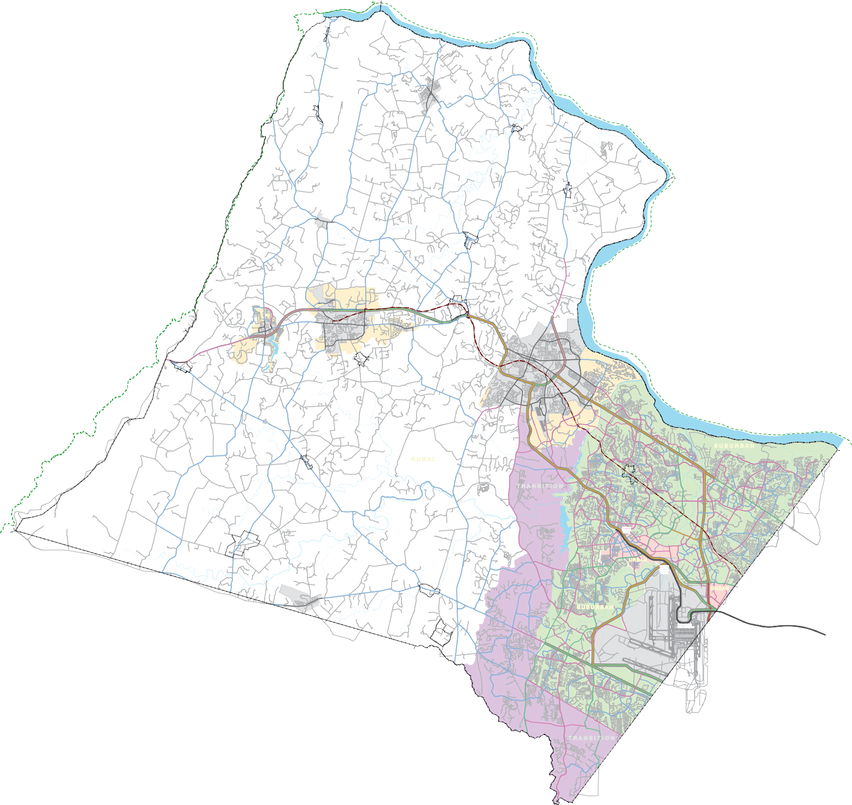

*##
*##

Loudoun Heights

D

*##

LOUDOUN 2040

*##

RD

*##
*## *##

COUNTYWIDE TRANSPORTATION BICYCLE AND PEDESTRIAN PLAN MAP

*##

*##

*##
Neersville

*##

*##

*##

*##
LOVETTSVILLE
*##

*##

*##

*##

*##

Taylorstown

*##

*##

*##

*##
LEGEND
ROADWAY ELEMENTS
Bicycle or Pedestrian Facilities Not Assigned
Motor vehicles and bicycles share the travel lane; pedestrian facilities provided as called for by geographic policy area
On-street striped bike lane; pedestrian facilities provided as called for by geographic policy areas
Trail on one side of the road and sidewalk on the other side of the road
Trails on both sides of the road (Urban/Suburban/Transition)
Trail on one side of the road (Rural) Washington & Old Dominion Trail Regional Trail
X Existing/Planned Interchange
YX# Existing/Planned Partial Interchange
") Existing/Planned Overpass
*## Scenic Byway
*## Proposed Scenic Byway
Metrorail Silver Line
"M Metrorail Station
Village Conservation Overlay District
Refer to Chapter 2 for Ultimate Roadway Geometry

DRAFT
*## *##

OCTOBER 23, 2018

*##

*##

*##

*##

*##

*##
*##

*## HILLSBORO *##
*## *##

*##
*##

*##

*##

*## *##

*## *##

#

*##

*##

Lucketts
*##

*##

*## *## *#
*## #

*##

*##
*##
*##

*##

*##

*##
*##

*##

*##

GAP

Waterford
*#

*##

*##

WOODGROV

J L M A

*##

*##

*## *##

*##

G
Y X ")
)"
X ") X
HAMILTON
#
Paeonian Springs *## *##
*##

E.
*##
X
#

ROUND X
HILL PURCELLVILLE
X ")
*## *#
*##
*## *# X
*## *##
*## X

*## Bluemont
JL M A
*##
Lincoln
*#
#

*##

*##

*##
*##

*##
X
")

") *##
*##

*##
LEESBURG

X
X J L M A
X

*## *#X

*## *##
*##

*##

#

HOPE P

*##
X ") X

*## *## X

*##

M
*## *##
*##

*## *##
X

LEESBURG

R
X

*## *##
*##
*##

C

XY#

EXECUTIVE AIRPORT

X

W

*##
*##

*##

*##
*## *##
N *## *## X

N

X
XY#
X

L

SU B U R B A N

*##

Philomont
*## *##

LO
*##
*##

*##
*##

*##
R U R A L

*##
*##

")

)"
V E MI
T R A N S I T I O N X

Old Ashburn

")

STI X

Y

T

S
X

E

*## *##

*##

*##
*##

*##
St. Louis

*##

*##

*##

*##

*##

*##

URN

X

L
)"

D ES

)"

Ashburn Metrorail Station
X

"M
")

J

MOO

URBAN

X
P X

GLOUCESTER

C

B

A

")

VD

A
XY# X

E

O

RID

*##

*##

##

*##

*##

*##
*##

*##

*##

*##

*##

*##

*##

*##

Aldie

*##

*##

#

*##
CHARITABLE
ST

RYAN

N

ST

OLYM DR

C

D
X
")

CEN

DR

E

X

YX#

"MX
Gateway X
Loudoun
Metrorail
Station
)"

X

X X

OX RD
URBAN

PACIFIC
X

N

DRAFT

*
MIDDLEBURG
*#
*##
SU B U R B A N E ")
#

FLEETWOOD RD
Innovation Center Metrorail Station
"M

CESS RD
X
μ

Aldie Mountain
*##
*##

*##

*##

*##
XY#YX
X

X X
X
WASHINGTON DULLES
X
INTERNATIONAL AIRPORT
)"

"M
Dulles Airport Metrorail Station

X US 50 ALTERNATE
X X
X
Location Map

Virginia
Roadway General Notes:
- Planned roadway alignments shown are conceptual and subject to further engineering. Alignments will be further refined as part of the planning process and through the land development application process.
- This map is part of the Countywide Transportation Plan, a component of the Comprehensive Plan, which includes more detail regarding roadway design and features.
- Refer to specific Town Plans for transportation plans within town limits. Roads within Town boundaries shown on this plan, except Routes 7 and 15, are for reference purposes only.
- Planned freeways along Routes 7, 28, and 50 will be considered for managed lanes through further study.
- While intersection and other localized improvements are not shown on this map, such improvements are considered to be part of the County's Comprehensive Plan.
- This is a planning document. Future County and VDOT improvements made based on this plan will meet all requirements for public input prior to construction.
- Road names for planned roadways are conceptual and some do not conform to the County Street Naming Ordinance. The final approved name must conform to the County Street Naming Ordinance.

Bicycle and Pedestrian General Notes:
- Accomodations for bicycles and pedestrians are anticipated on all roads shown on this map, as defined herein.
- Within the Rural Policy Area, sidewalks should be provided along both sides of all roads within Villages.
- Please refer to the street sections in the road design toolkit for further detail regarding facility design.
- AASHTO recommends that shared travel of bicycles and motor vehicles occur only on roads with speed limits of 35 MPH or lower.
")

O

EDGEWA

T R A N S I T I O N

Miles
0 1 2 3

Meters

0 2,000

1,000 3,000
4,000

