Chapter 6 - Fiscal Management & Public Infrastructure

Table of Contents
Chapter 6 - Fiscal Management & Public Infrastructure 2
Vision 2
Introduction 2
Public Facilities 3
Open Space Assets 6
Utilities & Infrastructure 7
Fiscal Management 9
Policies, Strategies, and Actions 12
Emergency Services Development Standards 15
Open Space (See also Chapter 3, Environmental, Natural, and Heritage Resources) 16
Sewer and Water (See also Chapter 2, Towns and JLMA) 19
Electrical 22
Communication 23
Fiscal Management 23
Reference Maps 28

Chapter 6 - Fiscal Management & Public Infrastructure

Vision
Provide high quality, efficient, and environmentally sensitive infrastructure systems supporting growth management goals and delivering innovative services to the community.

Introduction
Sustained growth since 2000 requires Loudoun County meet a significant demand for new public facilities, such as parks and recreation, fire and rescue, and schools. The County has maintained a reputation for quality facilities and services and exceptional fiscal management. Loudoun County’s success lies in establishing a close connection between land use and fiscal planning. Similarly, managing utilities, principally sewer and water, has had a direct influence in where new development occurs. Consistent policies and close collaboration with Loudoun Water has allowed the County to maintain an urban growth boundary and to subsequently focus other investments in roads and public facilities in eastern Loudoun. Loudoun Water’s strategy for a long-term water supply and its investment in high-quality water and sewer treatment has provided the County with a strong basis for growth decisions.

Loudoun County maintains a strong commitment to preserving open space and agricultural land and protecting natural and heritage resources. As such, the County established the Conservation Easement Stewardship Program to work with owners of property with conservation easements to ensure that the terms of the easements continue to be met. Over 72,000 acres of land throughout the County are protected through conservation easements.

Loudoun 2040 does not address the fiscal management and operational priorities of the companies and authorities that are independent of the County but operate key utilities serving County residents. Nonetheless, the cooperative relationship between the County Board of Supervisors (Board), Loudoun Water, the Virginia Department of Health (VDH), and others continues to ensure a close connection between infrastructure and land use planning.

Loudoun County’s innovative fiscal planning and budgeting strategy integrates land use planning, fiscal management, and facilities planning. The County’s fiscal program requires the Board to adopt a ten-year Capital Needs Assessment (CNA) every two years following a recommendation by the Planning Commission on consistency with the Comprehensive Plan, and adopt a six-year Capital Improvement Program (CIP) annually during the Board’s budget deliberations. The annual CIP funding plan and budget then align annual capital expenditures with County fiscal policy.

Since the 1990s, the County’s fiscal management strategy has evolved, enabling the County to anticipate and accommodate consistently high demand for services and facilities. This strategy helps ensure that Loudoun County retains a high quality of life and an economic balance that allows an affordable tax rate.

Public Facilities
The County’s fiscal management strategy is designed to anticipate and accommodate the impacts of increased demand for public services and facilities. As discussed in the Fiscal Management section of this chapter, careful development forecasting – including its location, type, and timing
- 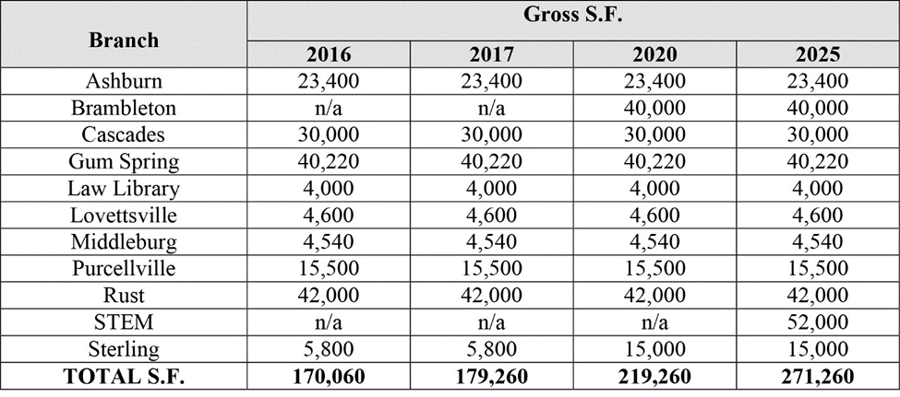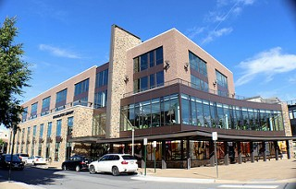is essential to anticipating facility needs. The County projects the capital needs associated with development proposals to determine expected impacts on public facilities and to calculate anticipated contributions to mitigate a project’s “fair share” of those impacts. Major components of the land use picture in Loudoun are public schools, parks and recreation, libraries, and emergency services. Each typically requires land in proximity of new development and are important elements of the community fabric.

Loudoun County Public Library (LCPL) is the information center of the community, providing free and equal access to innovative technologies and a full range of library resources to enhance the quality of life and meet the informational, educational, and cultural interests of the entire community. LCPL provides library materials, programs, technology, and services. It promotes the joy of reading and lifelong learning through early literacy programs, teen initiatives, humanities and arts events, technology training, and other educational opportunities.
Brambleton Library is a 40,000 square foot facility located in Brambleton Town Center. The state-of-the-art facility includes a “maker space” with 3D printer, laser cutters, recording studio, and other creative technologies.

LCPL currently has nine branches ranging in size from 4,000 square feet to 42,000 square
feet. The Ashburn, Cascades, Lovettsville, Middleburg, Purcellville, and Rust branches are standalone facilities, while Gum Spring, Law Library, Brambleton, and Sterling share structures with businesses or other Loudoun County facilities. LCPL Administration shares space in Leesburg with the Leesburg Senior Center.

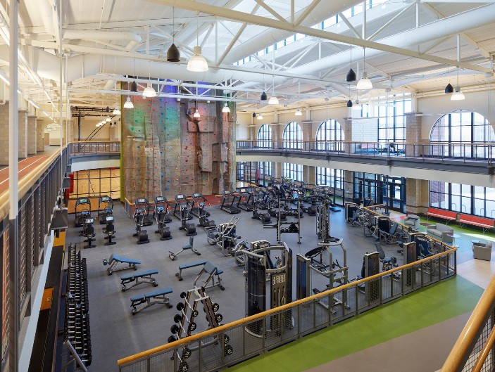LCPL continues to evolve to meet the needs and growing expectations of the community. The Library is expanding language learning services to non-native speakers. It also offers more Science, Technology, Engineering, and Math (STEM) programs, which are complemented by “maker spaces” that include 3D printers, robotics, recording studios, design software, computer labs, and other equipment for creating and learning. High-speed wireless internet access is essential to customers and is available at every facility. In addition, demand for conference and study rooms continues to rise; thus the need for large, multi-purpose rooms is an essential component for current and future branches. Also, as the number of residents without personal transportation increases, locations that offer ease of access through public transportation is critical.

LCPL recognizes the need to locate in high community activity areas and adapt to the County’s changing development patterns. For example, in recent years LCPL has opened facilities in commercial space in Brambleton’s town center and in Stone Ridge. Libraries have also located with or near senior centers, parks, and schools. Library programming is similarly evolving to accommodate community activities and educational programs that meet new needs of area residents.

The Department of Parks, Recreation, and Community Services (PRCS) operates a system of County-owned or maintained facilities that includes over 1,700 acres of open space, more than 60 miles of trails, 200 athletic fields, 27 parks (including three regional parks),
18 playgrounds, 10 community centers, six sports complexes, two indoor and two outdoor swimming pools, four historic/heritage sites, three adult day centers, three senior centers. PRCS also operates a senior activity center, a recreation center, a nature preserve, a nature center, a performing and visual arts center, an
Dulles South Recreation and Community Center features the latest fitness equipment, climbing wall, competition swimming pool, leisure pool with lazy river, vortex, 125-foot slide, hot tub, sports courts, and indoor jogging track. The Center also offers licensed preschool classes, full-day childcare, after- school programs, summer camps, trips, and other recreational opportunities.
industrial catering kitchen, and administrative offices.

PRCS and Loudoun County Public Schools cooperatively offer activities at County school sites. Programs and services encompass
childcare, preschool, after-school care, sports and recreation, community outreach, aging services, youth services, adaptive recreation, summer camp, health and fitness, planning and development, facility maintenance, customer service, and environmental stewardship. Offerings include sports activities for youth and adults, instructional and interpretive classes, programs for senior citizens, visual and performing arts, child care, preschool, after school activities, trips, camps, special events, volunteer opportunities, educational and prevention programs for youth, and programs for individuals with disabilities. In 2018, annual park visits for special events totaled 875,000. Over 55,000 children participated on sports teams and over 156,460 meals were served to senior residents.

PRCS faces significant challenges securing additional parks and trails to meet the service demands

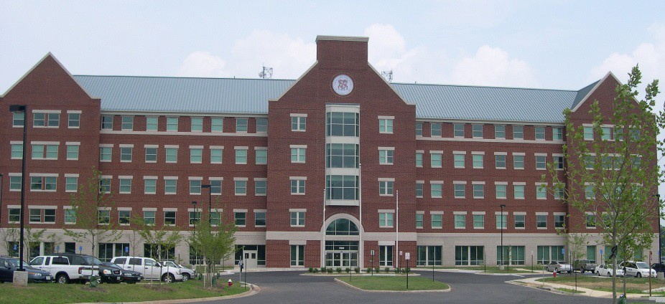of the County’s growing population. A lack of available land in eastern Loudoun, where the facilities are needed most, complicates the County’s ability to provide the desired facilities. A decreasing supply of land also means rising land values, which affects landowner’s contributions of land for parks facilities. Changing development patterns in eastern Loudoun, such as the urban development around the Metrorail stations and other high-density developments, will require new recreation concepts, and changing demographics will likewise demand new types of facilities. For example, the population of residents 55 years and older increased nearly 50 percent from 2010 to 2016, resulting in higher numbers of older adults seeking not only recreational programs but also other support services. PRCS offers community outreach events and increasingly serves as a conduit for a variety of services to the senior population.

Loudoun County Public Schools (LCPS) is the third largest school division in the Commonwealth of Virginia. Each year, approximately 2,500 new students enroll and one to three new school facilities are opened to accommodate them. In 2018, LCPS served more than 83,000 students in 92 facilities
including 15 high schools, 16 middle schools, 57 elementary schools, and four special
Loudoun County Public Schools employs 11,577 people, including 10,900 school- based staff and 710 non-school based and administration staff.
purpose schools (Academy of Engineering and Technology, Academy of Science, C.S. Monroe Technology Center, and Douglass School).

The LCPS student Class of 2017 had an on-time graduation rate of 95.5 percent and earned more than $54.7 million in scholarships. The Virginia Department of Education reports that 100 percent of LCPS schools were fully accredited in 2017. The student body is ethnically and economically diverse, with 52 percent of the population reporting as African American, Asian, Hispanic, or multi-racial. Approximately 19 percent of the student population is identified as economically disadvantaged. This cultural and economic diversity raises the need for a variety of academic and extracurricular programs to assist students, particularly in elementary schools, which have the highest percentage of economically challenged students.

Increasing demand for services is placing significant pressure on the school system, which each year must hire hundreds of additional classroom teachers and staff, expand support systems, and open multiple new schools. Families continue to endure shifting school boundaries as new students are assimilated into the school system. Securing building sites for new schools that are cost- effective but that also reflect their important social and civic functions in terms of location and design is an ongoing challenge. Changing development patterns in eastern Loudoun further complicate these issues. In the past, the County has relied on the donation and timely delivery of proffered school sites from the development sector. However, the supply of sites has not kept up with demand or with the LCPS construction timetable.

Urban development around the Metrorail stations and other high-density developments will require

innovative designs for new school facilities using less land and more vertical designs. Alternative school configurations that established urban communities have used successfully, such as shared space and public/private facilities, will become increasingly important.

As the population increases and continues to diversify, schools will likely continue to play a larger community role, such as accommodating a variety of non-school activities, sharing recreational facilities with the public, co-locating with compatible uses such as libraries, affordable housing and other services, and opening classrooms and space to other organizations.

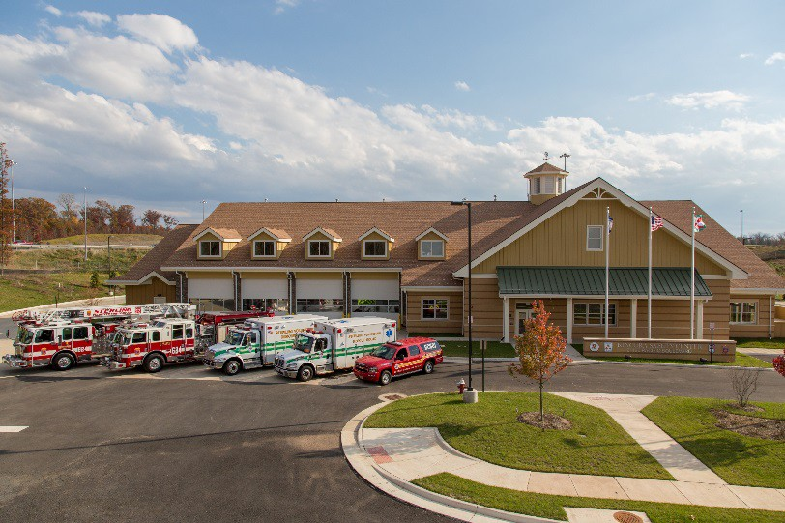Loudoun County Fire and Rescue (LCFR) delivers essential emergency and non‐emergency Fire and Emergency Medical Services (EMS) from 19 stations, responding to more than 29,000 incidents annually. The Department, as part of the Loudoun County Combined Fire and Rescue System (LC‐CFRS), provides administrative, operational, and logistical support to the County’s 15 volunteer fire-rescue companies, the LC‐CFRS Executive Committee, and its governance structure. Through the Oliver Robert Dubé Training Academy, LCFR coordinates the delivery of certification and continuing education programs for all System members.
The Loudoun County Combined Fire and Rescue System represents a joint effort of volunteer and career personnel responding to emergency incidents 24 hours a day.
LCFR functions as the Public Safety Answering Point (PSAP) for the County’s 9‐1‐1 system and operates the County’s emergency communications system. The Fire Marshal’s Office (FMO) has a multi‐faceted mission that includes fire prevention, fire lane plans review, life safety education, community risk reduction, investigation of fires, explosions, hazardous materials releases, and an oversight of the bomb squad.

LCFR has been in a consistent state of transition as the County has grown, moving from an all- volunteer system to a combined system, serving an increasingly suburban environment, and responding to growing service demands. As areas of the County transition to a more urban development pattern, the Department will continue to adapt to different demands and environments. Compact and higher density development and the introduction of Metrorail will affect emergency response times and equipment and training needs, and introduce other new challenges. In rural Loudoun, ongoing areas of attention will include updating existing stations and meeting service demands associated with growth in the rural economy.

Open Space Assets
Open space assets as defined in this chapter include linear parks, trails, recreational areas, and passive open space. These assets make up much of the County’s network of natural resources and may be held in private or public ownership. The County and individual property owners manage these elements through the regulation of protective buffers, donation of open space easements, Purchase of Development Rights (PDR), and performance standards.

The Board established the PDR Program in 2000 as a tool to protect Loudoun County’s open space and its cultural, natural, and agricultural resources. The PDR Program, which is voluntary in Virginia, is intended to financially compensate willing landowners for not developing their land; a landowner enters into an agreement to sell the development potential of qualifying property to the County while maintaining the right to continue to own and use the property. However, funding of the program was eliminated in 2004.

The open space assets addressed by this Chapter are aimed at maintaining, enhancing, and encouraging public interaction with the County’s network of natural resources through:

  - 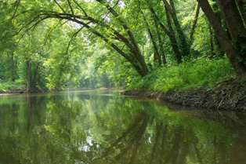A network of linear parks and other recreational resources along or extending from the banks of the Goose Creek, Broad Run, Bull Run, Catoctin Creek, Potomac River, and other river and stream corridors to form an interconnected system of linear open space.
  - Linear linkages within and among communities that offer potential for walking and bicycling, and connecting neighborhoods to parks, schools, and other community destinations.
1Elizabeth Mills Riverfront Park consists of over 100 acres of passive parkland with access to the Potomac River and Goose Creek.
  - Forested areas along public rights-of-
way, within neighborhoods, and elsewhere to filter air pollutants, provide shade, screen uses, and define communities and places.
  - A network of active and passive parks of various sizes and functions throughout each community to beautify neighborhoods and offer opportunities for recreation.

Utilities & Infrastructure
Sewer and Water (See also Chapter 2, Towns and JLMA)
On May 27, 1959, the Board took action to create the Loudoun County Sanitation Authority as a public body politic and corporate under the provisions of the Virginia Water and Waste Authorities Act. This body, now known as Loudoun Water, is chartered by the State Corporation Commission and is responsible for providing water and wastewater service to the unincorporated area of Loudoun County. As a political subdivision of the State, Loudoun Water is not a department of the County government and receives no tax money from the County. All Loudoun Water income is received from customers as payment for water and sewer service or as connection (tap) fees from land developers. Loudoun Water is governed by a Board of Directors consisting of nine members, each appointed by the County Board. Members of the Loudoun Water Board of Directors serve four-year terms and can be reappointed.

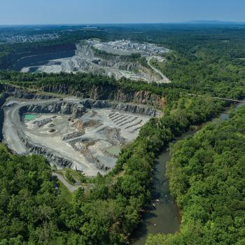Loudoun Water owns and operates water and wastewater treatment facilities and systems and has purchased capacity for wholesale water supply from Fairfax Water and wastewater treatment from DC Water. These water and wastewater systems serve the eastern region of Loudoun County. The Potomac River is the primary source of water for Loudoun County and the greater Washington, D.C. Metropolitan Area. Loudoun Water further benefits from using the Goose Creek, Beaverdam Creek Reservoir, and may use reservoirs created from retired rock quarries for storage in the future. With numerous water supply sources and local reservoirs, Loudoun Water has a resilient system to meet the demand for safe and healthy drinking water. To ensure the overall environmental quality of the water supply (watersheds and aquifers), Loudoun Water supports broad-based source water protection, management, and stewardship programs.
Loudoun Water’s plans to ensure an adequate supply of quality drinking water for a growing population include utilizing retired rock quarries to store up to 8 billion gallons of water.

In the western region of Loudoun County, Loudoun Water currently owns and/or operates over 40 smaller water and wastewater treatment systems. Community water and wastewater systems are freestanding systems usually serving residential developments that were installed by developers and are now operated by – and the responsibility of Loudoun Water. In the case of several small towns, water may be supplied to a rural village or hamlet by its own community wells and wastewater may be treated in a packaged treatment facility. These include systems the County has sponsored due to health hazard conditions, developer-initiated systems, and contract operations at systems throughout Loudoun.

Loudoun Water’s Capital Improvement Plan is a 10-year roadmap for creating, maintaining, and funding present and future infrastructure needs.1 The Loudoun Water CIP is approved by the Loudoun Water Board of Directors. Capital water and wastewater improvements are complex and interrelated and often require a great deal of planning over many years to define their extent, location, and cost. The underlying strategy of the CIP is to plan for facilities necessary for the safe and efficient delivery of water, wastewater, and reclaimed water services in accordance with policies, goals, and objectives adopted by Loudoun Water. A critical element of a balanced Capital Improvement Plan is to preserve and enhance existing facilities as well as provide new assets to respond to growth of the community and changing service needs as outlined in Loudoun 2040 and other Board policies.

Waste Management
The County operates the County Landfill and provides recycling opportunities for residents and businesses. Landfill operations are fee-supported. The County also offers recycling drop-off centers, household hazardous waste collection events, collection of seven materials for recycling or diversion at the landfill, and educational programs. The County anticipates continuing

1 The Loudoun Water Capital Improvement Plan can be accessed at www.loudounwater.org.

operations at the Evergreen Mills Road landfill site and relying on continued recycling and commercial facilities to redirect a significant amount of waste material. International demand for recycled material is, however, a key factor in the success of recycling success. Continued review and updating the County’s Solid Waste Management Plan will provide the more detailed management and planning necessary to meet State requirements to anticipate future needs.

Energy and Communication
Electrical and communication services are provided under the purview of State and Federal agencies. This limits the County’s ability to mitigate certain impacts. For example, the County regulates the location of electrical substations but not the transmission lines to and from the substations. Similarly, the County may review the location of cell towers and monopoles for impacts on surrounding properties, but cannot prescribe locations and therefore cannot require broadband or communication service in underserved areas. The County does, however, work with the providers to encourage improved service and locations.

Electrical demand in the County has grown dramatically in recent years with the development of data centers in eastern Loudoun. Demand is expected to continue to grow with new data center construction, the operation of the Silver Line Metrorail, and other land development. Changes in data center technology have resulted in electrical use increasing from 100 watts to 150 watts per square foot and in a few cases up to 300 watts per square foot. In 2018, 13.32 million square feet (msf) of data center has been constructed, 1.69 msf is under construction, and another 6.25 msf has or is expected to receive permits in 2018. Demand for data center development within the County is anticipated to be strong for the foreseeable future.

Rather than a centralized, regional substation to serve the County’s growing electrical demands, smaller substations have been constructed for individual providers. As demand for electrical power continues, consideration should be given to the appearance of substations and power lines and adequate screening of these facilities to reduce the visual impact upon the community.

Broadband internet service is an increasingly important asset to business in Loudoun as e- commerce grows throughout the nation. The lack of broadband service in western Loudoun is cited as a major constraint on the rural economy. It also puts western households and students in particular at a disadvantage. County efforts to extend broadband service have included regulatory changes to support new technologies. With limited control over market factors and federal regulation, the County will encourage landowners to put in place the conduits and other infrastructure to help minimize the cost of extending the service, and will explore other incentives to encourage network expansion.

Fiscal Management
Loudoun County uses an innovative integrated approach to land use and fiscal planning. This approach uses economic and demographic forecasting models, as well as service and facility standards, to help determine current and future capital facilities needs in the County. The Board established Loudoun County’s Fiscal Impact Committee (Committee) in 1992. This advisory committee reviews assumptions about future growth and capital facility needs. The Committee provides recommendations to the Board on four key documents that the County uses to coordinate land use and financial planning: 1) long-range forecasts and demographic, economic, and financial information included in the Fiscal Impact Committee Guidelines; 2) Capital Facility Standards

(CFS); 3) CNA; and 4) Capital Intensity Factors (CIF).

The capital facility planning and budgeting processes are distinctly different, but completely interrelated. CFS, CNA, and CIF are the three main aspects of the capital facility planning process that shape the CIP budget. The capital planning processes are integral in the development of:

    - Capital facility related cash, land, and in-kind proffer dedications to the County as a result of land use applications;
    - The development of the type, timing, and geographical placement of capital projects to be considered for funding in the CIP; and
    - The programmed use of proffers for capital facility development in the CIP.

Capital Needs Assessment
The CNA divides the County into ten planning subareas and uses the County’s forecasted population growth and adopted CFS to identify the type and quantity of facilities needed in each subarea. The CNA time period extends for ten years beyond the most recent CIP period. Using the population standards set by the CFS and factoring in facilities that already exist or are funded in the CIP, the CNA determines which facilities are needed to meet the adopted CFS standards. The CNA is generally updated every two years.

The population within each subarea drives the demand for facilities. In this way the County can identify more accurately where the demand is greatest and plan accordingly. The subareas define broad communities such as Leesburg and its environs or the three western towns along Route 7. However, the boundaries are based on Traffic Analysis Zones (similar to census tracts), which sometimes divide smaller communities. Furthermore, while the CNA is based on population, it does not account for the diversity of Loudoun’s population and the associated variations in facility needs and community desires. For these reasons, the Planning Commission, during their review of the FY 2020-2030 CNA, recommended the Board investigate a more community-driven planning approach that could address demographic differences, development constraints, and community expectations.

Capital Facilities Standards
The CFS determines the size and scope of facilities by establishing a maximum land use (in acreage) and construction footprint (in floor area). County Departments provide information on what standards to use for each of their facilities. The CFS also establishes a population threshold (“trigger”) for each type of facility. The 2020-2030 CAN estimates a need for approximately 2,100 acres of land throughout the County for additional facilities by 2030.

Example: The CFS determines a need for one fire station for every 25,000 persons in the Ashburn planning subarea. The current population forecast for Ashburn is 83,000 persons in 2017 and is projected to increase to 125,000 persons by 2023. As of 2017, the current need for fire stations is
3.32 (83,000 divided by 25,000). There are currently three fire stations existing in Ashburn and another one funded in the CIP (for a total of 4.0).The total need for fire stations will increase to
5.0 (125,000) by 2023, therefore, the CNA would identify one additional fire station by 2023.

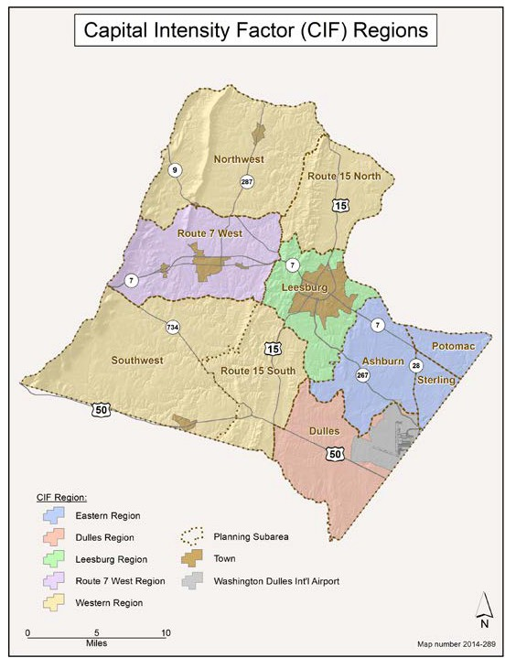Capital Intensity Factor
The CIF translates the anticipated capital cost and land requirements derived from the CFS into a per-housing-unit cost. The calculation determines costs per capita and costs per student, which then helps estimate the cost associated with different housing unit types based on average household sizes. The resulting cost per housing unit is valuable during development review to estimate impacts of individual applications and in proffer negotiations to determine a developer’s capital facility contributions.

1993 Choices and Changes General Plan standardized County’s the use of a CIF to estimate capital facilities proffers. The County, by policy, anticipated a landowner contribution of 25 percent of the anticipated capital impact of each residential unit over a base density of 1.6 units per acre. At that time, the CIF was a countywide number. With the adoption of the 2001 Revised General Plan,
County proffer policy called for
landowners to mitigate 100 percent of the capital impact for each unit above a base density established by current zoning or one unit per acre, whichever was lower. The County also developed a separate CIF for each policy subarea. The refinement acknowledged notable differences in land costs and other differences associated with constructing facilities in each subarea. The Board has also incorporated a separate CIF for age-restricted housing and additional housing types. Recognizing a pressing the need for certain transportation improvements, the County also allows landowners to redirect capital facilities money to transportation infrastructure in certain situations.

Capital Improvement Program
The six-year CIP refines the County’s CNA-forecasted future capital facility growth and provides a six-year program of the County’s general government and public schools’ land, facility, and equipment needs, with a financing plan to implement each need. The CIP schedules land acquisition, design, construction, and capital equipment procurement for each project. Potential projects are evaluated in relation to each other to ensure that the highest priority projects receive public funding, with essential improvements planned in a manner commensurate with the County's ability to pay.

The CIP is developed biennially, with the six-year period moving out an additional two years every other fiscal year. The CIP is a multi-year plan that does not constitute or require an appropriation

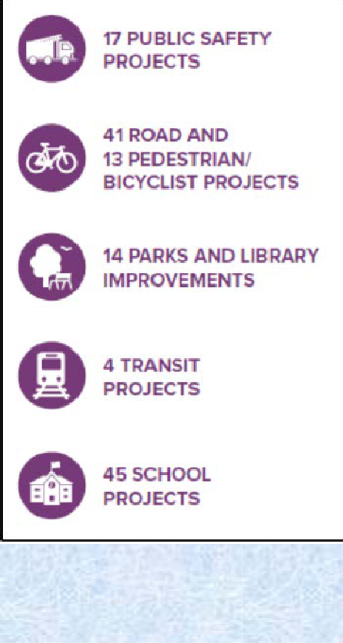of funds beyond those for the current fiscal year. Funding decisions concerning the CIP are made in conjunction with decisions regarding the County's operating budget. Most new facilities require an ongoing commitment in operating funds for new employees, heat, light, and other costs.

Going forward, the County will pursue additional refinements to the proffer guidelines to accommodate urban development concepts and more diverse housing into the CIF. In light of State legislation adopted in 2016 that limits the use of proffers, the County will also explore other mechanisms to diversify funding opportunities, including impact fees. Impact fees would apply equally to all residential units, whether permitted by rezonings or administrative approvals. Additional State enabling authority would be necessary to effectively use impact fee; existing legislation is limited in scope and imposes difficult implementation requirements, leading very few localities to take advantage of this tool.

As part of its strategic planning efforts on growth management, the County will consider expanding discussion of net impacts, including the capital needs and costs of individual projects on countywide infrastructure

The FY 2019 – 2014 Adopted Capital Improvement Program includes over $1.9 billion in County capital projects and almost
$500 million in School capital projects.

and the economic and revenue benefits of new development. As such, the County would evaluate
- the impact of a rezoning application on the local transportation network and public facilities, 2) what the application is or is not doing to mitigate the impact, and 3) what facilities exist and/or are funded to serve the subject property and surrounding area during the development review process. Additionally, the County is developing an analysis model to assist with evaluating the fiscal impact of future development.

Policies, Strategies, and Actions
Unless otherwise specified, the following policies, strategies, and actions apply Countywide. All of the Policies, Strategies, and Actions set forth in all of the following paragraphs of Chapter 6 shall apply and be applied by the County only subject to and in compliance with the limitations established by Virginia Code Section 15.2-2303.4 as applicable. In its consideration and acceptance of all proffers, the County will apply the standards of Virginia Code Sections 15.2- 2297, 15.2-2303, and 15.2-2303.4, as applicable, to evaluate the reasonableness of proffered conditions, and for those applications subject to Section 15.2-2303.4, the County shall accept only those proffers permitted or deemed reasonable under Virginia Code Section 15.2-2297 and not deemed unreasonable under Section 15.2-2303.4.

Fiscal Policy 1: Provide public facilities to meet identified needs.
Strategy
  - Use the CNA Program to plan and coordinate facility needs and location criteria to ensure

adequate dispersal and timely availability of County facilities.

Actions
    - Expedite the approval of public facilities by establishing performance standards that would eliminate the need for legislative review.
    - Support LCSB acquisition of needed sites through the fiscal planning and land development processes.
    - Co-locate public safety and other facilities whenever it will improve service efficiencies.
    - Design school-related open space and athletic fields and make them available for joint use by PRCS.
    - Evaluate Commission Permit applications for County facilities on the character and extent of the maximum development potential of the site in order to permit future expansion and co-location without requiring additional Commission approval under Code of Virginia Section 15.2-2232.

    - Combine public open space and parks with public and civic buildings, community centers, town centers, and other gathering places and include amenities such as seating areas, public art, playgrounds, gardens, etc.
    - Design public facilities to be a distinguishing feature of the community using sustainable materials, context-sensitive design, and architectural features.
    - Design new public facilities to be functional and efficient to persons with diverse abilities, to reflect the physical character of the surrounding community, and to maximize the broader social and cultural role the facility can play in the community.
    - Establish an expansion plan for the Fire and Rescue Training Academy based on a needs assessment of the existing campus as the needs of LCFR and the County increase. Ensure the requirements of Fire and Rescue training remain a priority during the development of surrounding areas.
Strategy
  - Support continued use of existing public facilities through ongoing capital asset replacement, renovation, and modernization, particularly where facilities play an important role in social and economic activity of the local community or are historically significant.

Action
    - Maintain and modernize existing County facilities to meet current resource demands and customer needs; for example, improve library space for collaborative, hands-on learning (maker spaces) with computer labs and large, multi-purpose rooms to meet the growing community demand for spaces to host community events.

Strategy
  - Strategically locate facilities where they can serve the community efficiently and effectively.

Actions
    - Locate new facilities on sites that can accommodate future expansions and allow co- location with other public safety agencies with similar activities or clients when possible. Use the expansion space around new facilities for parks, commuter parking, and other interim uses that are compatible with the new facility until expansion is required.
    - Investigate co-locating County facilities with complementary uses that would create a mutually beneficial relationship; for example, locate schools with affordable housing or libraries with parks.
    - Locate Fire and Rescue and Sheriff’s Office facilities in accordance with adopted response time goals and at the most strategic point in a proposed service area.
    - Locate libraries and other high traffic uses in highly visible, accessible locations with adequate automobile and pedestrian access; examples of such locations include mixed-use centers, towns, and villages.
    - Integrate housing, human services facilities, and other services for special needs populations in the Urban, Suburban, and Transition Policy Areas, Towns, and JLMAs to provide ease of access to associated commercial services, jobs, and amenities.
    - Link new facilities to adjacent neighborhoods by sidewalks, greenways, and trails.
    - Locate new public facilities in western Loudoun in close proximity to the Towns and JLMAs when suitable land is available and locations can meet response time and other service standards.
    - Continue to make the Town of Leesburg the principal location of County Government offices and the County seat.
    - Establish and maintain effective levels of public open space in all residential and mixed-use communities.
    - LCSB will determine the need for new public school sites and facilities in Loudoun County. The County will coordinate with LCSB to identify suitable sites based on the Loudoun 2040 Comprehensive Plan and its land use and growth policies in concert with LCSB’s standards and levels of service as adopted by the Board of Supervisors.
    - The County will acquire school sites in advance of LCSB’s recognized short and long- term future needs to minimize school transportation costs and to structure future planned growth.

Strategy
  - Encourage partnerships that contribute toward significant, meaningful, shared public facilities.

Actions
    - Support and encourage partnerships that develop sustainable housing for special needs populations, including the elderly, the mentally and physically handicapped, low income persons, and the homeless.
    - Support the acquisition of land and development of facilities such as the Potomac Heritage National Scenic Trail.
    - Work with the United States Department of the Interior, the Virginia Tech Conservation Management Institute, the Virginia Department of Historic Resources, NOVA Parks, and other local, regional, and state organizations and the incorporated Towns to define and recommend areas for open space preservation and development of a trail network that links the County’s natural, historic, and recreational resources.
    - Work with homeowners’ associations (HOA) and other property owner associations (POA) to encourage greater public access to association open space and facilities.
    - In subdivision plans for villages and clusters in the Rural Policy Area, include a plan outlining the proposed use of associated open space and suitability for rural economy uses.
    - Coordinate recreation-planning efforts with the Towns to prevent duplication of services.
    - Identify opportunities, such as public/private partnerships and co-location, to work with the private sector to provide public facilities.
    - Locate telecommunications facilities and equipment associated with public safety agencies in accordance with communication utility standards and the Comprehensive Plan.

Emergency Services Development Standards

Fiscal Policy 2: Enhance efficient and effective public safety and emergency services response through the implementation of appropriate development standards.

Strategy
  - Ensure adequate fire suppression for residential uses that are not served by an on-site water source and/or are located outside minimum response times of existing stations.
Actions
    - Create and maintain development regulations that require an adequate water supply, such as dry hydrants or tanks, for new residential subdivisions of more than five dwelling units when an alternative water source is not available on site.

    - Support adoption of State legislation enabling the County to adopt regulations requiring sprinklers for all new residential construction.
    - Encourage and offer incentives to voluntarily provide sprinklers in new residential construction.
    - Higher densities proposed in compact and mixed-use communities, and design concepts such as narrower streets, reduced yards and less space between buildings should be contingent on installation of sprinkler systems in all buildings.
    - As part of residential rezoning applications in areas that are subject to approved small area plans or approved Metrorail service districts, recommend that sprinklers be installed in all new residential construction that is located outside of the recommended emergency services response times established in agency services plans.
Strategy
  - Ensure adequate and efficient access for emergency vehicles.
Actions
    - Eliminate non-contiguous street names, duplicate street names, and sound-alike street names, and ensure that addresses reflect the access location.
    - Coordinate with Virginia Department of Transportation (VDOT) to ensure that all new traffic signals are equipped with signal preemption equipment to provide priority access to emergency vehicles responding to a call.
    - Establish a program that retrofits existing traffic signals, subject to VDOT approval, with signal preemption equipment to provide priority access to emergency vehicles responding to a call.
    - Require development applications to demonstrate adequate access for emergency apparatus.
    - Ensure that development regulations address the installation and maintenance of emergency apparatus access roads for fire and rescue resources.
    - Discourage the use of “emergency access only” gates and other roadway barriers.
Open Space (see also Chapter 3, Natural and Heritage Resources)

Fiscal Policy 3: Retain the County’s unique combination of urban, suburban, and rural communities by using open space to protect natural resources and habitat, to create a network of high-quality active and passive recreation spaces, and to delineate our built environments.
Strategy
  - Use contiguous linear parks, connected trails, and natural open space corridors to improve public access to open space, encourage healthy lifestyles, and link destinations throughout the County.

Actions
    - Build on and encourage links to current planned trails and park areas, placing greater emphasis on quality, connected, publicly usable, and accessible open space and identify desired locations and connections of future trails and parks to facilitate acquisition and development.
    - Establish programs and regulatory mechanisms to increase publicly accessible open space through easements, land dedications, and purchase; ensure that such programs and mechanisms are consistent with County facilities plans.
    - Incorporate open space amenities into the design of stormwater facilities and link such facilities by trails to create a network of water-based parks and greens.
    - Ensure that new developments extend publicly-accessible trails and linear parks into and through their projects with the intent of creating a network of public trails that is consistent with the County plans.

    - Language in HOA/POA bylaws should allow public access to some or all linear parks and trails, particularly those connecting to public facilities and to outside trails or parks.
    - Establish and maintain desirable levels of usable, public open space in all residential and mixed-use communities.
    - Increase the number of access points to key trail systems from adjacent neighborhoods and destinations.
    - Seek through public purchase, proffer, donation, or third-party open space easement, the preservation of natural areas and the development of linear parks, recreation space, and trails. Continue the Open Space Preservation Program, to the extent permitted by Virginia Code Section 15.2-2303.4, linking the loss of open space due to low-density residential land use and the demand for recreation and open spaces to the provision of open space easements or funds towards the purchase of open space easements that provide publicly accessible and usable open space as follows:
      - In the Suburban Policy Area, residential neighborhoods or land bays proposing densities less than the planned minimum number of dwelling units per acre should be associated with voluntary participation in the Open Space Preservation Program providing:
        - The equivalent of 50 percent public open space, consisting of on-site open space required by development regulations and additional on or off-site open space, or
        - A cash contribution, equivalent to the value of open space easements in the same policy area, towards the Open Space Preservation Program.
      - In the Urban Policy Area, residential neighborhoods or land bays proposing densities less than 12 or over 24 dwelling units per acre should be associated

with voluntary participation in the Open Space Preservation Program providing:
        - The equivalent of 50 percent open space consisting of on- site open space required by the Zoning Ordinance and additional on or off-site open space, or
        - A cash contribution, equivalent to the value of open space easements in the same policy area, towards the Open Space Preservation Program.
      - Link modifications reducing on-site open space, buffer, or landscaping requirements with the provision of an equivalent or greater amount of open space or an equivalent or greater cash contribution towards the Open Space Preservation Program.
      - Use open space easements or funding provided by projects in the Urban, Suburban, and Transition Policy Areas through the Open Space Preservation Program to extend existing public trails and provide active and passive parks unless otherwise directed by the Board.
    - Institute a program whereby the County facilitates acquisition of conservation easements by others by providing assistance such as a revolving loan program to reduce or defer the landowner cost of establishing conservation easements. The program should emphasize protecting the priority open space areas that are identified in this Plan that are not otherwise protected.
    - Encourage protection of the following priority open space areas through conservation easements acquired by the County or others, participation in the Open Space Preservation Program, development design, and other means:
      - Key green infrastructure features not already protected from development by conservation easements or regulation;
      - Rural areas immediately adjacent to the Towns, JLMAs, and Villages that help form greenbelts and gateway buffers;
      - Areas adjacent to the Potomac, Catoctin, Bull Run, Goose Creek, and Broad Run floodplains, to protect water quality;
      - Properties on the State or National Registers of Historic Places and within local historic districts;
      - Corridors and sites identified for trails and parks and additions to existing parks; and
      - Other areas of local natural, historic, or cultural significance including designated scenic rivers and roads.
    - Amend the development regulations as needed to permit a percentage of the open space required on an individual site to be met through off-site permanent open space that creates a more usable, desirable, or environmentally significant open space that is conveniently accessible to the same community.

Sewer and Water (see also Chapter 2, Towns and JLMA)

Fiscal Policy 4: The County will work with Loudoun Water, and the Health Department, to ensure timely provision of central, shared, or on-site sewer and water in accordance with the land use policies of this Plan.
Countywide Strategies Strategy
  - Implement strategies to resolve sewer and water issues in existing communities.
Action
    - Pursue funding sources to rehabilitate homes that currently lack adequate sewer and water systems.
Strategy
  - Define specific service areas for utility systems to protect the viability of County land use goals.
Actions
    - Establish the geographic limits of utility service and the capacity of the service, and ensure adequate environmental safeguards through the Commission Permit process prior to expanding existing service boundaries, or adding new boundaries in the case of the Rural Policy Area.
    - Prohibit connection to water distribution and wastewater collection systems that cross land outside a defined water or sewer service area. Establish permanent easements along such lines.
Strategy
  - Prohibit the use of any system(s) that do not ensure long-term safe, sustainable, and environmentally sound water supply and wastewater treatment.
Actions
    - Permit pump-and-haul operations only as a last resort and temporary wastewater disposal method to address a proven, public health emergency.
    - Ensure development proposals outside of those served by central system facilities can provide a safe, adequate, and long-term sustainable potable water supply and sewage treatment capacity in accordance with the land use policies of this Plan.
    - Encourage concentrating development away from water supply reservoirs and water supply sources.
    - Implement a pollution prevention and mitigation program to protect and improve the County’s surface water quality.

Urban, Suburban & Transition Policy Areas – Central Sewer and Water
Strategy
  - Loudoun Water will be responsible for the provision of central water and sewer service in the Urban, Suburban, and Transition Policy Areas.
Actions
    - Collaborate with Loudoun Water to ensure safe and adequate long-term water supply and wastewater treatment systems to meet County development goals.
    - Facilitate development and efficient operation of retired quarries as water supply reservoirs and protect reservoirs by establishing effective and sustainable watershed protection measures.
    - Collaborate with Loudoun Water and NOVA Parks so that water supply reservoirs can support safe, compatible public access and recreation.
    - Support use of Loudoun Water’s reclaimed water and/or gray water network.
    - Encourage clustering development away from water supply reservoirs and water supply sources.
    - Require new development in the Urban, Suburban, and Transition Policy Areas to connect to Loudoun Water’s central water supply and wastewater treatment systems.
    - Encourage existing residences and communities served by on-site or shared facilities to connect to central water or sewer facilities when such facilities become available.
    - Assist existing communities or residences to connect to a nearby public water or sewer system if on-site water supply or waste treatment capability has deteriorated to a point where there is a potential public health risk.
    - Construct new central wastewater and water lines and facilities in a manner that causes the least environmental risk and visual disruption. Identify and implement appropriate solutions such as upgrading or replacing failing systems, and where appropriate, installing shared systems.
    - Encourage existing communities or residences in the Urban, Suburban, and Transition Policy Areas to connect to a nearby central or municipal water or sewer system where there is a potential public health risk.
    - Examine ways to assist in extending sewer lines into existing communities or residences once development has brought trunk sewers to the edges of these communities.

Rural Policy Area – On site and Shared Systems
Strategy
  - Protect the rural character of western Loudoun by considering the ability of an area to support on-site or shared water and wastewater systems for any areas proposed for development.
Actions
    - Prohibit extension of central water and wastewater service into the Rural Policy Area, except as allowed herein to address a public health threat.
    - Institute a wellhead protection program to ensure adequate water quality.
    - Discourage the use of groundwater for nonagricultural irrigation and other nonessential purposes.
    - Recommend monitoring groundwater and surface water in the Limestone Overlay District and report any negative changes to the Board for appropriate action.
    - Maintain oversight of siting, design, installation, and maintenance of conventional, alternative, and alternative discharging on-site sewage disposal systems.
    - Implement an inspection and maintenance program for conventional on-site sewage disposal systems and provide homeowner educational materials on this and related well and septic safety for residents in the Rural Policy Area, particularly in the Limestone Overlay District.
Strategy
  - Collaborate with Loudoun Water and the Health Department to identify viable alternative wastewater treatment methods to septic and drainfield-based systems, including shared treatment plants and on-site treatment to support clustered residential development.
Actions
    - Implement wastewater treatment and disposal standards for alternative systems that protect water quality.
    - Allow shared water and wastewater systems in the Rural Policy Area:
      - To serve rural economy uses and residential clusters as defined in this Plan,
      - To solve potential public health risks, and
      - To serve public facilities.
    - Support construction of shared systems for existing rural communities facing a potential public health risk. In such cases, the shared system may be available to vacant lots within the existing community to support development that extends the viability of the community and is consistent with the scale, density, and character of the community.

    - Require Loudoun Water to own and operate all shared water and wastewater systems with more than 15 connections.
    - Require a Commission Permit, establishing a defined service area, prior to the construction of any shared water or wastewater system.

    - Support merging or connecting shared systems operated by Loudoun Water to address potential public health risks. A Commission Permit is not required where the merger or connection includes no change to previously approved service boundaries.
    - Permit the extension of municipal (town) sewer and water into the Rural Policy Area to serve public facilities or to address a potential public health risk.
Solid Waste Management

Fiscal Policy 5: Continue to implement an integrated solid waste management strategy that prioritizes reduction, reuse, and recycling of solid waste above resource recovery, incineration, and disposal into landfills.
Strategy
  - The County Solid Waste Management Plan will identify the type and level of service to be provided in the community.
Actions
    - Continue to ensure that the County always has an acceptable means of local waste disposal through the County landfill operations, should other waste disposal alternatives fail or become ineffective.
    - Continue to seek private sector support for the provision of current and future Solid Waste Management Services.
    - Develop a hazardous waste education program and increase residential access to the safe disposal of hazardous waste to protect groundwater resources.
    - Reduce landfill waste by promoting recycling and composting.

Electrical

Fiscal Policy 6: Support expanded electrical capacity through generation facilities that use clean burning and environmentally sound fuel sources and energy efficient design.
Strategy
  - Encourage local electrical generation in appropriate locations throughout the County.
Actions
    - Establish zoning standards that permit alternative electrical generation such as wind and solar generation by and for individual users.

    - Require the grouping and burying of utility lines and facilities to the extent permitted by law.
    - Work with electrical providers to locate new transmission lines and substations away from key travel corridors, sensitive cultural and historic resources, and residential communities or to place transmission lines underground when approaching such areas; and to minimize the number of substations by consolidating on existing sites, or locating regional facilities at key locations.
    - Encourage the use of stealth design techniques for electrical substations that are proposed adjacent to major travel corridors and residential communities.
    - Continue to monitor and minimize energy use in County facilities and create a program that would encourage benchmarking energy use in private buildings.

Communication

Fiscal Policy 7: The County supports the development of a high-quality wired and wireless telecommunications network to serve businesses, residents, and visitors.
Strategy
  - The County’s Strategic Land Use Plan for Telecommunication Facilities and other regulations and standards will be regularly updated to address emerging technologies, to create an environment attractive to businesses, and provide high-quality services to meet the demands of the County.
Actions
    - Review and update the County’s Strategic Land Use Plan for Telecommunication Facilities to facilitate the expansion of fiber and broadband service throughout the County.
    - Adopt zoning regulations and design standards requiring open access conduit to all development projects to facilitate future broadband extensions.
    - Establish performance standards for wireless communication facilities to minimize the need for legislative action.
    - Incorporate the capacity to locate broadband and wireless facilities into the design, approval, and construction of all public facilities.

Fiscal Management

Fiscal Policy 8: The County will link the goals of the Board of Supervisors’ adopted Fiscal Policy and the County’s Comprehensive Plan.
Strategy
  - Maintain a diversified and stable revenue structure by balancing residential and non- residential development.

Actions
    - Seek further revenue diversification to increase fiscal stability and thereby mitigate tax burdens on Loudoun County taxpayers.
    - Direct the majority of public investments into currently developed communities, Towns and non-residential areas of the County where development is planned according to the Comprehensive Plan and give priority to the redevelopment and enhancement of existing infrastructure, capital facilities, and services.
    - Where permitted, continue to seek private sector support for improvements or provision of current and future public facilities and sites, including proposals of cash and in-kind assistance for public facilities in addition to the timely provision of dedicated sites.
    - Seek authority from the state legislature to establish impact fees and a reasonable implementation process applicable in areas of the County where rezonings are not anticipated or where the provision of improvements and facilities through proffers associated with rezonings for new residential development is restricted by State legislation.
Strategy
  - Capital facility planning and budgeting will reflect anticipated needs based on forecasted development.
Actions
    - Update a series of financial and planning tools regularly to evaluate long-term land use, fiscal, and demographic issues under the oversight of the Board and its advisory committee, the Fiscal Impact Committee.
    - Develop long-range forecasts of residential and non-residential development, population, households, and employment.
    - Develop demographic, economic, and financial data that are used as inputs to demographic forecasts and for fiscal impact modeling.
    - Develop and regularly update the CIF – the dollar amount of the capital facilities impact measured by unit type or unit characteristics and geographic location that is calculated using County CFS and demographic inputs. The County uses the CIF to assess the capital facilities impacts of new residential development and provides a guideline for proffer negotiations during residential rezonings.
      - Calculate the CIF using the following formula:
CIF = (Household Size x County Facility Cost per Capita) + (Students per Household x School Facility Cost per Student)
    - Develop and refine CFS – the type, acreage, and size of future capital facilities, along with “triggers” based on population, population characteristics, or other community factors.
    - Develop and refine the CNA – the type and number of capital facilities needed over a ten-year planning period beginning at the end of the current six-year CIP.

    - Where permitted, ensure that the users or beneficiaries of a development will finance an equitable portion of public facility and infrastructure development costs that are directly attributable to a particular development project.
    - Evaluate, consistent with the Virginia Code Sec. 15.2-2283 and 15.2-2284, the adequacy of existing and planned public facilities and services when reviewing impacts of any legislative application for more intensive use or density. To fairly implement and apply this policy, the County will consider the following:
      - existing facilities;
      - facilities included in the CIP;
      - the ability of the County to finance facilities under debt ratios and limits established by its fiscal policies;
      - CFS and the effect of existing and approved development, and the proposed development, on those standards;
      - service levels of the existing transportation system – the effect of existing and approved development and the proposed development on those service levels and the effect of proposed roads which are funded for construction;
      - commitments to phase the proposed development to the availability of adequate services and facilities;
      - the availability of non-profit or HOA facilities to provide equivalent public access and programming; and
      - other mechanisms or analyses as the County may employ that measure the adequacy of such services and facilities for various areas or that measure the County’s ability to establish adequate services and facilities.
Strategy
  - Until such time as the General Assembly grants authority for other options, the County will consider landowner proposals of cash and in-kind assistance to mitigate capital facilities costs associated with new development, subject to the limitations established by Virginia Code 15.2-2303.4.
Actions
    - Consider proposals of the timely dedication of land, cash, and in-kind assistance from a landowner through proffered conditions submitted in accord with Virginia Code Sections 15.2-2303 and 15.2-2297, as applicable, in the provision of public facilities identified in the CIP or CNA.
      - The County expects that such proposals of public facility and utility assistance by developers will occur in conjunction with any rezoning request seeking approval of densities above the existing zoning.
    - Ensure that an equitable and a proportionate share of public capital facility and infrastructure development costs that are directly attributable to a particular development project are financed by the users or beneficiaries.

    - Apply all of the proffer policies and actions and guidelines set forth in this document only subject to and in compliance with the limitations established by Virginia Code Section 15.2-2303.4 as applicable. In its consideration and acceptance of all proffers, the County will apply the standards of Virginia Code Sections 15.2-2297, 15.2-2303, and 15.2-2303.4, as applicable, to evaluate the reasonableness of proffered conditions.
    - For those land development applications subject to Virginia Code Section 15.2- 2303.4, the County shall accept only those proffers permitted or deemed reasonable under Section 15.2-2297 and not deemed unreasonable under Section 15.2-2303.4.
    - Where and to the extent permitted by law, the County will structure residential proffer guidelines based upon the respective levels of public cost of capital facilities generated by the various types of dwelling units.
    - To assist the County in an equitable and uniform evaluation of developer proffers and other proposals, for proposed densities above the specified base density for each planning policy area, which otherwise conform with the policies of this Plan, the County anticipates developer assistance valued at 100 percent of capital facility costs associated with such increased densities.
    - Through the CNA, the County will consider differentiating between conventional suburban housing and other types of housing such as age-restricted, accessory, and micro units, and consider commitments to small unit sizes or affordability in estimating the capital facility needs and CIF.
    - Review the Capital Policy subarea boundaries to ensure, to the extent feasible, that they do not divide existing communities and consider service standards that provide flexibility to respond to demographics, land availability, and other characteristics of specific communities.
    - Consider developing capital standards for roads to incorporate into the CIF or providing credit against the anticipated capital facilities proffers for transportation proffers that exceed the anticipated transportation impact mitigation of the proposed development.
    - Establish the boundaries for Small Area Plans encompassing the Urban, Suburban, Transition and Leesburg JLMA policy areas, and the three Silver Line Metrorail Stations within the County. The planned land use within these Small Area Plan boundaries will reflect the land uses developed in the Loudoun 2040 Comprehensive Plan for each policy area until such time as the Board adopts more detailed plans.
Strategy
  - Use the following capital facilities proffer guidelines to evaluate proposed capital facility proffers subject to and in compliance with the limitations established by Virginia Code Section 15.2-2303.4 as applicable.
Actions
    - Use the following definition of “Capital Facility Proffer” to evaluate proffers: “A contribution consistent with County policies and service needs, in cash or in kind (land or improvement), that benefits County residents at large and is agreed to as a condition of a rezoning.”

To be considered a proffer based on this definition, the following criteria shall apply:
      - The proffered facility is dedicated to the County or to a local, state, federal, or regional authority or otherwise satisfies a need identified in the CFS, CNA, and/or CIP;
      - The measure of credit will be determined on a case-by-case basis and may not exceed what the County would expect to supply given the CFS and the population served at the date of official acceptance of the application or at the date of reactivation of an inactive application;
      - The contribution has a quantifiable value;
      - The value of land contributed for public use or use as a public facility site is recognized as a capital facility proffer;
      - Land for County facilities should be conveyed to the County or its designee;
      - The contribution would not be required under existing statutes or ordinances; and
      - The proffer is irrevocable.
    - Seek annual adjustments for proffers involving cash contributions based on the Consumer Price Index (CPI).
    - Base density thresholds beyond which capital facilities proffers will be anticipated are specified by planning policy areas as follows:
      - Rural Policy Area: The planned density for the Rural Policy Area is implemented by the existing zoning pattern and zoning amendments are not anticipated. However, for zoning map amendment applications within existing villages and other similar applications, include capital facility contributions for units above the density permitted by current zoning.
      - Transition Policy Area: Evaluate capital facilities proffers against the base density permitted by current zoning.
      - Suburban and Urban Policy Areas: Evaluate capital facilities proffers against the base density permitted by the current zoning or a base density of 1.0 dwelling unit per acre, whichever is lower.
      - Joint Land Management Areas: Evaluate capital facilities proffers against the base density permitted by the current zoning or a base density of 1.0 dwelling unit per acre, whichever is lower.
    - To evaluate proffers for public use sites, determine the per-acre value of unimproved land by a market appraisal of the site compared to properties with the same densities proposed by the applicant. The appraisal shall be conducted by an appraiser agreed to by the County, paid for by the developer, and the results provided to the County. For improved sites, consideration will be given as applicable to:
      - Site-preparation including clearing and grubbing, grading, erosion control, and related engineering and permitting costs.

      - Project infrastructure such as stormwater management ponds, sanitary sewer lines, and major off-site and on-site roadways serving the site.
      - A proportional share of improvements directly related to providing access to the site (pedestrian underpasses, construction of adjacent streets, trails, and sidewalks).

Reference Maps
Existing Facilities (Map #2018-147)
Small Area Plan Boundaries: 2018 (Map #2018-154) Trails and Parks (Map #2018-157)
Water/Sewer Service Areas: 2018 (Map #2018-158)

Loudoun County
Exis t ing Facilitie s
2040 General Plan

Animal Control Comm Facility Courts
Fire & Rescue
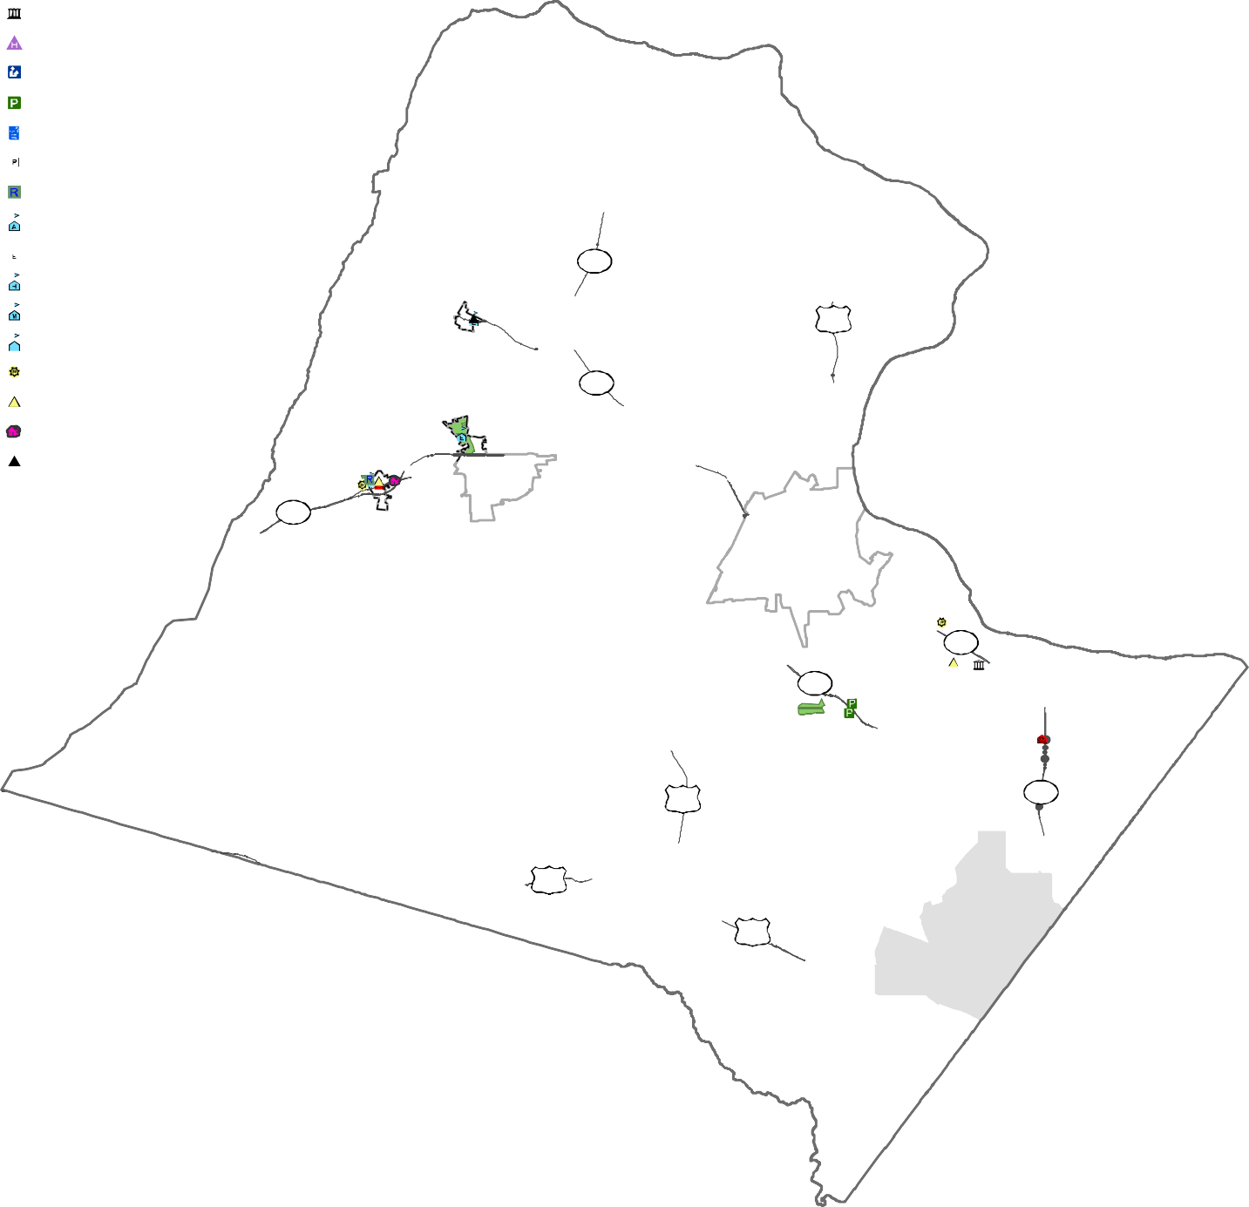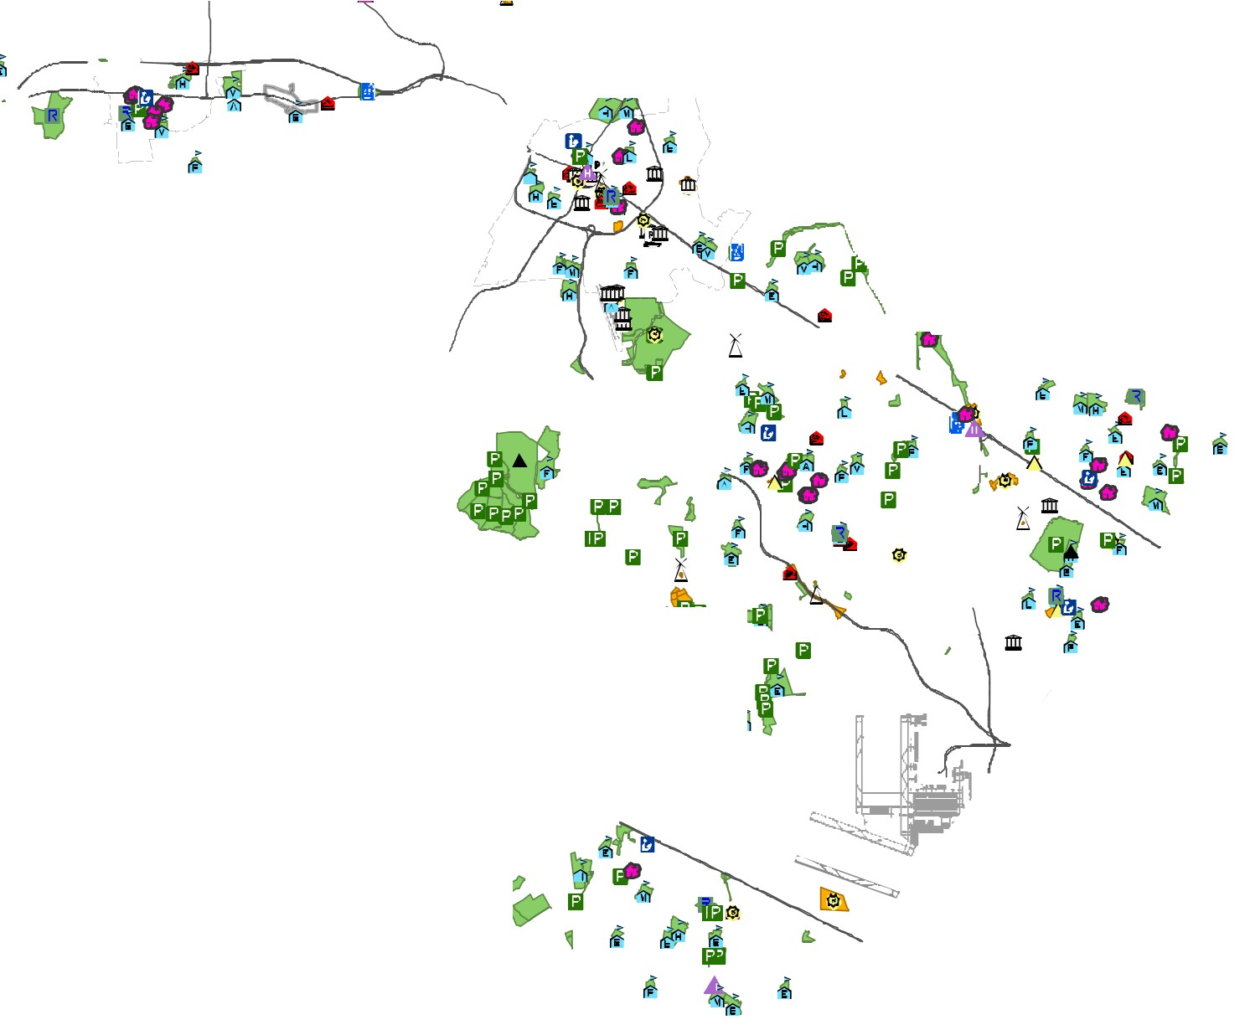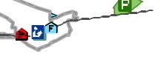General County Facility Historic Site
Library Park
Park & Ride
Parking Recreational
School: Administration
0 School: Elementary School: High School: Middle
School: Technology Center Sheriff
Sheriff CPO Social Service Waste Mgt
County Owned & Leased
County Work Site County Leased County Owned

- Round Hill

•

Hillsboro

287

9

ttsville

15
Love

- '
Purcellville
Leesburg

7

267

15 28

Middleburg
50

50
Washington Dulles
International Airport
&i
•

Loudoun County IS NOT LIABLE for any use
of or reliance upon this map or any information contained herein. While reasonable efforts have been made to obtain accurate data, the County makes no warranty, expressed or implied, as to its
accuracy, completeness, or fitness for use of any purpose.

0 1 2 4 6 8
Miles
Map Num be r 2 01 8- 1 47

D R A F T
CHAPTER 6-29

Loudoun County
Small Area P lan Boun daries : 2 018
2040 General Plan

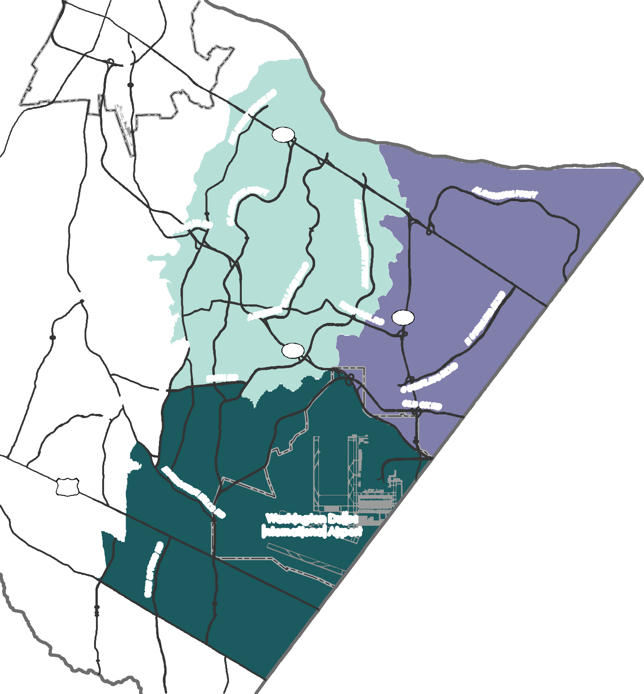Leesburg
I

7

28
NTY PKW

267
N RD

50

Washington Dulles International Airport

Small Area Plans
Ashburn Dulles
Potomac/Sterling

Loudoun County IS NOT LIABLE for any use
of or reliance upon this map or any information contained herein. While reasonable efforts have been made to obtain accurate data, the County makes no warranty, expressed or implied, as to its

0 0.5

1 2 3 4
Miles

D R A F T

Loudoun County
Wa ter / S ew er
Se rv ice Ar ea s: 20 18
2040 General Plan

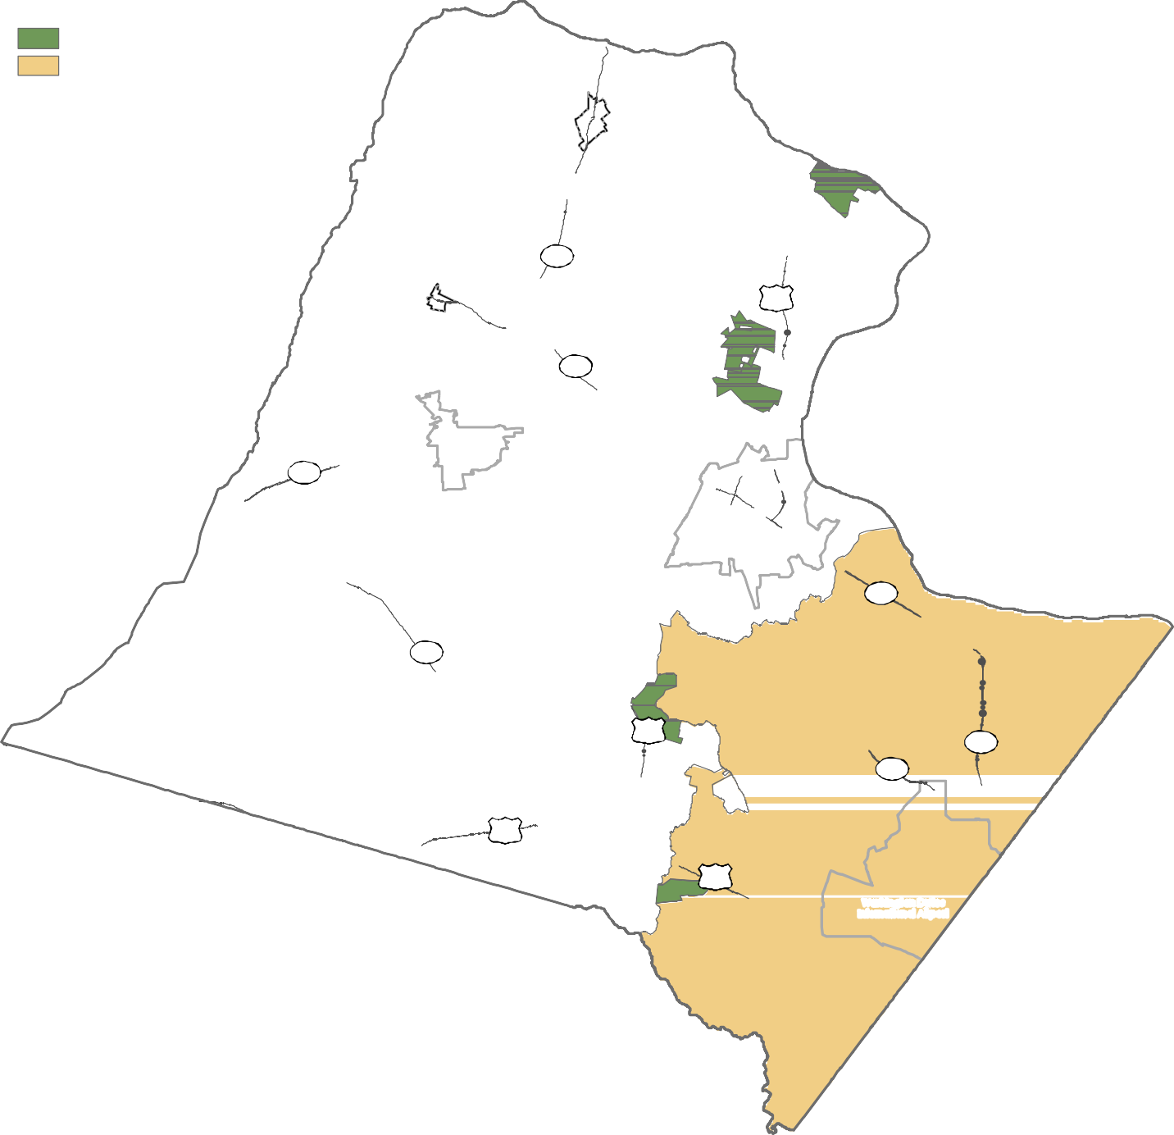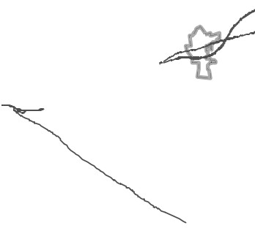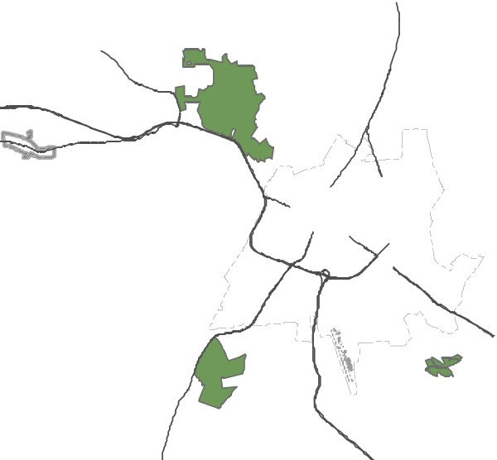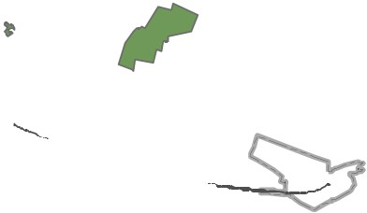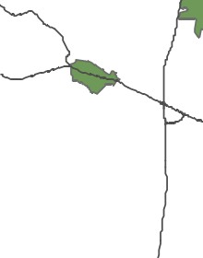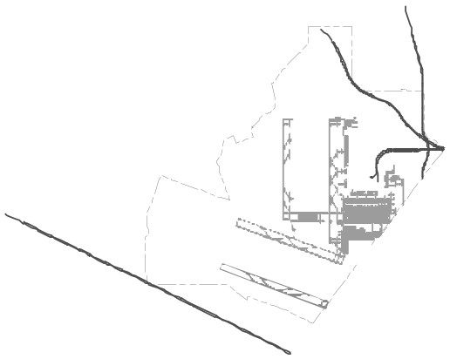Communal Or Shared System Loudoun Water Central System
Lovettsville

(

Hillsboro
287

15

' 1
9

amilton
Leesburg

H
Round Hill

7
Purcellville

7

734

15
28

50
Middleburg
267

Washin gton Dulles Internation al Airport

50

Loudoun County
Tra i ls a nd Pa rk s
2040 General Plan

, -.,,

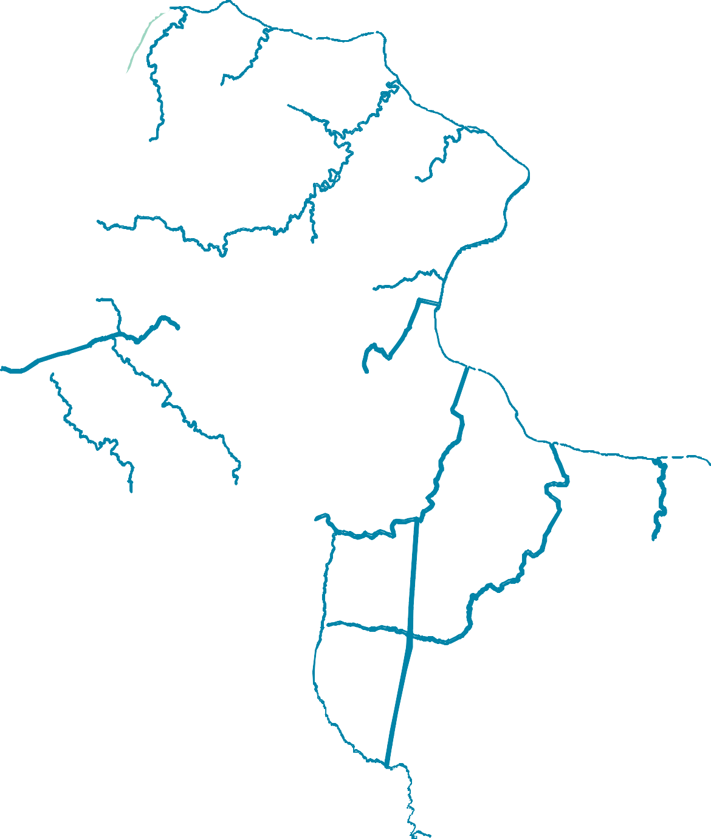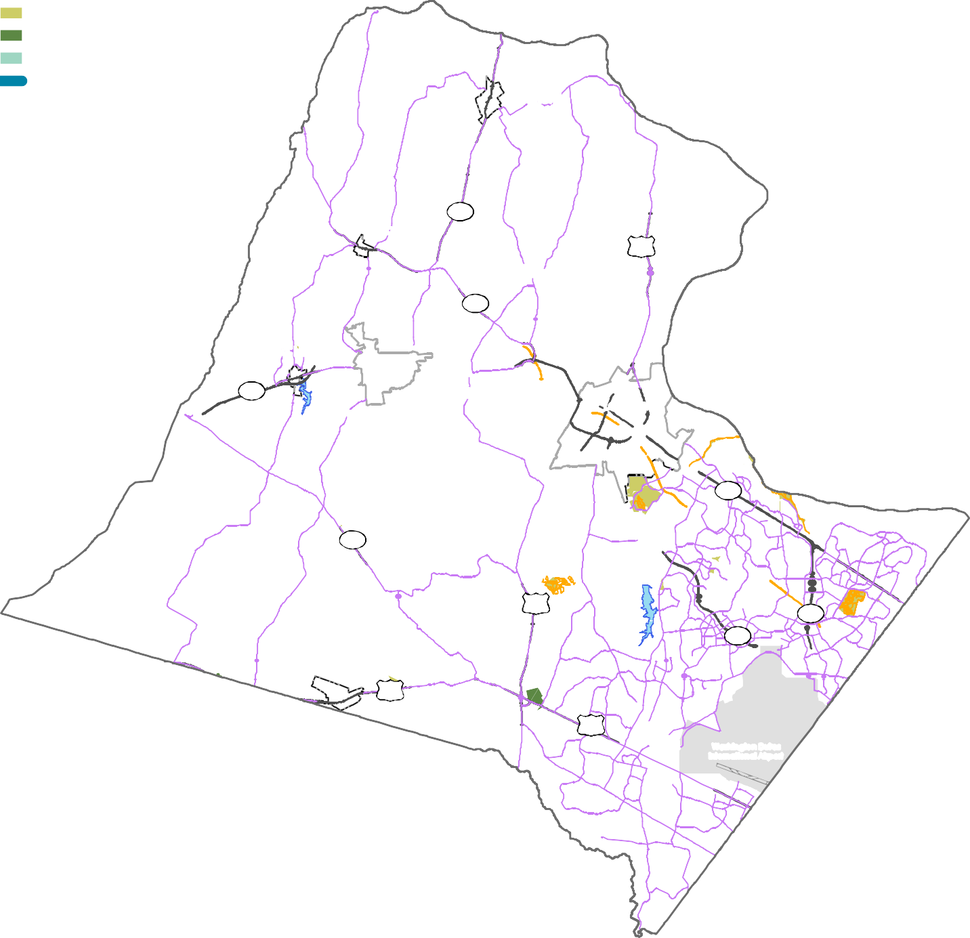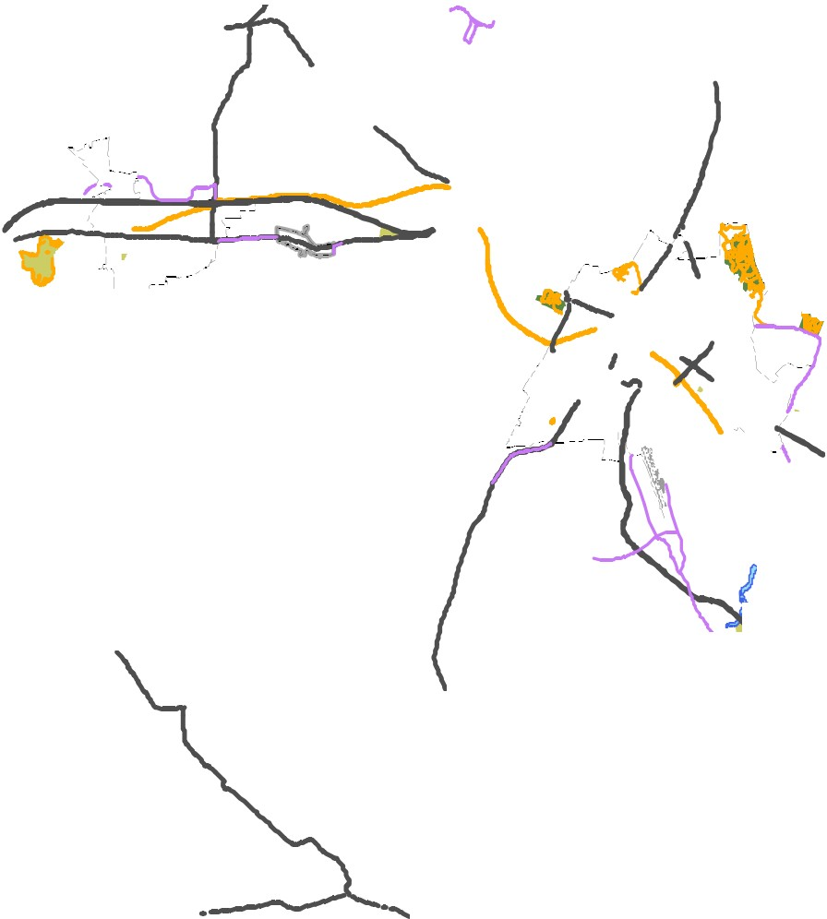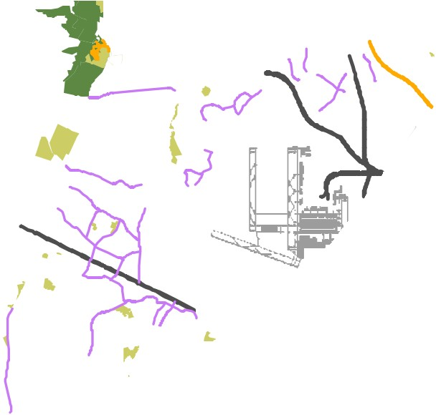Existing/Planned Bike Lane/Roadside Trail Existing Recreation Trail
Lake/Reservoir
County Owned/Leased NOVA Parks
State & Federal Parks Potential Trail Corridor

,Lovettsville

.J\
I

Hillsboro

(

287
' .
15 '
9

Hamilton
Leesburg
Purcellville

734

15

dleburg

50

IRound Hill

7

* ·7
,,., -
',
28
267

Wash in gto n Du lles Internation al Airp ort
'

Mid

50
I

