Chapter 5 -
Economic Development

Table of Contents
Vision 2
Introduction 2
Background 3
Targeted Cluster Strategy 4
Trends and Influences 5
Local Opportunities and Challenges 5
Workforce 6
Globalization 7
Digitization 7
Tourism 8
Demographics 8
Policies, Strategies, and Actions 9

Chapter 5 -
Economic Development

Vision
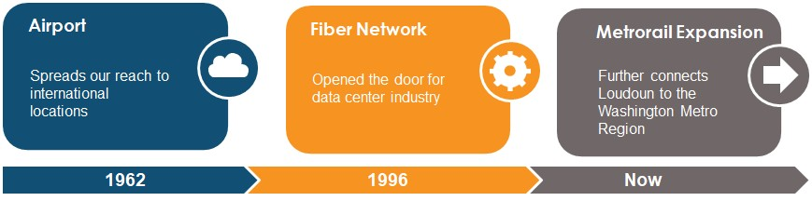A diverse and globally competitive Loudoun economy.

Introduction
Loudoun County has emerged as a leading hub of economic activity in the Washington, D.C. Metropolitan Area. Two major economic drivers have helped Loudoun’s economy grow exponentially – Washington Dulles International Airport and the world‐class digital fiber network
- and a third economic driver is on the horizon with the Silver Line Metrorail expansion to Ashburn.

Three Economic Growth Factors

Growth remains constant in technology sectors such as aerospace, cybersecurity, and data centers. The federal government continues to fuel employment for almost one-third of the County’s rapidly expanding population. Loudoun continues to have a strong agriculture-based business sector, in large part due to the growth of value-added agricultural products. Start-ups and corporations that span all of these burgeoning industries are thriving due to Loudoun’s location in the region, proximity to Washington Dulles International Airport, a highly-educated workforce, and a business-friendly government.
Loudoun’s sustained economic growth generates significant local tax revenue from businesses that supports quality schools, parks, public facilities, infrastructure, and low residential tax rates. These assets help create a high quality of life for the County’s residents, workers, and visitors. The list of accolades for Loudoun’s economy is long, however there are eight “number ones” that set the County apart from the rest of the region, nation, and the world:

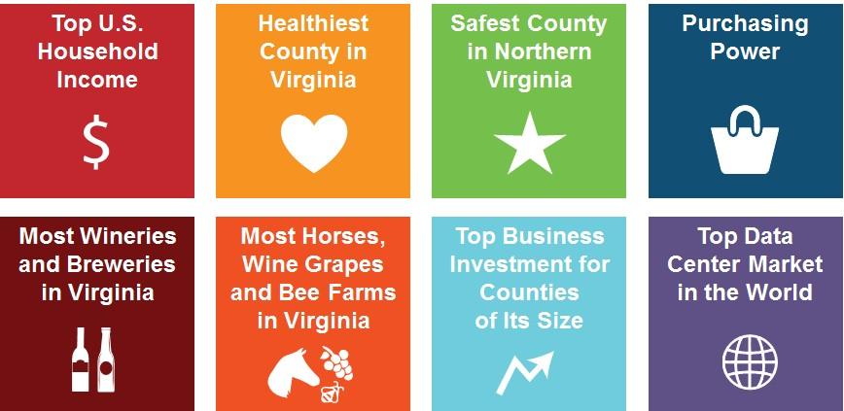Eight Ways Loudoun County, Virginia is No. 1

Sources: U.S. Census, WTOP, MWCOG, SmartAsset, USDA, Loudoun County
The median household income in Loudoun is more than double the state average, and ranks number one nationally for jurisdictions with a population of 65,000 or greater. Part of that can be attributed to having one of the most educated workforces in the country (almost 60 percent have at least a bachelor’s degree), as well as one of the lowest unemployment rates in the region.1
Loudoun also leads the U.S. in investment for counties of its size.2 Since the start of Fiscal Year 2014, Loudoun has announced more than 344 deals, representing approximately 13.5 billion dollars of commercial investment and 16,280 jobs created or retained.3
Much of this economic growth is fueled by the world’s largest and fastest-growing data center hub, which is a strong revenue source for the County’s General Fund; for every dollar in services Loudoun County provides for data centers, it receives back more than $9.50 in tax revenue. Major industry leaders such as Amazon, Verizon Business, Google, Facebook, and Salesforce rely on the connectivity in Loudoun County.
In addition to the tech infrastructure, Loudoun has expanding economic roots in agricultural business including almost 1,400 working farms. The quantity and quality of breweries, wineries, grapes, bees, and horses outpace all other jurisdictions in the state. This has helped Loudoun develop into a tourist destination, with an annual economic impact from domestic tourism of more than 1.7 billion dollars and approximately 17,000 tourism jobs.4

Background
In 2000, the Board of Supervisors adopted a guiding strategy for a sustainable economy in the County’s Revised General Plan. This fundamental economic development strategy identified five goals for the Loudoun community: 1) foster a prosperous and diverse business environment, 2) create a globally recognized economy, 3) maintain sound fiscal health, 4) develop an innovative

1 U.S. Census, 2012-2016 American Community Survey.
2 International Economic Development Council, 2017.
3 Loudoun County Department of Economic Development, 2018.
4 Virginia Tourism Corporation, 2018.

rural economy, and 5) become a world-class visitor’s destination. It also identified Loudoun’s primary competitive advantages:
  - Washington Dulles International Airport;
  - Location in the Washington, D.C. Metropolitan Area;
  - Qualified workforce skilled in advanced industries;
  - Quality of life;
  - Infrastructure that enables access to the region; and
  - Greenfield land zoned for commercial development.
The County refines its economic strategy regularly with assistance from specialized research consultants.5 Continually refreshing economic development Policies, Strategies, and Action items is essential since economic climate, county assets and constraints, and projected trends for the future are dynamic.

Targeted Cluster Strategy
Since 2008, the Board of Supervisors has focused economic development efforts on targeted clusters and overlays of businesses that have the largest employment sectors, demonstrated past growth, or have potential for future gains based on innovations and trends in the market. This economic development approach is based on industries that are more concentrated in Loudoun relative to the state/nation, and industries that are adding firms because of Loudoun’s strengths and opportunities. The County’s targeted clusters and sub-clusters are:
Cluster 1. Information & Communications Technology
    - Data Analytics and Technology Advancement
    - Cybersecurity
    - Data Centers
Cluster 2. Highly Specialized Manufacturing Cluster 3. Agricultural Businesses

Overlays that are targeted for business intensification include: (1) major projects, headquarters and associations; (2) small business and entrepreneurship; (3) international business attraction; (4) existing businesses (retention and expansion); and (5) Metrorail stations.
The Information and Communications Technology (IT) cluster continues to play a major role for Loudoun County in terms of employment, establishments, earnings, name recognition, and potential for future growth. The IT assets that Loudoun has cultivated over the last few decades including infrastructure (e.g. data centers), workforce, and general economic environment create a wealth of opportunities within the cluster for continued expansion.6
The Highly Specialized Manufacturing cluster includes industries and companies that are producing goods that are high-value and specialized in nature and, therefore, typically need to be

5 Camoin Associates, Atlas Integrated and ACDS are different economic consultants that have helped the County develop marketing, agricultural business, and cluster development strategies.
6 Camoin Associates, 2017.

made in small batches and shipped to their supply chain or final destination quickly. This cluster continues to be an emerging opportunity based on the County’s assets including Washington Dulles International Airport, existing manufacturing companies, a highly skilled labor force, and information technology strengths.7
The Agricultural Business cluster is made up of farms that provide value-add agricultural products8, traditional commodities, and agri-tourism. With direction and support of the Board of Supervisors, the County’s Rural Economic Development Council (Council) developed a blueprint for strategies that support the agricultural economy. Along with multiple stakeholders, and with the assistance of the County’s Department of Economic Development, the Council crafted the Rural Economy Business Development Strategy to guide marketing, research, and education; create financial tools to support agricultural entrepreneurs; provide resources; and inform public policy.
To strategically grow existing industry clusters or develop new ones, the County devotes resources (people and research) to becoming cluster experts that can anticipate the needs of businesses in a targeted cluster. This is achieved proactively through knowledge, relationships, and earned reputation. Cluster experts communicate the County’s competitive advantages for a targeted industry, connect prospective businesses to other businesses or resources in their cluster, and seek solutions to any barriers to entry. The objective is to attract new businesses to the cluster so that the global competitive advantage of Loudoun is strengthened in the targeted industry.

Trends and Influences
Non-residential forecasts identify that short‐term growth will be led by data center development. However, mid to long-term forecasts show data center construction slowing as land and resources become scarce. Diversifying the economic base, creating desirable places to attract new corporate headquarters, investing in the skill set of local workforce, marketing the County on a global scale, and promoting Loudoun as a tourism destination will help maintain a strong community for the next twenty years and beyond.
As part of the Loudoun 2040 General Plan process, the County reevaluated its economic advantages, challenges, and opportunities based on existing local market conditions. Additionally, macro trends were analyzed that will impact economic development in the areas of workforce, globalization, digitization, tourism, and demographics.

Local Opportunities and Challenges
The IT cluster, which includes data centers, remains a strong local competitive advantage. Northern Virginia has an exceptionally high concentration of tech talent, as measured by the number of civilian employed persons in computer and mathematical occupations—more than Seattle and comparable to that in the entire San Francisco/Silicon Valley area. Out of the cities and counties in Northern Virginia, Loudoun County has the highest concentration of people employed

7 Camoin Associates, 2017.
8 Value-add implies that an agricultural business is taking a raw product and adding value in the manufacturing process to create a different product (e.g. craft beverages).

in computer and mathematical occupations.9 Other economic development advantages include: 1) Washington Dulles International Airport and future Metrorail stations; 2) business-friendly local regulations and services; 3) highly-educated workforce and top-notch schools; 4) farms and agri- tourism; 5) affluent and culturally diverse residents; and 6) exceptional quality of life.
Despite the high concentration of tech workers in the region, talent attraction is still one of the biggest challenges that existing and potential Loudoun businesses face. The emerging workforce desires walkable urban places with a mix of amenities and housing types. A recent survey by the County’s Nighttime Economy Advisory Committee found that the younger workforce wants 1) special events; 2) arts, cultural, and entertainment districts; 3) attainable and desirable housing; 4) mixed-use and walkability; and 5) multimodal transportation alternatives.10 Lack of housing options and traffic congestion for commuting has also been cited by many business leaders as a challenge for employee recruitment.11

Workforce
As of 2017, the number of Americans on unemployment rolls has dropped to a 17-year low, which indicates the labor market nationwide is tightening and companies are facing challenges recruiting skilled workers.12 Some best management practices for economic development organizations to help address the expected talent shortage include: conducting a workforce sustainability study, collaborating with regional educational institutions, and developing industry-specific online portals for jobs.
The labor force participation rate in Loudoun is approximately 77 percent, which is higher than the national rate of 66 percent.13 Analysis of commuting pattern data illustrates just how interconnected the County’s employment and labor force is with the larger region − with the region relying on Loudoun and Loudoun relying on the region for workers and places of employment. Data shows that over 86,000 people come into Loudoun County each day from surrounding areas, over 121,000 Loudoun residents travel out of the County to their jobs, and over 51,000 live and work in Loudoun. The most common home or work location, besides Loudoun County, is Fairfax County.14 As of 2016, 50 percent of the County’s residents were working and living in Loudoun, which is a steady increase from approximately 41 percent in 2000.15
Self-employment in Loudoun accounts for approximately 7 percent of all employment; this is higher than within Maryland and Virginia (5.5 percent) and slightly higher than the rest of the nation (6 percent). Most of the self-employed individuals are government contractors and/or in the IT sector. Opportunities exist to encourage new start-ups and transition willing and interested

9 U.S. Census, 2012-2016 American Community Survey.
10 Loudoun County Nighttime Economy Advisory Committee, 2016.
11 Loudoun County Department of Economic Development, Business Community Interviews, 2017.
12 U.S. Bureau of Labor Statistics, 2016.
13 U.S. Census, 2012-2016 American Community Survey.
14 Camoin Associates, 2017.
15 U.S. Census, 2012-2016 American Community Survey.

companies from self-employment/sole-proprietorship to employing staff, which will support innovation, research and development, and job growth in the county.16
Loudoun County is home to seven institutions of higher education providing undergraduate, graduate, and continuing education opportunities. These include: George Washington Virginia Science & Technology Campus, George Mason Enterprise Center, Virginia Tech Equine Medical Center, Shenandoah University, Northern Virginia Community College, Strayer University, and Patrick Henry College. Local universities and colleges have partnered with local businesses and organizations to provide places for business ideas to incubate and grow, expand research and development opportunities, and provide targeted educational training opportunities. This continued collaboration strengthens the partnerships among government, business, universities, and public schools to ensure continued development of Loudoun’s highly skilled workforce.
As part of an international strategy, attracting immigrants to the workforce helps ensure a steady flow of skilled and unskilled workers. Loudoun County is well on its way to diversifying its local employment base, as one out of every four residents are foreign-born.17

Globalization
The County’s economic development strategies need to be prepared for the global economy. One in five American jobs are tied to international trade, and 95 percent of consumers – three-quarters of the world's purchasing power – is found outside United States borders.18 Locally, the percentage of Loudoun’s gross domestic product devoted to exports (9.9 percent) is top five for the Greater Washington area. Loudoun is also top five in Greater Washington for numbers of jobs in foreign establishments.19
Best practices for increasing foreign direct investment, attracting international companies, and recruiting international workforce are straight-forward: devote full-time staff to international trade missions and developing leads and recruiting abroad. Furthermore, globalization is no longer confined to the coastal cities, so the future domestic workforce (students) should be prepared early by emphasizing foreign studies and learning different languages.

Digitization
Digitization of the local government development process has become standard for larger local jurisdictions, which helps businesses start and expand easier and faster. Electronic plan submittals, business license portals, and online permit or entitlement tracking increase accountability and provide more certainty for the business community.
The continual shift to digital information, communication, and transactions results in steady demand for data storage infrastructure and IT workers. Loudoun is thriving in both business areas as 30 percent of the world’s physical data center buildings are in Loudoun County, and the

16 Ibid, 2017.
17 U.S. Census, 2012-2016 American Community Survey.
18 The Trade Partnership, 2015.
19 Brookings, 2014.

concentration of employees in IT as it relates to total County employment is stronger than the IT cluster in the states of Maryland and Virginia combined.

Tourism
Tourism and economic development are inextricably linked, as visitors to desirable destinations become repeat visitors, which can lead to relocation, entrance into the workforce, and potentially moving or starting a business. Loudoun County’s tourism industry is thriving and ranks third in overall visitor spending in the Commonwealth with $1.69 billion in 2016.20 Loudoun is uniquely situated in the Washington, D.C. region due to its agricultural economy in the western half of the County that also supports regional tourism. Northern Virginia generates the most agri-tourism revenue of all 10 state regions, contributing more than $552 million to Virginia’s $2.2 billion agri- tourism industry. Loudoun County farm businesses make up 51 percent of Northern Virginia’s agri-tourism venues.21
Best management practices for aligning economic and tourism development include using consistent “destination” branding across multiple lines of government, building recognition for year-round activities, and identifying the local community as a progressive tourism destination in marketing materials to business prospects.

Demographics
The generation still entering the workforce is the biggest cohort in United States history.22 The demographic shift brings changes in consumer spending, office amenities needed to attract workforce, housing preferences, and political ideologies. In general, the newest generation of workers are unique because of technological aptitude and reliance, propensity towards social tolerance, and high educational attainment.23

20U.S. Travel Association, 2016.
21 Virginia Tech, 2017.
22 Business Insider, 2015.
23 Pew Research, 2015.

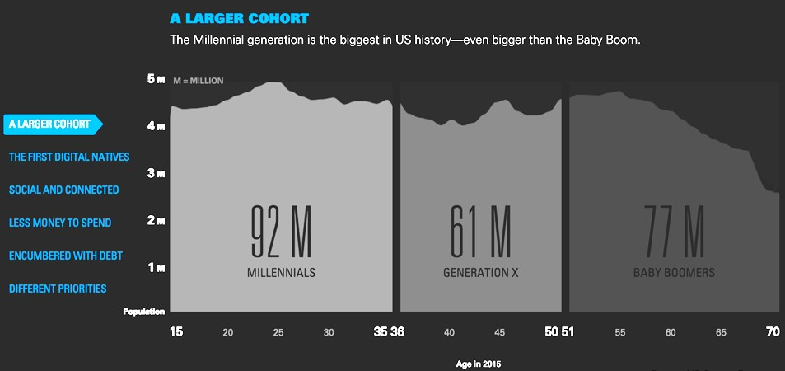Figure 3. Population Comparison of Recent Generations

Source: Business Insider, 2015

Most innovative companies looking to attract the next generation of workers are seeking “urban” places for their expansion or relocation efforts because they cluster offices, retail, entertainment, cultural attractions, services, and housing options in close proximity. The emerging workforce desires this amenity-rich environment and expects transportation options such as walking, biking, or transit for commuting or consuming daily goods and services. Transit-oriented on-Metro developments in Northern Virginia have seen remarkable growth, and Loudoun County is poised to capture this trend with the opening of the new Metrorail stations.
The key demographics of Loudoun County, including the growing population, lower median age, high education levels, and high income levels present opportunities to support a variety of well- paying knowledge and skills-based industries in addition to creating the demand for high-quality place and related amenities. Being able to attract and retain employees in Loudoun County will ensure companies will continue to choose Loudoun for their business.

Policies, Strategies, and Actions
The following Policies, Strategies, and Actions help achieve the County’s economic development mission and vision, as well as the overall economic development priority set by the Board of Supervisors to grow the commercial tax base.
Across all departments and within each economic development policy emphasis is placed on providing a stable and predictable business environment through customer-focused solution- oriented public service. Unless otherwise specified, the Policies, Strategies, and Actions apply Countywide.

Policy 1: Diversify the economy by strengthening targeted industry clusters.
Strategies
  - Attract new businesses in key industries so that the global competitive advantage of Loudoun is strengthened in the targeted industry clusters.
  - Work with existing businesses proactively and retain businesses that may be considering leaving Loudoun by helping with relocation or expansion efforts.
  - Catalyze start-ups and entrepreneurial growth by providing quality resources.
  - Continue to sustain economic growth at and around the Washington Dulles International Airport and the Leesburg Executive Airport, including support of land use restrictions in noise-sensitive areas located within 65 Ldn noise contours.
  - Expand international relationships and attract foreign businesses within targeted clusters.
Actions
    - Embed staffing resources in each cluster/overlay to attract or expand businesses using industry expertise, relationships, and earned reputation.
    - Use marketing and research to create promotional materials, conduct market analysis, assist with site selection, and provide ombudsman services.
    - Provide assistance with the regulatory process and streamline when possible using electronic plan submittals and online portals to get clients to market more quickly, provided all public safety, health, and welfare regulations are met.
    - Create mechanisms for the rural economy to maintain its status as a regional agricultural leader and local advantage.
    - Focus on providing resources, networking/education events, and other programs to startup companies that place a high value on growth, including assistance with establishing additional incubators, accelerators, co-working spaces, and makerspaces.
    - Reserve adequate amounts of developable commercially-zoned land for cluster growth.
    - Strategically use economic incentives as needed for attraction and retention.
    - Ensure new development does not create flight obstructions, or otherwise impede flight operations at Washington Dulles International Airport and Leesburg Executive Airport, notwithstanding building and height standards recommended elsewhere in Loudoun 2040.
    - Require developments that are subject to Federal Regulation 14 CFR Part 77 to provide the County with certification from the Federal Aviation Administration (FAA) that it will not constitute a hazard to air navigation. In addition, developments will comply with any recommendation(s) found in an FAA decision that results in a no hazard determination.

    - Require applicants to demonstrate that 14 CFR Part 77 notice is not necessary for their proposed development. Applicants may visit https://oeaaa.faa.gov/oeaaa/external/portal.jsp to view notice filing requirements or use the FAA’s Notice Criteria Tool to determine notice obligation.

Policy 2: Create desirable places in key corridors and employment centers.
Strategies
  - Ensure that the design and infrastructure of key economic corridors and employment centers creates desirable places for workers, businesses, residents, and visitors.
  - Support development projects near the Ashburn and Innovation Metrorail stations that provide a continuum of housing types, retail, entertainment, and employment options in a walkable environment.
  - Be flexible, customer-focused, timely, and open to interpretation in review and approval of commercial or mixed-use projects to keep pace with business innovations and reduce time to market.
  - Encourage multimodal infrastructure design, especially within biking distance of Metrorail stations and near other employment and major hotel centers, which minimizes impact to development potential of land.
  - Support a diversity of available commercial products when planning land use to improve attraction of a multifaceted business base.
  - Accommodate all types of critical infrastructure when planning for transportation; complete streets, power, water, and fiber.
Actions
    - Establish State-endorsed “Technology Zones” for the encouragement of new and expanding technology businesses that enable reduction of user and permit fees, local tax incentives, special zoning treatment, and exemption from local ordinances.24
    - Streamline the process for amending the Comprehensive Plan to allow for flexible and timely responses to evolving market conditions and technological innovation and to reduce project time to market.
    - Periodically update the County’s Zoning Ordinance to keep pace with innovation in the marketplace.
    - Extend support to the Towns to plan for enhancing the economic base.

24 Code of Virginia § 58.1-3850. Creation of local technology zones.

Policy 3: Invest in the skilled workforce needed for continued economic growth.
Strategies
  - Support continual growth of the workforce through recruitment assistance, training, and placement programs.
  - Proactively attract workforce, develop existing pipeline, and explore ways to increase access to qualified job applicants in targeted clusters.
  - Cultivate partnerships with schools, colleges, and businesses to link all levels of education (including K-12) to targeted industry needs.
  - Develop housing programs to create a continuum of housing types that are attainable and desirable to all levels of the workforce.
Actions
    - Collaborate with community and academic partners on connecting people to careers, expanding “learn by doing” programs, securing funding sources for training, and developing vocational training and industry certification and degree programs.
    - Actively engage local businesses to determine workforce challenges and needed skills.
    - Incentivize construction of attainable workforce housing using density bonuses, fee waivers, revolving loans, or assistance with required infrastructure.
    - Consider using the Economic Development Authority for property acquisition to bank land for public-private partnerships on workforce housing projects.

Policy 4: Market the County as a world-class business ecosystem.
Strategies
  - Market the County as a world-class place to do business using a variety of tools and communication platforms.
  - Promote gender and ethnic diversity of the local business community.
  - Market Washington Dulles International Airport as a destination portal to a diverse Loudoun economy.
Actions
    - Tailor messaging to decision makers and influencers who play a role in starting, expanding, or relocating businesses (e.g., owners, executives, site selectors, or brokers).
    - Post and respond on the County’s economic development website and social media channels in a timely fashion to maintain credibility.
    - Maintain economic development brands for custom professional-grade collateral.

Policy 5: Support the promotion and development of Loudoun County as a tourism destination.
Strategies
  - Collaborate with Visit Loudoun to support the development and enhancement of tourism and hospitality infrastructure, including hotels, bed and breakfasts, event facilities, and cultural attractions.
  - Encourage and support tourism destination development and marketing.
Actions
    - Establish State-endorsed “Tourism Zones” that enable the County to be eligible for gap financing from the State for tourism-related development projects. 25
    - Refresh online content and optimize for search engines regularly, translate into multiple languages, and focus design to reflect Loudoun’s unique personality and strengths.

25Code of Virginia § 58.1-3851. Creation of local tourism zones.

