Chapter 3 - Natural and Heritage Resources
Table of Contents
Chapter 3 - Natural and Heritage Resources 1
Vision 2
Introduction 2
Topics 3
Water Resources 3
Geologic and Soil Resources 5
Forest, Trees, and Vegetation 7
Historic and Archaeological Resources 8
Cultural Landscapes 9
Plant and Wildlife Habitats 10
Complementary Elements 11
Sustainability 12
Policies, Strategies, and Actions 14
Natural and Heritage Resources 14
River and Stream Corridor Resources 16
Soils and Geologic Resources 22
Forests, Trees, and Vegetation 24
Historic, Archaeologic, and Scenic Resources 25
Natural Heritage Resources 27
Complementary Elements 28
Sustainability 29
Reference Maps 32

Chapter 3 - Natural and Heritage Resources

Vision
Protect and enhance the County’s natural and heritage resources, which are fundamental to the health, safety, welfare, sustainability, and enjoyment of current and future generations.

Introduction
Abundant natural and heritage resources define Loudoun County’s unique sense of place. Loudoun County has a tradition of being in the forefront of natural and heritage resource protection in Virginia, which is evident in past planning efforts. The Loudoun County Choices and Changes Plan, adopted in 1991, grouped natural and heritage resources into categories that shared common elements, strengthening the relationships among them. The 2001 Revised General Plan retained the grouping of elements while also developing a Green Infrastructure strategy for the conservation, preservation, and restoration of these elements. The Revised General Plan also identified a Conservation Design method to allow for conservation of the Green Infrastructure elements while also providing for full development of the site. The Loudoun 2040 General Plan continues to build upon these ideas to better protect and enhance the County’s natural and heritage resources.
Natural and heritage resources include the Potomac River edge, major rivers, stream corridors, floodplains, wetlands, steep slopes, ridges and mountainsides, forested and vegetative landscapes, limestone geology areas, farmlands, soil resources, important plant and wildlife habitats, historic and archaeological sites, scenic areas and corridors, designated heritage areas, battlefields, historic cemeteries, and cultural landscapes. Complementary elements, such as air quality, aural environment, and the night sky are also important to the health, safety, and welfare of Loudoun residents. Natural and heritage resources are tangible assets that make the County an appealing place to live, work, play, and learn while contributing directly and indirectly to Loudoun’s economy. Preserving, protecting, and enhancing these resources is critical to the County’s long term economic, environmental, and social sustainability.
Protect and enhance natural and heritage resources through the following:
Conservation
Careful management of natural features within the built environment.
Preservation
Retaining and protecting natural and heritage resources.
Restoration/Recapture
Enhancing natural and heritage resources wherever possible.
Education
Communicating the importance of natural and heritage resources.

This chapter provides guidance for the protection of natural and heritage resources in conjunction with the development and redevelopment of the County. These resources are important County assets and should be a primary consideration in the development of a site. Although many of the County’s best preserved natural and heritage resources are located within the Rural Policy Area, important resources have been identified in all parts of the County and are, in many cases, critical to the character of individual communities both east and west (See Natural Resources Map). The County has a history of protecting and preserving these important resources through policies, regulatory measures, land acquisition, and educational programs. The protection of these resources will not only provide environmental and heritage benefits but will enable residents to experience the natural environment within the context of the built environment. The protection of these resources is interrelated, creating a network of natural and heritage resources. For instance, the protection and preservation of existing forest cover adjacent to a stream helps to filter pollutants from entering the stream and provide for streambank stabilization, while also improving air quality, conserving energy, creating wildlife corridors, and protecting archaeological resources.
Updating and adopting zoning regulations and development standards to implement the objectives of this chapter will be important for protecting the health, safety, and welfare of Loudoun residents as well as preserving natural and heritage resources for the enjoyment of future generations.

Topics

Water Resources
River and Stream Corridor Resources (RSCR) consist of rivers and streams that drain 100 acres or more, associated 100-year floodplains, adjacent steep slopes, and a 50-foot management buffer surrounding the floodplains and adjacent steep slopes (See River and Stream Corridor Resources Map). RSCRs constitute the County’s largest natural ecosystem, supporting air quality, water quality, and
Conservation Design techniques will protect and preserve river and stream segments draining less than 100 acres and wetlands that are not part of the RSCR.
biological diversity. In the event that the floodplain and adjacent steep slopes are less than 100 feet beyond either stream bank, a 100-foot minimum stream buffer will protect the river and stream corridor. The buffers help to maintain stream bank stabilization, temperature moderation, flood control, and aquatic habitat as well as filter nutrients and sediments from upland disturbances and adjacent development. Because rivers and streams and their associated floodplains are dynamic, the buffers help to ensure that development adjacent to the floodplain today will not be in the floodplain in the future. The 50-foot management buffer can be reduced if it can be shown that a reduction does not adversely impact the floodplain, adjacent steep slopes, wetlands, and riparian forests of the river and stream corridor.
The County has two State-designated Scenic Rivers: Goose Creek and the segment of Catoctin Creek that runs from Waterford to the Potomac River. These scenic rivers are an important part of the County’s river and stream corridor system. The County also seeks to preserve the Potomac River shoreline.

Major water resource issues for the County include ensuring an adequate supply of drinking water, protecting groundwater and surface water from contamination and pollution, stormwater management, and preventing the degradation of water quality in the watersheds.
Impaired Streams
Many stream segments across the County have been designated as “impaired” by the Virginia Department of Environmental Quality (DEQ). In 2009, the County conducted an assessment of streams within all the County’s watersheds. The County assessment indicated impairments
The County has completed several efforts regarding water resources since 2001:
- Water quality monitoring;
- 2009 County Stream Assessment;
- Strategic Watershed Management Solutions;
- Chesapeake Bay Watershed Implementation Plan;
- Comprehensive Watershed Management Plan;
- Upper Broad Run Watershed Management Pilot Project; and
- Countywide Floodplain Remapping of February 17, 2017.
in over 75 percent of County streams (see Impaired Streams Map). One tool used by the State to help restore these degraded waters is the Total Maximum Daily Load (TMDL) program, which is defined by Section 303(d) of the Clean Water Act (CWA). The TMDL represents the amount of a pollutant that a waterway can assimilate and still maintain its health. The TMDL identifies the responsible pollutant and the suspected cause and source of the pollutant. Based on the results of the TMDL, DEQ may require the County to develop and implement a TMDL Action Plan to reduce pollutants. If required, actions may
include stormwater pollutant reduction and mitigation
projects, such as stormwater infrastructure retrofits, reforestation, stream restoration, and/or riparian plantings. Additionally, Loudoun County is located within the Chesapeake Bay Watershed and is currently subject to the Chesapeake Bay TMDL and the Chesapeake Bay
Watershed Implementation Plan (WIP), which requires state jurisdictions within the watershed, including Virginia, to meet sediment, phosphorus, and nitrogen reduction goals by 2025.
Due to the length of the TMDL process and the number of impairments in the County, it may take decades before certain water quality restoration efforts achieve positive results. Additionally, given the anticipated rate of development within the County, many areas will likely have entitlements prior to the development of the local TMDL Action Plans. Therefore, a proactive approach towards water quality efforts will help to avoid costly and time-consuming processes to restore water quality to the required standards after development is completed. Actions and cooperation by all sectors including County Government, land developers, and property owners are needed to effectively control and meet required pollution standards to protect water resources.
Watershed Management Planning (See Watersheds Map)
The 2008 Comprehensive Watershed Management Plan (CWMP), provided a preliminary classification of the County’s 161 subwatersheds into categories of “improve,” “mitigate and maintain,” and “preserve.” The CWMP recommends approximately 90 specific watershed

management activities, some of which the County has already implemented.
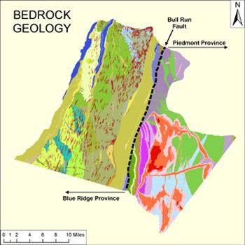The CWMP recommended a watershed management plan pilot project as the next step to achieving Loudoun County’s goal of effective management of the County’s water resources. The watershed management planning process is intended to address the many mandates that the County must meet in each individual watershed. These include the requirements of the National Pollutant Discharge Elimination System (NPDES), Municipal Separate Storm Sewer System (MS4) permit, watershed-specific TMDLs, and the Chesapeake Bay TMDL. The County developed the Upper Broad Run Watershed Management Pilot Project (UBRWMPP) in 2013-2014. The UBRWMPP assessed the current conditions within the watershed, developed watershed management practices that could be implemented to make progress toward TMDL or other pollutant removal goals for the Upper Broad Run watershed, and projected future conditions with and without the implementation of suggested watershed management measures. Lessons learned from the pilot project can be applied to the remaining County watersheds.
Surface and Groundwater Resources
Groundwater supply is the primary drinking water source for residents of the western Towns and rural areas. Loudoun Water provides drinking water from Goose Creek Reservoir and Fairfax County. The Town of Leesburg uses surface water from the Potomac River. The western Towns provide water from wells, and Purcellville augments this with surface water from the J. T. Hirst Reservoir. As of 2018, there are over 15,000 private groundwater wells, mostly in western Loudoun. In developed areas an increase in impervious land cover contributes to diminishing groundwater capacity and stream degradation, as rainwater that was once filtered through the soil to replenish groundwater and remove pollutants is now kept above ground artificially, due to the lack of natural infiltration recharging the groundwater, and carried directly to local streams or via
culverts and stormwater pipes directly to local streams.

Geologic and Soil Resources
The eastern half of Loudoun County is located in the Piedmont physiographic province, and the western half is in the Blue Ridge physiographic province. The Bull Run fault, coextensive with the eastern edge of the Catoctin Mountain, forms the boundary line between the two provinces. Soils and geologic information are important considerations in land development, predicting potential impacts on erosion, water quality and quantity, and failing slopes, as well as insight into mitigating post-development problems.
Physiographic provinces are determined based on geology and landforms.

Limestone
An area of approximately 18,000 acres (approximately 5.5% of the County) that lies predominately north of Leesburg and east of Catoctin Mountain is characterized as karst terrain (See Limestone Overlay District Map). Karst terrain refers to areas where mildly acidic water has gradually

dissolved the underlying limestone and other carbonate rocks, creating a landscape characterized by underground cavities, sinkholes, and springs. These areas are susceptible to increased cavity collapse, ground slippage, groundwater pollution, and threats to the stability of foundations and structures. In 2010, the Board of Supervisors (Board) adopted amendments to the Zoning Ordinance that established the Limestone Overlay District (LOD), which regulates development in karst areas.
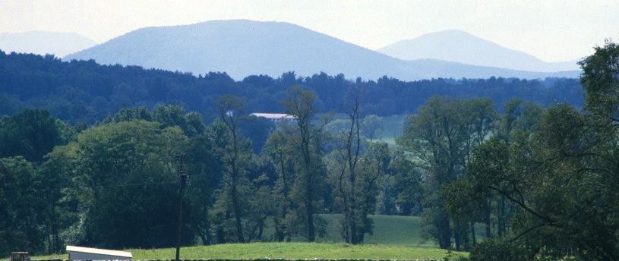Prime Agricultural Soils
Prime agricultural soils are soils that are best suited for conventional agricultural use. Nineteen percent of the County consists of prime farmland as defined by the U.S. Department of Agriculture. These soils are usually found in areas that are nearly level to gently sloping, well drained, and with access to water sources. Loudoun’s remaining best agricultural soils are generally located in the Rural Policy Area. Prime agricultural soils in Loudoun are often seen as desirable for residential development. Once this land-based resource is lost, however, it cannot be reclaimed. Because the County has emphasized the rural economy as an important part of its overall economic health, prime farmland and agricultural soils are especially valuable. Since the establishment of the Loudoun County Agricultural and Forestal District (AFD) Program in 1979, over 43,000 acres are enrolled within 23 Agricultural and Forestal Districts (AFDs)1 throughout the County.
Mountainside and Steep Slopes
Loudoun’s mountains are a valued environmental resource and distinctive feature of the County’s scenic beauty. Mountainsides contain headwaters to many of the County’s streams and are identified as a critical groundwater recharge area for western Loudoun County.
Residents, visitors, and rural

businesses value the scenic vistas that the hills and mountains provide.
Loudoun’s mountains are a significant attraction for residents and visitors and contribute to the County’s distinctive beauty.

They are also highly sensitive to land disturbance and development. In addition to the destruction of prime viewsheds, uncontrolled land disturbance within these areas can cause major soil slippage, debris flows, or landslides. Disturbances that can initiate these land surface failures include removal of trees and vegetation; cutting, filling, or blasting of the soil and bedrock; and altering the soil moisture content by excessive groundwater withdrawal or changing surface water runoff. The Zoning Ordinance regulates these areas through the Mountainside Development Overlay District (MDOD). The MDOD contains land use restrictions and performance standards to minimize the destruction of individual resources and the disturbance of the ecological balance

1 As of September 25, 2017

of these resources. The boundaries of the MDOD are based on a range of both technical and aesthetic factors. Mountainside areas are divided into three areas depending on the elevation and the types of resources present as determined by weighted analytical criteria (Somewhat Sensitive, Sensitive, and Highly Sensitive). Policies in this Plan also encourage mountainside areas to be placed under permanent open space easement. Updates to the MDOD are included as an action step to bring the Zoning Ordinance and the Plan guidance into alignment.
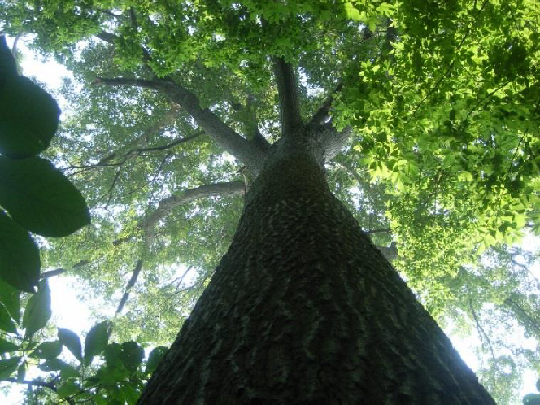Recognizing the importance of protecting steep slopes beyond the mountainous areas of the County, in 1993 the Board adopted an amendment to the Zoning Ordinance establishing standards for development on steep slopes. Since the adoption of the Steep Slope standards, several revisions have occurred, resulting in greater flexibility in the standards. Steep slopes and moderately steep slopes occupy an area of approximately 53,000 acres (approximately 16 percent of the County). Moderately steep slopes are areas with a 15 percent to 25 percent grade (identified by Slope Class D on Loudoun County soil maps). Steep slopes refer to more environmentally critical slopes with a grade greater than 25 percent (identified by Slope Class E on Loudoun County soil maps). Improper use and disturbance can trigger increased erosion, building failure, road failure, downstream flooding, and other hazards.

This specimen Shumard oak at Algonkian Regional Park is one of the largest trees in Loudoun County, measuring 112 feet tall and 176 inches around.
Forest, Trees, and Vegetation Loudoun County has some of the state’s best hardwood stands for lumber and veneer production. Working forests in rural areas contain valuable stands of hardwood timber, while trees and forest resources in the more urban portions of the County help to make them attractive places to live, work, and visit. The County’s forests and trees also improve air and water quality, offer important habitat for birds, small mammals, and other wildlife, and provide buffers between communities. Forests and trees conserve energy by providing shade and evaporative cooling through transpiration. They also reduce wind speed and redirect

airflow, reduce stormwater runoff and soil erosion, and can increase real property values. Riparian
forests along streams provide the greatest single protection of water quality by filtering pollutants from stormwater runoff, decreasing stream bank erosion, and maintaining the physical, chemical, and biological condition of the stream environment.
The County supports the incorporation of existing tree cover into required buffers as well as the control and removal of invasive species. The use of existing vegetation to meet screening and landscape buffer requirements is preferred over the removal and planting of new vegetation. Action steps call for the submittal of a Tree Cover Inventory as part of development applications to evaluate existing tree cover and identify areas worthy of preservation. Forest resources are also

protected through AFDs, easements, and other voluntary means, as well as through the implementation of the MDOD, LOD, and Steep Slope standards in the Zoning Ordinance.

Historic and Archaeological Resources
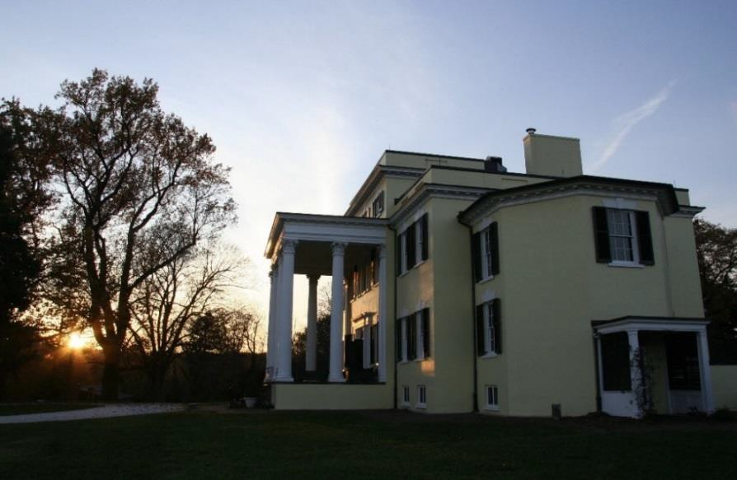The cultural heritage of the County is reflected in its remaining rural landscapes, scenic road networks, historic structures, and archaeological sites. Identification, preservation, conservation, and sensitive reuse of these resources is critical for the retention of the County’s distinctive character. Where these resources have not yet been identified or studied, public and private resource surveys are increasingly important to inventorying and preserving them. Most of these elements will remain in private ownership and can be preserved through private stewardship, protective buffers, donation of open space easements, County historic district zoning standards, and context-sensitive site design. A number of incentive-based programs can also be used, including State and federal tax credit programs.
Since 1972, Loudoun County has helped protect its unique historic assets through the designation of local historic districts. There are six County-administered Historic and Cultural Conservation Districts (Aldie, Bluemont, Goose Creek, Oatlands, Taylorstown, and Waterford) and two County- administered Historic Site Districts (Welbourne and the Broad Run Toll House properties). The County has also designated a
Historic Roadways District, the Beaverdam Historic Roadways District, which comprises a network of 32 rural roads (See Historic Districts Map). In addition, the incorporated Towns of Leesburg, Middleburg, and Purcellville administer local historic districts through their zoning ordinances. There are also five National Historic Landmarks

in the County, including Balls Bluff Battlefield, Dodona Manor, Oatlands Plantation, Oak Hill, and Waterford. Resource surveys have
Oatlands Plantation, a historic estate dating from the late 18th century, is one of 88 County sites listed on the National Register of Historic Places.

identified nearly 7,000 individual historic structures and archaeological sites in the County to date. The County has 88 sites listed in the National Register of Historic Places. The County last conducted a comprehensive architectural resource survey in 2004; however, an analysis of the number of heritage resources that may have been impacted or lost in the interim has not been conducted. The County’s inventory of heritage resources is constantly expanding as property owners, developers, and preservation organizations document and record new resources.

Most of the County-initiated comprehensive survey work was completed in the early 2000s, such as the Post-Civil War Structure Survey (2003) and an African-American Historic Architectural Resources Survey (2004). The County also conducted surveys in 2016 for the
Ball’s Bluff Battlefield Expansion Project and a Rural Schools Survey. The County and State database of surveyed resources is largely augmented through the Phase 1 archaeological and historic resources surveys that are required with

Archaeological Investigations at Lansdowne.

legislative and preliminary subdivision applications, as well as private property owners requesting listing in the National Register of Historic Places.
The Board adopted the Heritage Preservation Plan (HPP) in 2003 and a subsequent amendment to the HPP in 2009. The Board created the Heritage Commission (HC) in 2011 to implement many of the recommendations in the HPP. The HC brings a range of public and private sector experience and expertise to heritage issues. Since the adoption of the HPP in 2003, the County has recognized the need to focus attention on heritage resources associated with historically marginalized communities in the County. Because African American communities and Native American communities are not well represented in the historic written record, the County recognizes the importance of archaeological resources, oral histories, historic settlements, cemeteries, burial grounds, and places of worship to understand, preserve, and interpret the lives and contributions of these Loudoun residents (See African American Historic Communities Map). Development applications will be evaluated using both the HPP and this Plan.

Cultural Landscapes
Cultural landscapes include heritage areas and corridors, scenic byways and waterways, battlefields, and historic cemeteries. There are several roadways within the County that are designated as Virginia Byways. Goose Creek and a portion of Catoctin Creek are designated as State Scenic Rivers. In 2002 the County established the Beaverdam Creek Historic Roadways District to protect a cultural

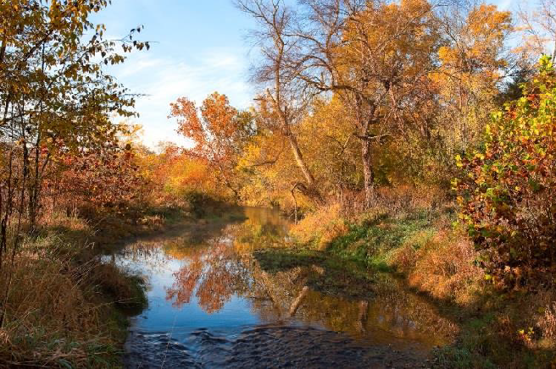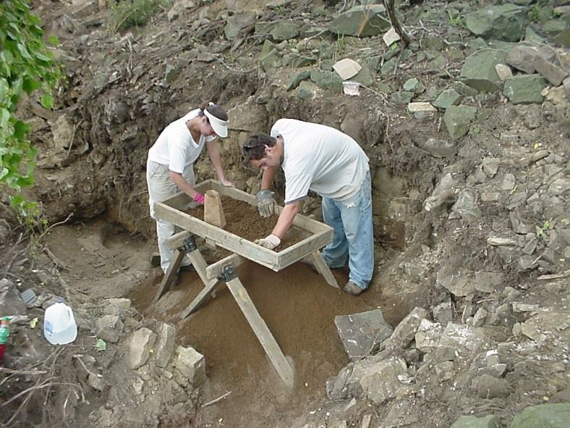landscape that has changed little since Loudoun County’s formation in 1757.
Catoctin Creek
Photo Credit: James Hanna

Loudoun County’s scenic network of more than 200 miles of unpaved roads is the most extensive in the state.
A nationally recognized heritage area, The Journey Through Hallowed Ground, as well as a state-designated heritage area, the Mosby Heritage Area, fall within the boundaries of Loudoun County. The Journey Through Hallowed Ground follows Route 15/29 from Gettysburg in Pennsylvania (a designated National Byway), through Loudoun County, to Monticello near Charlottesville, Virginia. In 2008, the Board passed a resolution in support of the Heritage Area, and the County is a partner with The Journey Through Hallowed Ground project. The Mosby

Heritage Area, formed in 1995, represents the cultural landscape and landmarks of three centuries of our nation’s history. The Mosby Heritage Area encompasses parts of five counties, including all of Loudoun County.

Plant and Wildlife Habitats
Plants and animals play an important role in nature’s lifecycle and its ecosystems. For wildlife habitats, large contiguous parcels of natural open space are preferable to more numerous but disconnected and smaller areas. The creation of a larger network helps ensure the viability of the habitat.
While many high-quality plant and animal habitats have already been lost or altered due to land development, the County still has a number of unique and natural habitat areas. The largest contiguous areas of forest and naturally vegetated land are on mountainsides, steep slopes, and along stream channels. These areas play a key role in preserving the abundance and diversity of the County’s remaining plant and wildlife resources. The integrated

approach to preserving natural and heritage resources is intended to help
Heron rookery adjacent to the Broad Run near Ashburn.

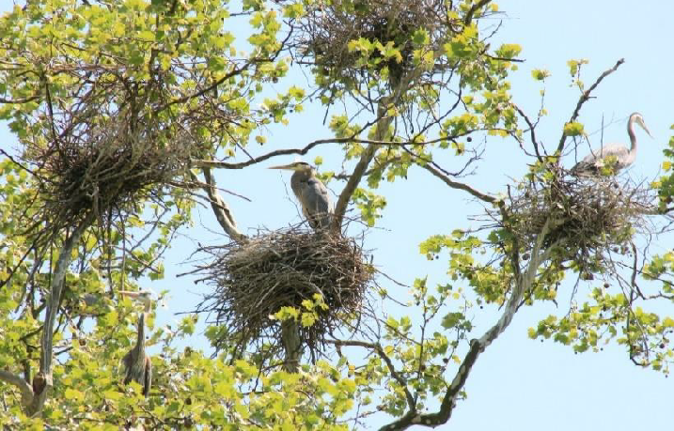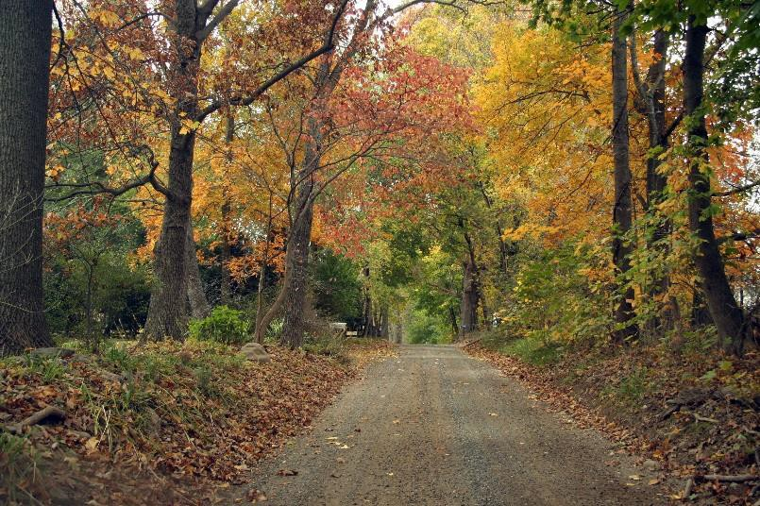prevent habitat fragmentation, while enhancing ecological connections with larger areas.
The County strives to protect, preserve, and create large-scale plant and wildlife habitats that overlap with other important resources and resource systems. The County will also protect rare, threatened, and endangered plant and animal species habitats in accordance with the Federal

Endangered Species Act. Action steps call for legislative development applications that have the likelihood of one or more natural heritage resources to conduct a species assessment and develop a plan for impact avoidance in cases where the presence of the species is identified.
Natural heritage resources include rare, threatened, and endangered plant and animal species; exemplary natural communities, habitats, and ecosystems; and other natural features of the County.

Complementary Elements
Complementary elements consist of elements that are not directly a part of the land-based environmental and heritage resources but complement them. They include air quality, aural environment and lighting, and the night sky.
Air Quality
Loudoun’s air quality is threatened by air pollution from automobile and aircraft emissions, open burning, removal of forest cover, heating furnaces, and power plants. In order to meet the federal goals of the Clean Air Act, the County offers an integrated land use approach that protects air quality by planning development in locations that are close to major transportation facilities and transit nodes, limiting gross densities in the Rural and Transition Policy Areas, and promoting and implementing alternative modes of transportation. Loudoun is included in the United States Environmental Protection Agency’s (EPA) Washington DC nonattainment area for meeting national standards for air contaminants. The County has an active role on the Metropolitan Washington Air Quality Committee (MWAQC) and the National Capital Region Transportation Planning Board (TPB).
Aural Environment
Efforts to protect existing and future residents from increased levels of environmental noise have focused primarily on airport noise surrounding Washington Dulles International Airport (IAD) and Leesburg Executive Airport (see Airport Impact Overlay District Map). The Airport Noise Impact Overlay District imposes development restrictions within specified areas to protect existing and future residents as well as maintains the economic viability of these important transportation and economic development resources. Future Airport Noise Corridor studies could lead to updates to the noise contours surrounding IAD.
The County also has policies to protect noise-sensitive uses adjacent to major roadways, calling for appropriate noise mitigation measures to be incorporated into the overall project design when Noise Abatement Criteria (NAC) Hourly A-Weighted Sound Levels are approached or exceeded.
Lighting and the Night Sky
The County’s night sky is an asset that should be protected from excessive and improper lighting. The County recognizes the need for artificial lighting for the purposes of public safety and visibility, but such lighting should be designed and programmed to minimize light pollution. Action steps call for updating lighting standards that promote quality and energy-efficient lighting, preserve the natural beauty of the night sky, and minimize impacts on people, plants, and wildlife.

Sustainability
Sustainability seeks to achieve economic development, social equity, and environmental protection in a balanced manner. Sustainability is commonly defined as development that meets the needs of the present without compromising the ability of future generations to meet their own needs. Over the last several decades, Loudoun County has integrated sustainability into the community fabric in order to foster a high quality of life. The County will continue its leadership and infuse a sense of responsibility among all sectors of the community to take a more active role in sustainability.
Sustainable development calls for practices that are cost-effective, enhance human health and well- being, and protect and restore the environment. The County has developed and implemented the following programs and plans that demonstrate the County’s commitment to a more sustainable community:
- Clean Waters Initiative, which hosts educational and partner projects, from floating wetlands, to native tree planting, to rain gardens, to pasture and crop management, to stream protection.
- The Loudoun County Energy Efficiency and Conservation Program, which provides leadership, guidance, education, and technical expertise to reduce energy consumption, improve energy efficiency, reduce energy costs, and facilitate energy conservation in County facilities.
- Energy Strategy 2009, a 30-year road map of energy strategies for the Loudoun County government and community.
- Environmental Policy, which provides outreach and guidance regarding pollution reductions set by the Total Maximum Daily Load (TMDL), which was established by the EPA for the Chesapeake Bay. Monitors environmental legislation and regulatory activity that may have an impact on Loudoun County operations and residents, including federal legislation such as the EPA’s Chesapeake Bay TMDL.
- Stormwater Management Program, which addresses the design, development, improvement, operation, inspection, maintenance, and oversight of the stormwater management system.
- Water and Wastewater Program, established through Water and Wastewater Needs Assessment Implementation Plan, the Program recognizes the need for a detailed, systematic approach to solve existing and potential future water and wastewater problems in the county, including assistance and support for communities experiencing issues with deficient or absent water and/or wastewater systems.
The County monitors inefficient energy sources at government facilities and eventually shifts to an alternative source of energy. As an example, Loudoun County converted Purcellville Library’s oil HVAC system to electric and propane.

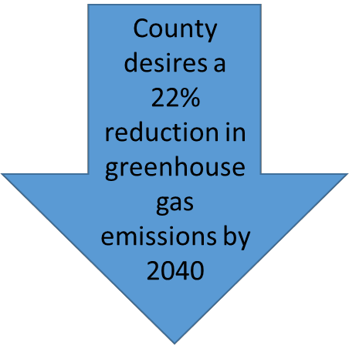Energy use is the major human cause of greenhouse gases. The electricity sector is currently the largest emitter of greenhouse gases, followed by the transportation sector; industry, commercial, and residential fuel use; and agriculture. In 2007, the County Energy Strategy (CES) concluded that if Loudoun County remained on a business- as-usual track with its countywide growth – while accounting for some expected improvements in the efficiency of both existing structures and new construction
– then by 2040 the County would require 46 percent more energy to manage the expected growth,. Over the same period, total greenhouse gas emissions would increase by 50 percent.
The County enforces the 2012 International Energy Conservation Code (IECC), the most current model code establishing the minimum design and construction requirements for energy efficiency. County policies have a goal of constructing County facilities to Leadership in Energy and Environmental Design (LEED) Silver, or equivalent standards, where it makes sense to do so. Green building rating systems provide a consistent metric for measuring site development and building performance. Also, rating systems raise awareness of the environmental impacts of site development and buildings and help determine measures to minimize those impacts.
Loudoun County is a member of the Metropolitan Washington Council of Governments (MWCOG). MWCOG focuses on the following environmental planning areas: water resources, air quality, climate and energy, recycling and solid waste, and agriculture and forestry. Loudoun County assists in advancing the goals laid out in MWCOG’s Region Forward for clean water, air, and land, and a more sustainable region.
The County is committed to policies, strategies, and actions that protect natural and heritage resources and integrate the concepts of sustainability into greater community planning and development goals. As the County continues to grow, as will the opportunities and challenges related to preservation and conservation of natural and heritage resources. A proactive approach to water quality could help to avoid costly and time-consuming processes to restore water quality as part of TMDL Action Plans. Through watershed management plans, the County has the opportunity to identify areas where management practices will most effectively enhance water quality. The County also has the opportunity to document efforts to promote sustainability, environmental stewardship, and protect the environment. The County should continue to support and build upon work that has already begun and consider the development of a sustainability plan or an annual report highlighting work that is being done. The Board can use this report to identify future goals. Essential to the preservation of heritage resources and cultural landscapes is proactive survey and evaluation of these resources as provided in the HPP. The following Policies, Strategies, and Actions reflect these concepts and more, balancing the environmental, social, and economic factors that will shape the County for future generations.

Policies, Strategies, and Actions
Unless otherwise specified, the following Policies, Strategies, and Actions apply Countywide.
Natural and Heritage Resources
(See also Chapter 6, Fiscal Management and Public Infrastructure)

NHR Policy 1: Provide protection for natural and heritage resources.
Strategy
  - Support mechanisms to further the goals of conservation, preservation, restoration, recapture, and education to protect the health, safety, and welfare of Loudoun residents.
Actions
    - Maintain a map of natural and heritage resources as part of an integrated system and contiguous network of natural and passive open spaces and active recreational sites.
    - Identify those properties that are not conducive to development due to sensitive environmental, cultural, and historical characteristics, and promote their preservation through various public and private programs (such as the PDR program, Open Space Preservation Program, conservation easements, etc.).
    - Adopt zoning regulations and development standards that implement a Conservation Design or similar process applicable to land development.
    - Update the Facilities Standards Manual, the Land Subdivision and Development Ordinance, and other development standards to implement the natural and heritage policies in this Plan.
Conservation Design consists of a 4 step process:
- Identifying the environmental, natural, and heritage features of a site to be preserved.
- Locating buildings on the unconstrained land.
- Locating street, utility, and trail on the development plan.
- Locating lot lines.
    - Consider establishing a PDR program that protects agricultural, natural, historic, and scenic resources.
    - Use the Conservation Design process, Use Value Assessment Program, AFDs, the PDR program, public-private partnerships, and
other regulatory and incentive-based efforts for the preservation, conservation, restoration, and management of the County’s natural and heritage resources. Explore and implement additional incentive-based approaches.
    - Retain conservation easements as a tool to protect open space areas in subdivisions and to ensure long-term maintenance and protection of the area. Such easements will be recorded as part of the subdivision process and include public access where appropriate.

    - Direct public investment and resources toward completing a natural and heritage resource network and recapturing natural and heritage resources in developed areas.
Purchase of Development Rights (PDR) and Conservation Easements are tools that are available to the County and public and private entities to protect and preserve open space, farms, and natural and heritage resources in perpetuity, allowing landowners to retain ownership of their property, while maximizing the economic value of the land.
    - Require development proposals that impact one or more natural and heritage resources to offset impacts by enhancing and/or recapturing natural and heritage resources elsewhere onsite.
    - Require development proposals to create links to adjacent natural and heritage
resources to create an integrated network and prevent habitat fragmentation.
Strategy
  - Promote private, state, and federal conservation programs and their allocated resources to advance conservation programs within the County through public and private means such as grants, voluntary easements, and dedications.
Action
    - Study and, if feasible, aid in the establishment of a public-private conservation foundation to facilitate communication, grants, easements, education, and partnership opportunities to conserve and protect natural and heritage resources.
Strategy
  - Act as a leader and educator in environmental design to achieve and sustain a high-quality built environment.
Action
    - Provide incentives for innovative design, and support collaborative public-private- community partnerships for program implementation including provisions for awards of certificates of excellence in environmental design for the public and private sectors.

Strategy
  - Link natural and heritage resources to create opportunities for open space corridors for the enjoyment of current and future generations.
Action
    - Encourage protection of the following priority open space areas through conservation easements acquired by the County or others, participation in the Open Space Preservation Program, development design, and other means:

      - Key green infrastructure features not already protected from development by conservation easements or regulation,
      - Rural areas immediately adjacent to the Towns, JLMAs, and Rural Villages that help form greenbelts and gateway buffers,
      - Areas adjacent to the Potomac, Catoctin, Bull Run, Goose Creek, and Broad Run floodplains to protect water quality,
      - Properties on the State or National Registers of Historic Places and within local historic districts,
      - Corridors and sites identified for trails and parks and additions to existing parks provided they permit the construction of such facilities, and
      - Other areas of local natural, historic, or cultural significance including designated scenic rivers and roads.
River and Stream Corridor Resources

RSCR Policy 2: The County will protect natural ecosystems, restore water quality, serve Loudoun’s population, and support the built environment through healthy surface and groundwater resources.
Strategy
  - Establish and maintain a healthy river and stream corridor ecosystem that meets desired water quality standards, protecting from the damages of soil erosion and flooding while promoting biological diversity.
Actions
    - Amend zoning regulations and development standards, including but not limited to the Floodplain Overlay District (FOD) and Scenic Creek Valley Buffer sections, to address the objectives of the RSCR policies. Zoning regulations and development standards will establish performance standards and best management practice (BMP) requirements to ensure the health and biological integrity of the river and stream corridors and minimize adverse impacts.
    - Develop and implement a watershed management plan for each watershed, establishing development guidelines and performance standards to protect water quality. The County will follow the recommendations of the 2008 Comprehensive Watershed Management Plan.
    - Establish appropriate regulations for Catoctin Mountain, Short Hill Mountain, and the Blue Ridge Mountains to limit diversions of water from the Catoctin and Goose Creek headwaters and prevent stream pollution.

    - Maintain a working relationship with the Federal Insurance and Mitigation Administration of the Federal Emergency Management Agency (FEMA) for continued participation in the National Flood Insurance Program (NFIP). The County

will also maintain its current status as a Cooperating Technical Partner in FEMA’s Flood Map Modernization program.
    - Work with the incorporated Towns to establish overall water quality goals and specific standards for individual streams and river and stream corridors, consistent with County RSCR objectives and policies.
    - Coordinate with the Metropolitan Washington Airport Authority regarding water quality protection within the Broad Run watershed.
    - Promote and encourage community programs, such as the “Adopt-A-Stream” program, in order to keep river and stream corridors free of litter and debris and as a means of promoting public awareness of the County’s river and stream corridors.
    - Support the interstate 2014 Chesapeake Bay Watershed Agreement, a watershed partnership signed by the governors of Virginia, Maryland, West Virginia, Delaware, New York, and Pennsylvania, as well as the District of Columbia and the United States EPA. The County supports Virginia’s action towards meeting the Chesapeake Bay TMDL and WIP.
    - Support the mitigation of stream and wetland impacts and the creation of stream and wetland mitigation banks within Loudoun County to improve water quality in Loudoun.
    - Maintain the County’s Predictive Wetland Model and require submittal of digital wetland delineations in conjunction with land development applications in order to develop a reliable wetlands inventory and map of wetland areas.
Strategy
  - Establish River and Stream Corridor Resource (RSCR) buffers to promote river and stream health (streambank/streambed

Examples of measures to help mitigate a reduction in the 50-foot management buffer:
- Reforestation of open areas adjacent to the stream and floodplain;
- Increasing Tree Conservation Areas adjacent to the floodplain (especially when the floodplain is narrow);
- Buffering streams and wetlands outside of the RSCR;
- Enhanced stormwater and erosion and sediment control measures.
stability, temperature moderation,
nutrient removal, sediment removal, flood control, and aquatic food and habitat).
Actions
    - Amend zoning regulations and development standards to establish a minimum 100-foot stream buffer to protect rivers and streams when floodplains and adjacent steep slopes do not extend beyond either bank by 100 feet.
    - Amend zoning regulations and

development standards to establish a 50-foot management buffer as part of the RSCR surrounding floodplains and adjacent steep slopes. Specific criteria for allowable reductions in the 50-foot management buffer should be included to ensure that reductions do not adversely impact the other elements of the RSCR. The RSCR 50-foot management buffer will not be added to the 100-foot minimum stream buffer.
    - Develop and use incentives to encourage property-owners to establish and maintain a 100-foot minimum riparian stream buffer.

Permitted Uses in the RSCR
Permitted uses within the RSCR are intended to support or enhance the biological integrity and health of the river and stream corridor. These uses are intended to have minimal adverse effects on natural and heritage resources. Development of such uses requires mitigating impacts while complementing the hydrologic processes of the river and stream corridors including flood protection and water quality. New uses should be limited to:
- Road crossings, rail crossings, bridges, and drive-way crossings
- Public water and sewer
- Local and regional stormwater management facilities within the minor floodplain river and stream corridor resource only (subject to BMP requirements)
- Public lakes and ponds (subject to BMP requirements)
- Public water supply reservoirs
- Historic and archaeological sites
- Paths and trails – including footpaths, biking or hiking paths, and horse trails (of a permeable material only)
- Passive recreation – limited to hiking, biking, horseback riding, picnicking, camping, climbing, hunting, fishing, and wildlife viewing
- Active recreation within the minor floodplain river and stream corridor resource only
- Agricultural activities, but not structures – including crop planting and harvesting and grazing (subject to appropriate BMP requirements)
- Silviculture – as required to care for forests and not commercial forestry (limited to forest preservation and tree planting, limited tree clearing and clearing of invasive species, tree trimming and pruning, and removal of individual trees (subject to appropriate BMP practice requirements)
- Planting native vegetation (subject to appropriate BMP requirements)
- Conservation – including stream restoration projects, wetland mitigation banks, facilities and activities; Adopt-A-Stream programs; scientific, nature, and archaeological studies; and educational programs
- Raised boardwalks

Strategy
  - Protect and improve stream quality and watershed health by decreasing the amount of stormwater runoff and pollutants from reaching local waters.

Actions
    - Develop appropriate standards and regulations to protect natural streams from the harmful effects of increased stormwater volume, velocity, and pollutant loads resulting from development.
    - Encourage stormwater BMPs on-site or as close to the area being treated as possible to prevent increased nutrient and sediment runoff.
    - Establish incentives and/or a funding program for reforestation, SWM/BMP projects, and SWM/BMP retrofits.
    - Support the retrofitting of older stormwater systems and the rehabilitation of degraded areas to enhance pollution removal capabilities and create open space amenities.
    - Promote the use of low-impact development to replicate natural hydrologic patterns and alleviate the strain on centralized systems.
    - Support and incentivize reforestation for degraded forested areas in upper stream reaches that do not include Major Floodplain and promote natural regeneration within the limits of the Major Floodplain to mitigate the loss of native canopy coverage as a result of construction.
    - Maintain standards for activities that propose pollution sources such as the storing and dispensing of fossil fuels, chemical storage, and sale or transfer of potential contaminants.
Strategy
  - Protect and enhance impaired streams and their tributaries to improve water quality and provide ecological benefits while also providing opportunities for passive recreation.
Actions
    - Encourage the implementation of enhanced pollutant control measures and watershed management strategies such as: downspout disconnection; tree planting/reforestation, especially within riparian areas; storm drain marking; stream restoration; wetland creation; adding BMPs; enhanced stormwater management ponds; enhanced pollution/erosion control measures; coordination and outreach with the Virginia Department of Transportation (VDOT) and owners associations on use of sand and anti-ice materials in snow removal/road clearing operations; and stormwater pond water quality enhancements.
    - Actively participate in regional water quality initiatives to protect and improve water quality.
    - Comply with the Virginia General Permit for stormwater discharges from small Municipal Separate Storm Sewer Systems (MS4 General Permit).

    - Prepare and implement TMDL Action Plans, as necessary to meet TMDL requirements. The Action Plans, designed to improve the County’s surface water quality may include working with other entities, such as the Loudoun Soil and Water Conservation District (LSWCD) and Virginia Cooperative Extension-Loudoun (VCE- Loudoun).
    - Collaborate with the Department of Environmental Quality on any pollution impairment issues within streams and support volunteer water quality monitoring efforts and coordination of these efforts with federal, state, and local water quality data collection.

Surface Water Resources
Strategy
  - Protect rivers and public drinking water reservoirs to ensure a clean, safe, and adequate supply of drinking water.
Actions
    - Protect public water supply reservoirs, Scenic Rivers, the Potomac River, and the Bull Run by establishing a 300-foot no-build buffer or the other elements of the RSCR buffer, whichever is greater. Areas outside of the no-build buffer are priority open space areas for the creation of a greenbelt. The greenbelt will be created through various mechanisms such as land donations, conservation easements, PDR, and other land conservation mechanisms.
    - Protect lands that are critical to the quality of key water supplies through easement, fee simple acquisition, regulatory measures, or other sufficient measures. Restore filtration and erosion control functions through the re-naturalization of these areas.
    - Develop and implement a watershed overlay district for all public water supply reservoir watersheds, establishing more stringent development guidelines and performance standards to protect water quality.
    - Develop and implement a Potomac River shoreline management plan and seek to coordinate this effort with adjacent jurisdictions (local, state, and regional organizations, advisory boards, and citizen groups). This Plan should include:
      - The boundaries of the study area,
      - A comprehensive natural resources inventory,
      - Existing and proposed private/public water access entry points,
      - Policy recommendations for river corridor management and protection,
      - A process for integrating the participating groups, and
      - A plan for acquiring and managing open space corridors along the Potomac River.

    - Establish appropriate standards and land uses to protect drinking water supplies.
    - Develop a community-based Source Water Protection Plan in cooperation with Loudoun Water.

Groundwater Resources
Strategy
  - Preserve and protect groundwater quantity and quality.
Actions
    - Develop and implement a comprehensive groundwater protection strategy to ensure adequate and sustainable water supply.
Additional Notes:
- The RSCR performance standards, BMP requirements, and list of permitted uses will apply to the no-build and transitional buffer, except adjacent to existing or planned drinking water reservoirs where stormwater management facilities are not permitted.
- The limits of the 300-foot no- build buffer for reservoirs is based on their projected high water mark where expansion is proposed.
    - Initiate and maintain a comprehensive pollution management program to protect groundwater resources.
    - Local wellhead protection plans will be taken into consideration during review of development applications to maintain drinking water quality and protect groundwater from contamination.
    - Limit the installation of additional wells and limit the number of additional households and irrigation systems that are dependent on wells through water conservation efforts and through the use
of communal and/or central water systems where feasible and as approved by Loudoun Water.
    - Ensure the location, depth, and rate of extraction of individual wells do not impact the quality and quantity of municipal wells.
    - Assess the recharge and consumption rates for groundwater in each watershed by analyzing data from groundwater level monitoring and stream flow measurements. If negative impacts are detected, the information will be presented to the Board of Supervisors for appropriate action.

    - Develop standards for uses that consume and/or require the usage of large quantities of water in those areas that could affect neighboring wells and aquifers.

    - Provide education to school children and homeowners on the use and consumption of groundwater for areas of the County that are not connected to the central water supply.

Soils and Geologic Resources

SGR Policy 3: Preserve and protect the County’s soils, unique geologic characteristics, farmland, steep slopes, mountainsides, and ridgelines recognizing their sensitivity to land disturbance and development as well as their contribution to healthy ecosystems and the quality of life valued by residents and visitors.

Limestone Geology Areas
Strategy
  - Protect limestone geology areas susceptible to sinkholes, cavity collapse, ground slippage, pollution, and other hazards.
Actions
    - Maintain performance standards for lands within areas underlain by limestone — including minimum setback distances from Karst features (e.g., sinkholes and rock outcrops) —to ensure structural stability and prevent adverse impacts to environmental and public health
    - Limit density and intensity of development within areas underlain by limestone, especially on sites proximate to identified Karst features.
    - Require communal water and wastewater systems for new development in areas underlain by limestone, unless the developer/property owner demonstrates to the County that other types of systems would achieve the same or superior performance standards.
    - Identify pollution sources and establish appropriate standards for reducing pollution in areas underlain by limestone.
Monitor groundwater and surface water in areas underlain by limestone, and if monitoring recognizes negative impacts, present the information to the Board of Supervisors for appropriate action.

Prime Agricultural Soils
Strategy
  - Preserve and protect prime farmland and agricultural soils, recognizing their importance to the overall economic health of the rural economy.
Action
    - Develop a public education program that will focus on communicating advantages associated with private protection of Prime Agricultural Soils.
    - Encourage the retention and conservation of prime agricultural soils within open space areas.

Steep Slopes, Moderately Steep Slopes and Mountainside Areas
Strategy
  - Protect steep slopes, ridgelines, and mountainside areas against destabilization, erosion, building and/or road failure, downstream flooding, and other hazards and to maintain the scenic and rural nature of these areas.
Very steep slopes are those with a grade of more than 25 percent and/or with the soil Slope Class of E. Moderately steep slopes are those with a grade from 15 to 25 percent and/or with the soil Slope Class of D.
Actions
    - Manage development in mountainside areas using performance standards and regulations to minimize negative environmental impacts; minimize land
disturbance; protect the ridgelines; maintain woodlands, plant, and wildlife habitats; and preserve natural features and rural character as requirements for approval of the location of proposed development.
    - Prohibit land disturbance on naturally occurring very steep slopes, with limited exceptions such as access easements to existing lots where no other access is possible. Agricultural or silvicultural activities, excluding structures, may be allowed provided that a County approved Farm Management Plan or Forest Management Plan, whichever is applicable, is implemented. Apply performance standards to protect soils, vegetation, and other environmental features when roads are permitted or allowed by special exception.
    - Apply performance standards to protect moderately steep slopes to include BMPs and locational clearances for clearing and grading. Develop incentives to locate development outside of moderately steep areas.
    - Preserve forests and native vegetation on very steep slopes. Limit clearing to only essential clearing that is necessary for home construction, road construction, and utility installation on moderately steep slopes.
    - Protect ridgelines through updates to the Mountainside Development Overlay District or the development of a Ridgeline Protection Overlay District.
    - Require special exception approval for the subdivision of properties into three or more lots in Sensitive and Highly Sensitive Mountainside Areas.
    - Seek the expansion of passive outdoor recreational opportunities in mountainside areas, including the development of public park sites and improving access to existing recreational facilities such as the Appalachian Trail.
    - Review and amend zoning regulations and development standards to ensure consistency with the objectives of the mountainside area policies.

    - Establish performance standards for unavoidable development on questionable soils as defined by the International Building Code.
Forests, Trees, and Vegetation

FTV Policy 4: Preserve, protect, and manage Loudoun County’s forests and trees for current and future use and enjoyment, recognizing these resources provide many benefits, such as improving air and water quality; offering important habitat for birds, small mammals and other wildlife; providing buffers between communities; conserving energy; reducing wind speed and redirecting airflow; and reducing stormwater runoff and soil erosion.
Strategy
  - Preserve, protect, and manage forest resources for their economic and environmental benefits.
Actions
    - Require applicants to submit a Tree Cover Inventory as part of all development applications and, where applicable, require applicants to submit a Tree Conservation Plan for designated Tree Conservation Areas; such Tree Conservation Plan should demonstrate a management strategy that ensures the long-term sustainability of these designated areas and address the removal and monitoring of invasive woody vegetation and insects.
    - Incentivize and encourage the preservation of existing trees within required landscape buffer areas and for screening of uses.
    - Require the removal of invasive plant species during the development process.
    - Develop and adopt a Tree Preservation Ordinance.
    - Inventory and map trees and native vegetative resources to be preserved or managed in accordance with County standards and create and maintain a database of these resources to include, but not be limited to, old growth forests, significant tree stands, specimen trees, heritage trees, and State or National Champion trees.
    - Participate in community tree projects such as the Arbor Day Foundation’s Tree City USA Program.
Strategy
  - Promote tree planting and preservation as a means to reduce the heat island effect, manage stormwater run-off, and improve water quality, air quality, and wildlife habitat.
Actions
    - Prioritize the planting of native vegetation, specifically along those corridors that

provide connections to other natural and heritage resources.
    - Develop Countywide goals and objectives for the creation, maintenance, and preservation of the County’s tree canopy.
Historic, Archaeologic, and Scenic Resources

HASR Policy 5: Loudoun County’s distinctive cultural landscapes encompass scenic and heritage resources, including Scenic Rivers and Byways, historic buildings, archaeological sites, battlefields, and historic cemeteries. These resources are foundational elements of the County’s changing landscape that together tell the story of the formation and settlement of the County. The County will protect and enhance these resources, recognizing them as relevant, character-defining elements of both the natural and built environments.
Strategy
  - Preserve cultural and scenic character through conservation and preservation of designated heritage areas, battlefields, cemeteries, scenic corridors, Scenic Rivers, the Potomac River, significant geological features, archaeological sites, historic structures and their settings. Convey the benefit of these resources to the public through public education in collaboration with private landowners and preservation organizations.
Actions
    - Evaluate land development applications within the context of this Plan as well as those more specific policies contained in the Heritage Preservation Plan.
    - Evaluate the Heritage Preservation Plan every five years and update if necessary.
    - Require an archaeological and historic resources survey for all development applications. This survey must include a plan for recordation of identified resources and measures for preservation, mitigation, and adaptive reuse. The County will maintain a repository for artifacts recovered from required surveys; such artifacts will be used for research and public education purposes.
    - The County will update its cultural resource inventory through the land development process and County-sponsored historic surveys.
    - Evaluate the historic or archaeological value of inventoried resources based on criteria set forth in the Secretary of the Interior’s Standards, which include historic context and site integrity. The County will evaluate resources for consideration for State and National Registers. Identify, through survey and community outreach, locally important historic and archaeological resources that meet criteria for listing on the County Heritage Register as outlined in the Heritage Preservation Plan.
    - Identify, delineate, and map historic cemeteries, burial grounds, and graves to ensure

they are protected from destruction or neglect. Ensure that adequate buffers are provided around these sites to protect them during the development process.
    - Identify African American and Native American cultural resources to fill voids in the County’s database of heritage resources and create policies and programs that protect, preserve, and interpret these resources for the benefit of County residents.
    - Maintain the County’s database by using the inventory of cultural resources as a dynamic body of data to be reevaluated as needed.
    - Conduct a staff assessment to determine historic significance prior to issuing a demolition permit for a structure that is 50 years old or older.
    - Work with local communities to protect and enhance the character of cultural landscapes and historically significant sites through the designation of County Historic and Cultural Conservation Districts.
    - Preserve and protect significant cultural and scenic resources from development impacts by promoting private or public acquisition and/or conservation easements, and the use of a PDR program.
    - Where consistent with the applicable provisions of the Virginia Code Section 15.2- 2303, applicants may provide cash contributions to the County for the enhancement and/or improvement of historic features within Loudoun to fulfill the open space guidelines if the County agrees to or requests the exchange.
    - Prioritize the adaptive reuse of historic structures that are of local, regional, or national significance as the primary method of preserving the County’s diverse collection of historic architecture within the framework of sustainable development.
    - Amend zoning regulations and development standards to ensure the viability of adaptive reuse, particularly in the County’s villages where the ability to reuse historic structures is vital to the historic character and vitality of these communities.
    - Prepare and implement corridor management plans, including identifying and defining viewsheds for the County’s Scenic Rivers in order to protect their natural and scenic quality.
A viewshed analysis for a Scenic River typically involves looking at both the view from the resource itself as well as the view towards the resource.
    - The County does not permit diversion of Scenic Rivers under any circumstances.

Natural Heritage Resources

NHR Policy 6: Preserve, protect, and create a network of privately and publicly protected open space, favoring large contiguous areas rather than smaller disconnected areas, maintaining green infrastructure assets, preventing habitat fragmentation, and reinforcing the unique character of the diverse communities in the County.
Strategy
  - Conserve and protect natural heritage resources including rare, threatened, and endangered plant and animal species; species of greatest concern; exemplary natural communities, habitats, and ecosystems; and other natural features of the County.
Actions
    - Utilize open space requirements, passive recreation, nature preserves, incentives, and regulations to protect areas of natural biodiversity and rare, threatened, and endangered plant and animal species, and plant communities to foster the implementation of the Federal Endangered Species Act and the Virginia Wildlife Action Plan.
    - Development applications will identify Loudoun County’s natural heritage resources through coordination with the Virginia Department of Conservation and Recreation (VDCR) – Division of Natural Heritage and the Virginia Department of Game and Inland Fisheries (VDGIF). For those development applications that have a likely presence of one or more natural heritage resource, the County will require the applicant to conduct a species assessment. In cases where the presence of the species is identified, the County will require the applicant to develop and submit a plan for impact avoidance.
    - Ensure that the study of natural heritage resources is conducted by qualified research organizations such as the VDCR and VDGIF, and develop implementation strategies for the preservation of identified natural heritage resources.

Wildlife Habitats
Strategy
  - Conserve and protect wildlife habitats, wildlife travel corridors, and access to streams and water sources through the preservation of natural resources such as native vegetation, forest cover, woodlands, floodplains, streams and stream corridors, wetlands, and undeveloped areas associated with steep slopes.
Actions
    - Require development proposals to create links to adjacent open space and natural resources to help prevent habitat fragmentation and foster biodiversity.

    - Identify essential wildlife corridors and encourage protection of these areas through conservation easements acquired by the County or others, participation in the Open Space Preservation Program, development design, and other means.
    - Ensure that new development, redevelopment, and infill development incorporates existing native vegetation and plantings of native vegetation into the landscape design.
    - Encourage the preservation and plantings of native vegetation to protect pollinators, migrant birds, and other wildlife.
    - Promote and support the establishment of public and private nature preserves throughout the County as part of the protection and enjoyment of natural and heritage resources.
Complementary Elements

CE Policy 7: The County promotes healthy air and low levels of noise and light pollution as essential elements for current and future residents.
Strategy
  - Preserve and protect air quality.
Actions
    - Comply with the requirements of the Federal Clean Air Act Amendments of 1990 through support of the State Implementation Plan (SIP).
    - Evaluate methods to reduce emissions of airborne pollutants including particulates, greenhouse gases, ozone precursors, and other gases known to adversely affect human and environmental health.

Strategy
  - Protect noise sensitive uses.
Actions
    - Continue to support the Washington Dulles International and Leesburg Executive Airports by continued and complete prohibition of new residential and other noise sensitive land uses from the areas located within the Ldn 65 and higher aircraft noise contours for both airports and by requiring non-noise sensitive land uses within these noise impact areas.
The Airport Noise Impact Area (ANIA) consists of three (3) components or aircraft noise contours:
- Within the Ldn 65 or higher
- Between the Ldn 60-65
- Outside of but within one mile of the Ldn 60

    - Continue to work with the Metropolitan Washington Airports Authority to refine airport operations and routes at Washington Dulles International Airport to minimize the effects on noise sensitive uses.

    - Prohibit residential encroachment into the existing areas designated as within the Ldn 65 or higher aircraft noise contours to ensure that residential development will not create pressure for reductions in the intensity of service or prohibit the expansion of service at the airport.

    - Continue to enforce and update with the most current information, as appropriate, the Airport Noise Impact Overlay District included as part of the Loudoun County Zoning Ordinance.

    - Require roadway noise studies for residential, institutional, or other noise sensitive uses adjacent to existing or proposed arterial and major collector roads to ensure that forecasted noise levels fall within acceptable levels, or can be abated to meet County standards (See also Loudoun 2040 Countywide Transportation Plan, Chapter 8, Environmental and Heritage Resources).

Strategy
  - Prevent light pollution.
Actions
    - Update lighting standards to achieve the following:
      - Promote the use of lighting for convenience and safety without the nuisance associated with light pollution;
      - Promote a glare-free environment through proper lighting performance standards to improve visibility and enhance public safet;
      - Promote appropriate lighting standards to conserve energy;
      - Develop appropriate lighting standards to prohibit unnecessary and intrusive light trespass that detracts from the beauty and view of the night sky; and
      - Promote Dark Sky standards to prevent light pollution.
Sustainability

SUS Policy 8: Encourage sustainability efforts throughout the County.
Strategy
  - Support sustainability practices within the Loudoun County Government.

Actions
    - Update and implement the County Energy Strategy (CES) due to unpredicted growth

in population and high energy demand uses, technological changes allowing improved energy storage, changing renewable energy markets, and the impacts of climate change.

    - Continue to evaluate the energy demands of government buildings as well as transportation needs and develop plans for energy efficiency.

    - Encourage benchmarking the energy use of existing and planned County buildings to establish a baseline for energy demand estimates.

    - Use the data from benchmarking the energy use to influence policy and regulations in the County.

    - Whenever feasible, build County-constructed facilities to LEED Silver, or equivalent, standards.

    - Continue to evaluate all sustainability efforts and improve efforts as new options and technologies become available.

    - Continue to monitor and support all efforts with MWCOG.

    - Support Loudoun Water in the expansion of the reclaimed water and/or gray water network.

    - Incorporate green infrastructure and BMPs into County Energy Strategy.

    - Prioritize government purchase and use of goods and services that have reduced impacts to human and environmental health.

    - Prioritize the use of Loudoun farm products in government purchase of food.

    - Develop a Sustainability Plan for the County that provides the framework to achieve economic development, social development, and environmental development in a balanced manner.

Strategy
  - Support energy efficient practices for all in Loudoun County.
Actions
    - Evaluate the energy demands of residential and non-residential buildings, including data centers as well as transportation needs and develop plans for energy efficiency.

    - Research and support opportunities for micro-grid energy and district energy systems.

    - Encourage the use of Commercial Property Assessed Clean Energy (C-PACE) and research and support residential PACE program.

    - Prioritize public investment in energy efficient, clean products and infrastructure.

Strategy
  - Support sustainable economic practices within Loudoun County to strengthen economic growth and innovation.
Actions
    - Create partnerships with universities and private sector companies to foster growth of a sustainable economy that supports workers and students in the advanced technology and science industries.
    - Promote the production and access to sustainable, healthy local food.
    - Support and expand community gardens throughout the County.

SUS Policy 9: Encourage sustainable development practices, including long-term water conservation, green building principles, sustainable site design, renewable energy, preservation and adaptive re-use of historic structures, and integrated energy management planning.
Strategy
  - Promote water conservation through innovative, cost-effective reuse systems, domestic water saving devices, and low impact development techniques, which integrate hydrologically functional designs with methods for preventing pollution and educational programs.

Actions
    - Educate and encourage the harvesting of rainwater for non-potable use, such as landscape irrigation.
    - Establish incentives for sustainable development.

Strategy
  - Promote the use of salvaged, recycled, or locally produced materials whenever possible.
Strategy
  - Evaluate the establishment of Eco-districts within the County.
Strategy
  - Promote green building standards and green building.

Strategy
  - Support renewable energy.
Actions
    - Adopt solar zoning and permitting best practices for accessory use solar development.
    - Become certified as a “solar-ready” community under the Department of Energy’s SolSmart program.

Reference Maps
Natural Resources (Map #2018-141)
River and Stream Corridor Resources (Map #2018-142) Watersheds (Map #2018-143)
Historic Districts (Map #2018-144)
Airport Impact Overlay District (Map #2018-145)
African American Historic Communities (Map #2018-201) Impaired Streams (Map #2018-203)
Limestone Overlay District (Map #2018-204)

Loudoun County
Nat ur al R e so urce s
2040 General Plan

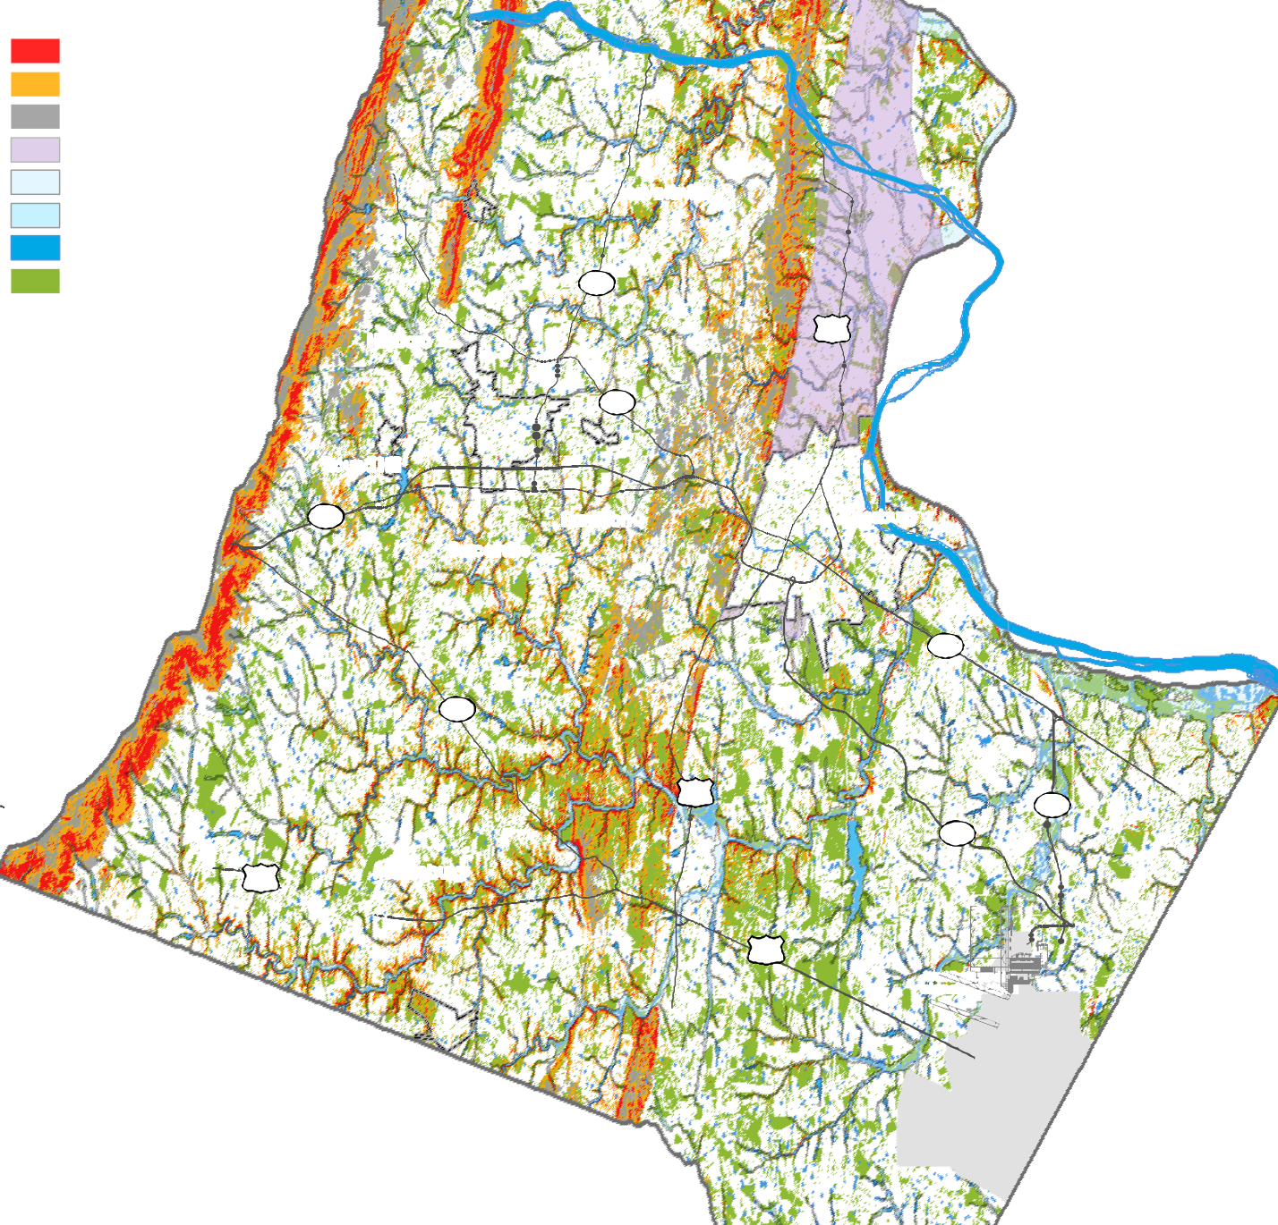
Very Steep Slopes Moderately Steep Slopes Mountainside Overlay District Limestone Overlay District Major Floodplain > 640 AC Minor Floodplain < 640 AC Water Sources
Wooded Area

287

Lovettsville

Hillsboro 15
9
Round Hill
mi
i

7
Purcellville
i
Hamilton
Leesburg

7
734

15
50 Middleburg
i
28
267

50
Washington Dulles International Airport
in
lle
I
l
ir

Loudoun County
Ri ve r an d S t re am Co r r i do r Re so urce s
2040 General Plan

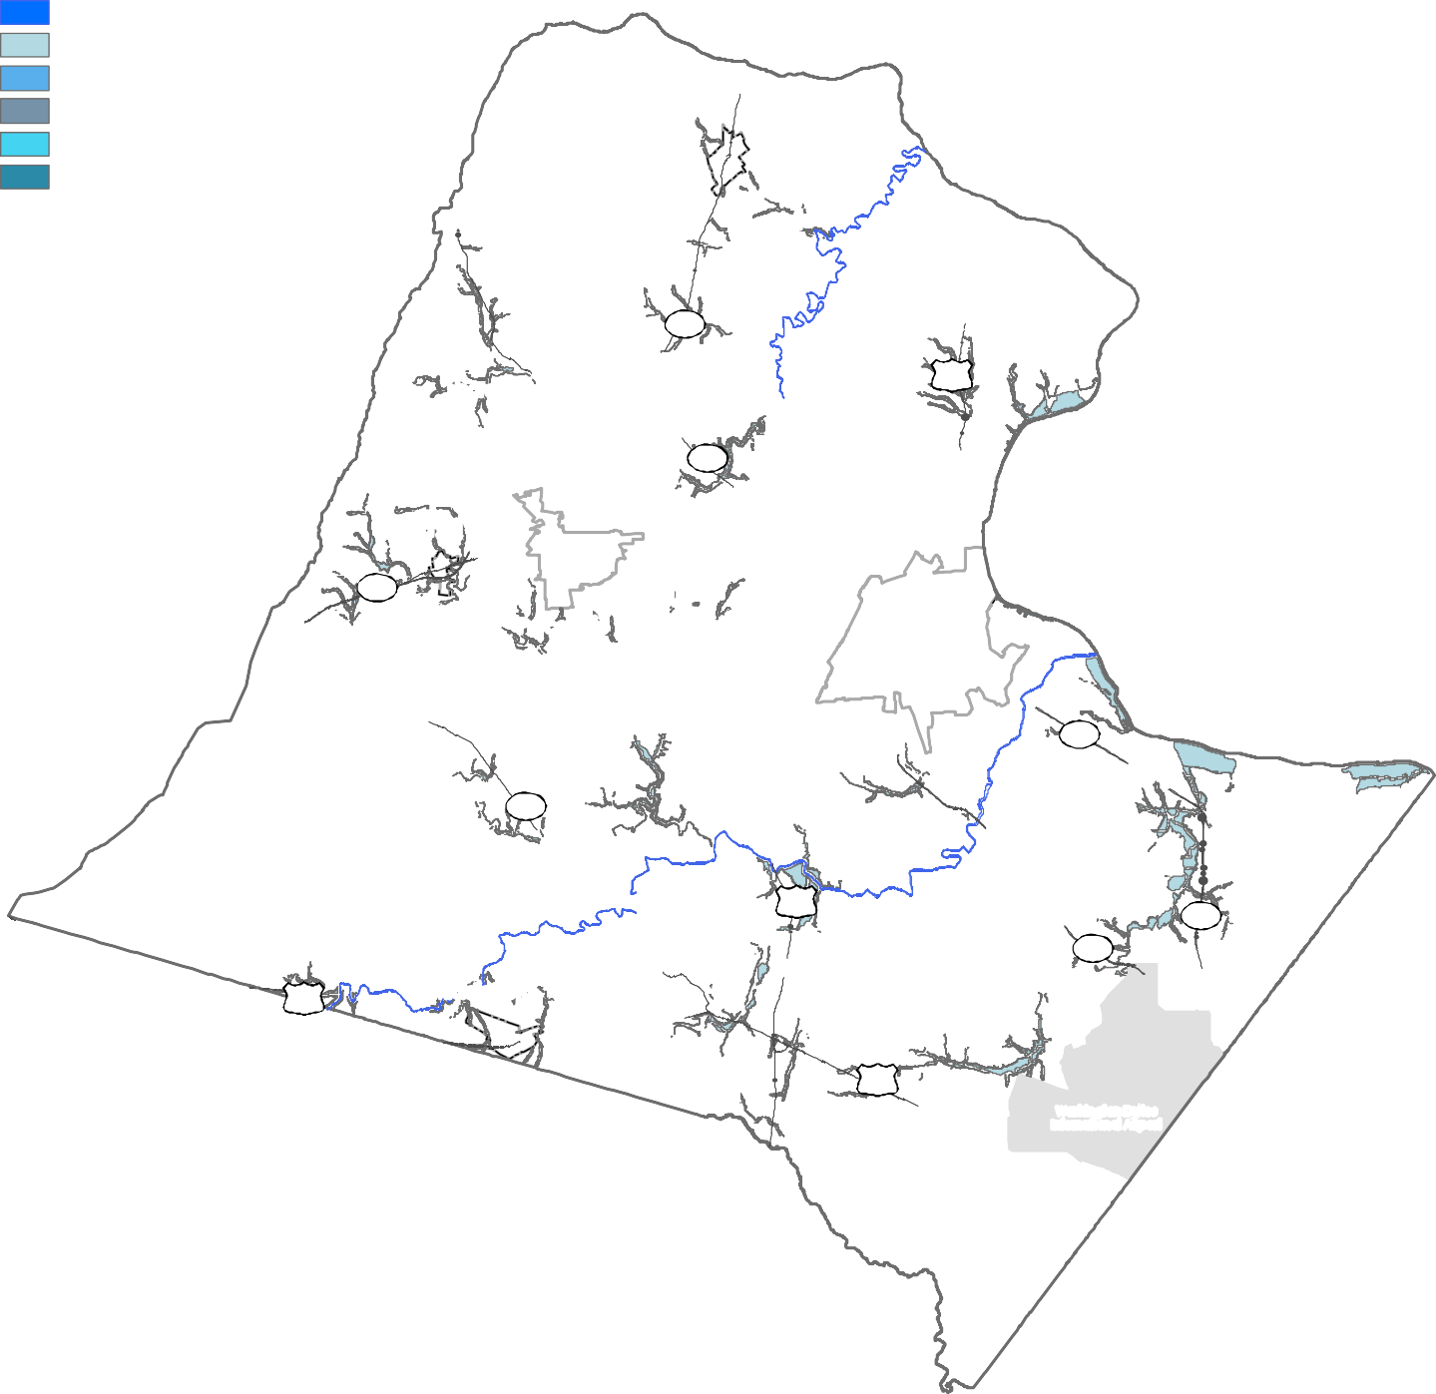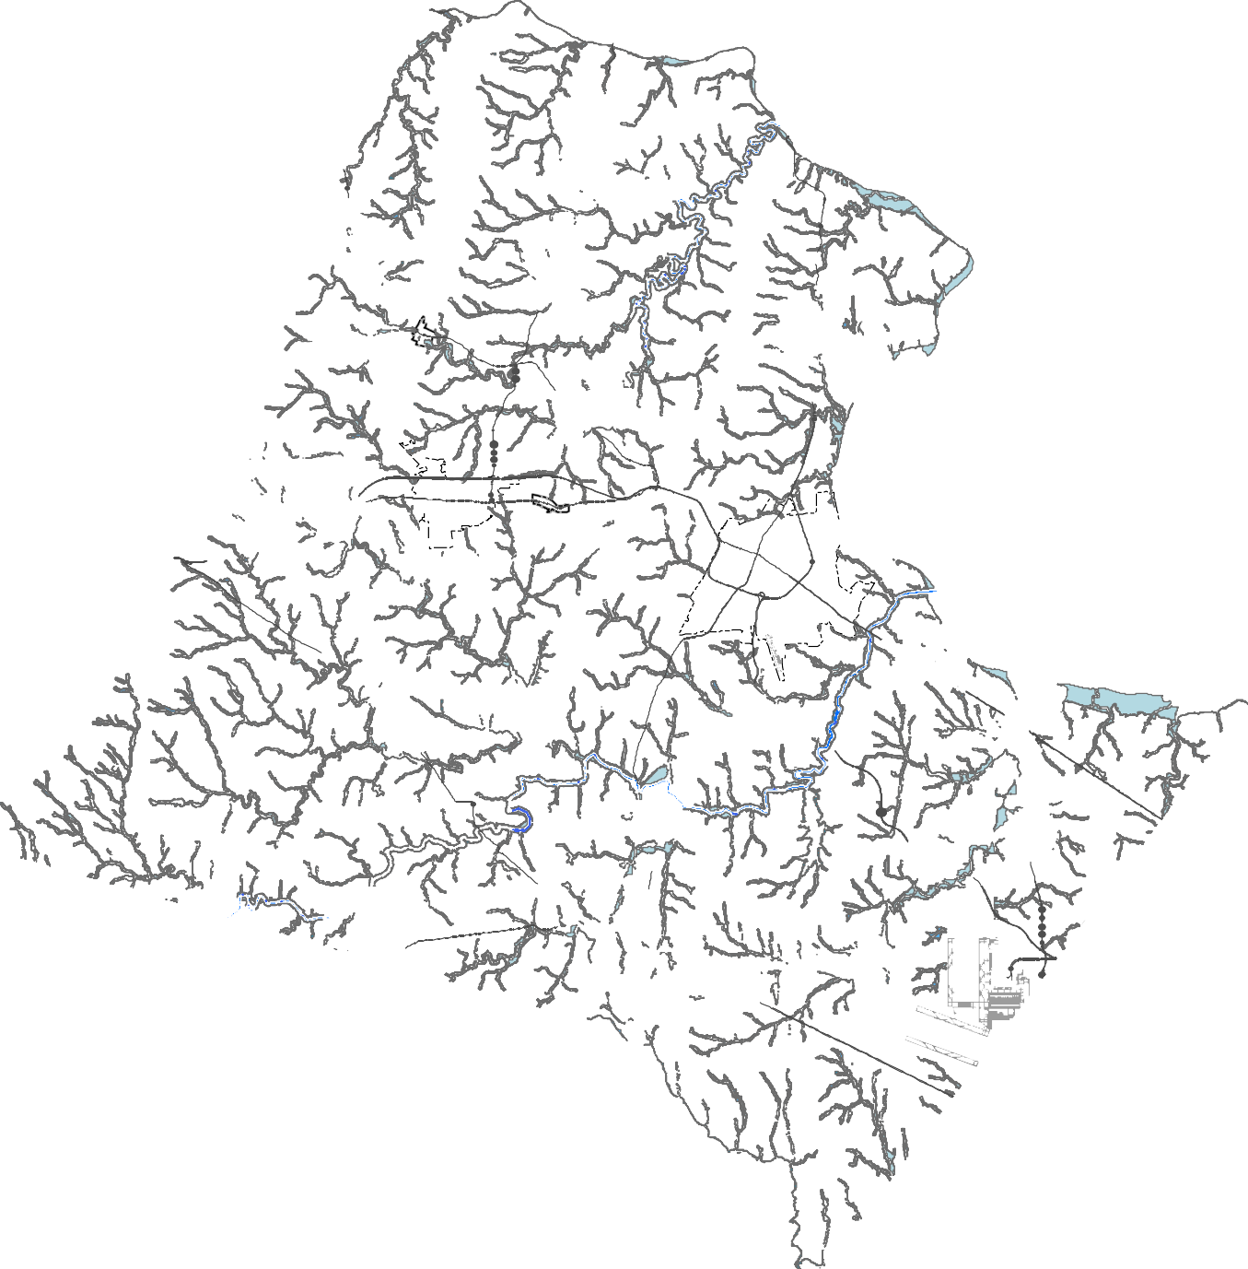Scenic Rivers
100-year Major Floodplain (drains greater than 640 acres) 100-year Minor Floodplain (drains 100 to 640 acres) Adjacent Steep Slopes (25% or greater)
Management Buffer (50' buffer) Minimum Stream Buffer (100' or 300')
Lovettsville

287

Hillsboro 15
9
Round Hill
mi
i

7
Purcellville
Hamilton
Leesburg

7
734

15
50 Middleburg
28
267

50
Washin gton Dulles Internation al Airport
in
lle
I
io
l
ir

Loudoun County
Watersheds
2040 General Plan

Piney Run

Dutchman Creek
Lovettsville

287
Quarter Branch

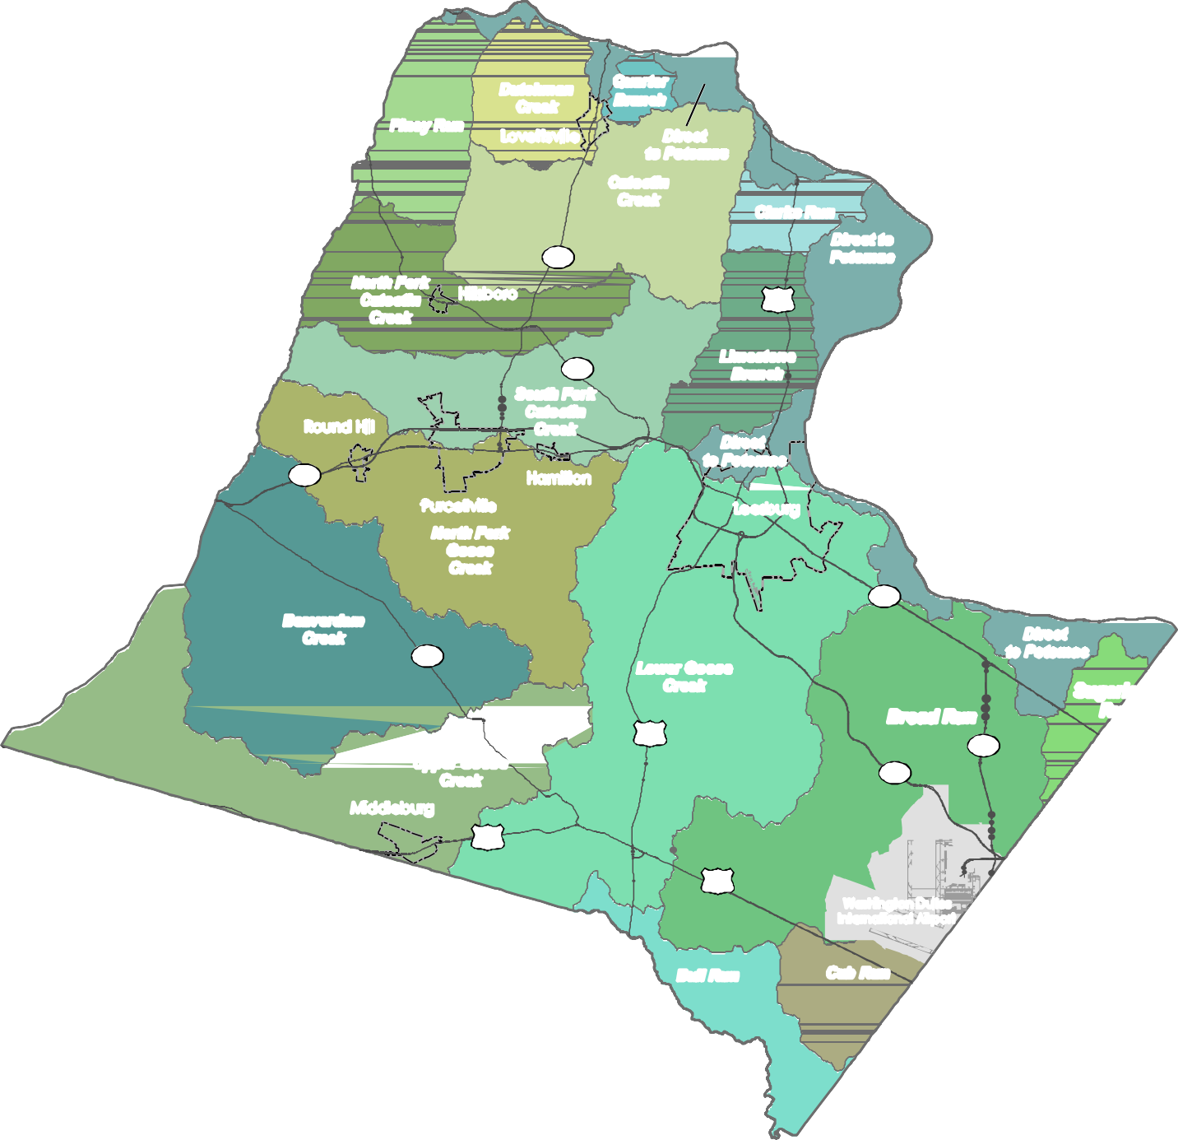
Direct
to Potomac
Catoctin Creek

Clarks Run
Direct to Potomac

North Fork Catoctin Creek
Hillsboro 15

Round Hill

7

Beaverdam Creek

Purcellville
North Fork Goose Creek

734

Upper Goose Creek

9
South Fork Catoctin Creek

Hamilton

Limestone Branch

Direct
to Potomac

Leesburg

Lower Goose Creek

15

7

Broad Run
28
267

Direct
to Potomac

Sugarland Run

Middleburg
50

50
Washington Dulles International Airport

Bull Run
Cub Run

Loudoun County

Historic Districts
2040 General Plan

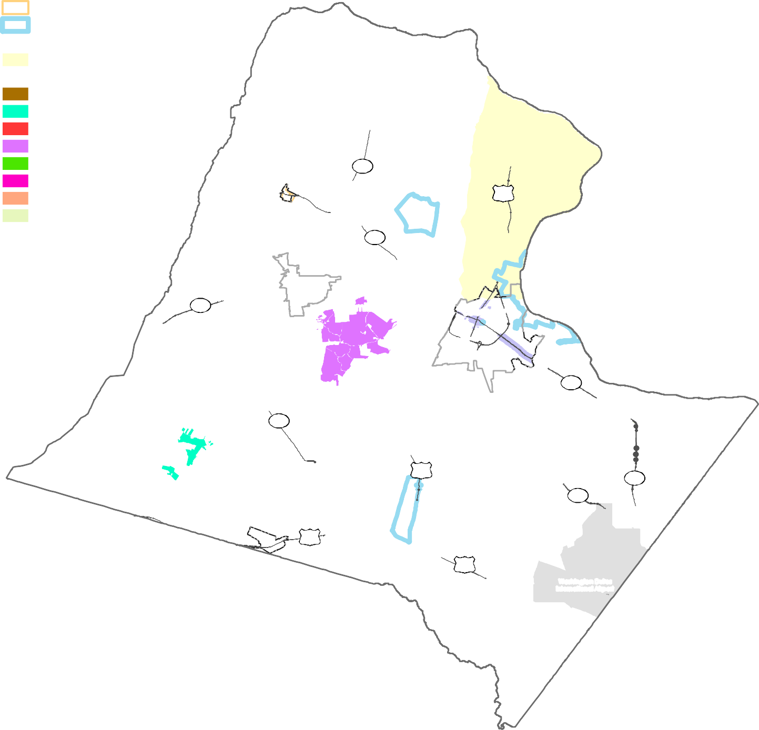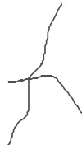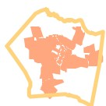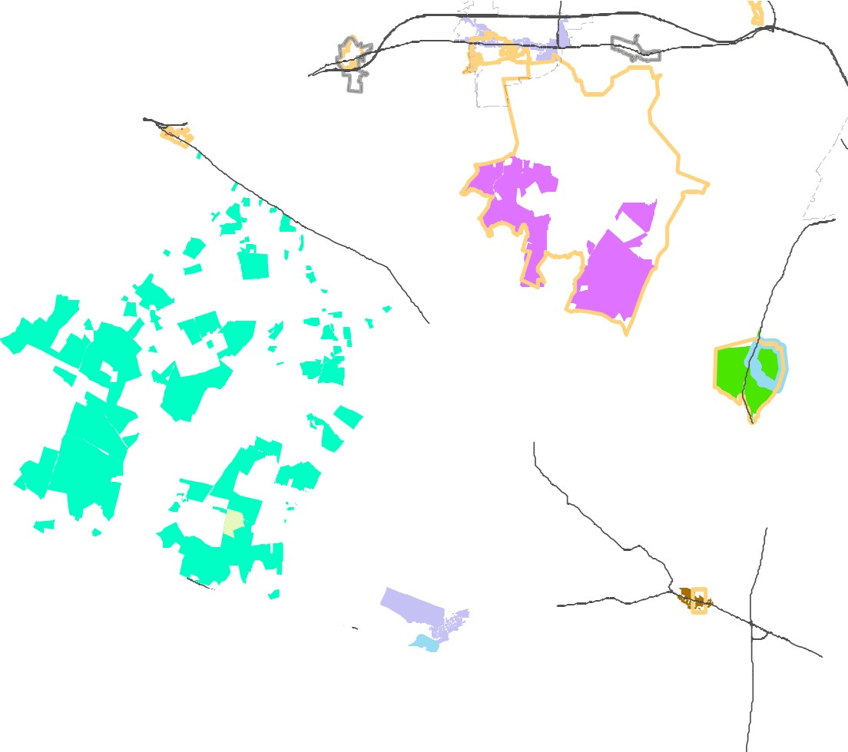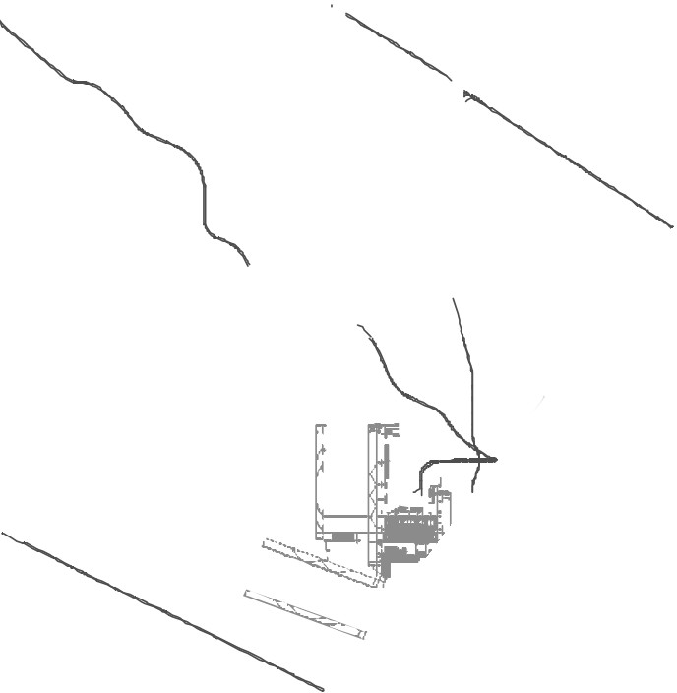Town Historic Districts
National Register Historic Districts National Historic Landmarks
Virginia Historic Landmarks Register
Catoctin Rural Historic District
Loudoun County Historic Districts
Aldie Historic District
Beaverdam Creek Historic District Bluemont Historic District
Goose Creek Historic District Oatlands Historic District Taylorstown Historic District Waterford Historic District Historic Site Districts

Hillsbor
o

287

9

Lovettsville

15

)
Round Hill

7 Hamilton
Purcellville

734

15

Middleburg
50

Leesburg

I
\
\, 7

50
28
267

Wash in gto n Du lles Internation al Airp ort

Loudoun County
Airp or t Im pa ct Ove rla y D i str ict
2040 General Plan

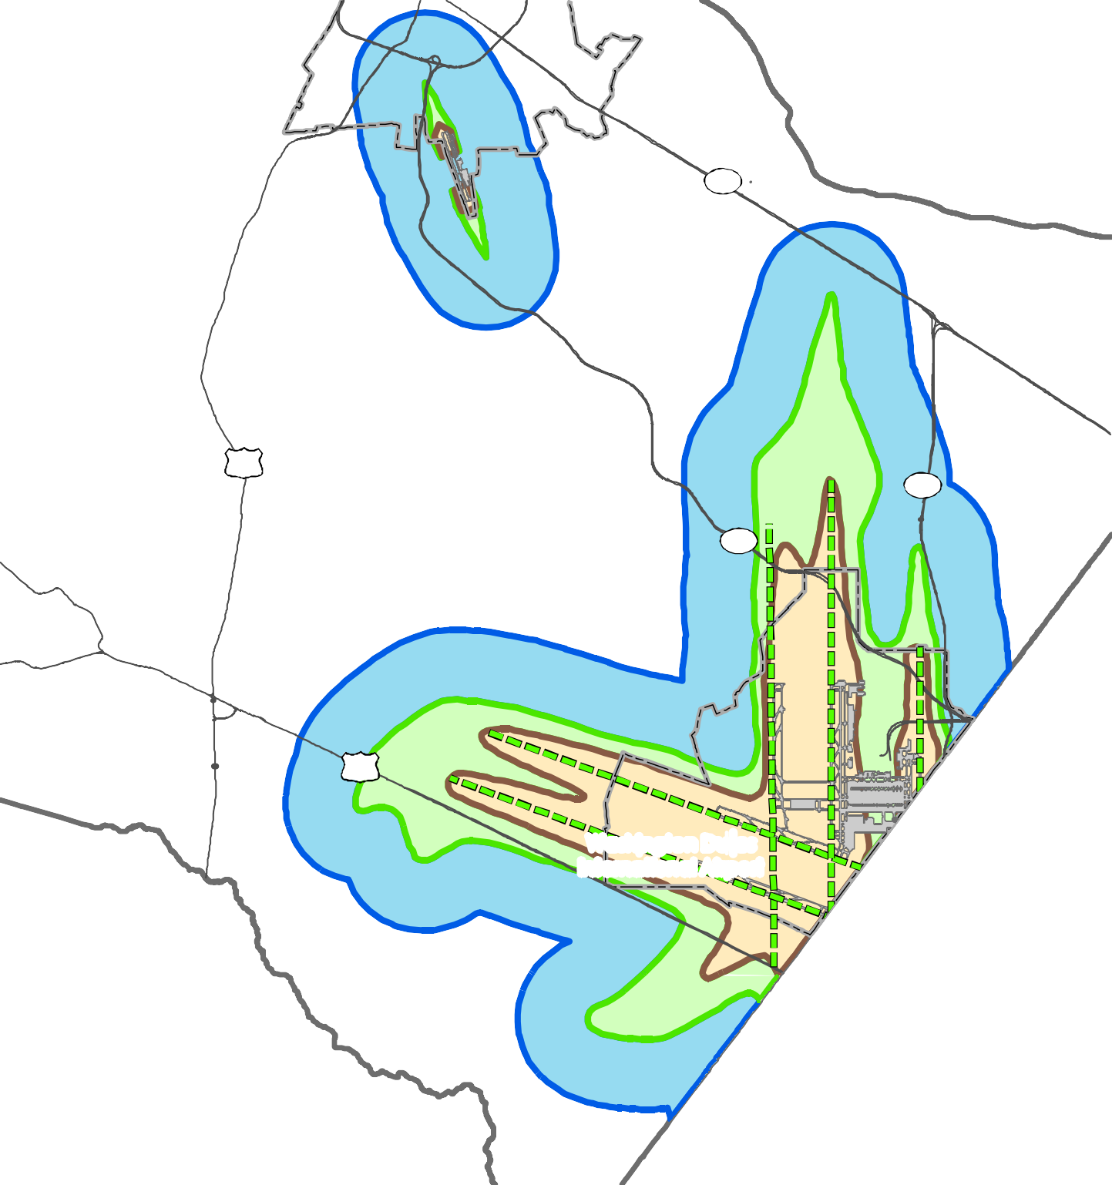Leesburg

7

15
28

267

50

Washington Dulles International Airport

Extended Runway Centerline Airport Runway

Between the LDN 60-65
Outside of but within 1 mile of the LDN 60 Within the LDN 65 or higher

Loudoun County IS NOT LIABLE for any use
of or reliance upon this map or any information contained herein. While reasonable efforts have been made to obtain accurate data, the County makes no warranty, expressed or implied, as to its

0 0.5

1 2 3 4
Miles

D R A F T

Africa n A merica n
Hi stor ic Com munities
2040 General Plan

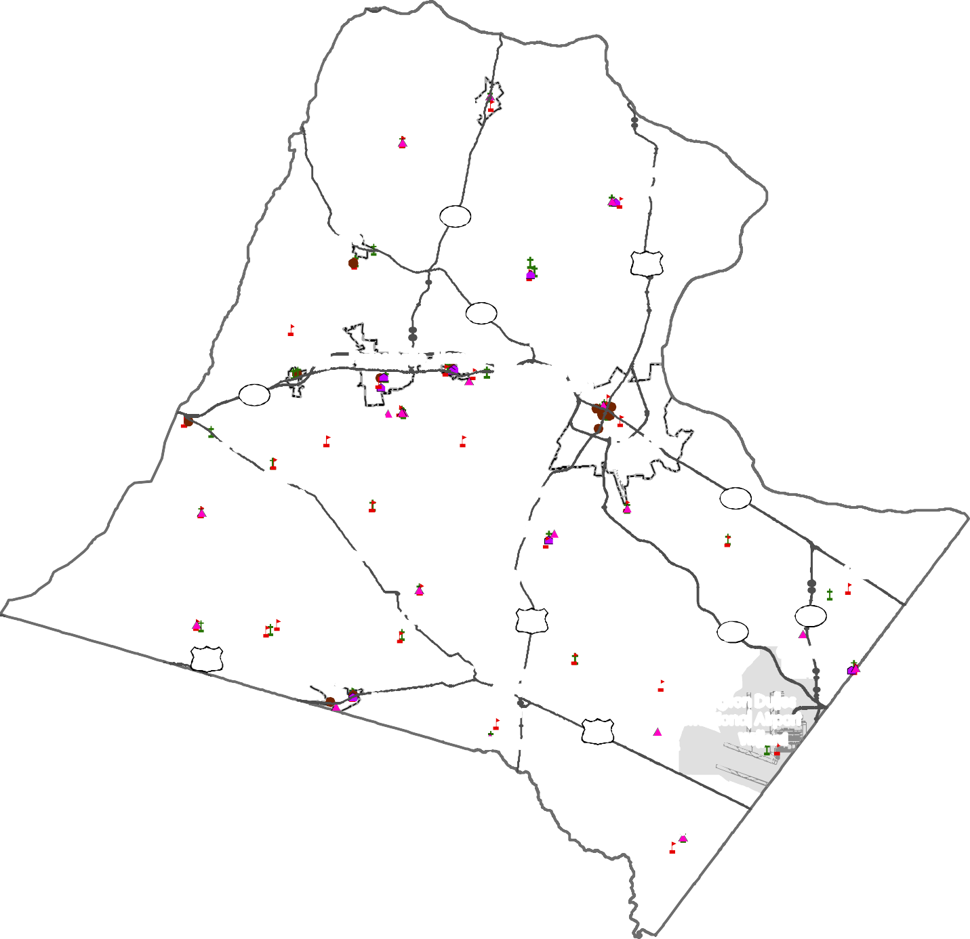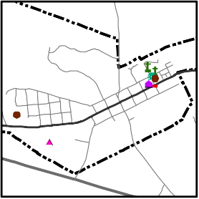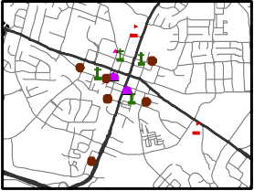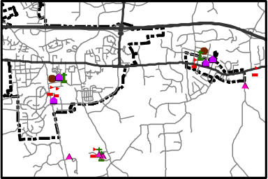Cemetery Church Fraternal Lodge
Government Office
Predominantly Black Neighborhood School
Biracial Community
Predominantly Black Community

Lovettsville Britain
(Guinea) Mt Pleasant
(Scattersville)

Leesburg

Hillsboro
287
Waterford 15

9
Ivandale
Paeonian Springs
Irene

Round Hill
7
Purcellville
Hamilton
Brownsville
(Swampoodle)

Bluemont
Murphy's
Cooksville
Guinea Hill
Lincoln

Hughesville

Leesburg

Corner
Powell's
Grove

Rock Hill
Guinea Bridge
Greggsville Trammeltown
Gleedsville

7
Sycolin

Howardsville

Willisville
(Austin Grove or Midway)

St Louis
Tylertown Turnertown
Marble Quarry Berryman 15
Little Washington
Ashburn (Farmwell)

28
267

Nokesville

50 Brown's

Dover

Back in
Watson
Oak Grove

Middleburg Corner
Macsville
the Hollow Stewarton
Bowmantown 50

Washington Dulles International Airport
Willard

Ivandale Irene

Conklin

Purcellville/Hamilton

Middleburg

Im pa i r ed S t r ea ms
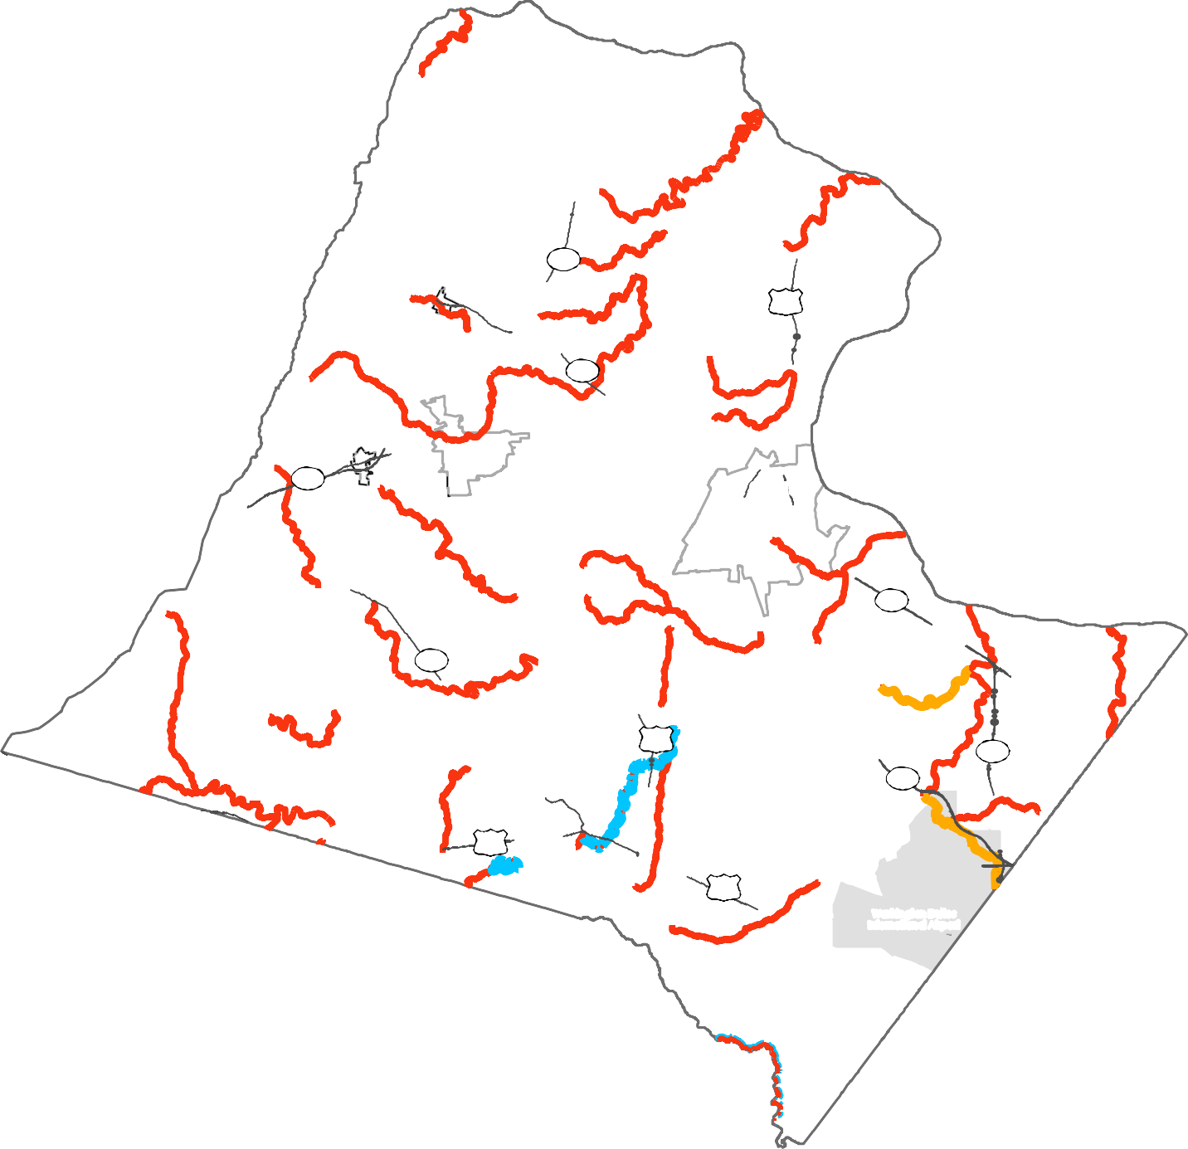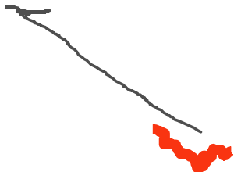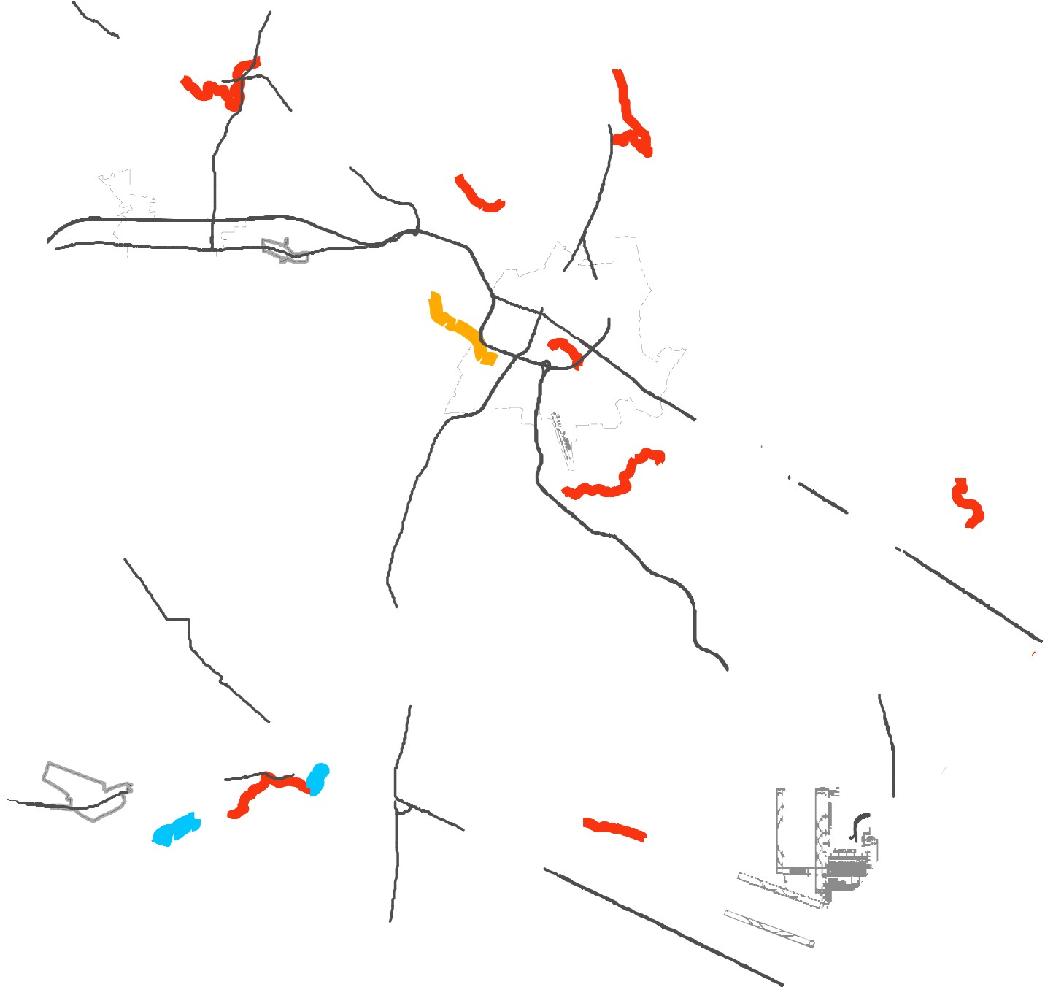2040 General Plan

2016 Impairments
2014 Impairments
2016 Delisted Impairments

Lovettsville
Stream impairment data is based on Virginia Department of Environmental Quality’s (DEQ) 2016 305(b)/303(d) Water Quality Assessment Integrated Report. As stream impairments are evaluated and summarized by DEQ biennially, please refer to the DEQ’s website for current stream impairment information.

287

Roun
Hillsboro
15

9

d Hill

Hamilton Leesburg
Purcellville

7

734

15
28
267

Middleburg
50

50
Washington Dulles International Airport

7

I

I

Loudoun County
Li me st o ne
Ove r la y Di st r i ct
2040 General Plan

Lovettsville  287  9  Hamilton | 15  Leesburg | 7 | 28 |  | Limestone Overlay District

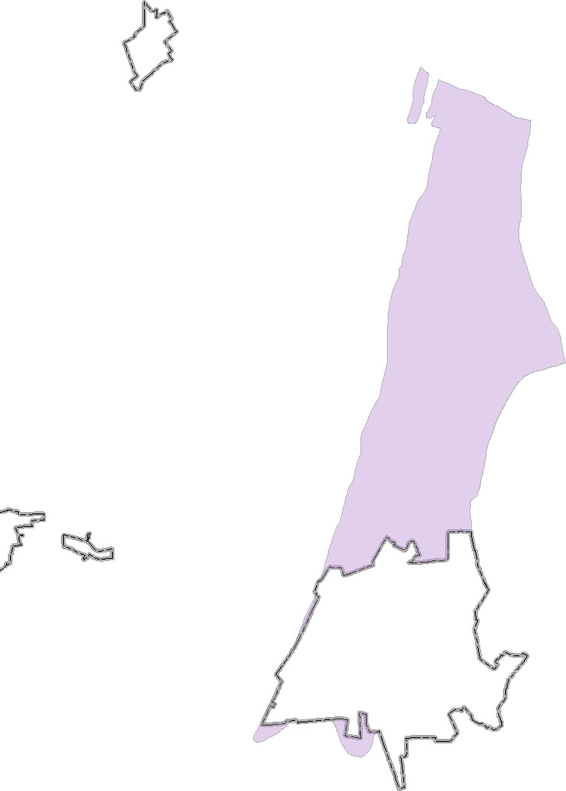Loudoun County IS NOT LIABLE for any use
of or reliance upon this map or any information contained herein. While reasonable efforts have been made to obtain accurate data, the County makes no warranty, expressed or implied, as to its

0 0.5

1 2 3 4

Miles

D R A F T

