Rural Policy Area

Vision
The Rural Policy Area (RPA) is an enduring rural landscape that is characterized by a unique composite of natural and man-made environments, rural economy uses, working agricultural lands, open space, and a limited residential base.

Introduction
The RPA occupies the western half of the County and is the largest of the County’s Policy Areas. It encompasses approximately 230,000 acres, representing about 67 percent of the County’s total land area. The RPA comprises a blend of low-density residential, working farms, rural economy uses, pastoral landscapes, forested areas, mountains, and wildlife habitats. The RPA encompasses six of the County’s seven incorporated Towns, 12 existing Rural Villages, and numerous smaller crossroad communities. As of April 1, 2017, the population of the RPA is approximately 40,400 people, representing approximately 10 percent of the County’s total population.
The RPA is divided into two areas—the Rural North and the Rural South. Each of these distinct geographic areas (see Rural Policy Area Place Types Map) has different base residential densities in response to their dominant rural land use and development patterns. The Rural North (geographically defined as north of Goose Creek and the North Fork of Goose Creek to the County border with Montgomery, Frederick, and Washington Counties, Maryland; Jefferson County, West Virginia; and Clarke County, Virginia) is characterized by a mix of smaller lots that are interspersed with larger parcels that are still in agricultural use. The Rural North, proximate to the Towns within the Route 7 Corridor, has the highest concentration of residential development and a more developed paved roadway network with easy access to commuter routes. Additionally, the Route 15 corridor, both north and south of the Town of Leesburg, has experienced substantial residential growth since the Board adopted the Revised General Plan in 2001. The Rural South (defined generally as south of Goose Creek and the North Fork of Goose Creek to the County border with Clarke, Fauquier, and Prince William Counties, Virginia) is characterized by an existing large lot pattern and represents the center of Loudoun’s prominent equine industry. The Rural South contains a number of large working farms that are accessed by a network of mostly unpaved rural roads. The Rural South contains Loudoun County’s largest amount of permanently protected land that is held under voluntary conservation easements. Both the Rural North and Rural South are marked by a scattering of Rural Villages and small crossroad communities, which provide limited retail and commercial services to rural residents and visitors.
Approximately 700 miles of public roads maintained by the Virginia Department of Transportation (VDOT) serve the RPA. Unpaved gravel roads constitute approximately 255 miles of this road network – the most of any county in Virginia. VDOT, in collaboration with the County, has worked to maintain the delicate balance between service needs and the preservation of the aesthetic character of the road network in the RPA, providing adequate transitions from major rural highways to main streets to rural paved and unpaved road segments. Specific long-range plans and local projects have generally sought to maintain two-lane rural section roadways along most rural

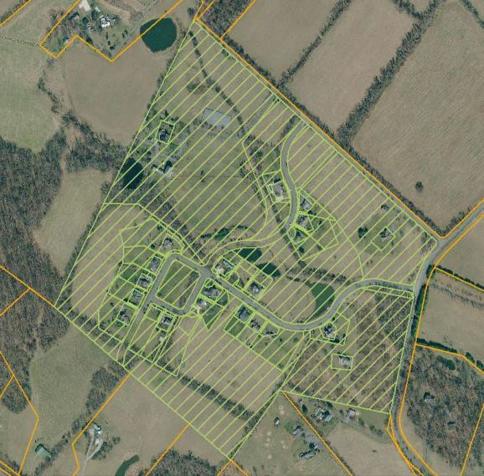corridors, while providing improvements to major commuter routes. These include the Virginia Scenic Byway program; national and state historic district designations; traffic calming projects at appropriate locations; the VDOT Rural Rustic Roads Program; and the incorporation of low- impact modern improvements, such as roundabouts, in lieu of traffic signals and interchanges. As increased demand and growth continues to place stress on the rural road network, the County will need to make comprehensive and strategic decisions regarding the best ways to provide reasonable mobility, while protecting the rural character and scenic quality of rural roads in the RPA (see Loudoun 2040 Countywide Transportation Plan).
The Rural North and Rural South are home to a centuries old farming community that shaped the physical landscape and the social and economic fabric of Loudoun. However, over the past 30 years, as portions of the County and the region have become more urbanized, the RPA has faced increased challenges related to demographic changes, land use, economics, and transportation improvements, thus facilitating and enabling the conversion of land for rural residential subdivisions at an increasing rate as some residents seek an alternative to urban life. The adoption of the Revised General Plan in 2001 and the accompanying down-zoning of the majority of the land in western Loudoun in 2003 and in 2006, marked a dramatic turn in the County’s effort to limit residential development in the RPA and established an approach for land preservation tied to the creation of a viable rural economy and the clustering of homes to preserve the rural character of the land. The Loudoun 2040 General Plan carries this approach forward.

Rural Residential
A variety of residential development options exist within the Rural Policy Area, including conventional subdivision, spin-off lots, and rural clusters which permit different densities. Among the existing subdivision options, rural clusters remain the preferred residential development pattern in the RPA because these designs better preserve the natural features and open character of the land by tightly grouping homes on smaller lots so that a majority of the land is available for rural economy uses, agriculture, and/or open space. The concentration of homes in a rural cluster also minimize the amount of roads, clearing and grading, and the overall footprint of development, in comparison to a conventional by-

right subdivision which require placement of homes on a uniform size lot dispersed over an entire property.
Birch Hollow Hamlet, Hillsboro. Clustered residential lots with remainder working farm on 109 acres.

Between 2000 and 2016, 5,653 residential units have been built in the RPA. The “build out” analysis for the RPA, which reflects conditions as of July 1, 2016, identifies 91,000 acres of land uncommitted to development projects. This results in the potential for up to 11,643 residential units under current policy and entitlements. The acreage calculation includes parcels that are

partially or fully developable and excludes floodplain, conservation easements, mountainside, and steep slope, which do not have development potential. The forecasted development from 2016 to 2040 in the RPA is 7,500 residential units based on current trends and the base density allowed by current zoning, which leaves approximately 4,000 residential units to be developed after 2040. The 2040 forecasts and the ultimate residential buildout for the RPA may be much lower than projected above if property owners continue to retain and preserve large areas of land for agricultural, equine activities, open space, and rural economy uses. Land trusts are anticipated to continue establishing conservation easements on properties in the RPA, reducing the residential development potential allowed by current zoning. Current and future county policies and initiatives, including land use- based property tax assessments and land conservation programs, may also affect future development potential in the RPA.

Rural Economy
The County’s land development approach for the RPA is to limit residential development so that land will remain available for the continued operation, expansion, and establishment of agricultural and rural economy uses that preserve the rural character of the landscape and support the County’s environmental goals. Loudoun’s rural economy has grown to become a collection of business uses that currently include: crop and livestock production, forestry, horticulture and specialty farm products, farm markets and wayside stands, the equine industry, orchards, vineyards, farm wineries, cideries, and breweries, hospitality services such as farm-to-table restaurants, rural resorts, bed and breakfasts, country inns, banquet/event facilities, private camps and parks, and other similar uses. These rural economy uses largely depend on the agricultural productivity, scenic quality, and rural character of the RPA to derive income to sustain business activities. Additionally, a range of businesses providing either direct or indirect support and services to agricultural, forestal, horticultural, and animal husbandry activities also contribute to the rural economy. These agriculture-supportive uses include farm machinery sales and repair services, veterinary services, blacksmiths, agricultural product storage and processing, feed and seed supply, and similar uses. The importance of all these rural businesses to Loudoun County has led to the implementation of a business development plan for the County’s rural economy that aims to double the growth of the County’s rural economic sectors by 2023. The business development plan strives to create an environment for high value agricultural production that supports the equine and tourism industries, maintains prime farmland, and recognizes that commercial growth in eastern Loudoun is augmented by a thriving rural economy in western Loudoun (see The Long View, A
Business Development Plan for Loudoun County’s Rural Economy).

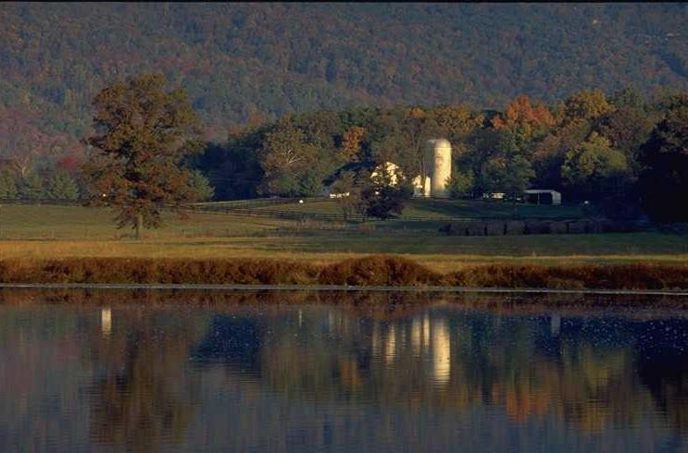The 2012 Federal Census of Agriculture identified 1,396 farms in Loudoun County (gross income of $1,000 or more) with a total of approximately 135,000 acres of farmland in production. Over half of these farms (824) were less than fifty acres in size and a quarter of the farms (301) were between fifty and one- hundred and seventy-nine acres. These numbers are slightly down from 2007 when the County identified 1,427 farms with a total of 142,452 acres of farmland

One of Loudoun County’s working farms in the RPA.

in production. This illustrates a number of changes: 1) a shift in the type of farming in the County as land and operational costs continue to rise, 2) the subdivision of larger farms into residential lots, and 3) the decline in the number of farmers. In response to market trends, many farmers in the County have shifted to the direct marketing of agricultural products to consumers through either on-farm sales and/or farmers markets to increase profitability. These specialty farms tend to be smaller in size than traditional farms that produce row crops or raise livestock. These farms include a number of pick-your-own farms which may have fruits, vegetables, flowers, Christmas trees, and other farm-grown products available to the public. A number of farms have also implemented Community Supported Agriculture (CSA) programs where people buy a subscription from a farmer to receive a weekly share of local seasonal produce, meats, and other products (depending on the farmer’s offerings).
The equine industry is a major component of the rural economy. Loudoun County leads the state in the number of horses, and the equine industry is the County’s largest agricultural employer providing thousands of jobs associated with the care of these animals and the operation of barns and stables. The Virginia Tech Marion DuPont Scott Equine Medical Center is located north of Leesburg, with Morven Park, Glenwood Park, and Oatlands providing regional venues for horse events. Other smaller stables are scattered throughout the County, which provide private lessons, boarding, trail rides, and camps, and host smaller events.
Loudoun County has the highest concentration of wineries in Virginia, with over 45 wineries and 738 acres in vineyards as of 2017. Loudoun County has been marketed as ‘DC’s Wine Country’, though it also has the highest number of breweries in the state. The County has a total of 28 breweries, seven of which are farm breweries located within the RPA. Black Hops Farm, located near Lucketts, is the site of the region’s first hops processing center and Virginia’s first dedicated malting operation. As of 2017, there are 10 hops yards in the County with 16 acres in production, and there are two growers cultivating 140 acres of malting grain for the production of beer and distilled spirits. Farm wineries, breweries and cideries that grow their own products maintain significant amounts of land in agricultural use which protects the rural character of the RPA.
The RPA is home to a number of hospitality and tourism businesses, which provide thousands of jobs and contribute millions of dollars to the local economy through visitor spending on

restaurants, retail goods, lodging, and the hosting of weddings and events. County-sponsored events such as the Spring and Fall Farm Tours, Stable Tours, Wine Trail, Ale Trail and Artisan Trail allow visitors to enjoy self-guided driving tours which support local growers, producers and artisans. Numerous community events such as the Bluemont and Waterford fairs draw thousands of residents and visitors to western Loudoun annually. Heritage tourism is also an important contributor to the County’s economy, which include the Journey Through Hallowed Ground National Heritage Area and National Scenic Byway, the Waterford National Historic Landmark District, Balls Bluff Battlefield and National Cemetery, Morven Park, Oatlands, Aldie Mill, as well as other historic sites, museums and battlefields. Like many of Loudoun’s other rural business uses, these hospitality and tourism businesses rely on the natural, scenic, and rural character of the RPA to attract visitors. Therefore, it is critical to maintain the natural and heritage resources that provide the setting and context for our rural tourism economy.

Farmland Preservation and Protection
To support the rural economy and ensure that agriculture continues as a long-term use in the RPA, the County will continue to develop and support voluntary participation in programs that provide assistance and reduced tax burdens to landowners. Such programs and measures as the Land Use Assessment Program, the Agricultural and Forestal District (AFD) program, and public/private conservation easements will be used to encourage landowners to use their land to expand the rural economy, rather than convert it to residential use. These programs also assist in the protection of the RPA’s unique manmade and natural environment, which directly benefit the rural economy.

The County’s Land Use Assessment Program and AFD program are tools used to protect agricultural lands and forests. The Land Use Assessment Program provides tax relief to landowners to protect farmland for future agricultural use and to protect historic and scenic resources for the economic and cultural benefits derived from their preservation. The AFD program limits the subdivision of large, farmable acreages and forested lands (typically 20-40 acres), and prohibits cluster subdivisions. While the County’s Land Use Assessment Program and the AFD rogram support keeping land in production and/or open space for a specified number of years, they are voluntary programs that do not preserve land in perpetuity. The only means of preserving agricultural land and open space permanently is through the establishment of conservation easements on individual properties, which restrict residential and non-agricultural uses. Conservation easements currently preserve over 70,000 acres in the County, the vast majority of which are held by private land trusts. The County should commit to supporting efforts to increase the total acreage of land held in conservation easements as part of an overall land use strategy to further reduce density in the RPA, and ensure that farmland and open space are available in perpetuity for future generations. The County may consider implementation of programs such as the Purchase of Development Rights (PDR) program, cost-share initiatives to assist in establishing conservation easements, and/or public/private partnerships with existing land trusts to leverage efforts and funding to support the recordation of additional conservation easements.

Future of Rural Strategy
Loudoun County and its citizens continue to recognize the importance of maintaining and preserving the farming and equine heritage, cultural and natural resources, open space, and scenic beauty of the RPA as a fundamental component of the County’s identity. The RPA contributes to the overall economic vitality of the County and quality of life of its residents. The County’s current growth management approach, which is being carried forward in this Loudoun 2040 General Plan, has been successful in limiting residential growth and sustaining the rural economy. This approach has contributed to the County’s economic success through attracting businesses, residents, and visitors while maintaining the character of the RPA. The strength of the agricultural sector and the rural economy is a critical component of supporting the economic development and fiscal policy goals of the County. In the future, development pressures and the incremental loss of productive agricultural land to residential development will require continued monitoring by the County to maintain the RPA’s unique character.

Place Types
As described in the beginning of this chapter, the following Place Types have been designated for specific locations as displayed on the accompanying map. The Place Types will work in concert with the Design Guidelines and Policies, Strategies, and Actions of the RPA and Rural Villages to fulfill the land use patterns and community characteristics intended for the area.

Loudoun County
Ru ral Po l icy Are a Pla ce T y pe s
2040 General Plan

Policy Areas
Parks & Recreation
Place Types
Rural North Rural South Rural Village

LOUDOUN HEIGHTS

Lovettsville

NEERSVILLE

TAYLORSTOWN

Round Hill

Hillsboro

Purcellville

287

9

WATERFORD

PAEONIAN SPRINGS
LUCKETTS

15

7

BLUEMONT

Sleeter Lake
Hamilton
LINCOLN
Leesburg

7
PHILOMONT
734

ST LOUIS

Middleburg
50

15

ALDIE

Beaverdam Reservoir

267

BOWMANTOWN
50

Washington Dulles International Airport

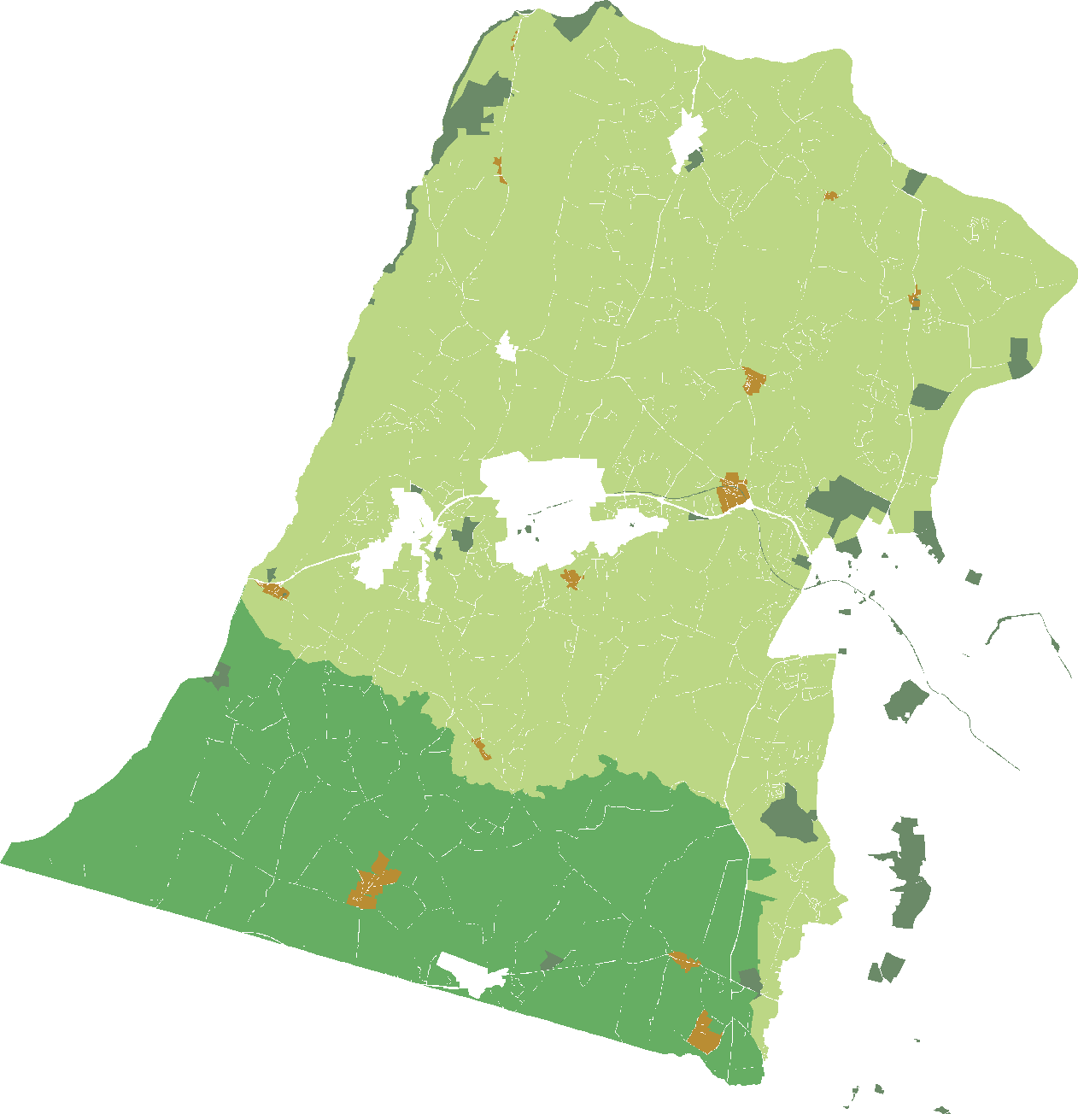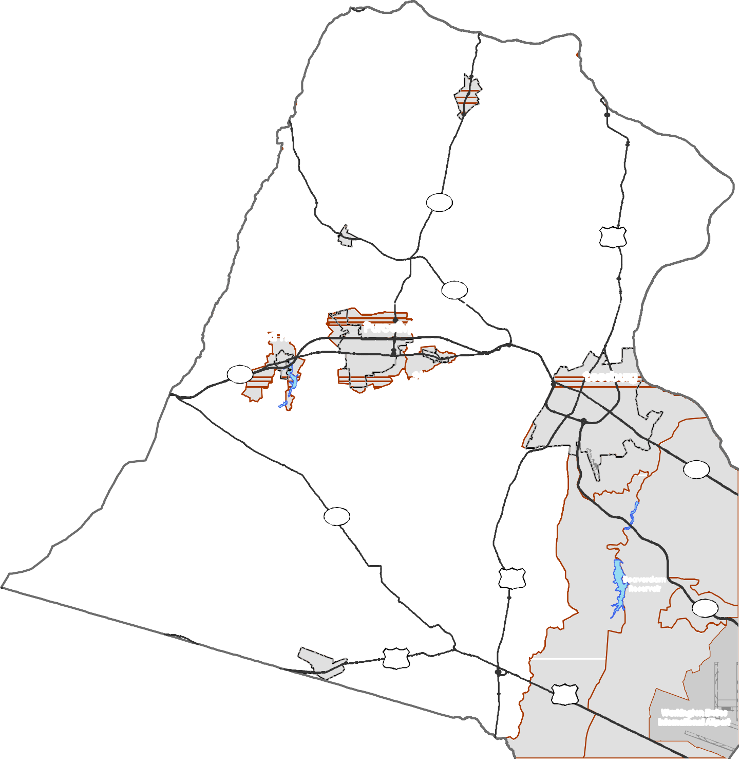Loudoun County IS NOT LIABLE for any use
of or reliance upon this map or any information contained herein. While reasonable efforts have been made to obtain accurate data, the County makes no warranty, expressed or implied, as to its
accuracy, completeness, or fitness for use of any purpose.

0 1 2 4 6 8
Miles
Map N um be r 20 18 -152

D R A F T

Rural North

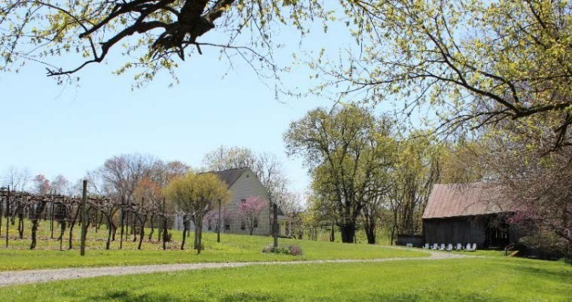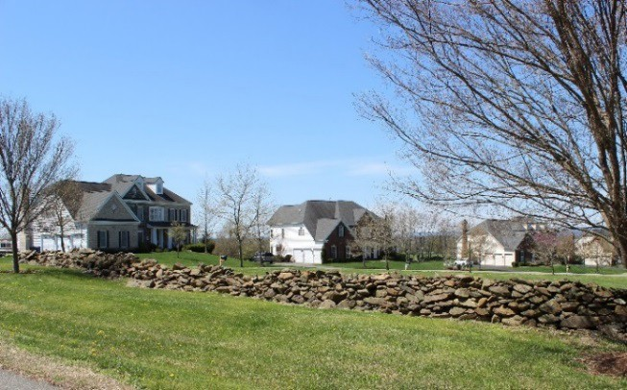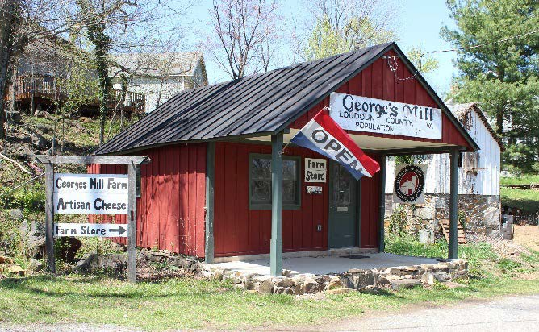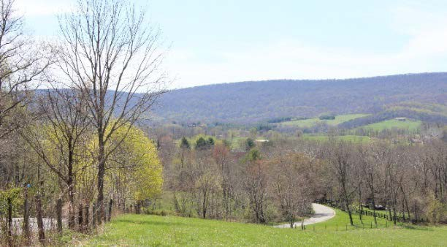The Rural North consists of pastoral and forested landscapes that serve mostly agricultural and agricultural supportive uses with limited residential. The area allows for complementary agricultural, rural business, and tourism uses that constitute Loudoun’s rural economy. This category also includes low-density, large-lot residential subdivisions that are compatible with the surrounding pastoral character, and subdivisions that cluster smaller residential lots while retaining large lots for open space, agricultural production and/or rural economy uses. Public utilities are not provided, but shared water and wastewater systems are encouraged for cluster developments and rural economy uses. Minimum lot sizes vary according to land use and the development option chosen. All developments should incorporate natural and heritage resources while preserving important viewsheds that contribute to the rural landscape through a conservation design approach.

Predominant Uses | Secondary Uses
- Agriculture  - Agricultural Supportive Businesses  - Equine Facilities  - Rural Economy | - Large Lot Residential  - Clustered Residential Subdivision  - Accessory Residential Units  - Agritourism  - Rural/Heritage Tourism  - Public Facilities  - Civic, Cultural & Community  - Institutional

DESIGN CHARACTERISTICS

Context
Large areas of land preserved for open space, agriculture, and rural economy uses to retain the rural character of the area with limited low-density residential and clustered residential development that blends with and is compatible with the surrounding area.
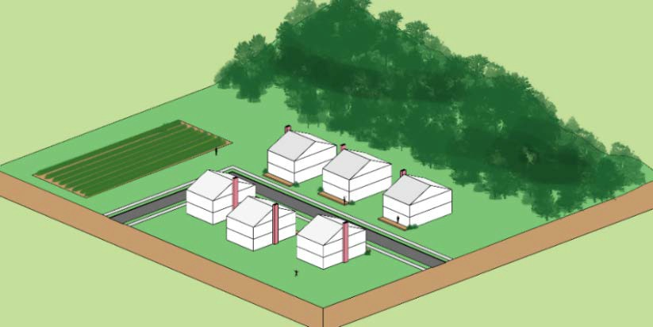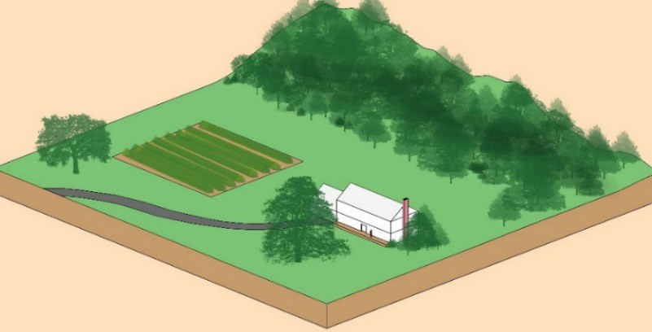

Place Type Rendering
An oblique projection of development within a Place Type to showcase the qualitative characteristics of how buildings within the Place Type should interact to create activity.

Residential Density: Up to 1 du / 20 acres
Residential Cluster Option: Up to 1 du / 5 acres equivalent Building Height: Up to 2 stories
Street Pattern:
Contour Forming, Fragmented Parallel
Block Length: Irregular (0.5-5 mile) Building Setback:
Varies (incorporate existing natural features to protect viewsheds)
Parking:
Surface lot, driveway, garage, shared
Open Space:
Working farms, natural areas, and open space 70% of site for clustered subdivisions

Transition
Locate buildings and structures to blend with the existing topography and natural features. Preserve and incorporate existing trees and vegetation on the property and its perimeter to buffer and screen views for adjoining properties. Provide landscaping or supplemental plantings comprised of native species when screening and buffering are required between rural uses.

Rural South

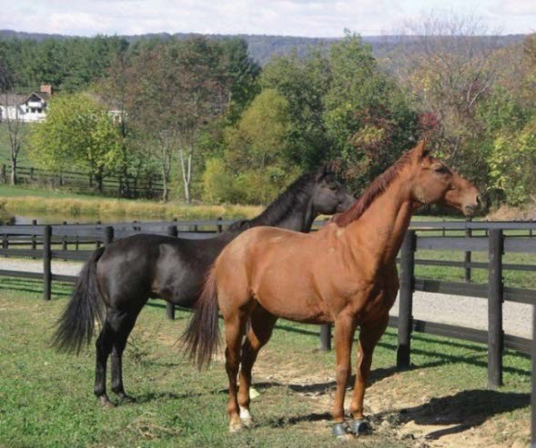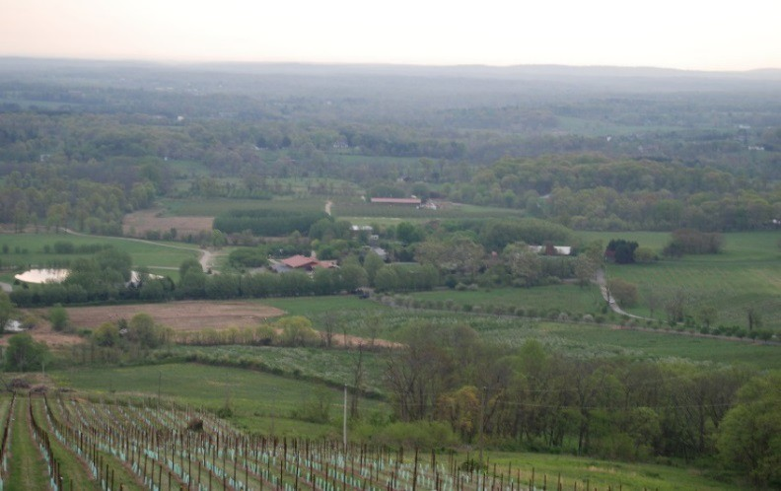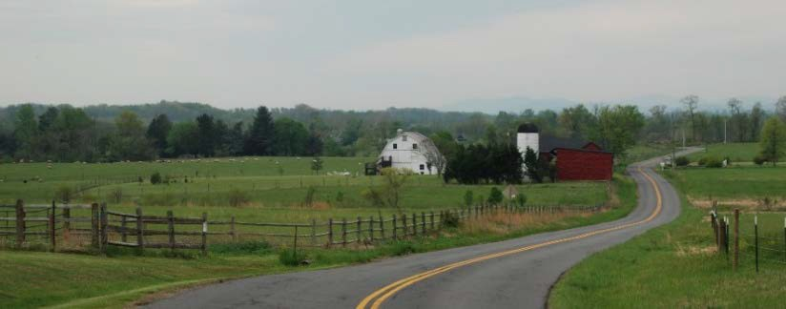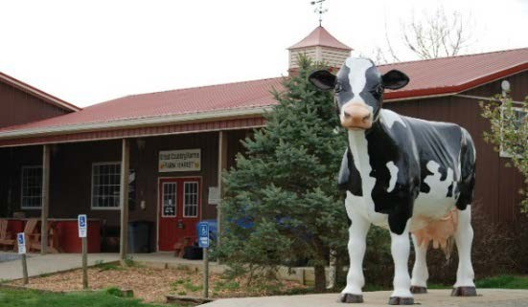The Rural South contains mostly agricultural and equine uses and allows for complementary rural economy uses. This Place Type includes very low-density residential with homes located on large lots that are compatible with the surrounding pastoral character and clustered subdivisions that group smaller residential lots while retaining large lots for open space, agricultural production, and/or rural economy uses. Public utilities are not provided, but shared water and wastewater systems are encouraged for cluster developments and rural economy uses. Minimum lot sizes vary according to land use and the development option chosen. All developments should maintain the distinctive rural character through the incorporation of natural and heritage resources and the preservation of important viewsheds through a conservation design approach.

Predominant Uses | Secondary Uses
- Agriculture  - Agricultural Supportive Businesses  - Equine Facilities  - Rural Economy | - Large Lot Residential  - Clustered Residential Subdivision  - Agritourism  - Rural/Heritage Tourism  - Accessory Residential Units  - Public Facilities  - Civic, Cultural & Community  - Institutional

DESIGN CHARACTERISTICS

Context
Large areas of land preserved for open space, agriculture, and rural economy uses to retain the rural character of the area with limited low density residential and clustered residential development that blends with and is compatible with the surrounding area.
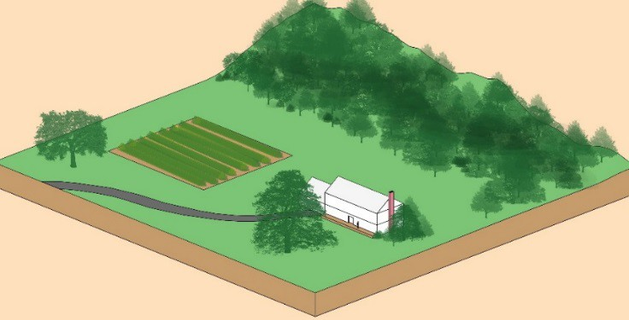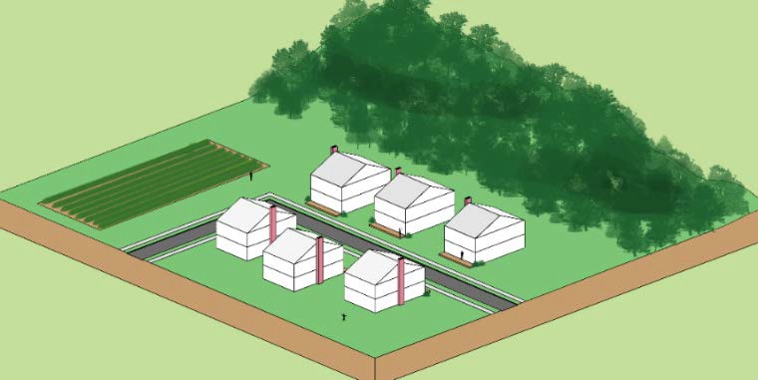

Place Type Rendering
An oblique projection of development within a Place Type to showcase the qualitative characteristics of how buildings within the Place Type should interact to create activity.

Residential Density: Up to 1 du / 40 acres
Residential Cluster Option: Up to 1 du / 15 acres equivalent Building Height: Up to 2 stories
Street Pattern:
Contour Forming, Fragmented Parallel
Block Length: Irregular (0.5-5 mile) Building Setback:
Varies (incorporate existing natural features to protect viewsheds)
Parking:
Surface lot, driveway, garage, shared
Open Space:
Working farms, natural areas and open space 70% of site for clustered subdivisions

Transition
Locate buildings and structures to blend with the existing topography and natural features. Preserve and incorporate existing trees and vegetation on the property and its perimeter to buffer and screen views for adjoining properties. Provide landscaping or supplemental plantings comprised of native species when screening and buffering are required between rural uses.

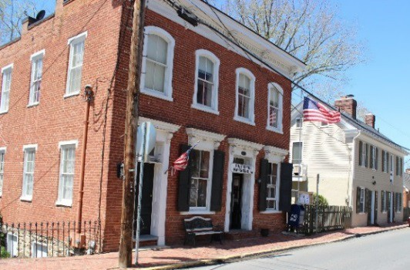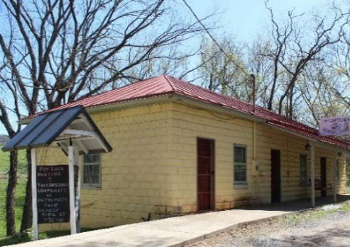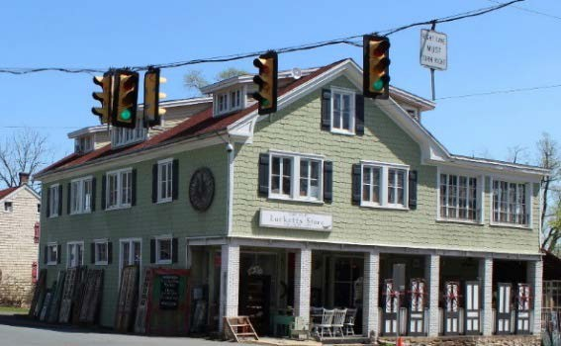

Rural Villages

Rural Villages consist of small, pedestrian-scale rural communities that are compact in comparison to the surrounding agricultural landscape. The majority of these villages have developed around a small residential and/or commercial core that provide for the daily needs of village residents, surrounding rural residents, and visitors. Villages are characterized by low-density residential development situated on smaller lots interspersed with limited commercial uses. Residential and commercial uses are generally located in detached stand-alone two-story buildings which are located close to the street. In some instances office or residential uses are located above first floor retail. Each Rural Village has its own unique character linked to its historic development pattern, spatial organization, and location within the County.

Spacing of buildings—both commercial and residential—should respect each village’s historic precedents for lot size, building setbacks, and orientation to the street. Buildings should be designed to be sensitive to the context of the village through compatible siting, size, scale, massing, materials, design details, and roof forms.

Predominant Uses | Secondary Uses | Ideal Mix of Uses
- Single Family Detached Residential  - Retail & Service Commercial | - Office  - Live/work units  - Civic, Cultural, & Community  - Rural/Heritage Tourism  - Rural Economy  - Accessory Residential Units  - Public Facilities | Non Residential 30%  Residential 70%  Possible Ranges: Res: 60-80%  Nonres: 20-40%

DESIGN CHARACTERISTICS

Context
Small-scale and often historic buildings sited in a compact pattern that contain residential or commercial uses that may also be vertically mixed. Each Rural Village has a unique character and sense of place that should be preserved and enhanced.

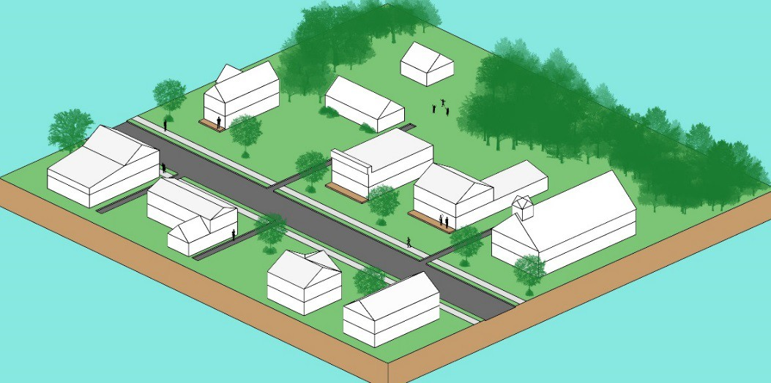Transition

Place Type Rendering
An oblique projection of development within a Place Type to showcase the qualitative characteristics of how buildings within the Place Type should interact to create activity.

Residential Density: Varies by individual village; no more than 4 du / acre Building Height: Up to 2 stories
Street Pattern: Rectilinear Grid Block Length: 100-600 feet Building Setback: Shallow
Parking:
On-street, driveway, garage
Open Space:
Community Green and natural areas.
Maintain areas of open space and natural areas on the perimeter of the villages to maintain a hard edge and visual separation from surrounding uses. Within the village, preserve existing trees and vegetation, which define building lots and contribute to the streetscape. New construction should be designed to complement surrounding properties and maintain the existing development pattern within the Village.

Policies, Strategies, and Actions
Unless otherwise specified, the following Policies, Strategies, and Actions apply only within the RPA.

Land Use & Development

RPA Policy 1: Foster land use and development patterns that incorporate natural, cultural, heritage, and agricultural resources to preserve character-defining features of the rural landscape while providing opportunities for rural living and businesses.
Strategy
  - Support uses that protect, preserve, and enhance natural areas and open space, retain farmland and the vitality of the rural economy, and foster a high quality of rural life for residents.
Actions
    - Incentivize the consolidation of underutilized or undeveloped small lots into larger parcels for agricultural and rural economy uses.
    - Use public funds to create public and private conservation easements, in order to reduce the land that is available for residential development and to provide landowners with financial options to support working farms, rural economy uses, and/or stewardship of the land.

Rural Residential

RPA Policy 2: Limit residential development to protect the land resource for agricultural operations, rural economy uses, and open space uses; minimize traffic impacts; and reduce the demand for additional public facilities and services.
Strategy
  - Where residential development does occur in the RPA, it should be designed to preserve the rural character, work with the land form to preserve and protect natural features, and conserve land for agriculture, rural economy uses, passive recreation, and open space.
Actions
    - Establish subdivision regulations and design standards that improve the design of subdivisions and clustered residential development by incorporating a Conservation Design approach.
    - Establish regulations and design standards to facilitate publicly accessable and connected open space.
    - Educate property owners about alternatives to residential subdivision by providing information on conservation easements, the Land Use Assessment Program, and other efforts to keep rural properties intact and productive.

Rural Economy

RPA Policy 3: Agricultural and rural business uses that are compatible with the predominant land use pattern will be developed in a manner that is consistent with the County’s growth management, economic, and environmental goals.
Strategy
  - Ensure compatibility of rural economy uses through the evaluation of the scale, use, intensity, and design (site and building) of development proposals in comparison with the dominant rural character and adjacent uses.
Actions
    - Adopt zoning regulations and development standards for rural economy uses. Such regulations and standards will address traffic capacity limits, safe and adequate road access, number of employees, site design standards (i.e., land disturbance, buffering, use intensity, siting, and architectural features), and public health, safety, and welfare.
    - Allow the establishment and/or expansion of existing commercial, industrial, and institutional uses by Special Exception if the use and/or expansion is: 1) small in scale and compatible with the rural character, 2) preserves ridgetops, natural resources, farmland, and open space, and 3) meets applicable zoning regulations and development standards.
    - Non-agricultural commercial uses may be permitted by Special Exception if the use is compatible in scale and intensity with the agricultural and rural character of the area; poses no threat to public health, safety, and welfare; and helps to preserve farmland, open space, and/or continued agricultural operations.
Strategy
  - Promote the retention and development of rural business uses that sustain the rural economy and support the County’s agricultural and equine industries.
Actions
    - Adopt zoning regulations and development standards that include new types of rural business and agricultural uses, permit flexibility for the sale of farm products, and promote rural tourism, hospitality uses, and similar kinds of rural business uses that are compatible with the character of the RPA.
    - Develop zoning standards to permit a variety of residential unit types, including accessory apartments for seasonal farm laborers and year-round tenant housing, that support the rural economy.
    - Create zoning regulations and development standards for existing and new types of rural recreational uses to evaluate their appropriateness and ensure their compatibility with the character of the RPA.
    - Develop County parks with trail networks, cross country courses, and equestrian riding rings or other equestrian-related features.
    - Develop a publicly accessible multi-use trail network (i.e., pedestrian, bicycle, and

Strategy

equestrian) to link private and public lands in the RPA in partnership with nonprofit entities, landowners, and developers of rural properties.

  - Promote and expand agricultural enterprises and the rural economy, and attract rural entrepreneurs to locate in Loudoun.
Actions
    - Promote rural business sectors and community events to support rural tourism, showcase the rural economy, and strengthen the economic vitality of rural businesses, villages, and towns.
    - Develop a coordinated service approach to assist rural landowners in the review and development of proposals to maintain agricultural operations, preserve the agricultural potential of farmland, institute farm and rural business plans, and assist in filing applications, which support agriculture, agricultural activities, and the rural economy.
    - Retain the Rural Economic Development Council (REDC) as an advocacy and advisory committee on initiatives, programs, and policies that affect the economic growth and development of rural Loudoun County.
    - Support public education and job training in agriculture-based careers to ensure a stable agricultural work force and promote the region’s agricultural and tourist based economy.
Strategy
  - Maintain the Land Use Assessment Program to provide property tax relief to retain and support agriculture, horticulture, forestry, and open space as critical components of the RPA.
Actions
    - Regularly review, update, and enhance the Land Use Assessment Program and other voluntary agricultural programs, such as the AFD program, to strengthen the rural economy, preserve rural character, and maintain the viability of farming.
    - Develop additional incentives to retain and encourage agricultural enterprises and support land preservation.
Strategy
  - Promote and encourage the preservation, rehabilitation, and repurposing of farm buildings and structures to maintain infrastructure for future agricultural enterprises and rural economy uses. Where possible, rural business uses should locate in existing agricultural and historic structures.
Action
    - Adopt zoning regulations and development standards to facilitate the use of existing agricultural and historic structures.

Strategy
  - Support and increase farming activities and maintain a resilient food network for local consumption.

Actions
    - Promote community supported agriculture (CSA); the direct sale of farm products between farmers and local consumers including farmers markets, local restaurants and retailers; and the establishment of a permanent year-round indoor farmers market in the eastern portion of the County.
    - Facilitate effective distribution and assist in the marketing of locally grown products.
    - Promote best practices in farming, including adapting to new crops, livestock, and technology, to address market demands and diversify agricultural production.
Strategy
  - Protect farming and farmers from nuisance complaints in accordance with the provisions of the Right to Farm Act, Code of Virginia §3.2-301.
Actions
    - Develop zoning regulations and design standards that protect the right to farm.
    - Support and provide educational programs about farming practices and activities to reduce potential conflicts associated with the proximity of agriculture to nonagricultural uses.

Design Guidelines
The Design Guidelines are to build upon our current development patterns in a manner that allows innovative design and new responses to the market. While the Design Guidelines are not regulatory requirements, the County prefers that all future developments comply with these guidelines. The Design Guidelines do not supersede or otherwise limit the application of adopted zoning regulations, ordinances, building codes, or any other design standards or regulations administered by Loudoun County.
When using the guidelines make sure to analyze the impact a potential development may have on the landscape, considering not only appearance, but practical considerations such as proximity to roads, utilities, and community amenities to maximize the use of existing infrastructure and limit travel distances. Development should contribute to creating unique places within the Rural Policy Area by working with existing topography and site features, responding to the local context, and reinforcing the landscape’s character, rather than simply attempting to place suburban design onto the rural landscape. Sustainability requires maximum consideration for using the landscape for benefits such as solar heat gain or shelter from wind when siting buildings. It is imperative that buildings and structures are treated as objects in the rural landscape and given due attention to their location and form to ensure they blend with the topography, protect viewsheds, and contribute to the traditional pattern of development in the RPA. The County encourages the adoption of a conservation design approach when planning development in the RPA so that natural and heritage resources are conserved and incorporated into the site design. Unless otherwise specified, the following guidelines apply only within the RPA:
- Development on ridgelines or hill tops should be avoided to retain the rural character of the landscape and protect viewsheds.

- Site development to preserve existing land forms and minimize significant alterations to the topography while incorporating natural features, trees, hedgerows and other vegetation into the design to protect viewsheds and provide visual buffers between parcels.
- Locate development within the landscape to minimize visibility from roadways and other properties.
- Limit the use of outdoor lighting to areas where activity occurs and use the minimum light intensity necessary to eliminate glare and light trespass.
- Provide trail connections when feasible to link private and public lands as part of a multi- use trail network.
- Rural Cluster subdivisions are a land development design that compactly groups homes on lots as small as a quarter acre in a traditional community pattern while retaining large tracts of land for open space, agricultural production, and/or rural economy uses to preserve natural features and the rural character. When developing Rural Cluster subdivisions in the RPA:
  - Use existing topography, hedgerows, mature woodlands, and other site features to influence the location of the clusters to maintain the rural and scenic quality of the landscape.
  - Vary lot sizes and setbacks to provide a compact cluster of building lots and maximize open space.
  - Design roads and driveways to follow the natural contours of the land. Roads and driveways should be the minimum width necessary to provide safe travel ways.
  - Cluster development to retain large areas of agricultural soils for farming.
  - Encourage the use of shared water and wastewater systems to serve cluster developments to protect water resources.
- Site building and structures to blend with the natural landscape to reduce their perceived scale, mass, and height; thus, reducing their impact on the landscape and surrounding viewsheds.
- Buildings should incorporate architectural styles and design elements that emulate and relate to the historical and regional architecture of Loudoun which contributes to the visual quality and identity of the RPA.

Rural Villages

Vision
Rural Villages are important historic settlements that possess significant heritage, cultural, social, and economic assets that contribute to the character of the Rural Policy Area.

Introduction
The County recognizes the Rural Villages as important features of the RPA that possess unique scenic and historic resources, act as gathering places for citizens, provide services to the surrounding community, and support rural tourism. The existing Rural Villages were established during the 18th and 19th centuries, in areas located around historic mills, railroad depots, or major crossroads that later developed as commercial and mercantile business centers that served the surrounding farming communities.
Rural Villages
Aldie

Bluemont Bowmantown Lincoln
Loudoun Heights Lucketts Neersville Paeonian Springs Philomont
St. Louis Taylorstown Waterford
The Rural Villages have gradually developed over a number of years and feature a variety of building setbacks, types, and styles as well as streetscapes that reflect the historic growth and character of the individual villages. The Rural Villages are dominated by residential dwellings with some commercial structures that have upper floor apartments and offices. Small
scale, non-residential uses, such as country stores, restaurants, antique shops, and other retail establishments that meet local needs and support tourism, are located within the Rural Villages. In addition, numerous civic uses, such as churches, post offices, community centers, fire and rescue stations, and schools, are also located within the Rural Villages.
The County’s land development approach for the Rural
Villages is to limit residential, business, and commercial activities to uses that are compatible with the historic development patterns, community character, and visual identity of the individual villages. Loudoun 2040 strives to maintain the traditional development pattern and distinguishing features of the individual villages while accommodating opportunities for compact, small-scale growth where appropriate in a manner that enhances existing residential and commercial areas. By encouraging limited compact, residential and non-residential development within the Villages, these policies complement the County’s efforts to preserve open space and maintain the character of the rural area. Although limited development is anticipated in the Villages, that development should not adversely affect the quality of life of residents nor pose a threat to public health or safety. Only three of the existing Rural Villages – Aldie, St. Louis and Waterford – are currently served by public community wastewater systems. Aldie is the only village that is served by a private water company. The remainder of the properties located within the Rural Villages are

currently served by individual water wells, and septic sewage systems (i.e., conventional drainfields, alternative systems, etc.), which limit the potential scale and intensity of development. Additionally, a number of the Rural Villages are bisected by major roadways that experience high volumes of commuter traffic and impact the quality of life of residents. With careful planning and growth management, the Rural Villages will maintain their scenic and historic character as well as their social and economic viability.

Policies, Strategies, and Actions
Unless otherwise specified, the following Policies, Strategies, and Actions apply only within the Rural Villages.

RV Policy 1: Development and uses in Rural Villages must be compatible with the historic development pattern, community character, visual identity, intensity, and scale of the individual villages.
Strategy
  - Encourage the retention and development of a variety of compatible residential and commercial uses that enhance the attractiveness and vitality of the Rural Villages.
Actions
    - Develop criteria to evaluate existing Rural Villages to determine if their current designation is warranted and amend the Comprehensive Plan and Zoning Ordinance as appropriate.
    - Develop small area plans and master plans for the Rural Villages to support community goals and address issues related to land use and zoning, economic development, natural and historic resources, community facilities and services, water and wastewater, and transportation to maintain the character of the villages.
    - Develop zoning regulations, design standards and guidelines to achieve compatible building and street design to ensure that quality development occurs within the Rural Villages.
    - Clearly differentiate entrances into the villages from surrounding areas through appropriate street design, landscaping, and building placement.
    - Incorporate traffic calming measures where appropriate to reduce vehicle speeds and provide a pedestrian-friendly environment within the Rural Villages.
    - Retain existing Rural Commercial (RC) zoning and consider new zoning regulations and development standards for commercial uses in the Rural Villages which are compatible with the settlement patterns and neighborhood scale.
    - Develop criteria for evaluating other crossroads communities in the RPA for designation as Rural Villages and amend the Comprehensive Plan and Zoning Ordinance as appropriate.

Strategy
  - Preserve the character of the villages and their historic structures and sites through the rehabilitation and adaptive reuse of existing buildings.
Actions
    - Promote and support building maintenance and improvements to preserve the existing building stock and the character of the villages.
    - Establish and expand the County Historic Zoning Districts for the Rural Villages.
Strategy
  - Limited increases in residential densities within the Rural Villages may be considered when the design of the project reinforces the character, development pattern, and identity of the village. Conventional, suburban forms of development are not appropriate in or contiguous to Rural Villages.
Action
    - Adopt zoning regulations and design standards to encourage traditional housing on smaller lots, allow accessory apartments attached to single-family residential units, and allow residential units above commercial/retail uses within the Rural Villages to provide housing options.
Strategy
  - Business and commercial uses in the Rural Villages should be small scale, compatible with existing development, meet local community needs and support rural tourism.
Action
    - Adopt zoning regulations, design standards and performance criteria that are specific to the types of small-scale, community-related commercial uses that the County encourages within the Rural Villages.

Design Guidelines
The Design Guidelines are to build upon our current high quality development in a manner that allows innovative design and new responses to the market. While the Design Guidelines are not regulatory requirements, the County prefers that all future developments in the Rural Villages comply with these guidelines. The Design Guidelines do not supersede or otherwise limit the application of adopted zoning regulations, ordinances, building codes, or any other design standards or regulations administered by Loudoun County.
When using the guidelines make sure to analyze the impact potential development may have on the Rural Village and surrounding landscape, considering not only appearance, but practical considerations such as road and street access, siting of buildings and parking, safe and adequate water and wastewater, community amenities, jobs, and housing to assess compatibility. Development should contribute to the unique character of the Rural Villages to integrate and blend with existing development patterns and building styles.
Many properties within the Rural Villages of Aldie, Bluemont, Lincoln, Taylorstown and Waterford are located within County Historic and Cultural Conservation Districts which are

zoning overlays that regulate the appearance of properties through architectural design guidelines. Any alterations, additions, demolition or relocation of an existing structure, or any new construction within the conservation districts requires approval from the County’s Historic District Review Committee. The goal of the architectural review processes is to ensure the historic, architectural, and landscape characteristics that are unique to the villages are protected, preserved, and enhanced for future generations. While the remainder of the Rural Villages do not have historic district zoning overlays, the County’s policies also support compatible development and the retention of the unique character of the individual villages. Public water and wastewater facilities are encouraged to provide services to the villages. The following design guidelines apply to development within the Rural Villages.
- New development should reinforce the existing pattern of streets/roads in the Rural Villages.
- The streetscape of Rural Villages should incorporate sidewalks, crosswalks, lighting, landscaping and other street amenities which enhance the pedestrian experience and contribute to the visual quality of the village.
- Sidewalk and trail networks within the Rural Villages should be expanded to provide connections to surrounding trail networks in the RPA.
- Incorporate and retain existing trees and other site vegetation, especially when these features form a visual edge defining the streetscape or space between properties.
- New buildings will be oriented on their site to maintain the existing street pattern, street design, and relationship to other buildings to reinforce the historic development pattern of the village.
- The scale, size, massing, and design of new buildings will adopt building forms and architectural styles related to the individual character of the village.
- Where the footprint of a new building is larger than existing buildings, reduce the perceived mass by dividing the building into smaller pieces with varying wall planes and rooflines. Design new commercial development to conform with the storefront configuration of existing historic examples, when no local precedent exists look to other examples in the villages to inform new construction.
- Site parking, mechanical units, and other site features placed in locations which diminish their visual impact from the street.

Towns and JLMAs

Vision
The western Towns will continue to be hubs of economic and cultural activity in western Loudoun.

Introduction
In 2016, approximately 59,000 Loudoun residents lived in Loudoun’s incorporated Towns. The seven incorporated Towns in Loudoun County offer a window to the County’s past and are a key component of Loudoun’s unique character today. Leesburg serves as the County seat and is the largest of the Towns. Hamilton, Purcellville, and Round Hill are in proximity along the western Route 7 corridor. Middleburg is the southernmost Town and is located astride Route 50. Lovettsville is in the northern portion of the County along Route 287 and Hillsboro, the smallest incorporated Town in the County, is in the northwest section of the County on Route 9. All have existed as independent incorporated entities for more than a century, first as agricultural business centers providing markets for farm products, and supplying the necessary goods and services for rural residents. They were also distribution points linked by railroad to markets to the east. While still influenced by their agricultural tradition, the Towns play a larger economic and cultural role that includes retail and service-based businesses, educational opportunities, medical centers, and industrial centers. What was once a railway link has become an important regional trail link still tying the Towns to each other and communities to the east.
The Joint Land Management Areas (JLMA) concept, in place since 1991, intends to accommodate the outward expansion of the Towns; permitting moderate growth until the Towns chose to annex property at densities and designs suitable to the Towns. The JLMA zoning regulations offer a range of densities, design guidelines, and utility requirements. While Leesburg, Round Hill, Purcellville, and Hamilton have seen extensive development in the JLMA, such development has not always reflected the design and historic character of the Towns. Lovettsville, Middleburg, and Hillsboro have over time chosen not to have a JLMA because of utility constraints, concerns about growth, or a desire to concentrate inside their existing limits. Leesburg’s JLMA has a distinct suburban pattern with predominantly residential development north of Route 7 and business and employment uses south of Route 7.

Place Types
As described in the beginning of this chapter, the following Place Types have been designated for specific locations as displayed on the accompanying map. The Place Types will work in concert with the Design Guidelines and Policies, Strategies, and Actions of the JLMAs to fulfill the land use patterns and community characteristics intended for these areas.

Loudoun County
JLMA Place Types
2040 General Plan

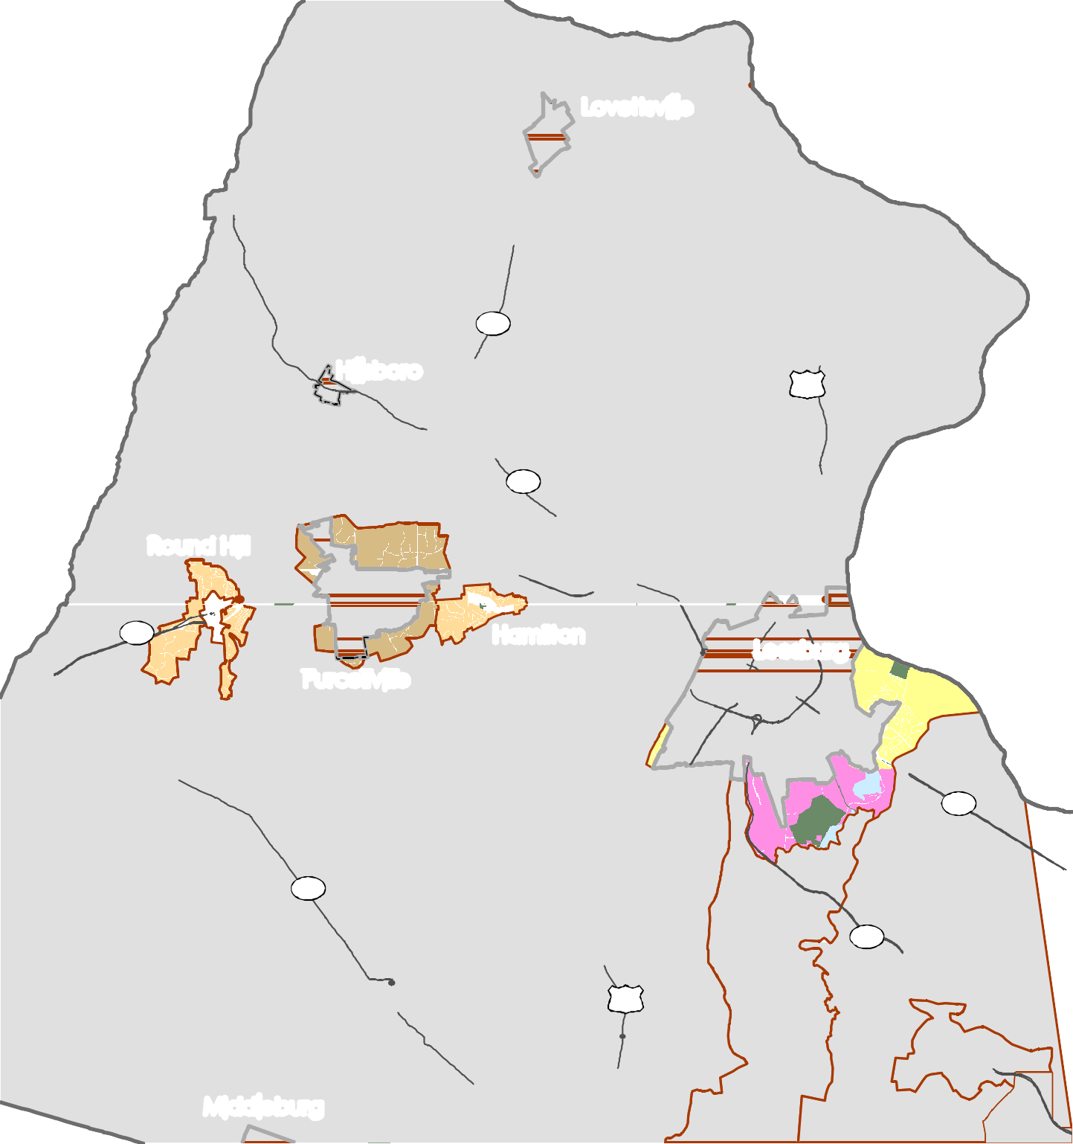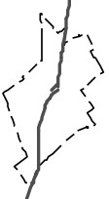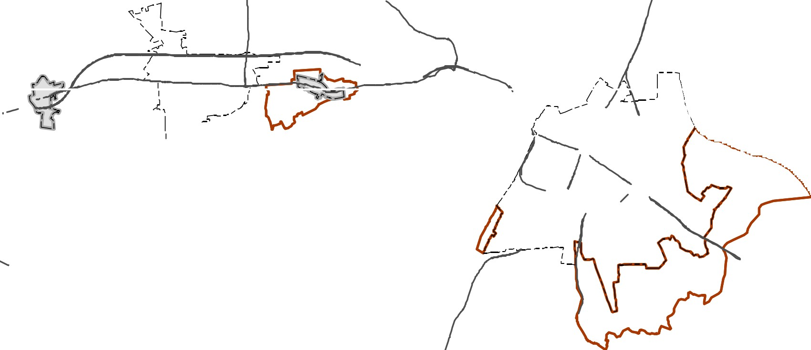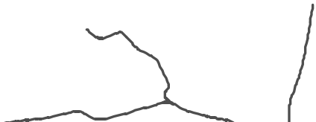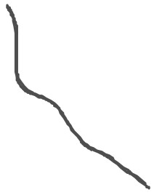Policy Areas
Parks & Recreation
Place Types
Purcellville JLMA Rural Neighborhood Western JLMA Neighborhood Leesburg JLMA Employment
Leesburg JLMA Industry/Mineral Extraction Leesburg JLMA Residential Neighborhood
\

Lovettsville

Hillsboro

287

15

9

Ro
und Hill

Hamilton Leesburg
Purcellville

7

7

....
734

l 15
267

Middleburg

Loudoun County IS NOT LIABLE for any use
of or reliance upon this map or any information contained herein. While reasonable efforts have been made to obtain accurate data, the County makes no warranty, expressed or implied, as to its
accuracy, completeness, or fitness for use of any purpose.

0 0.5

1 2 3 4 5
Miles
Map Num be r 2 01 8- 1 49

D R A F T

Purcellville JLMA Rural Neighborhood

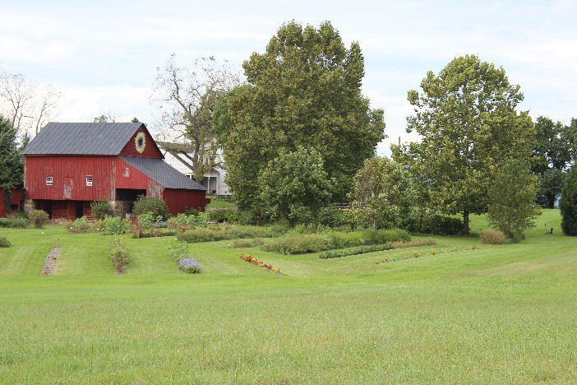
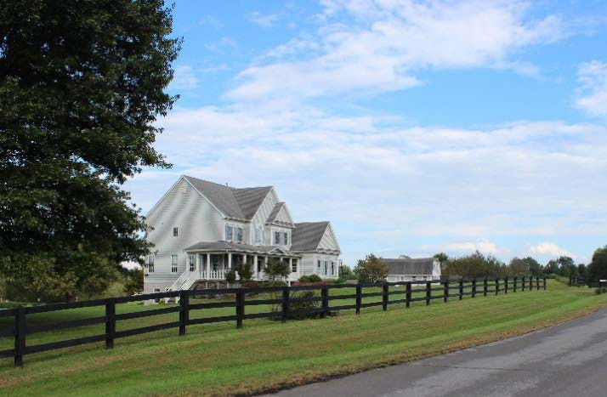
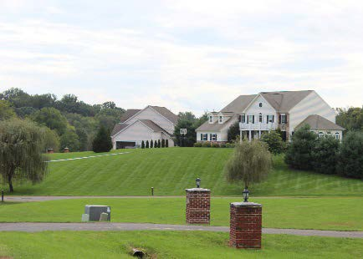
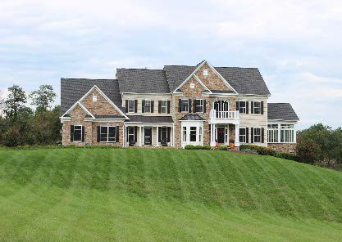
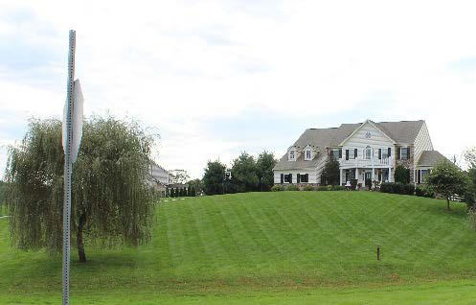

The Purcellville JLMA Rural is a combination of low-density rural residential uses and limited agriculture and related businesses in a rural visual setting that is easily distinguished from the Town development pattern. Uses are predominantly residential but limited agriculture-supportive businesses that can be accommodated by onsite well and septic systems are appropriate. Municipal (town) utilities are not anticipated except to address potential health threats, but shared water and wastewater systems are permitted for public facilities.

Predominant Uses | Secondary Uses
- Large Lot Residential  - Agriculture  - Agricultural Supportive Businesses  - Equine Facilities  - Rural Economy | - Clustered Residential Subdivision  - Accessory Residential Units  - Agritourism  - Rural/Heritage Tourism  - Public Facilities  - Civic, Cultural & Community  - Institutional

DESIGN CHARACTERISTICS

Context
Large areas of land preserved for open space, agriculture, and rural economy uses to retain the rural character of the area leading to the Town with limited low-density residential and clustered residential development screened from the roads to maintain the distinct identity of the Town.
Street Pattern:
Contour Forming, Fragmented Parallel
Block Length: Irregular (0.5-5 mile) Building Setback:
Varies (incorporate existing natural features to protect viewsheds)
Parking:
Surface lot, driveway, and garage
Open Space:
30-50%

Place Type Rendering
An oblique projection of development within a Place Type to showcase the qualitative characteristics of how buildings within the Place Type should interact to create activity.

Residential Density: 0.3 – 2.0 du / acre Building Height: 1-3 stories
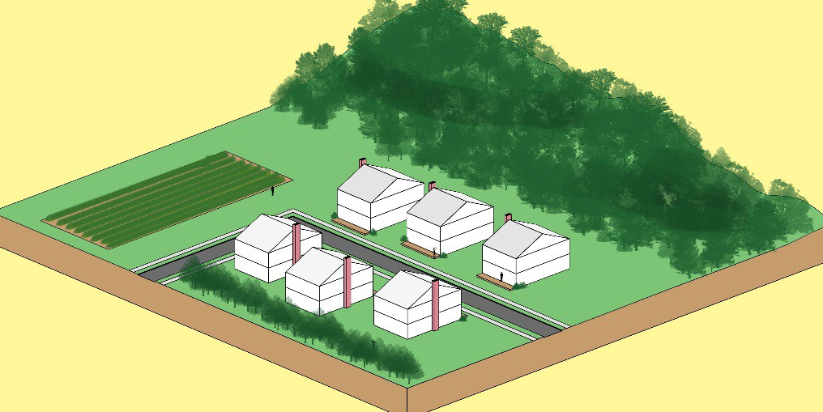

Transition
Locate buildings and structures to blend with the existing topography and natural features. Preserve and incorporate existing trees and vegetation on the property and its perimeter to buffer and screen views for adjoining properties. Provide landscaping or supplemental plantings comprised of native species when screening and buffering are required between uses.

Western JLMA Neighborhood
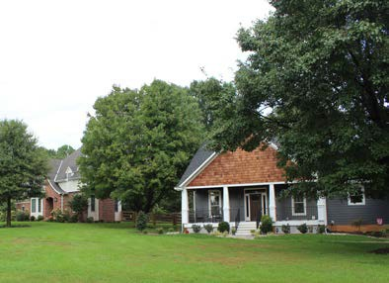
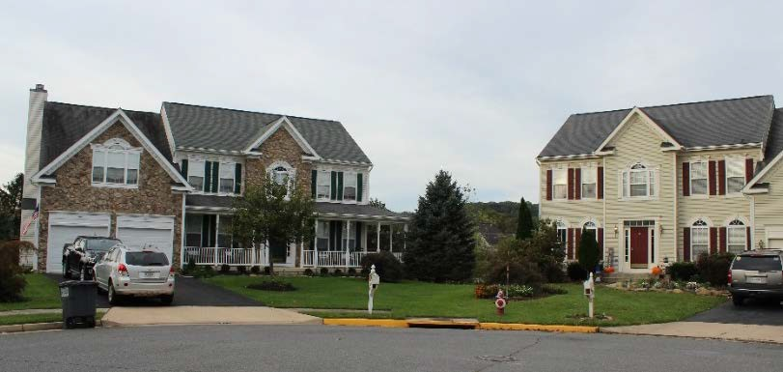
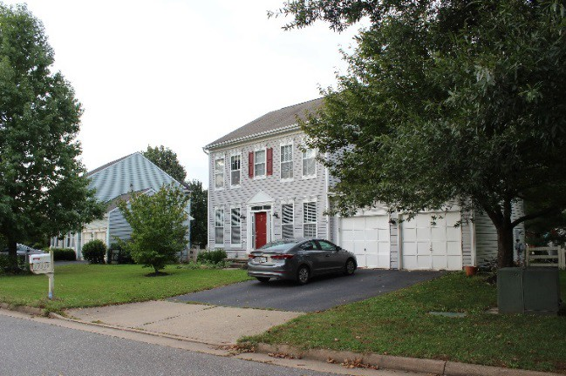
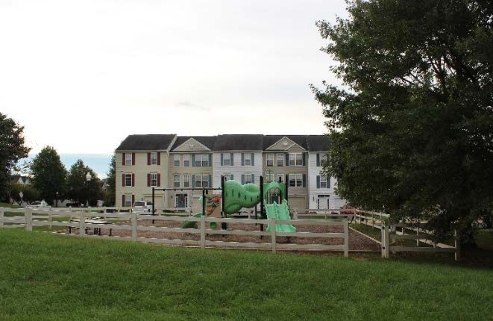

The Western JLMA Neighborhood applies to areas around Round Hill and Hamilton. This Place Type includes a variety of residential subdivisions ranging in densities from 0.3 to 3.0 units per acre. The higher density development is adjacent to Round Hill and resulted from the Round Hill Associates rezoning that was approved in 1991. Remaining areas include densities from 0.3 to 1.0 units per acre. Most neighborhoods are connected to Town utilities.

Predominant Uses | Secondary Uses
- Large Lot | - Accessory Residential Units
Residential  - Cluster Residential | - Public Facilities  - Civic, Cultural & Community  - Institutional  - Agriculture
 | - Equine Facilities
 | - Rural Economy

DESIGN CHARACTERISTICS

Context
Low-density residential neighborhoods maintaining the development pattern around Hamilton and Round Hill. Much of these JLMA areas has been developed and remaining sites should develop with a consistent and compatible pattern and intensity.
Street Pattern:
Contour Forming, Fragmented Parallel
Block Length: Irregular (0.5-5 mile) Building Setback:
Varies (incorporate existing natural features to protect viewsheds)
Parking:
Surface lot, driveway, garage, shared
Open Space:
30-50%

Place Type Rendering
An oblique projection of development within a Place Type to showcase the qualitative characteristics of how buildings within the Place Type should interact to create activity.

Residential Density: 0.3 – 2.0 du/acre Building Height: 1-3 stories
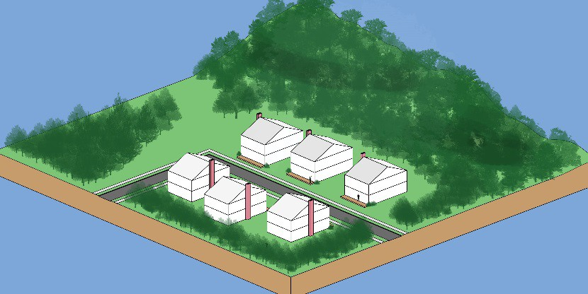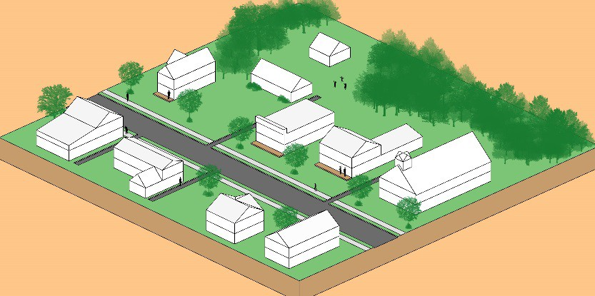
Transition
Buildings and structures should be surrounded by natural buffers that visually screen the development from view of surrounding roads and from other developments.

Leesburg JLMA Residential Neighborhood
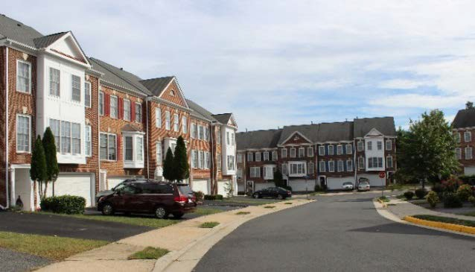
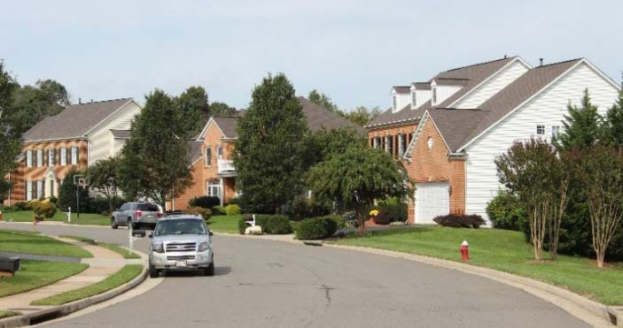
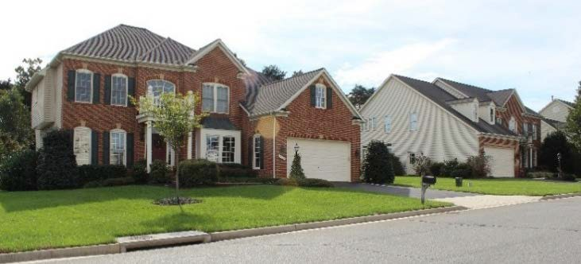
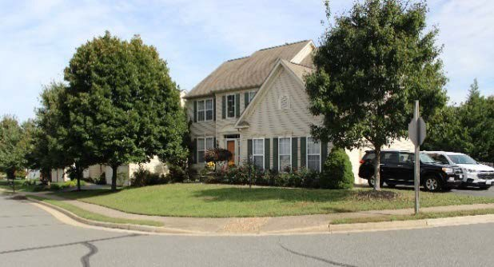

The Leesburg JLMA Residential Neighborhood reflects a suburban residential pattern with densities between 0.3 and 4.0 units per acre. This Place Type applies primarily to areas north of Route 7 near the eastern boundary of the Town and adjacent to the Woodlea Hills community on the southwest side of the Town. Single family detached and attached homes are the predominant land use. Neighborhoods include a range of amenities and community open space.

Predominant Uses | Secondary Uses | Ideal Mix of Uses
- Single Family Detached  - Single Family Attached | - Accessory Residential Units  - Public Facilities  - Civic, Cultural & Community  - Multifamily Residential  - Retail & Service Commercial | Public/Civic 10%  Non  Residential 5%  Residential 85%  Possible Ranges: Res: 85-100%  Non-Res: 0-15%  P/C: 0+

DESIGN CHARACTERISTICS

Context
Low-density residential neighborhoods maintaining the development pattern along the eastern and western boundary of Leesburg. Much of these JLMA areas has been developed and remaining sites should develop with a consistent and compatible pattern and intensity.
Street Pattern:
Fragmented parallel and warped parallel, limited loops and cul-se-sacs
Block Length: 600-1,500 feet Building Setback:
Shallow to medium
Parking:
Driveway, garage, or on-street
Design Amenities:
Sidewalks, street trees, lighting, crosswalks, common open spaces
Open Space:
Minimum 30%

Place Type Rendering
An oblique projection of development within a Place Type to showcase the qualitative characteristics of how buildings within the Place Type should interact to create activity.

Residential Density: Up to 4.0 du/acre Total Nonresidential FAR: Up to 0.4 Building Height: 1-3 stories
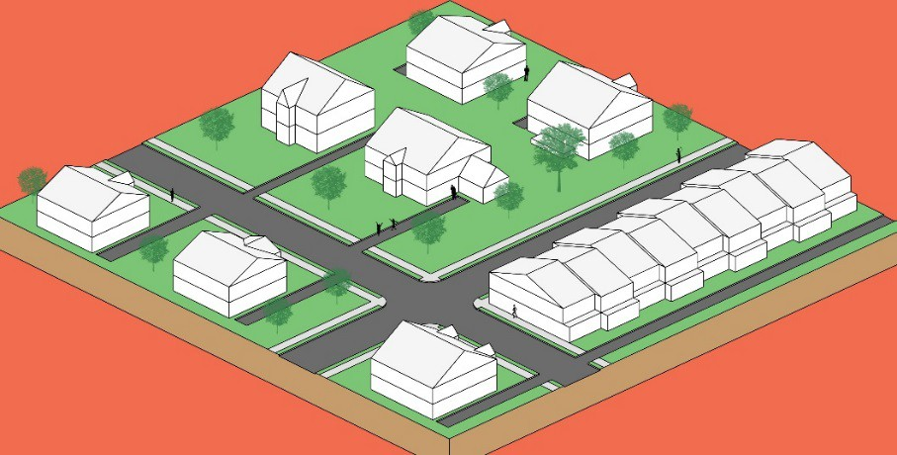

Transition
Development is intended to be consistent with surrounding neighborhoods. Transitions should be gradual, and appropriate transitional techniques include variations in building orientation, height step down, and creative and extensive use of landscaping and natural features. Fencing or other barriers should not be used as the sole means of screening and buffering. Where possible, new developments within Leesburg JLMA Residential Neighborhood areas should locate uses along their perimeter that are similar in use and density with adjacent neighborhoods.

Leesburg JLMA Employment
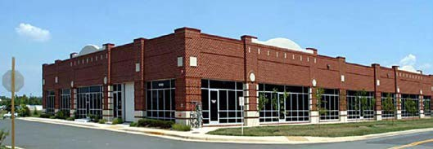
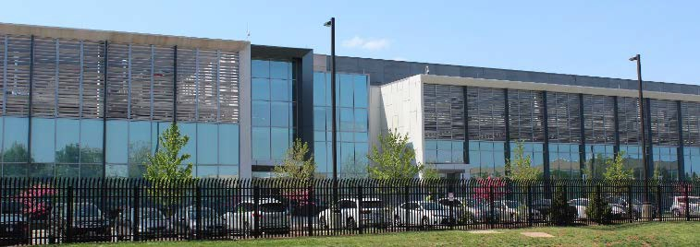
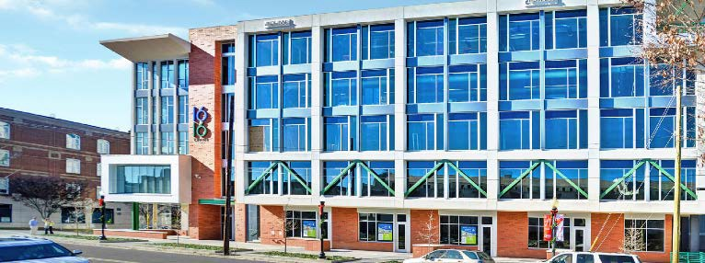

Leesburg JLMA Employment areas provide opportunities for a range of light and general industry uses similar to the existing pattern south of Route 7 and around the Leesburg Executive Airport. This Place Type accommodates flex space, manufacturing, warehousing, contractor services and other productive uses.

Predominant Uses | Secondary Uses
- Production  - Warehousing  - Fleet & Equipment Sales & Service  - Contractor  - Flex Space  - Research & Development  - Institutional  - Civic, Cultural & Community  - Public Facilities | - Office  - Retail & Service Commercial  - Data Centers

DESIGN CHARACTERISTICS

Context
Primarily separate one-to-two-story buildings used for industrial and employment uses.
Street Pattern:
Rectilinear Grid or Fragmented Parallel
Block Length: 300-1,000 feet Building Setback:
Short to medium; greater if flex use
Parking:
Structured, on-street, accessory, or short-term
Design Amenities:
Sidewalks, street trees, shade trees, bike racks
Open Space:
20% of the site

Place Type Rendering
An oblique projection of development within a Place Type to showcase the qualitative characteristics of how buildings within the Place Type should interact to create activity.

Total Nonresidential FAR: Up to 1.0 Building Height: 1-4 stories
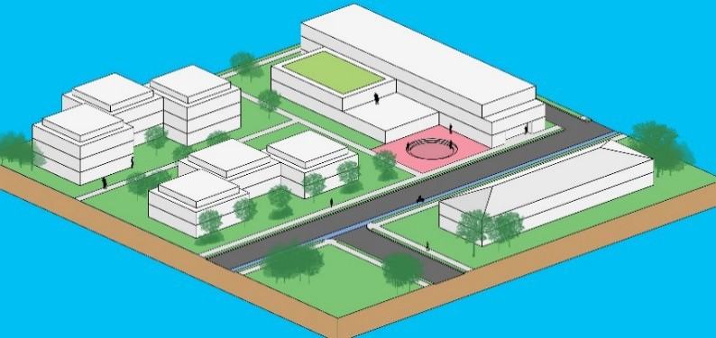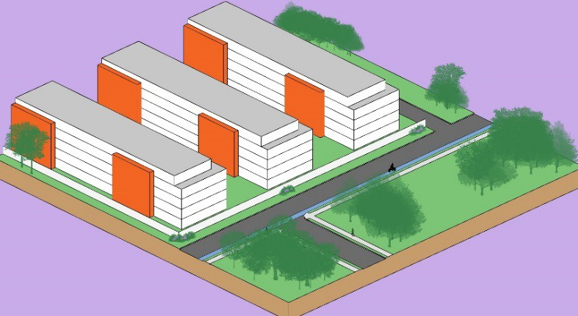
Transition
Extensive buffering including berming and, where appropriate, walls can separate and screen parking, loading and other industrial activities from public roads and adjacent uses. Larger projects should situate lower intensity uses next to residential or other sensitive uses. Landscaping, lawns and retained natural areas will frame buildings and streets.

Leesburg JLMA Industrial/Mineral Extraction
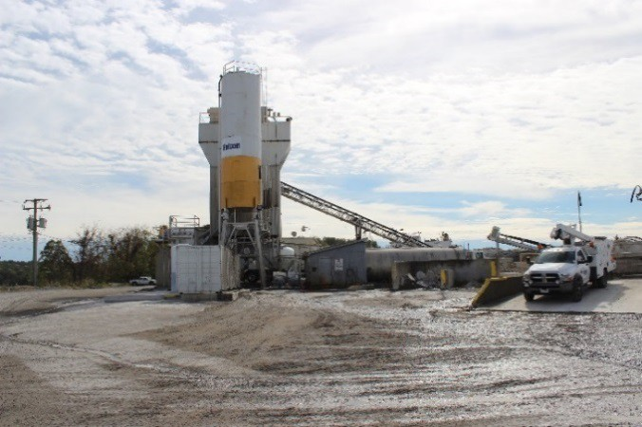
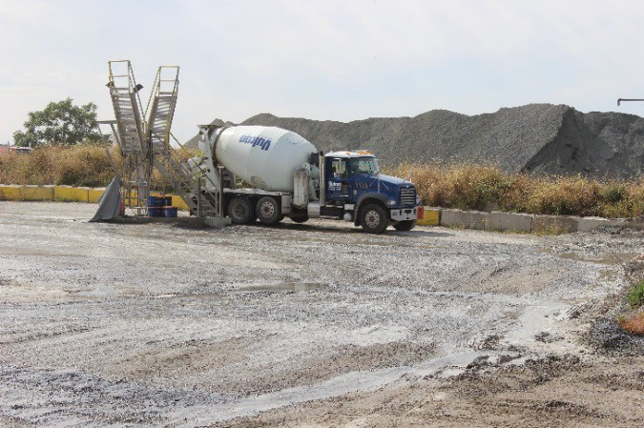
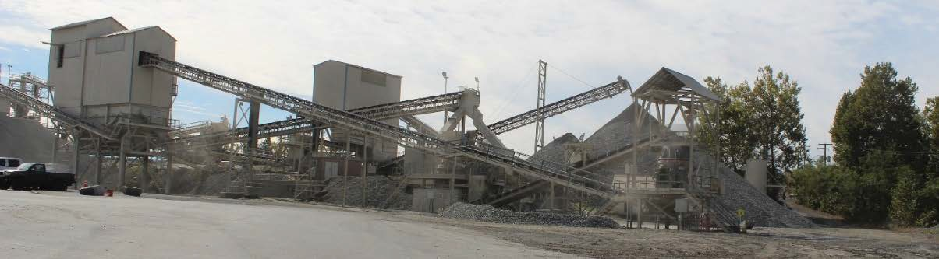

Leesburg JLMA Industrial/Mineral Extraction areas consist of large manufacturing, warehousing, and other productive uses. Streets in this district are typically designed to accommodate freight ingress and egress. This Place Type also includes mineral extraction areas such as quarries and mines as well as associated uses such as asphalt plants and cement plants. Industrial and mineral extraction uses are incompatible with residential uses due to the prevalence of outdoor storage and the emissions of noise, odor, and vibrations. Buffers between these uses and residential uses are necessary to ensure compatibility and maintain commercial viability.

Predominant Uses | Secondary Uses
- General and Heavy Manufacturing and Assembly  - Warehousing  - Data Centers  - Fleet & Equipment Sales & Service  - Outdoor Storage  - Public Utilities  - Quarry | - Office  - Retail & Service Commercial  - Flex Space  - Light Production  - Public Facilities  - Research and Development

DESIGN CHARACTERISTICS

Context
Primarily one-to-two-story buildings used for warehousing, data centers, contractor services, or manufacturing.
Street Pattern:
Rectilinear Grid, Contour Forming
Block Length: 300-1,000 feet Building Setback:
Deep, varying with use
Parking:
Surface Lot
Design Amenities:
Sidewalks, street trees, shade trees
Open Space:
20% of the site

Place Type Rendering
An oblique projection of development within a Place Type to showcase the qualitative characteristics of how buildings within the Place Type should interact to create activity.

Total Nonresidential FAR: Up to 1.0 Building Height: 1-4 stories
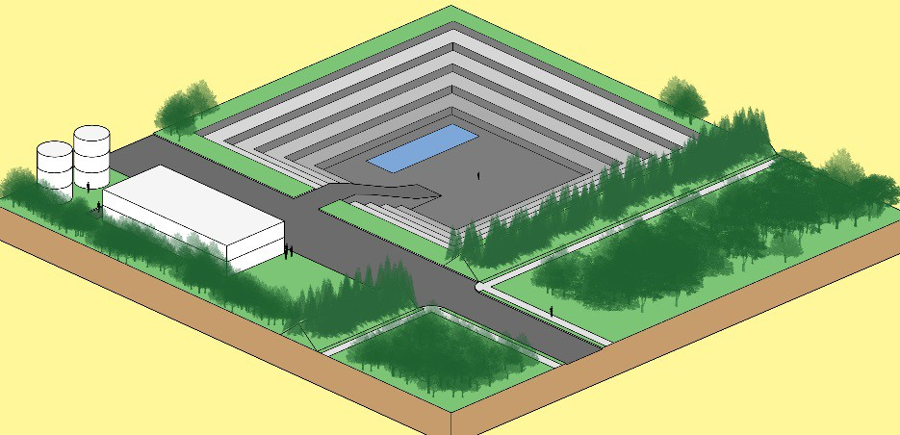

Transition
Transitions between Leesburg JLMA Industrial/Mineral Extractive uses and other developments, in particular adjacent residential neighborhoods, are critically important to the viability of long- term industrial operations. Extensive buffering, berming, and distance should separate and screen adjacent uses. Larger projects should situate lower intensity uses next to residential or other sensitive uses. Storage and loading areas are to be oriented away from and screened from streets and adjacent uses.

Policies, Strategies, and Actions

Town Policy 1: The County will collaborate with the Towns on matters of common interest to preserve the identity of each Town and their role as economic and social centers.
Strategy
  - Work with the Towns to develop and implement a shared vision for the Towns and their environs.
Actions
    - Continue to rely on jointly approved area management plans and refer to applicable Town policies on matters within the JLMA.

    - Grant authority over subdivision applications within 1 mile of its corporate limits, upon request of a Town and in accord with County regulations.

    - Establish a regular coordination program with Towns to anticipate, monitor, and address development and planning matters.

    - Undertake joint planning efforts in the JLMA.

    - Support the towns in their negotiations with VDOT and other agencies for safety improvements and traffic calming, particularly along Routes 15, 50, 7, 9, and 287 in proximity to the Towns, and other changes in roads and/or transportation services that are consistent with both the Town’s and the County’s development goals and priorities.

    - Assess the effectiveness of the JLMA approach and associated zoning in protecting town character, maintaining a "hard edge" between the town and the rural areas, and/or as a tool for expanding economic development objectives.

    - Add provisions to the rural and JLMA zoning districts specific to roadway corridors leading into each town that would establish deeper building setbacks variable building and lot configuration and orientation, “hedgerow” landscaping and buffering along the road, and other measures that retain or create a traditional rural or natural appearance leading into the town.

    - The County will work with the Towns and interested groups to identify open-space and agricultural-preservation strategies such as: donation of conservation easements, fee- simple purchase, clustering, and the possible creation of a conservation service district and/or nonprofit foundation to promote and implement open-space preservation around the Towns.

Strategy
  - Encourage new development to locate within the Towns before moving into the JLMAs or surrounding area.

Actions
    - Encourage the maintenance, improvement, or adaptive reuse of existing building stock in a manner that supports social and economic diversity within the community.

    - Promote the commercial areas within the Towns as the preferred location of retail and service businesses, office development, and public and civic uses.

    - Work with the Towns to enhance their economic base and maintain viable commercial areas through marketing, capital investments, and business attraction.

    - Support annexations by the Towns when water and sewer extend into a JLMA in accordance with the annexation guidelines in this section and to resolve jurisdictional questions for property owners.

    - Encourage development in the JLMA to extend the existing and planned development patterns of the Town.

Strategy
  - Continue to recognize the Towns as the preferred location of public facilities in western Loudoun County when consistent with Town policies and when suitable land and services are available.
Actions
    - Encourage the continued use of existing public facilities located in the Towns and JLMAs and seek to maintain existing community-based schools as an important social and economic component of the communities.
    - Cooperate with the Town Councils of those communities providing local law enforcement to ensure a coordinated enforcement strategy within the Town JLMAs.
    - Support development of sidewalks and recreational, multi-use, and equine trails connecting the Towns to each other, to regional trail networks such as the W&OD and C&O Canal, and to area destinations.

Hamilton
First settled in the 1730’s and incorporated in 1875, the Town of Hamilton is located along business Route 7 between Leesburg and Purcellville. Hamilton served as a commercial and tourism hub after the railroad was extended west of Leesburg, though by the mid-1900’s had become primarily a residential community. Hamilton’s population of 640 residents represents an increase of approximately 25 percent since 20101. The existing JLMA around Hamilton and the adjacent RPA along the north side of its boundaries have also developed with residential uses. While Hamilton has extended utilities outside of its boundaries and has water facilities in the JLMA, it does not foresee expansion of the JLMA. An existing school and school support facilities on the western edge of the JLMA serve to separate the community from Purcellville.

1 Annual Estimates of the Residential Population, 2017 Population Estimates, United States Census Bureau.

The Town of Hamilton Comprehensive Plan for the Town of Hamilton and JLMA serve as Loudoun County’s planning document for the Hamilton JLMA. The Comprehensive Plan for the Town and JLMA was jointly adopted by Loudoun County and the Town of Hamilton and planned for a period through 2020. The Policies, Strategies, and Actions specific to Hamilton address the continued coordination between the Town and County regarding future updates to Hamilton’s Comprehensive Plan.
The Town of Hamilton supports the Town’s ability to annex land within its JLMA. The Town believes such annexations provide “win-win” scenarios that enable the Town to provide better and additional services to property owners, while the County still receives applicable tax revenue from these areas.
The Town of Hamilton also supports collaboration between Loudoun County and the Town regarding development issues near the Town, especially to the west and east along Business Route 7/Colonial Highway.
Hamilton’s wells are vital to the continued provision of potable water to County and Town residents. As such, Hamilton supports Policies, Strategies, and Actions regarding the location and depth of private wells to protect municipal wells that provide water to thousands of people throughout Loudoun County.
The Town of Hamilton supports an emphasis on affordable housing and supports increased efforts to provide housing that is affordable to the workforce, seniors, teachers, firefighters, police, and others who allow Loudoun County to function as a community.
Strategy
  - Development within the Hamilton JLMA will comply with the comprehensive plan for the Town of Hamilton and the adjacent area in the Joint Land Management Area.
Actions
    - Maintain the Town of Hamilton authority over subdivision applications within 1 mile of its corporate limits.
    - Work with the Town of Hamilton to update the Comprehensive Plan for the Town and JLMA after the adoption of the 2040 Plan.
    - Support the Town of Hamilton efforts to develop an identifiable town center to serve as a community focal point for the Town of Hamilton and the JLMA.
    - Seek to improve street connectivity as the redevelopment and infill development occur in the JLMA and connect to the existing streets in the Town of Hamilton, where feasible, with roads that are compatible with traditional town designs.
    - Work with the Town of Hamilton to effectively manage transportation systems around the Town and to explore methods of traffic calming on Business Route 7 through town including the possible use of a traffic circle at Route 7 and St. Paul Street.
    - Maintain a distinct identity for the greater Hamilton community separate from the adjacent rural areas by establishing a greenbelt around the Town of Hamilton and the

JLMA using conservation easements, passive and active parks and other means.
    - Work with the Town of Hamilton to achieve a balanced land use pattern that will retain Hamilton’s historic small-town character in a rural setting and maintain its unique sense of place.
    - Support continued operation of Hamilton Elementary school at its present site.

Hillsboro
Established in 1752 in the narrow gap of the Short Hill Mountains and known simply as “The Gap” until incorporated as Hillsborough in 1802, today’s Town of Hillsboro is among the best preserved 18th/19th-century rural villages in the Commonwealth. Although a 2016 boundary line adjustment nearly doubled the Town’s area, with a population of approximately 100 residents2, Hillsboro remains the fourth smallest town in Virginia.
First placed on the National Register of Historic Places in 1977, the Hillsboro Historic District was expanded in 2010 to encompass 152 acres with 52 contributing structures dating primarily from the 18th and mid-19th centuries. The compact linear village is bounded on its south by Catoctin Creek and South Short Hill, and the North Short Hill on the north, and is bisected by Historic Charles Town Pike (Va. Route 9), which has become a major commuter route connecting Northern Virginia to West Virginia and Maryland and carrying more than 17,000 vehicle trips daily.
Hillsboro successfully supported a Traffic-Calming and Congestion Mitigation project with the intent to reduce delays during peak hours, control speeds via dual roundabouts and traffic-calming features and create a safe pedestrian/multi-modal environment with the addition of sidewalks, raised crosswalks, and a series of multi-modal trails. Utilizing context-sensitive materials, streetscaping, and burial of overhead utilities, this project preserves Hillsboro’s historic character and enhances its sense of place. With safe parking and pedestrian access allowing appropriate small-scale enterprises, Hillsboro looks to regain its historical role as the hub of a robust agricultural region, which has also become a major tourist destination with an expanding array of vineyards, breweries, and recreational activities – including Virginia’s newest state park.
In addition to Hillsboro’s Traffic-Calming project, the complete overhaul of the Town’s drinking water system and installation of a low pressure sanitary sewer force main, in anticipation of a community wastewater treatment facility, will serve the community for years to come.
With its transformative infrastructure projects, Hillsboro’s Comprehensive Plan and Zoning Ordinance will be updated to better reflect the potential for appropriate economic development within the existing built environment that is consistent and complementary to historic preservation and provides a broader tax base to ensure long-term viability. The Town will continue the repurposing of its landmarks, Old Stone School and Gap Stage, into a regional venue for the arts in addition to serving as Hillsboro’s Town Hall and community/visitor center.

2 2012-2016 American Community Survey 5-Year Estimates.

As the traditional “home town” for a nearly 50-square mile rural region in Northwest Loudoun, the Town of Hillsboro has taken a leadership role in unifying and “branding” the area. The Town supported and facilitated the conversion of the Hillsboro Elementary School into Loudoun’s second public charter school in 2016, led a successful effort in 2017 to reestablish an official Hillsboro postal identity for this area, and fostered the creation of the Greater Hillsboro Business Alliance.
With more than a dozen vineyards, numerous specialty farm operations and Loudoun’s greatest concentration of bed and breakfasts within five minutes of the Town’s center, Hillsboro is the gateway to one of Virginia’s most dynamic rural economies. As such, the Town has an existential stake in the preservation of the farmlands and open spaces, mountainside forests and ridge lines that surround it. Hillsboro’s historic integrity as a rural village situated on the 18th-century “Great Road” – Charles Town Pike – is largely defined by the still existent swaths of farmlands on its east and west approaches. As Hillsboro’s National Register of Historic Places nomination describes: “The majority of the buildings in Hillsboro are nestled along Charles Town Pike. The nominal setback of these buildings contributes to Hillsboro’s sense of time and place, as the uniformity and integrity of the building stock has been maintained…. The buildings share a commonality in their setback, maintaining Hillsboro’s integrity of location and feeling. The rural character of Hillsboro is further increased by the size of the outlying properties.”
Hillsboro’s uniquely unspoiled rural and historic character – despite its location within one of the nation’s most economically dynamic, fastest-growing and wealthiest counties – makes the Town and its environs assets that will only become more valuable with the urbanization of eastern Loudoun. Proactive preservation of farmland in the RPA through private permanent conservation easements and full utilization of the County’s Purchase of Development Rights (PDR) program is essential.
The renaissance that Hillsboro is currently experiencing will serve as a catalyst to ensuring the long-term viability of a strong recreational/agritourism economy in Northwest Loudoun. In partnership with Loudoun County, the Town is committed to forging policies that protect and preserve the vital rural assets that contribute to economic vitality and quality of life for all Loudoun residents.
Strategy
  - Enhance the role of Hillsboro as a gateway into the County from the west.
Actions
    - Maintain the distinct identity for the Hillsboro community, separate from the adjacent rural areas, by encouraging establishment of a greenbelt around the Town using conservation easements, development design techniques and other means to help maintain the distinct edge to the Town of Hillsboro.
    - Support the development of entry features into the town, to enhance the identity of the Town of Hillsboro as a gateway community.

    - Encourage rural economy business development in the Hillsboro Area to provide local goods, services and jobs to residents and visitors.
    - Encourage the preservation of those resources which contribute to the identity of Hillsboro.
    - Oppose any increase in density and development outside of the Town of Hillsboro that is not consistent with the traditional rural character of western Loudoun County.
    - Work with the Town of Hillsboro and with VDOT to identify short and long-term solutions for improving the safety of Route 9 in western Loudoun and through Hillsboro that do not compromise the rural character of Hillsboro.
    - Promote safety measures for pedestrian movement along and across Route 9.
    - Work with the Town of Hillsboro to establish a safe and adequate water supply.

Leesburg
Leesburg, the largest and most populous of the incorporated towns with a population of approximately 49,000 residents3, has the added distinction of serving as the seat of the County government. By its location, it functions and appears to be a commercial hub at the junction between suburban areas to the east and rural areas to the west. The pressures for growth in Leesburg are the result of the robust regional economy that will continue to draw more businesses, government jobs, and residents. Town character is of paramount importance to Leesburg. The Old and Historic District is the basis of Leesburg’s identity. It is a compact, mix of land uses; its blocks and buildings are human scaled; a resurgence in entertainment retail uses and downtown residential development have brought new development interest to the community. Other portions of the Town have a different, more suburban character where more uniform uses and large lots, curved streets, and cul-de- sacs dominate the landscape. Between 2001 and 2016, Leesburg added 5.5 million square feet of retail, commercial, office, and institutional development, and approximately 4,300 residential units.
The Town’s planning vision for the foreseeable future is to continue the diversity in economic and housing opportunities in a manner that reflects the best and essential qualities of the old and historic downtown. Leesburg will maintain a high quality of life by providing a full range of community facilities and services and diverse economic opportunities, protecting natural and heritage resources, and protecting against negative environmental impacts. The Town of Leesburg is approximately 90 percent built out and, like other towns, has limited land area for new government facility development. County strategies recognize the fiscal impact of public facilities on a Town with limited land resources and has added more flexibility to locating such facilities in and around towns.
Leesburg’s JLMA is situated almost entirely to the south and east of the corporate limits and contains approximately 7,000 acres. The northeast portion of Leesburg's JLMA has developed in

3 2012-2016 American Community Survey 5-Year Estimates.

the manner recommended by Town and County plans with a distinct suburban residential pattern, while other areas of the JLMA are planned for non-residential uses.
The Town views the main purpose of JLMA land uses between Route 7 and the Greenway to serve as an expansion of economic development goals by focusing on employment uses. JLMA planned land uses reflect Leesburg’s Comprehensive Plan and no major changes to land use are proposed.
On the south, west, and north sides of Leesburg there is no JLMA; instead, policies support a greenbelt and a “hard edge” adjacent to the Town. Loudoun 2040 implements the greenbelt by maintaining a rural zoning up to the Town boundary and proposing specific development guidelines along the major roads leading to the Town to preserve distinctly rural development pattern.
Strategy
  - Ensure development within the Joint Land Management Area complies with the Leesburg Area Management Plan, the Annexation Area Development Policies as amended, and the Leesburg Town Plan.
Actions
    - Continue to make Leesburg the County seat, and the principal location of County Government offices, and collaborate with the Town of Leesburg on locating new facilities in the Town or JLMA.
    - Maintain the planned land use of the JLMA consistent with Town of Leesburg land use policies; maintaining an emphasis on employment uses south of Route 7 and residential to the north of Route 7.
    - Prohibit power generation plants in the Leesburg JLMA.
    - Define the Town of Leesburg and JLMA as a distinct community separate from the Suburban and Rural Policy Areas by retaining rural policies and zoning to the north and south of the Town boundary and west of Evergreen Mills Road, and protecting the Goose Creek and Sycolin Creek floodplains to the east and south of the JLMA.
    - Preserve the rural character of the viewsheds along Route 15 as it approaches the Town of Leesburg from the north and south by encouraging additional conservation easements and instituting design guidelines.
    - Cooperate with the Town of Leesburg to complete the Heritage Trail and conserve open space along the Potomac River.
    - Coordinate with the Town of Leesburg and VDOT on the feasibility of planning and building Edwards Ferry Road as a two-lane facility with a bike path. The County will work with the Town and VDOT to designate the road as a scenic by-way.
    - Protect the viability of the Leesburg Airport by ensuring development in the JLMA does not impede Airport operations.

Lovettsville
Lovettsville, originally known as the German Settlement, is a small town with historical roots that go back to 1732. The Town served as a thriving commercial center for the surrounding farming areas for over one-hundred years. This function was eventually eclipsed during the post-World War II period by other, larger communities in Loudoun County, Northern Virginia, and nearby Maryland, which is about three miles from the Town.
Since 2005, Lovettsville has experienced a rapid increase in population and housing associated with growth of single-family detached residences. The population influx consists of people who are attracted to the traditional main street character of Lovettsville set in the larger context of the (mostly) rural northern Loudoun Valley.
Lovettsville continues to focus on development inside its existing boundaries and prefers a “hard edge” between its boundaries and the surrounding rural landscape. Lovettsville has made significant investments in streetscape improvements and trails. Commercial development has also occurred at the Town Center and along East Broad Way (Route 673). Lovettsville supports continued County cooperation on transportation and public facilities, with a strong interest in developing multi-use County trails that connect the town to the W&OD and C&O Canal trails.
Significant land use changes have occurred within the Town. Most notably the evolution of the Lovettsville Town Center from its initial concepts to a nearly-completed, neo-traditional community centered on a pedestrian-friendly and centrally-located business district having wide sidewalks, decorative streetlamps, and ample public gathering spaces. This development, residential subdivisions on infill properties, redevelopment of properties in the “Old Town” for modern commercial uses, and implementation of streetscape projects throughout, has contributed to Lovettsville’s growth from a population of 853 in the year 2000 to approximately 2,300 residents in 20184. Several large properties within the Town limits are available for future development, although much less land is available for new residential development compared to 18 years ago.
The County has not established a JLMA around Lovettsville, consistent with the Town’s desire to focus development inside the existing boundaries. The Town has identified several limited areas outside of its corporate limits that may be candidates for annexation for the purposes of supporting existing and developing future civic, commercial, or employment uses, and achieving the Town’s economic development goals. Future annexation of these areas will be considered on a case-by- case basis and is dependent on the capacity of Town water and wastewater services to accommodate the future development of these properties, something that the Town evaluates through its Water and Sewer Master Plan.
The County is actively improving and constructing public facilities in and around the Town including the Lovettsville Community Center, Lovettsville Community Park, Lovettsville Volunteer Fire and Rescue Station, and Lovettsville Elementary School. Coordination is critical to providing utilities and access to these facilities and to planned future development, which may require access through the County to afford multiple points of connection to and from public

4 Annual Estimates of the Residential Population, United States Census Bureau.

streets. The Town also seeks continued County funding for streetscape enhancements and for pedestrian safety improvements and traffic calming on Town streets near County facilities.
Strategy
  - Support the Town of Lovettsville in efforts to consolidate development within its boundaries.
Actions
    - Retain and recruit businesses that serve the needs of Lovettsville and northern Loudoun County residents and align with Town plans.
    - Collaborate with the Town of Lovettsville in the planning and regulation of development along Route 287 north and south of Lovettsville to protect the scenic quality and the rural character of the road as it approaches the Town.
    - Link the County’s greenways and trails system with the Town of Lovettsville’s internal trail and bikeways network to link Lovettsville with the C&O Canal in Brunswick, Maryland, and the W&OD bike path in Purcellville.
    - Plan the location and design of County facilities within Lovettsville, in consultation with the Town of Lovettsville.
    - The County will collaborate with the Town of Lovettsville and VDOT on transportation planning in and around Lovettsville to improve traffic safety in the Town of Lovettsville and to improve regional road networks and access to employment centers.
    - Cooperate with the Town of Lovettsville, pursuant to County Annexation Guidelines, on boundary-line adjustments to resolve jurisdictional questions, to serve public and civic uses, and to support the Town of Lovettsville’s economic goals and priorities.

Middleburg
The Town of Middleburg, established in 1787, is the southernmost town in Loudoun County and retains a traditional village character that is treasured by its citizens and visitors. Middleburg is both the hub of a larger rural area and a major tourist destination. The character of Middleburg is irrevocably tied to the preservation of the farms, vistas, vineyards, open spaces, and forests that surround the Town, with equestrian facilities, estates, wineries, and associated businesses central to Middleburg’s way of life and tourism industry.
The commercial core of Middleburg contains both retail and service businesses that serve rural area residents and the tourism industry. Specialty and high-end accommodations, including the Salamander Resort opened in 2013, as well as retail, food, and beverage are cornerstones of the Town’s economy. The rural nature and character of its surroundings are critical to its continued success. Visitor dollars spent at restaurants, shops, and accommodations within Middleburg generate 75 percent of annual Town revenues.
The Town is home to 656 people and expects its population to increase modestly in the future. A significant portion of the Town has been placed on the National Register for Historic Places and the Town administers a local Historic District to carefully control the look and feel of new

development. While undeveloped land is scarce within the Town limits, the Salamander Resort has plans for 109 new residential units, and a limited number of other infill and redevelopment opportunities exist.
To preserve the character of the Town and the rural area that surrounds it, Middleburg promotes a “hard edge” between in-town development and open and agricultural lands outside of town. The hard edge will be established by the uses and development pattern of the Southern Rural Place Type and by identifying the lands adjacent to the Town as priority open space areas for conservation easements. For this reason, a JLMA is not proposed and the public utilities will not be extended beyond the Town limits except as supported by the Town and consistent with the Sewer and Water policies of this section. A high priority for the community is to safeguard the protection of its historic character and to ensure the viability of its local and tourism economies. Town citizens and surrounding property owners are extremely concerned about the rate of growth in the County and want to protect the open space around the Town from rural residential and commercial encroachment through land use regulation and conservation programs.
Middleburg is bisected by U.S. Route 50, one of two major east-west routes through the County. The community remains concerned about the volume and speed of traffic on this route, which serves as the Town’s main commercial street within the corporate limits. Even with the success of a traffic calming project completed in late 2016, traffic congestion and safety issues remain high priorities and require the County and Town to work together to identify and implement additional traffic demand reduction and traffic calming measures aimed at mitigating local and pass-through traffic in the Town.
Cooperation and regular collaboration should continue between the County and Middleburg to address issues important to both jurisdictions, including issues of economy, rural preservation, and transportation.
Strategy
  - Maintain a “hard edge” at the Town of Middleburg’s boundary in lieu of a JLMA to clearly distinguish where the Town of Middleburg stops and the rural, undeveloped countryside begins.
Actions
    - Collaborate with the Town of Middleburg on zoning and development activities outside the Town but in its vicinity, with the goal of preserving the rural character of its gateways and surrounding environs.
    - Work with the Middleburg community and interested preservation groups to identify open-space and agricultural preservation approaches such as: conservation easements, land acquisition, and development standards to promote and implement open-space preservation around the Town of Middleburg to help establish a greenbelt and protect the rural appearance of roadways leading into the Town of Middleburg.
    - Protect rural roads and scenic views through measures such as revised state road improvement standards; scenic easements; historic corridor overlay zoning for John

Mosby Highway (Route 50), Foxcroft Road (Route 626), and the Plains Road (Route 626); and development setbacks.
    - Assist, when requested, in the promotion of tourism, as a means of increasing public support for preservation of the scenic and historic Middleburg area.
    - Work with the Town of Middleburg to implement strategies that will preserve and enhance agriculture as the predominant use in the RPA around Middleburg.
    - Establish a “hard edge” by implementing the uses and development pattern of the Southern Rural Place Type and by identifying the lands adjacent to the Town of Middleburg as priority open space areas for conservation easements.

Purcellville
Purcellville was first settled in the mid-1700’s, given its official name in 1852, and incorporated in 1908. Purcellville has seen significant growth, with its population of 7,727 in 2010 growing to over 9,700 in 2017.5 Residents of Purcellville have expressed their support for maintaining the small town character of the Town as expressed by the traditional architecture of the older neighborhoods, the downtown, the repurposed farm buildings that serve as evidence of the Town’s rural past, the rural landscape, farmland, and green space that gives the community a sense of history. To maintain some of these factors requires cooperation between the Town and County to protect the rural nature of the land around the Town and to encourage continued economic development in the Town, which benefits western Loudoun residents.
Demand for housing in and around Purcellville is expected to increase. As Purcellville considers potential future growth demands, the Town’s preference is to focus on infill development within the Town limits and to protect surrounding rural landscapes. Purcellville does not anticipate extending utilities beyond the current Town boundaries. Any growth in or around Purcellville will increase the need for transportation improvements to be coordinated between the Town, County, and State, such as the Route 690 interchange and the Route 7 Bypass/Route 287 intersection.
Purcellville supports the protection of existing and the establishment of new open spaces in the JLMA along with trail connections, particularly between the W&OD Trail and Franklin Park. On the east and west sides of Purcellville the Town directly abuts the Rural Policy Area and there is no JLMA; however, the RPA provides for one dwelling unit per 10 acres. The Town supports a greenbelt extending to incorporate properties that fall within approximately one-quarter mile of the Town limits, with a “hard edge” within the RPA. The Town supports preservation and protection programs within these areas.
The Town also supports implementation of gateways protecting rural view sheds at the east, west, north, and south entrances to the Town. To this end, the Town and County dissolved the Purcellville Urban Growth Area Management Plan (PUGAMP) in 2013 and adopted a rural development policy for the JLMA. The County encourages a low density, rural mix of residential

5 2017 Population estimates, United States Census Bureau.

and business uses around the Town that are distinguishable from the intensity and character of development in Purcellville.
Strategy
  - Support Town of Purcellville’s efforts to accommodate growth within the existing Town limits and to maintain its role as a hub of economic development in western Loudoun.
Actions
    - Establish a “hard edge” by implementing the uses and development pattern of the Southern Rural Place Type and by identifying the lands adjacent to the Town of Purcellville as priority open space areas for conservation easements.
    - The County will work with the Town of Purcellville to plan for a trail extension that connects the W&OD Trail with Franklin Park.
    - Include setbacks, height limitations, and landscaping standards for developments along Route 7, Route 287, and the Route 7 Bypass to establish and maintain a greenbelt or “hard edge” around the Town of Purcellville characterized by open space and tree-lined roadways.
    - The County will encourage the use of frontage roads, coordinated development plans, and other means of minimizing the number of driveways along Route 7 and Route 287 leading into Purcellville.
    - Encourage new commercial uses to locate in the Town of Purcellville before locating in the JLMA.
    - Encourage owners of historic projects in the JLMA to place properties into the Purcellville or County Historic District.
    - Protect historic structures in the context of their natural settings.

Round Hill
Round Hill first became a recognized community in the mid-1800’s, after the construction of the Leesburg and Snicker’s Gap Turnpike, now Route 7. Incorporated in 1900, Round Hill served as a destination for those looking for a holiday from Washington, D.C., benefiting from the Washington and Old Dominion Railroad and proximity to the Shenandoah River.
The population within the Town’s limits is approximately 668 residents.6 Growth potential within Round Hill’s boundaries is very limited with a projected buildout of only 20 additional residences. In contrast, the JLMA around Round Hill has experienced the addition of 1,200 new homes and approximately 3,000 residents over a 16-year period. Approximately 400 additional homes can be built in the JLMA. As development in the JLMA increases, Round Hill’s ability to balance revenue and costs will be a significant consideration in annexing these residences into Round Hill’s

6 2017 Population Estimates, United States Census Bureau.

boundaries. The Town continues to seek commercial gateways at the east and west entrances to Town and is constrained downtown by the lack of space. Maintenance of the local roads is also a growth consideration. Maintenance is currently the responsibility of the Virginia Department of Transportation (VDOT) but would become a Town responsibility if the Town reaches a certain population through annexation.
There is a desire to expand public-use facilities and provide the community with additional amenities, such as a daycare, senior center, and community center. Round Hill also has an opportunity to become an Appalachian Trail community by taking advantage of its proximity to Bear’s Den and Blackburn trail stops.
Strategy
  - Support planning efforts to retain the small-town character of Round Hill and assist the Town of Round Hill in efforts to preserve the historic character and resources in and around the town.
Actions
    - Development within the Round Hill JLMA will comply with the Round Hill Area Management Plan and Round Hill Comprehensive Plan and adopted policies applicable to the Joint Land Management Area.
    - To that end new development should:
      - Be of a density, lot pattern, street pattern, and scale which replicates existing development within the Town of Round Hill.
      - Become an extension of the existing town, forming logical and natural additions to the historic fabric and enhancing the existing town as the central focal point of the entire community.
      - Demonstrate that adequate water and sewer service will be available to serve the proposed development.
      - Support the clustering of residences as a method to obtain additional open space.
      - Oppose development that proposes an average density greater than it would have been without clustering unless a rezoning is also involved.
      - Advocate for walkable neighborhoods in the JLMA using connected streets in a grid pattern and discourage the use of cul-de-sacs.
    - Encourage housing for the elderly that will allow residents to remain in the Town of Round Hill.
    - Encourage rural economy business development in the greater Round Hill Area to provide local goods, services and jobs to Town of Round Hill residents and visitors.
    - Oppose any increase in density and development outside of the JLMA that is not consistent with the traditional rural character of Western Loudoun County.

    - Avoid high density development between the current boundaries of Purcellville and Round Hill and expand open space around Franklin Park to help maintain a greenbelt between communities.
    - Enhance the identity of the Town of Round Hill by developing gateway features into the town.
    - Support development of sidewalks, trails, and linear parks that connect civic and public facilities with residential and commercial neighborhoods in the Town of Round Hill and JLMA and extend to Franklin Park and the W&OD Trail.
    - Coordinate transportation planning with the Town of Round Hill to ensure that traffic generated from development within the County does not adversely affect Round Hill. The County will work with the Town of Round Hill on traffic calming measures.
Towns and Joint Land Management Areas – Municipal Water and Sewer Town Policy 2: Town municipal systems will be given priority to provide utilities to surrounding Joint Land Management Areas. An alternative provider shall only be used when the Town, the County, and the Health Department agree.
Strategy
  - Serve all development in Joint Land Management Areas by municipal sewer and water when agreed to by the Towns.
Actions
    - Acquire written assurance from the Town of water and sewer service prior to approval of development in the JLMA beyond current zoning.
    - Protect Town wells from potential impacts of surrounding development.
    - Any future expansion of municipal (Town) sewer and water into the County JLMA will support development that is consistent with the goals and policies of County’s and Town adopted plans.
    - Retain the option to use shared or alterative sewer and water facilities to serve Town and County owned and operated public facilities upon agreement between the Town and the County.
    - Permit the extension of municipal sewer and water into the Rural Policy Area to serve public facilities or to address a potential public health risk. (See also, Chapter 6, Fiscal Management and Public Infrastructure, Rural Sewer and Water)

Development Guidelines
The County supports a conservation design approach to development being proposed with onsite utilities. These guidelines will be reviewed concurrently and coordinated with Town guidelines or policies related to the JLMA area.

- Support the preservation and protection of historic, cultural, and environmental resources in and around each Town.
- Support development of distinct “gateways” into each community and protect rural view sheds leading into the towns.
- Protect the natural or rural scenic views along roads leading into the Towns through measures such as revised State Road Improvement Standards, scenic or conservation easements, the creation of historic corridor overlay zoning, and rural or Conservation Design concepts.
- Encourage a variety of housing types and commercial development within the JLMA that are consistent with applicable Town and County policies, are compatible with the existing communities, and extend in a contiguous, rational and convenient manner from the Towns.
- Encourage residential communities in the JLMA that propose to connect to municipal utilities to exhibit:
  - A variety of lot sizes and, where permitted, a variety of unit types,
  - A street network without cul-de-sacs and P-loop streets with numerous connections to existing streets,
  - An interconnected block pattern with compact lots, shallow front and side-yard setbacks, and small block sizes,
  - Sidewalks along all streets, providing access to the town or neighborhood center, public buildings, parks, and other destinations,
  - A compatible mix of complementary residential and non-residential uses such as home-occupation businesses, churches, and schools,
  - Parks, squares, or greens that provide a combination of natural and passive open spaces throughout the development, and
  - A central public focal point consisting of any combination of a park (village green); a public facility such as a church or community center; natural features; or neighborhood commercial uses.

County/Town Annexation Agreement/Corporate Boundary Line Adjustment Guidelines
The County and the incorporated Towns will explore alternatives for entering into annexation agreements to facilitate the annexations of properties that are receiving Town sewer and water services. Agreements might include language based on the following recommendations:
- It should be the intent of the County and of the Town that any property located within the Joint Land Management Area (as defined in the policies of this Plan) which is presently or would be served by Town sewer and/or water in accordance with the utility policies included in this Plan, should, in the future, be annexed by the Town.
- The Town and the County should only honor requests for the extension of sewer and/or water services outside the Town’s corporate limits, within the designated JLMA when the beneficiaries of such service provide written acknowledgement of the right of the Town Council to annex the subject properties. If the Town should desire, this written

acknowledgement may include the beneficiaries’ written agreement to join with the Town in a joint annexation petition.
- Parcels located within the designated JLMA and contiguous to the corporate boundaries of the Town, which have agreed to annexation in exchange for Town sewer and/or water service, should be immediately annexed by the Town upon County approval of the rezoning and/or development proposal that requires water and/or sewer service.
- Parcels located within the designated JLMA, which have agreed to annexation in exchange for Town sewer and/or water but which are not contiguous to the corporate boundaries of the Town, should enter into an agreement with the Town as follows: that annexation of these parcels should take place at such time as the subject parcels become contiguous with the corporate limits of the Town or five years from the date of County approval of the rezoning and/or land development proposal, which requires Town water and/or sewer service, whichever comes first. In the latter case, where parcels receiving Town sewer and water remain noncontiguous to the corporate limits of the Town, any parcels lying between the corporate limits of the Town and the noncontiguous parcel which is receiving Town sewer and water should be annexed at the end of the five-year period. However, these intervening parcels should not be required to hook into the Town sewer and/or water service unless desired by the property owner or necessary to maintain public health standards.
- When the County approves the rezoning and/or development proposal of a property in the JLMA, which would require Town sewer and/or water service, such approval should constitute the County’s approval of such annexation. At the time of such approval, the County should also provide the Town with written consent of annexation.
- All Towns may proceed with annexations or with corporate boundary line adjustments irrespective of whether the Town has a JLMA. In cases where there is a need to make a minor adjustment to a corporate boundary, the Town and the County may process a corporate boundary line adjustment pursuant to the State Code provisions. For incorporation of property which is more expansive in size or which will have broader jurisdictional and land use implications for the Town as well as the County, an annexation proceeding is appropriate. The State Code provisions apply to annexations and the County will work with each Town on an annexation pursuant to state requirements.

Reference Maps
Policy Areas (Map #2018-155)
Priority Commercial Redevelopment Areas (Map #2018-156) Urban Policy Areas Place Types (Map #2018-150)
Suburban Policy Area Place Types (Map #2018-151) Transition Policy Area Place Types (Map #2018-148) Rural Policy Area Place Types (Map #2018-152)

