Transition Policy Area

Vision
The Transition Policy Area (TPA) is visually distinct from adjoining policy areas, providing expansive open space with recreational opportunities while accommodating a development pattern that promotes environmental protection, housing diversity, quality design, and economic growth.

Introduction
The TPA provides a distinct development pattern focused on retaining substantial open space to frame a unique built environment accommodating a variety of communities. The open spaces serve as dominant landscape, providing significant opportunities for public recreation and facilities within the context of an assortment of community designs. TPA communities range from rural estate developments to compact residential and mixed-use centers that can provide a variety of housing options and protect natural and heritage resources.
The TPA extends over an area of approximately 24,000 acres1, constituting 7.1 percent of Loudoun County’s total area of 333,558 acres. Between 1991 and 2001, the geographic area of what is now the TPA went through four iterations:
- In 1991, the area was planned for suburban development that was to be phased with ultimate development expected to occur by 1995.
- In 1993, the Dulles South Area Management Plan added Upper Broad Run to the Dulles South suburban area at densities between 3 and 6 units per acre and added the Upper and Lower Foley and Lower Bull Run areas at densities between 1 and 3 units per acre.
- In 1997, the Dulles South Plan reestablished a suburban development phasing boundary west of Northstar Boulevard. The phasing area was then subject to the policies of the Rural Policy Area until the County chose to expand the Suburban Policy Area.
- In 2001, the TPA became a distinct policy area in the Revised General Plan to serve as a buffer between the Suburban Policy Area (SPA) and Rural Policy Area (RPA). Six subareas of the TPA were established, each with density and open space requirements.
In 2017, there were approximately 5,600 residential units, along with parks, schools, and commercial development on 16,600 acres in the TPA and approximately 6,200 acres remaining available for potential development. Although the TPA is predominantly residential, there are areas designated for industrial development in the northern portion of the TPA in close proximity to planned improvements to Sycolin Road and existing industrial land south of the Leesburg Joint Land Management Area (JLMA). Limited areas for commercial and mixed use development are located along Route 50 and Braddock Road. Agricultural uses are desired and encouraged as a productive use of the open spaces found throughout the TPA.

1 Includes 937 acres of land designated Rural Policy Area in previous comprehensive plans.

Important drinking water resources are located within the TPA, and watershed protection extends over significant portions of the Goose Creek and the Beaverdam Reservoir to help protect these resources. Conservation easements, proffered open space, and development setbacks provide the 300-foot buffer adjoining Goose Creek. Loudoun Water owns the land surrounding Beaverdam Reservoir, while the County and NOVA Parks own parkland adjacent to the reservoir.

Development Approach
While continuing to focus growth in the Urban Policy Area (UPA) and SPA to the east, Loudoun 2040 General Plan acknowledges the limited amount of land available for development in the SPA and proposes new approaches in the TPA to accommodate some of the County’s needs. These needs include accommodating high demands for housing to support the County’s economic development goals, ensuring a high quality of community design, preserving open space, and maintaining a quality of life that hinges on a healthy and vibrant natural environment. There are several factors that enable the County to meet these needs, while also protecting the RPA from encroachment of suburban development.
A number of existing neighborhoods along the western side of the TPA have already established a low density development pattern with significant amounts of permanently protected open space, which provide a visual and spacial buffer between the rural west and development that may occur in the eastern portion of the TPA. This existing buffer helps deter suburban expansion westward and frames the remaining areas of the eastern TPA which allow for a mix of development intensities. These eastern TPA developments will still be required to preserve large open space areas that are a hallmark of the TPA’s character, thus providing a distinctly different development pattern from the SPA which requires preservation of much less open space.
Transportation projects in the eastern TPA, including improvements to Ryan Road and Sycolin Road, and the completion of Shreveport and Creighton Roads, will provide better connections to the east without necessarily adding to the congestion of Route 50. Loudoun 2040 proposes to concentrate future development proximate to existing and planned transportation improvements where capacity exists. Large tracts of undeveloped and underdeveloped land south of Braddock Road and east of Northstar Boulevard are in close proximity to the Suburban Policy Area immediately to the north, yet are separated by several miles from the Rural Policy Area further to the west. This southeast portion of the TPA is also directly adjacent to Prince William County across the Bull Run to the south and Fairfax County to the east. The principal constraining factor in this area is the current lack of traffic capacity on existing roads and, while major roads are planned, new development will need to be timed to occur in conjunction with the availablity of additional road capacity.
Since 2005, central utilities have been allowed to extend into the TPA. This enables more compact development than previously planned when the TPA was only served by wells and septic systems. Areas of higher intensity development interspersed with substantial open spaces that are publicly accessible can accommodate smaller, more affordable, and more efficient residential units and neighborhoods. Evaluation of new development proposals will focus on community design concepts that create a distinct community character, utilize open space to protect and provide public access to existing natural and heritage resources, and create integrated civic and park spaces.

Residential developments will be expected to support a continuum of housing options and affordability to match the County’s evolving demographics and market demands. Small, mixed- use commercial centers will offer local services and amenities so that the TPA will become a more self-sustaining community; thereby, reducing the need for residents to travel further east for these services.

Place Types
As described in the beginning of this chapter, the following Place Types have been designated for specific locations as displayed on the accompanying map. The Place Types will work in concert with the Design Guidelines and Policies, Strategies, and Actions of the TPA to fulfill the land use patterns and community characteristics intended for the area.

Loudoun County
Transition Po licy Area Place Types
2040 General Plan

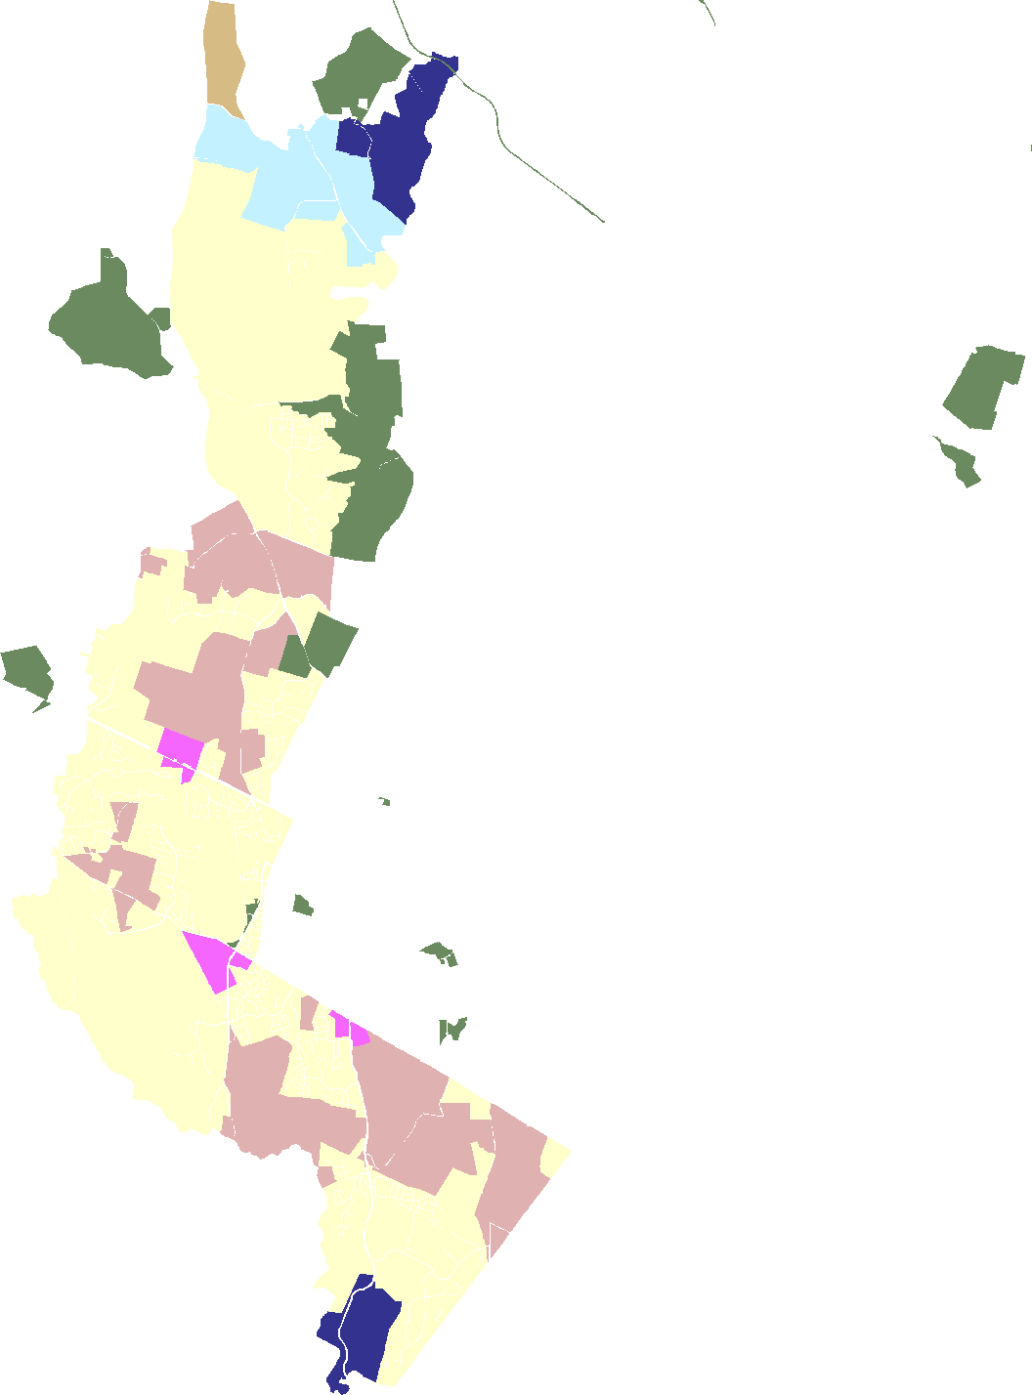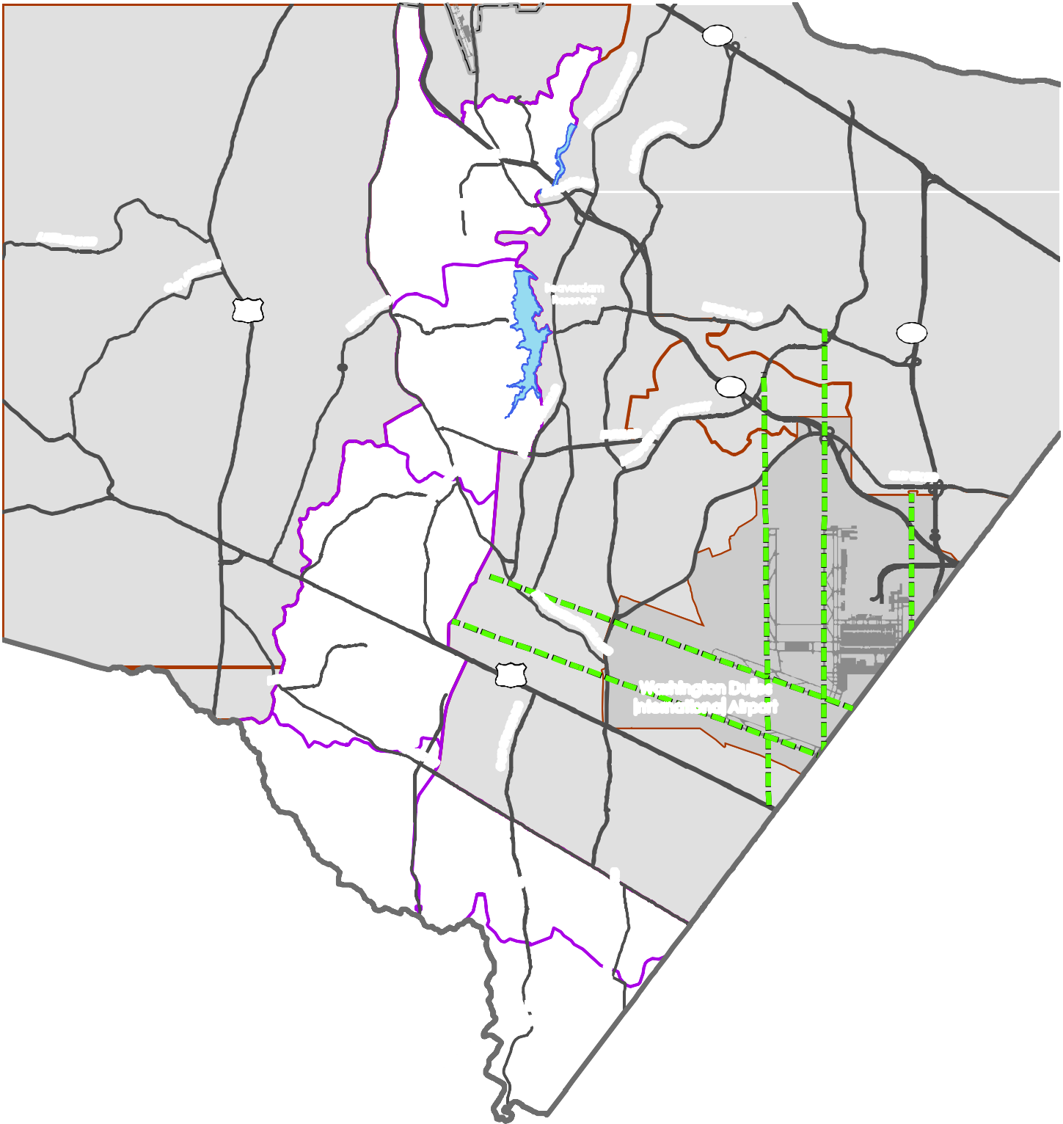7

LOWER SYCOLIN

RD

15

MIDDLE GOOSE
Beaverdam Reservoir

28

267
N RD

UPPER
BROAD RUN 50
Washington Dulles International Airport

UPPER FOLEY

Loudoun County IS NOT LIABLE for any use
of or reliance upon this map or any information contained herein. While reasonable efforts have

LOWER FOLEY

LOWER BULL RUN
U
STOFFICE RD

Policy Areas
Transition Policy Subareas Parks & Recreation Extended Runway Centerline Airport Runways
Place Types
Transition Large Lot Neighborhood Transition Small Lot Neighborhood Transition Compact Neighborhood Transition Community Center Transition Light Industrial
Transition Industrial/Mineral Extraction

been made to obtain accurate data, the County makes no warranty, expressed or implied, as to its
accuracy, completeness, or fitness for use of any purpose.
0 0.5
1 2 3 4
Miles
D R A F T
Map Num be r 2 01 8- 1 48

Transition Large Lot Neighborhood

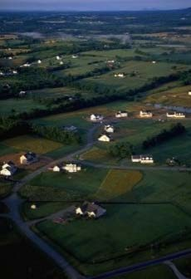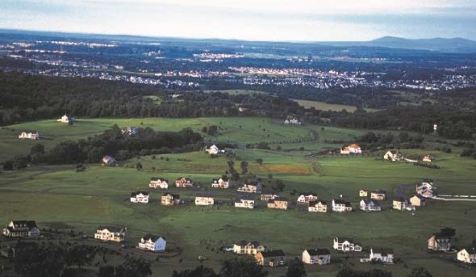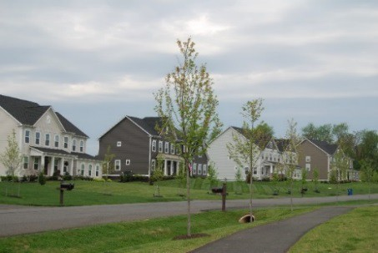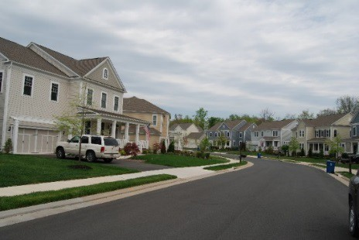Transition Large Lot Neighborhoods include projects such as Willowsford, Red Cedar and Evergreen, which offer detached homes and substantial open space in low-density communities. Agriculture and related uses are encouraged as active uses on these open spaces. Neighborhoods should offer a variety of house styles and sizes and, similarly, a variety of lot sizes and configurations. Development layouts follow land contours, incorporate natural features into the development, and protect sensitive resources. Extensive open space should partially conceal views of the new residential development from perimeter roadways and adjacent development and protect natural and cultural resources.

Predominant Uses | Secondary Uses | Ideal Mix of Uses
- Large Lot Residential  - Clustered Residential  - Accessory Residential Units | - Civic, Cultural, & Community  - Agriculture  - Agricultural Supportive Businesses  - Equine Facilities  - Agritourism  - Public Facilities | Public/Civic  Non 5%  Residential  5%  Residential 90%  Possible Ranges: Res: 90-100%  Non-Res: 0 - 10%  P/C: 0%+

DESIGN CHARACTERISTICS

Context
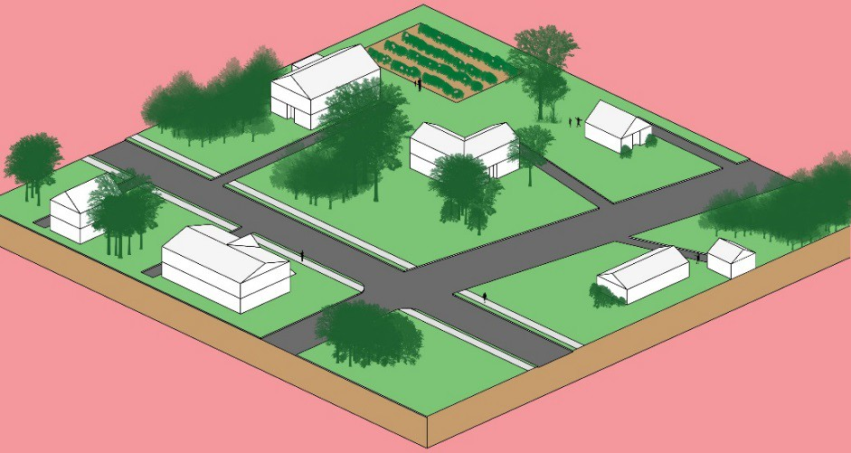Low-density residential neighborhoods with significant open spaces allowing agricultural uses and the protection of adjacent environmentally sensitive areas such as the reservoirs and stream corridors.
Place Type Rendering
An oblique projection of development within a Place Type to showcase the qualitative characteristics of how buildings within the Place Type should interact to create activity.
Total Nonresidential FAR: Up to 0.1
Building Height: 1-3 stories
Street Pattern: Warped Parallel Block Length: Varies
Building Setback:
Deep
Parking:
Driveway, garage, or on-street
Design Amenities:
Sidewalks, street trees, lighting, crosswalks, common open spaces
Open Space:
50% of the site

Target Residential
Density
Lower Sycolin | 1 du/10 ac
Middle Goose  Creek | 1 du/10 ac
Lower Bull  Run | 1 du/3 ac
Upper Broad Run | 1 du/1 ac or  1 du/3ac
Upper Foley | 1 du/3 ac
Lower Foley | 1 du/3 ac

Transition
Transition Large Lot Neighborhood projects should be surrounded by natural buffers that visually screen the development from view of surrounding roads and from other developments.

Transition Small Lot Neighborhood

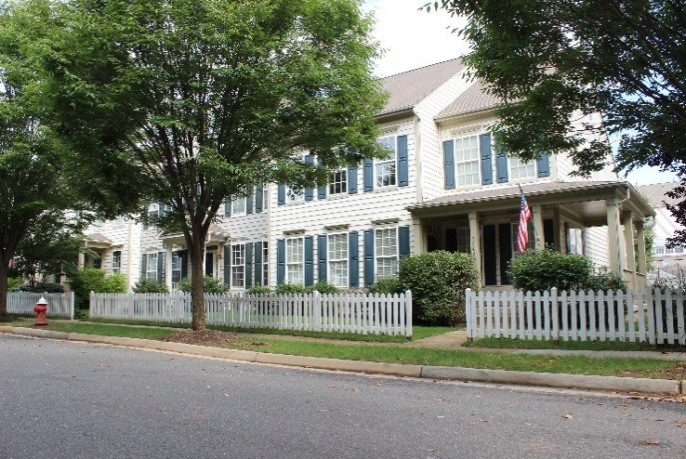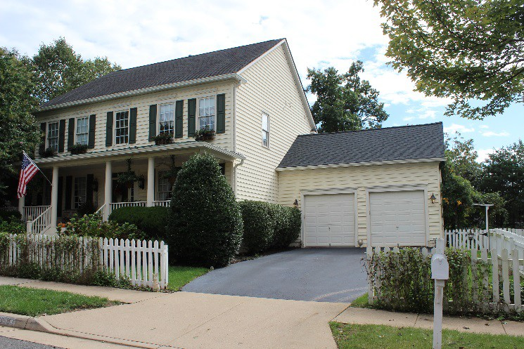Transition Small Lot Neighborhoods include residential neighborhoods arranged in a cluster arrangement that includes a focal point such as a civic use, park, or green. The predominant use is single family detached housing and some single family attached housing in larger projects. The lot pattern within each community should align with the topography and key environmental features to minimize the visibility of the structures. Open space and natural vegetation are the dominant visual features and provide public and private trails, passive and active recreation, and significant perimeter and environmental buffers.

Predominant Uses | Secondary Uses | Ideal Mix of Uses
- Single Family Detached Residential  - Single Family  Attached Residential | - Civic, Cultural, & Community  - Agriculture  - Agricultural Supportive Businesses  - Equine Facilities  - Institutional  - Live/Work Units  - Accessory Residential Units  - Public Facilities | Non Residential 10%  Residential 90%  Possible Ranges: Res: 90-100%  Non-Res: 0-10%  P/C: 0%+

DESIGN CHARACTERISTICS

Context
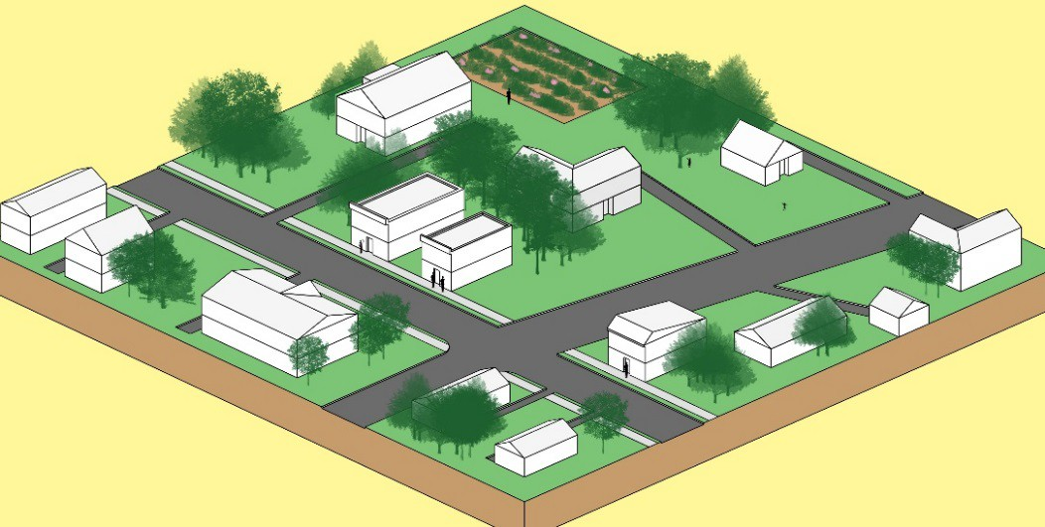Neighborhoods offering assorted lot configurations, sizes, and shapes with substantial open space, offering easy access to trails and natural areas internal to the neighborhood and connecting adjacent communities. The community is to be surrounded by extensive wooded buffers maintaining the rural appearance of surrounding roads.
Place Type Rendering
An oblique projection of development within a Place Type to showcase the qualitative characteristics of how buildings within the Place Type should interact to create activity.
Residential Density: Up to 1 du/ac Total Nonresidential FAR: Up to 0.2
Building Height: 1-3 stories
Street Pattern:
Fragmented Parallel and Warped Parallel
Block Length:
Varies
Building Setback: Medium to deep Parking:
Driveway, garage, or on-street
Design Amenities:
Sidewalks, street trees, lighting, crosswalks, common open spaces
Open Space:
50% of the site

Transition
Transition Small Lot Neighborhood projects should be surrounded by natural buffers that visually screen them from view of surrounding roads and from other developments.

Transition Compact Neighborhood

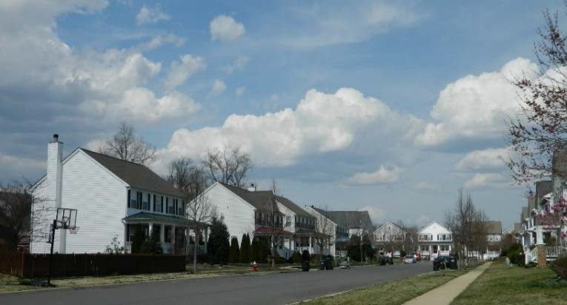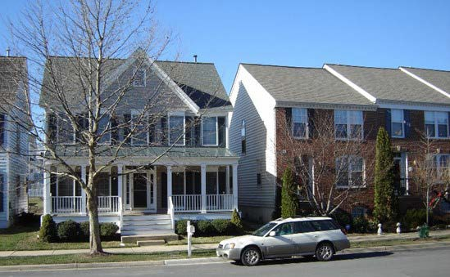Transition Compact Neighborhoods include a variety of single family homes arranged around a focal point such as a civic use, park, green or small commercial center. The predominant use is a mix of single family detached and attached housing. If included, neighborhood-serving retail or employment space (such as shared office space) should be situated in conjunction with civic space or a central park or green to create a neighborhood core or focal point.
The lot pattern within each community should exhibit an easily recognizable diversity in lot size and configuration, a variety of house sizes, heights and styles, and a mix of housing types along each street frontage and within each block. A pattern of interconnected streets is intended to provide a walkable community. Open space and natural vegetation are the dominant visual features and provide public trails, passive and active recreation and significant perimeter and environmental buffers. Transition Compact Neighborhood developments will also form the major residential component of a Transition Community Center, surrounding the commercial component of the Center and providing a transition to other surrounding uses. In such cases, residential densities should be lower next to the adjacent communities.

Predominant Uses | Secondary Uses | Ideal Mix of Uses
- Single Family Detached Residential  - Single Family Attached  Residential | - Civic, Cultural, & Community  - Retail & Service Commercial  - Entertainment Commercial  - Office  - Accessory Residential Units  - Public Facilities | Public/Civic 10%  Non  Residential 5%  Residential 85%  Possible Ranges: Res: 85-90%  Non-Res: 0-5%  P/C: 10% +

DESIGN CHARACTERISTICS

Context
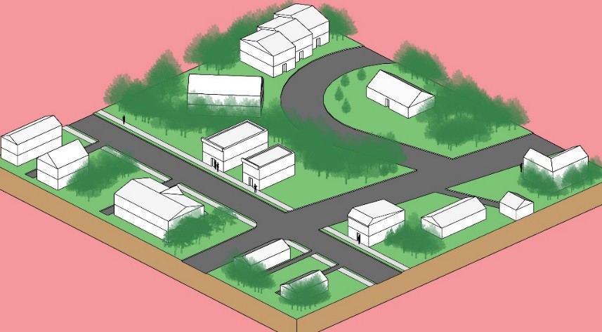Neighborhoods providing assorted lot configurations, sizes and shapes, and smaller, intermixed housing types and styles, characteristic of historic towns and neighborhoods. Communities are to be walkable and residents and the public are to have easy access to parks, playgrounds, and trails internal to the neighborhood and connecting adjacent communities. The community is to be surrounded by extensive wooded buffers maintaining the rural appearance of surrounding roads.
Street Pattern:
Rectilinear Grid, Fragmented Parallel, and Warped Parallel
Block Length: 400-800 feet Building Setback: Medium to deep Parking:
Driveway, garage, on-street, or alley-oriented
Design Amenities:
Sidewalks, street trees, lighting, crosswalks, common open spaces
Open Space:
50% of the site

Place Type Rendering
An oblique projection of development within a Place Type to showcase the qualitative characteristics of how buildings within the Place Type should interact to create activity.

Residential Density: 4-8 du/ac
Total Nonresidential FAR: Up to 0.6 Building Height: 1-3 stories

Transition
Transition Compact Neighborhood projects should be surrounded by natural buffers that visually screen them from view of surrounding roads and from other developments.

Transition Community Center

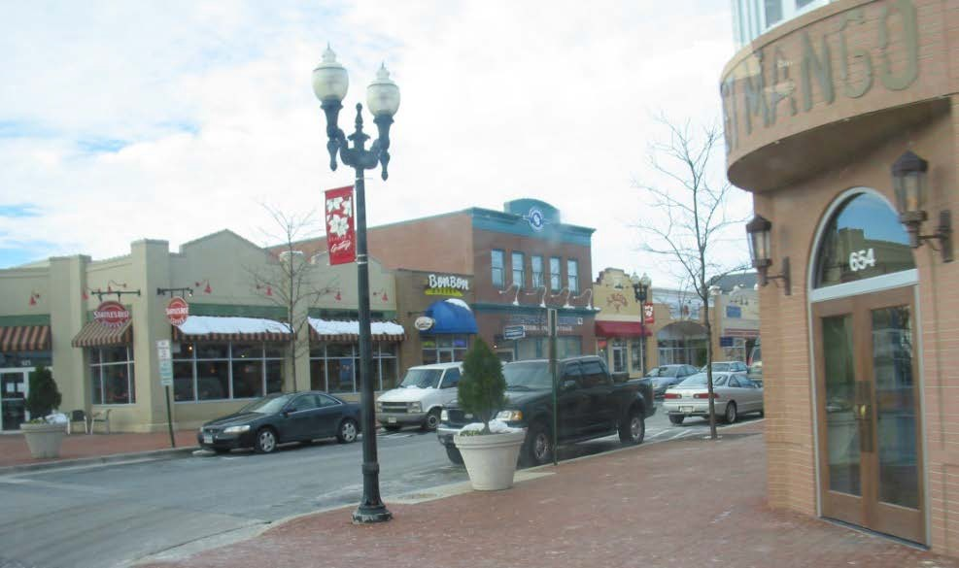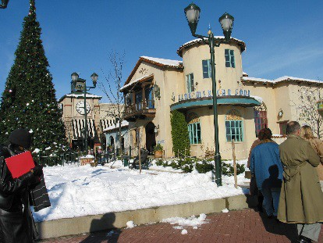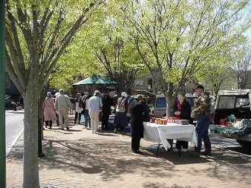Transition Community Centers consist of a mix of predominantly single family homes in residential neighborhoods integrated into and extending from a pedestrian-scale commercial development that provides retail sales, entertainment, and civic functions. The residential component will implement the Transition Compact Neighborhood Place Type. The commercial center will create a pleasant and attractive pedestrian shopping and entertainment environment with second-story residences and businesses, convenient and safe pedestrian and vehicular connections to adjacent neighborhoods, extensive landscaping, particularly at the perimeter, and outdoor activity and community space.

Predominant Uses | Secondary Uses | Ideal Mix Of Uses
- Single Family Detached Residential  - Single Family Attached Residential  - Retail & Service Commercial  - Civic, Cultural, & Community  - Entertainment Commercial  - Public Facilities | - Multi-Family Residential  - Office | Public/Civic 20%  Non Residential 10%  Residential 70%  Possible Ranges: Res: 70-90%  Non-Res: 5-10%  P/C: 5%+

DESIGN CHARACTERISTICS

Context
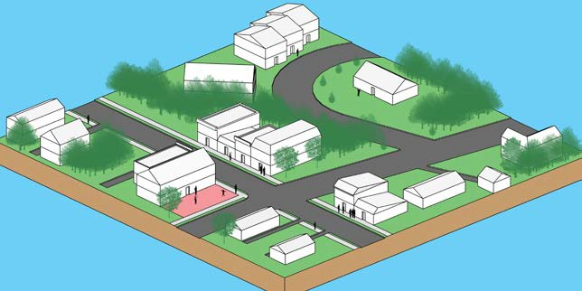Pedestrian-scale retail centers with small footprint retail uses and no “big box” retailers, with the exception of grocery or drug stores, surrounded by a mix of small detached, zero lot line and attached homes on an easily discernable mix of lot sizes and configurations which vary within most neighborhood blocks.
Place Type Rendering
An oblique projection of development within a Place Type to showcase the qualitative characteristics of how buildings within the Place Type should interact to create activity.
Residential Density: 4-8 du/ac Total FAR: Up to 0.6
Building Height: 1-3 stories
Street Pattern:
Rectilinear Grid (Commercial) Irregular Layouts (Residential) Block Length:
200-800 feet Building Setback: Varies
Parking:
Structured, on-street, or alley-oriented
Design Amenities:
Sidewalks, street trees, lighting, crosswalks, common open spaces
Open Space:
50% of the site

Commercial Center Floor Area Mix
Residential | 0-60%
Commercial | 35-95%
Public/Civic | 5%+

Transition
Single family housing should form the perimeter of the Transition Community Center, complementing adjacent residential neighborhoods. A substantial part of the 50% required open space should provide perimeter screening against other communities and adjacent roads.

Transition Light Industrial

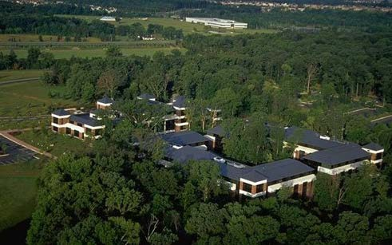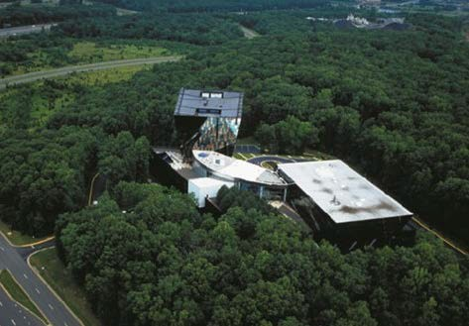Transition Light Industrial areas provide opportunities for low-traffic industrial and employment uses. Predominant uses are data centers, contractor establishments, and small-scale assembly or production. Open space that creates effective visual buffers and environmental protection on the site will encompass the business. Trails and passive parks are also appropriate.

Predominant Uses | Secondary Uses | Ideal Mix of Uses
- Light Production  - Data Centers  - Flex Space  - Contractor | - Institutional  - Civic, Cultural, & Community  - Public Facilities | Non Residential 100%

DESIGN CHARACTERISTICS

Context
Industries and businesses within an environment dominated by open space of established forests or thickly vegetated buffers that screen such uses from roads and adjacent development.
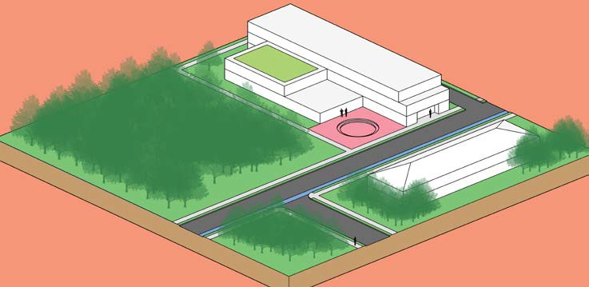
Place Type Rendering
An oblique projection of development within a Place Type to showcase the qualitative characteristics of how buildings within the Place Type should interact to create activity.
Total Nonresidential FAR: Up to 0.6
Building Height: 1-3 stories
Street Pattern:
Rectilinear Grid, Warped Parallel
Block Length: 300-1,000 feet Building Setback: Deep
Parking:
Surface lot
Design Amenities:
Sidewalks, street trees, shade trees, lighting, crosswalks
Open Space:
50% of the site

Transition
Transition Light Industrial projects will be visually screened from view of roads and separated from adjacent residential development and sensitive environmental and water supply reservoirs by large wooded buffers, berms, and distance.

Transition Industrial/Mineral Extraction

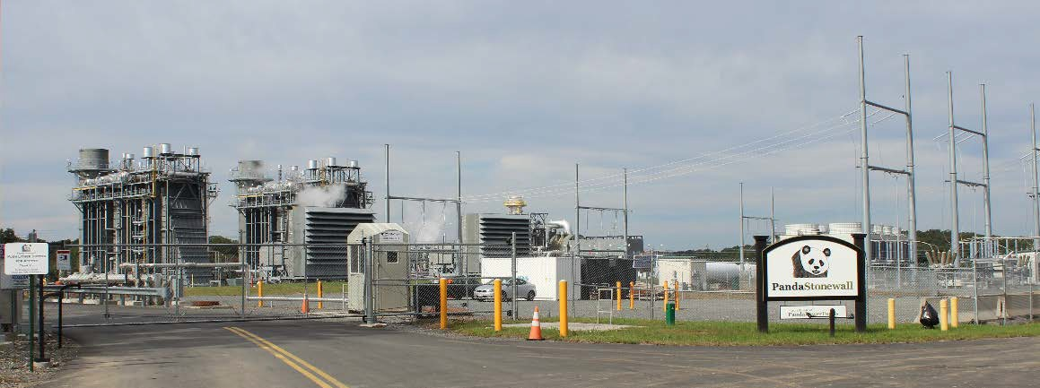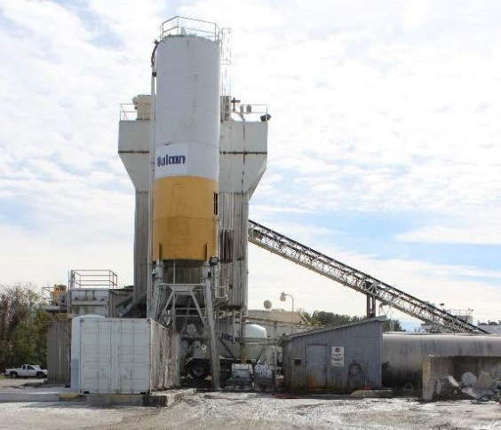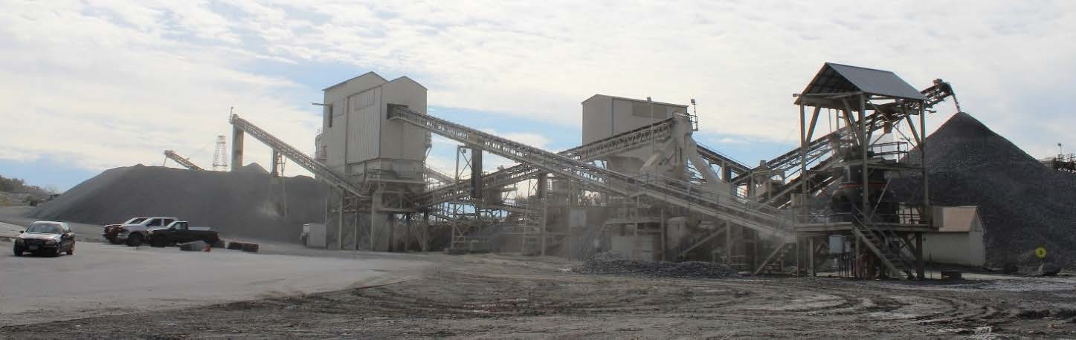As a primary industry, mineral extraction should be supported and protected as long as the quarries remain productive. Predominant uses are quarries, large-scale public facilities, and complementary manufacturing operations. Such uses are generally incompatible with residential development and considerable screening and setbacks are necessary to protect their viability.

Predominant Uses | Secondary Uses | Ideal Mix of Uses
- General Manufacturing and Assembly  - Data Centers  - Research and Development  - Outdoor Storage  - Public Facilities  - Quarry | - Office  - Outdoor Manufacturing  - Ancillary Retail | Non Residential 100%

DESIGN CHARACTERISTICS

Context
Existing quarries and quarry-related industries and businesses surrounded by substantial open space.
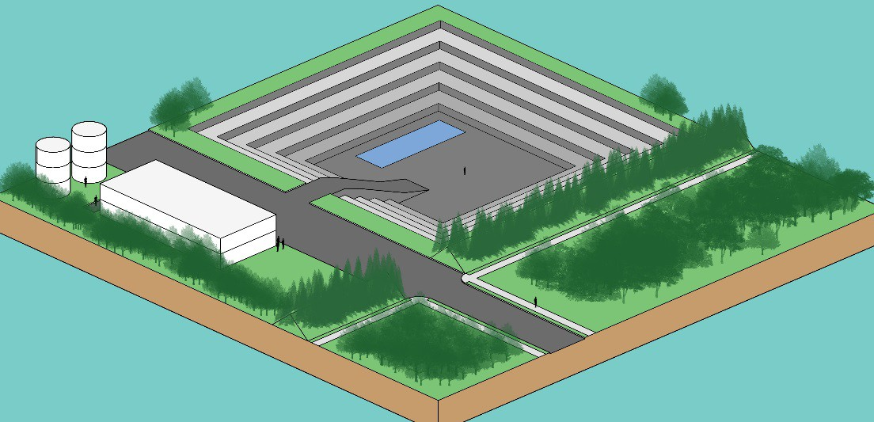
Place Type Rendering
An oblique projection of development within a Place Type to showcase the qualitative characteristics of how buildings within the Place Type should interact to create activity.
Total Nonresidential FAR: Up to 0.6
Building Height: 1-4 stories
Street Pattern:
Rectilinear Grid, Contour Forming
Block Length: 300-1,000 feet Building Setback: Deep
Parking:
Surface lot
Design Amenities:
Sidewalks, street trees, shade trees
Open Space:
50% of the site

Transition
Industry/Mineral Extraction projects should be separated from adjacent development and sensitive environmental and water supply reservoirs by wide, wooded buffers, berms, and distance.

Policies, Strategies, and Actions
Unless otherwise specified, the following Policies, Strategies, and Actions apply only within the TPA.

TPA Policy 1: Ensure that the Transition Policy Area retains the distinct visual character established by extensive natural open space by using compact development concepts with substantial open space requirements, and low profile construction to minimize visual intrusion into the natural environment.
Strategy
  - Promote a conservation design approach to new communities that provides more affordable and innovative residential communities in compact development patterns, while preserving open space, natural and heritage resources, and other valued features that may exist on site.

Actions
    - Encourage a variety of housing within individual developments by permitting small and large lot single-family detached units, duplexes, semi-detached units, accessory units, townhouses, and other housing types that expand affordability opportunities and support the lifestyle preferences of a diverse community.
    - Develop standards to accommodate mixed-use Transition Community Centers, Transition Compact Neighborhood, and Transition Small Lot Neighborhood Place Types to expand housing diversity and improve commercial viability.
    - Require new development to connect to Loudoun Water’s central water and wastewater systems and encourage existing development to connect.
    - Continue to define the TPA by six subareas to implement the existing Transition Large Lot Residential Neighborhood development pattern as identified on the Transition Policy Area Place Types Map.

TPA Policy 2: Offer safe and accessible parks and recreation opportunities that provide diverse activities for all ages, interests, and abilities.

Strategy
  - Provide a network of protected open space that maintains natural and heritage resources and reinforces the TPA’s unique character.

Actions
    - Develop a Master Plan for parks, open space, and trails in the TPA that: 1) builds on and links current planned trails and park areas, and 2) places greater emphasis on quality, connected, usable, and publicly accessible open space.
    - Protect the drinking water resources of the Occoquan, Beaverdam, and Goose Creek Reservoirs with natural stream and reservoir buffers, improved stormwater management, and other means.

    - Retain 50 percent open space throughout the TPA, and seek to reserve publicly usable, accessible, and interconnected open space.
    - Establish programs and regulatory mechanisms to increase publicly accessible open space, consistent with County facilities plans, through easements, land dedications, and purchase.
    - Require Open Space Plans with individual development applications to illustrate proposed use, public accessibility, resource protection, and connection with other open space.
    - Take advantage of existing or planned parks, stormwater ponds, and stream valley corridors, particularly the Goose Creek and Bull Run corridors, to create a linear park network linking larger park facilities and destinations.

TPA Policy 3: Target specific areas of the TPA for higher density residential and mixed use development that create affordable and diverse housing opportunities in compact communities recalling the historic pattern of villages and towns in Loudoun.

Strategy
  - Establish guidelines to accommodate higher density residential and mixed use communities in specified areas to provide sustainable and affordable housing.

Actions
    - Support Transition Compact Neighborhoods in areas specified on the Transition Policy Area Place Types Map provided they comply with the Place Type standards and incorporate the following features:
      - A combination of housing types, including detached, duplexes, zero-lot-line, semi-detached and/or attached.
      - Housing units that are smaller and more affordable than the County medians for each respective housing type.
      - Minor but discernible variations in lot shape and building setbacks along residential street frontages in a manner reflective of traditional villages and towns to visually distinguish individual residential structures.
      - Design concepts within units and neighborhoods that allow residents at different stages of their lives to remain in the community.
      - A walkable community design with minimal use of cul-de-sac streets and easy access to parks, playgrounds and amenities.
      - Public trails and parks internal to the neighborhood and connecting to adjacent communities and public facilities.
      - Extensive buffers screening the intensity of the development from surrounding roads and communities through the use of dense vegetation, earthen berms, and/or natural topography.

    - Support Transition Community Centers in areas specified on the Transition Policy Area Place Types Map provided they are consistent with the Place Type standards and offer the following features:
      - Small footprint retail uses and no “big box” commercial retailers with the exception of grocery or drug stores.
      - An attractive pedestrian shopping and entertainment environment with second- story residences and businesses.
      - Convenient and safe pedestrian connections to adjacent neighborhoods and public facilities.
      - Extensive landscaping, particularly at the perimeter to screen the project intensity from adjacent roads and communities.
      - Outdoor activity and community space.
      - A residential component consisting of residences within the community center and an integrated Transition Compact Neighborhood as defined by this Loudoun 2040 General Plan.

TPA Policy 4: Non-residential uses will include uses that are compatible with desired development patterns and the rural landscape.

Strategy
  - Provide for development of commercial, employment, and public uses in areas specified on the Transition Policy Area Place Types Map that are compatible with desired residential development patterns and the character of the TPA.
Actions
    - Require Industrial uses to:
      - Be located in locations consistent with the Place Types Map.
      - Be visually compatible within a rural environment.
      - Minimize the effects of noise, vibration, and odor.
      - Have access to adequate infrastructure.
      - Integrate visually into the natural environment.
      - Enhance water quality protection when near key water supply reservoirs.
    - Continue to protect the extractive industry by maintaining a quarry notification overlay zoning district.
    - Establish regulations that ensure new development does not hinder the operation of quarries.

Design Guidelines
The Design Guidelines are to build upon our current development patterns in a manner that allows innovative design and new responses to the market. While the Design Guidelines are not regulatory requirements, the County prefers that all future developments comply with these guidelines. The Design Guidelines do not supersede or otherwise limit the application of adopted zoning regulations, ordinances, building codes, or any other design standards or regulations administered by Loudoun County.

When using the guidelines make sure to analyze the impact a potential development may have on the landscape, considering not only appearance, but practical considerations such as proximity to utilities, community amenities, jobs, and housing to maximize the use of existing infrastructure and limit travel distances. Development should contribute to creating unique places within the TPA by working with existing topography and site features, responding to the local context, and reinforcing the landscape’s character, rather than simply attempting to place suburban design onto the rural landscape. Sustainability requires maximum consideration for using the landscape for benefits such as solar heat gain or shelter from wind. Buildings should be treated as parts of the landscape and attention given to their form and scale relative to their surrounding environment. Avoid bulky designs by breaking down the mass into smaller elements that follow natural contours. The County encourages the adoption of a conservation design approach when planning development in the TPA so that natural and heritage resources are conserved and incorporated into the site design. Unless otherwise specified, the following guidelines apply only within the TPA:
- A minimum of 50 percent of any development will be designated as open space that integrates buildings and parking into the existing natural landscape and provides useable space that is accessible to residents and the public, subject to the following:
  - Perimeter open space screening from roads and other communities may be the predominant component of the 50 percent open space requirement,
  - Distribute community greens, playgrounds, and gathering spaces within residential development,
  - Link open space to surrounding neighborhoods and public facilities with pedestrian and bicycle networks,
  - Link open space to natural and heritage resources, unique site features, and open space in other communities,
  - Locate low intensity parks that emphasize undisturbed open space in highly visible areas or in conjunction with schools, churches, and neighborhood commercial centers where they can serve as a buffer for adjoining homes.
- Ensure that open space within developments creates or enhances the following:
  - The 300-foot buffer and 200-foot transitional area along the Bull Run in the Upper and Lower Foley and Lower Bull Run subareas,
  - The 300-foot buffer and 1,000-foot voluntary open space area along the Goose Creek, Goose Creek Reservoir, and Beaverdam Reservoir in the Lower Sycolin and Middle Goose subareas,
  - A contiguous network of green spaces to supplement the natural and heritage resources connecting communities and natural resource areas, and
  - A public trail and park network to destinations throughout the area.
- Locate development on areas of the site that afford the least disruption of views of the rural landscape.
- Protect the historic context of nearby archaeological and historic sites and along scenic corridors.
- In all development, provide trails and sidewalks that connect to adjacent neighborhoods and other destinations within and outside the project.

- Ensure that clusters of residential units proposed in TPA communities are small in scale and number of units to reflect a traditional hamlet scale with multiple clusters separated by open space areas and featuring:
  - A variety of lot sizes with no minimum lot size requirement,
  - A predominantly single-family detached residential development pattern,
  - A network of publicly accessible trails and pedestrian sidewalks linking communities and amenities, and
  - A network of tree-lined streets constructed at minimum required widths to merge into the open landscape and slow traffic.
- Ensure that housing diversity and affordability are components of larger and higher density developments, such as Transition Compact Neighborhoods, and Transition Community Centers, by including a mixture of housing types, a range of building and lot sizes, and configurations.
- Include varying densities in neighborhoods with higher densities generally in close proximity to community greens, civic uses, or small-scale retail uses.
- Diversify housing size, unit types, lot sizes, and lot pattern along each street frontage and in the same blocks to reflect the design of traditional villages and towns.
- Include pedestrian features, landscaping, short blocks, few dead ends, and traffic calming features.
- Locate buildings close to the street but require some discernable variations in building setbacks along residential streets.
- Address parking in Transition Compact Neighborhoods and Transition Community Centers through a combination of on-street and off-street choices designed and located to minimize their visual impact.
- Develop employment uses at a scale that minimizes their intrusion into the rural and natural landscape and their impact on surrounding roads and communities by:
  - Screening all outdoor storage and equipment parking areas from view of adjoining properties and roads,
  - Minimizing the number of entrances from major collector or arterial roads;
  - Ensuring adequate road and infrastructure capacity,
  - Avoiding large expanses of blank building surfaces by using articulation, fenestration and façade treatments, especially when the facades are visible from public roads, and
  - Separating industrial uses from residences by locating less-intensive uses adjacent to residential uses or using natural or manmade barriers between the uses.

