Suburban Policy Area

Vision
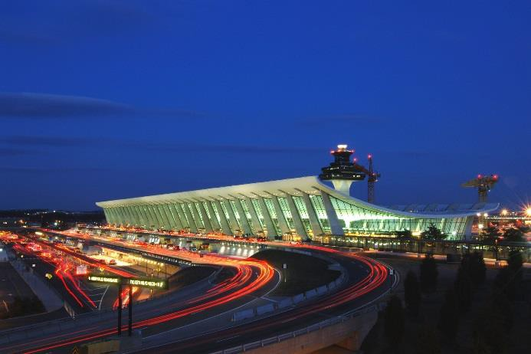The Suburban Policy Area (SPA) contains self-sustaining communities that offer a mix of residential, commercial, and employment uses; a full complement of public services and facilities; amenities that support a high quality of life; and a design that incorporates a holistic approach to maintaining and improving community character through compatible development.

Introduction
The 46,000-acre SPA is located in the easternmost portion of the County, in close proximity to the job centers and activity areas located east of Loudoun. The Suburban Policy Area is defined on the north by the Potomac River and on the south by Braddock Road. Its eastern edge is the Fairfax County line, and its western edge begins at the Potomac River and follows a southerly path along the Goose Creek just east of Leesburg, the Goose Creek and Beaverdam Reservoirs, and a combination of property lines, roads, power line easements, and Washington Dulles International Airport’s 65 Ldn (day-night average noise level) noise contours. The earliest planned development occurred within the Potomac and Sterling communities during the 1960s signaling the beginning of the transformation of eastern Loudoun County from farmland with a centuries old rural heritage to the suburban area that it is today.
The SPA is designated as one of the growth areas of the County and has accommodated most of the residential and commercial development over the past decades due to the presence of central water and sewer utilities and an expanded road
network. Two major events helped to open the SPA to residential development: 1) the construction of Washington Dulles International Airport, and 2) the construction of a major sewer line that accommodated the airport and improvements to Route 7 and Route 28.
Route 7 and Route 28 have evolved into critical transportation corridors that are contributing to Loudoun County’s reputation as an international center for technology, communications, and
global data management sectors. Given its connection to the Washington Dulles International Airport, Route 28 continues to play a major economic role for Loudoun County as a key location for on-going development. The County is committed to the continuing growth of and need for an economically vibrant Route 28 corridor, and the Route 28 Highway Transportation Improvement District, aids in accomplishing this goal by levying additional tax assesments on commercial and industrial properties to finance transportation improvements to Route 28. Additionally, the SPA surrounds the Urban Policy Area near the Silver Line Metro Stations that will include new dense, urban, transit-oriented types of development.

Land Use
The SPA consists of a mix of commercial areas and neighborhoods that provide a broad range of quality environments. The commercial areas of the SPA are focused areas for employment uses within a variety of commercial and workplace environments, including traditional office and industrial parks, mixed use centers, and neighborhood-serving commercial centers.
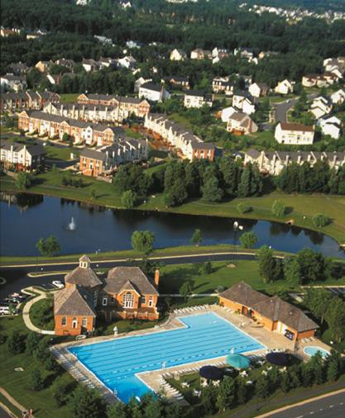Residential neighborhoods in the eastern corner of the County were built between 1960 and 1990, while neighborhoods built in the western area of the SPA were built in the early 1990s or later. The older neighborhoods commonly reflect the housing styles and neighborhood designs that were prominent in the era they were developed and provide a more limited mix of housing types (primarily single-family) while relying on neighborhood commercial developments located on major roads like Route 7 for easy access to amenities. The master planned developments west of Route 28 include a variety of housing types organized around neighborhood centers designed as the focal point of the community and provide easy access to daily needs. Parks, greenways, and open space frame developments and link neighborhood residents to

nature, neighborhood destinations, and beyond in both the western and eastern neighborhoods.

Influences and Opportunities
Suburban Neighborhood

The County will focus efforts on fostering and maintaining community identity within the SPA and its communities. The SPA is not and should not be one homogenous area. Many existing neighborhoods in Eastern Loudoun are becoming increasingly diverse, bringing a new set of expectations and attitudes to these communities. As new development continues in this area, the roads are becoming increasingly congested, and the lack of transit access and safe pedestrian connections is a mounting concern. Continuing the County’s goal to create communities with unique community visions would help identify and strengthen the creation of distinct places within the SPA, ensure that they are well designed and serviced, and that they provide diverse and stimulating social, cultural, recreational, and livable environments for their residents. Policies below address ways to improve livability through: 1) protecting and enhancing elements of Natural and Heritage Resources, including open space and pedestrian connections; 2) ensuring compatible and complementary infill development; and 3) revitalizing existing neighborhoods in a way that protects and enhances our existing communities. The concept of creating Community Plans is one that offers tremendous potential to ensure that the vision of the SPA is fully achieved and to guide the remaining build-out of each area.
Rapid growth in the County, with the majority occurring in the SPA, has increased development pressure outside of the SPA. Today there is little undeveloped land remaining in the SPA as most

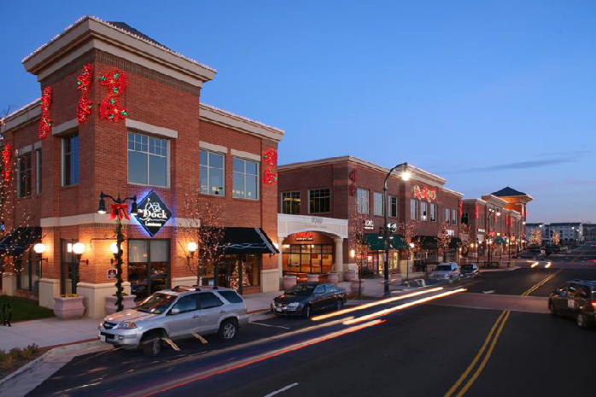land has already been developed or is approved for development. With limited developable land in this area, the County is at a juncture in its planning efforts for greenfield development. Redevelopment and infill will soon begin to play an increasing role in development decisions within the SPA, which will mark a significant shift in the county’s planning and development activities. Because much of the SPA is currently developed, most new projects will be smaller in scope and need to be evaluated based on how they can be integrated into the surrounding community. The amount of limited land available and the added growth from redevelopment and infill will make adding public facilities to the SPA a challenge. Public facility standards may need to change to continue to adequately address the needs of the population. As the primary location for suburban-scale residential and nonresidential development, the manner of growth and redevelopment in the SPA is of vital importance.

Growth and Demand
The demographic, market and land use trends of the past decades have led to greater demand for mixed-use and urban environments. National trends show that changes in typical households (for example millennials, seniors, empty nesters) may demand different housing types, public services, and lifestyle options than provided in the past. To attract top talent, many employers are focusing on employee satisfaction when considering locations and designs of office space. Employers in professional services, technology, and innovation sectors are shifting away from traditional suburban offices towards urban “live, work, play” environments to enhance quality of life. While the County previously established an overall land-development strategy that encouraged compact, mixed-use development providing people with the opportunity to live, work, recreate, and shop in a pedestrian-friendly environment, the development that has occurred in Loudoun has largely remained single-use and automobile-oriented.

Mixed Use Development
Loudoun County continues to be an attractive place for residential development given its geographic location in the region, school system performance, and notable quality of life measures. Demand for residential product will need to meet a wide variety of preferences, driven by attractiveness for families, young adults forming new households, and downsizing occurring in the Baby Boomer generation. Demand for non-residential development will be driven by the addition of new households, the County’s assets,

infrastructure, and the County’s technology sector. Retail users will follow new residential development, seeking locations that offer accessibility and visibility to an expanding customer base. Other employers seeking office and industrial space will locate in areas that serve their target needs.

The County previously designated land along its primary transportation corridors for “Keynote Employment” areas to provide locations for corporate campus style office development; however, new suburban-style office developments are no longer envisioned in these areas due to declining demand and concerns about the sustainability of single-use development patterns.
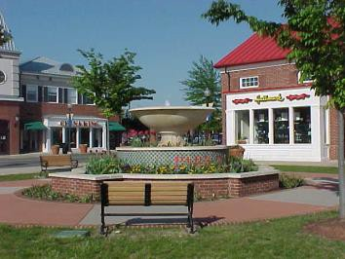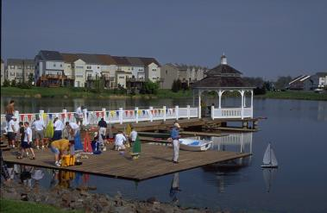It is expected that mixed-use developments, such as One Loudoun or those proposed near the future Silver Line Metro Stations, will be the most attractive environments for retail and office uses in the coming years. To provide alternative means of addressing office development and land uses along Route 7, Loudoun County Parkway, and Route 28, this Plan replaces the “Keynote Employment” planned land use designation with a number of designations. To continue to maximize the commercial development potential within the Route 28 corridor, the Suburban Employment and Suburban Mixed Use Place Type designations offer planned land uses that reflect the full economic potential of properties and provide employment settings that reflect the kind of environments sought by business users.

Community Character
Community character is the
aggregate of features and traits that form the individual nature and uniqueness of a community. It includes the constructed and natural landmarks and surroundings that cause
someone to identify with a particular place or community.
This character is shaped by natural, cultural, societal,
historic, and economic forces.
In addition, changes in technology over the past decade have contributed to the escalated development of data centers within the County. To date, there are
approximately seventeen million square feet of data center facilities completed, under construction, or planned. Future demand for data centers will need to be accommodated in places that have access to utilities, including electricity, water, and fiber. The supply of industrial and flex space is being outpaced by demand, resulting in low vacancy rates. As available greenfield sites in eastern Loudoun County become more limited, targeting key tracts of land for employment uses will be critical to ensure future economic growth.
Overall, the County’s approach is to ensure that future
development is complementary to the existing development pattern of the SPA while supporting the necessary flexibility in form and use that will be needed to create vibrant mixed-use environments. As each new development is absorbed into the SPA’s built environment, it will be viewed in the context of its larger community with an emphasis placed on the character of the development and how it contributes to the needs and overall identity of the SPA and Loudoun County.

Place Types
As described in the beginning of this chapter, the following Place Types have been designated for specific locations as displayed on the accompanying map. The Place Types will work in concert with the Design Guidelines and Policies, Strategies, and Actions of the SPA to fulfill the land use patterns and community characteristics intended for the area.

Loudoun County
Su burba n P olic y A re a Plac e T ypes
2040 General Plan

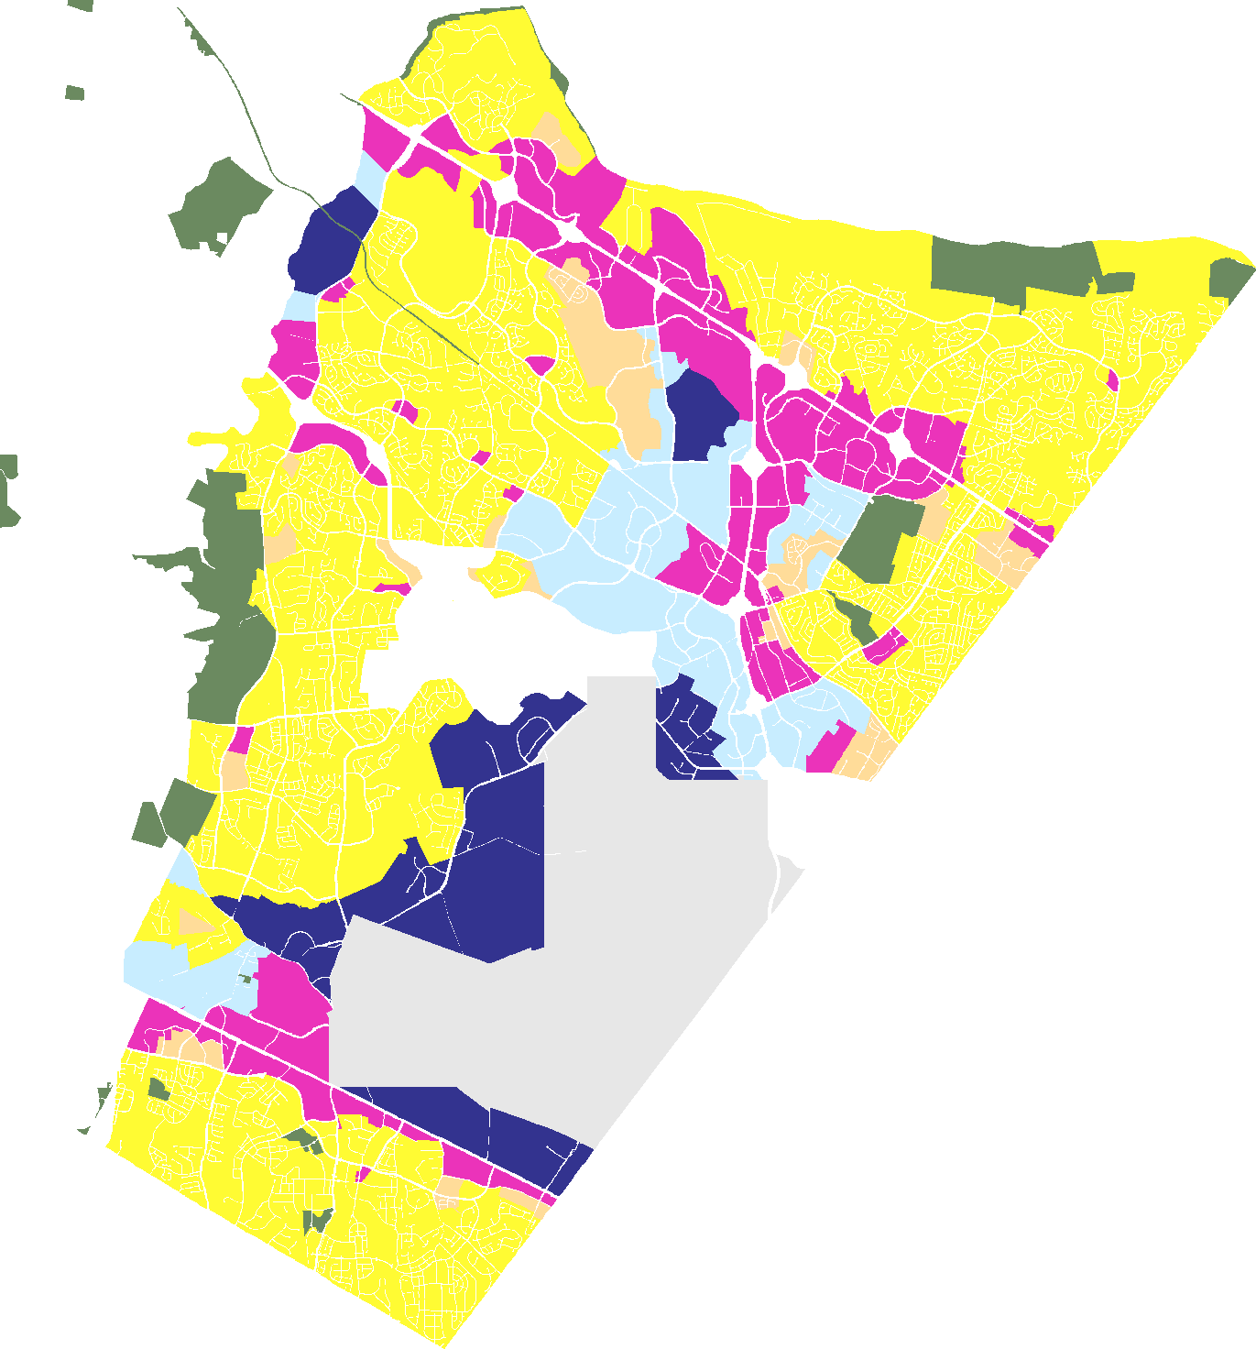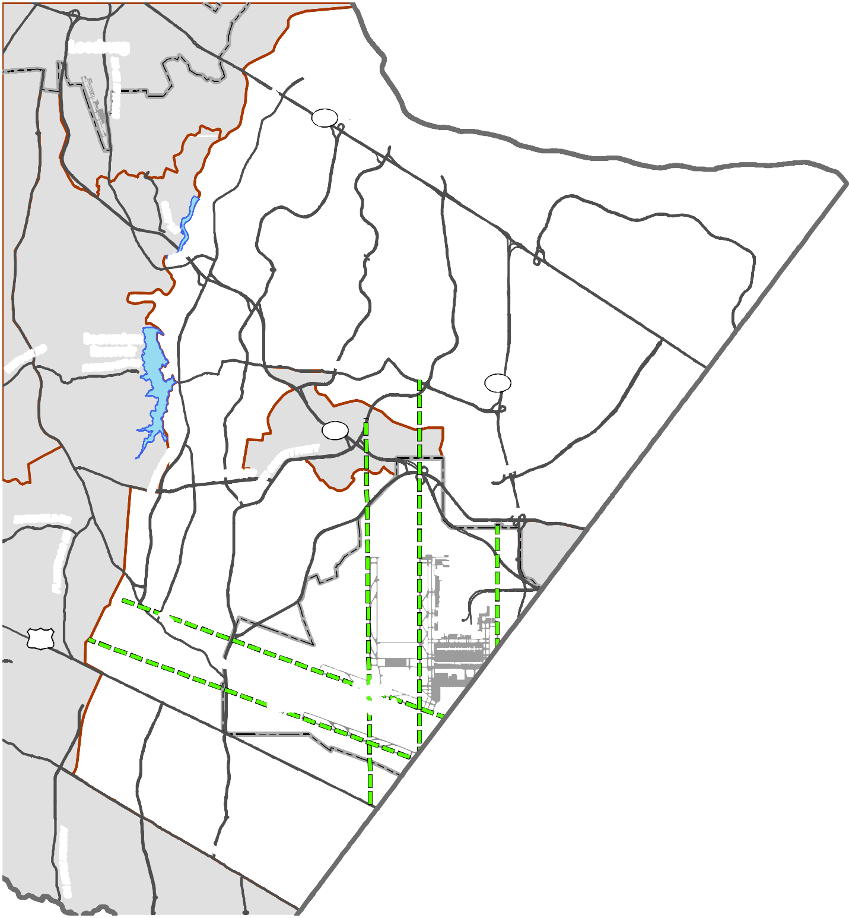Leesburg

7

Beaverdam Reservoir

28

267
N RD

50

Washington Dulles International Airport
Policy Areas
Parks & Recreation Airport
Extended Runway Centerline Airport Runways
Place Types
Suburban Neighborhood Suburban Compact Neighborhood Suburban Mixed Use
Suburban Employment
Suburban Industrial/Mineral Extraction

Loudoun County IS NOT LIABLE for any use
of or reliance upon this map or any information contained herein. While reasonable efforts have been made to obtain accurate data, the County makes no warranty, expressed or implied, as to its
accuracy, completeness, or fitness for use of any purpose.

0 0.5

1 2 3 4
D R A F T
Miles
Map N um be r 2 01 8 - 1 5 1

Suburban Neighborhood
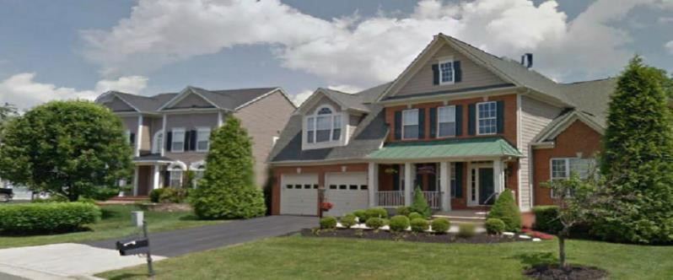
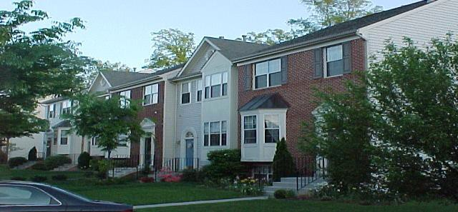

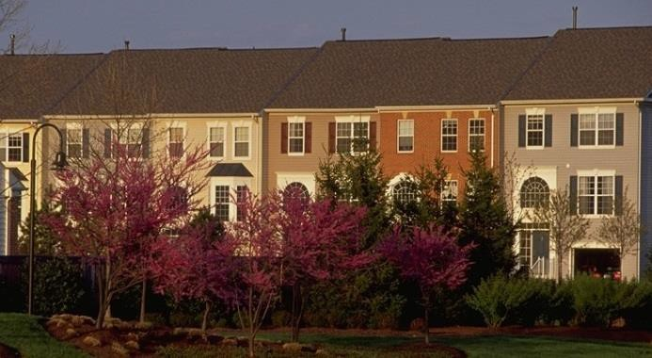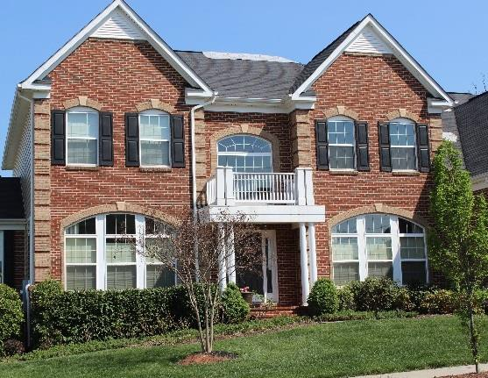

Suburban Neighborhood areas include Loudoun’s master planned neighborhoods of predominantly residential uses arranged on medium-to-large lots. Accessory residential units can be appropriate for the area and may consist of apartments in the principal structure, garage apartments, or other outbuildings approved by the County. Retail and service uses that serve the routine shopping needs of the immediate neighborhood (e.g., grocery, drycleaners, etc.) should be integrated into the area at significant intersections and along major roads.
The Suburban Compact Neighborhood Place Type may be appropriate for infill parcels designated as Suburban Neighborhood on the Place Type map.

Predominant Uses | Secondary Uses | Ideal Mix of Uses
- Single Family Detached Residential  - Single Family Attached Residential  - Civic, Cultural, & Community | - Office  - Retail & Service Commercial  - Public Facilities  - Active Adult Retirement Communities  - Multi-Family Residential  - Accessory Residential Units | Public/Civic 10%  Non Residential 10%  Residential 80%  Possible Ranges: Res: 80-90%  Non-Res: 0-10%  P/C: 10%+

DESIGN CHARACTERISTICS

Context
Primarily single family detached and attached residential uses that are integrated in a walkable street pattern.
Street Pattern:
Fragmented parallel and warped parallel, limited loops and cul-de-sacs
Block Length: 600-1,500 feet Building Setback: Shallow to medium Parking:
Driveway, garage, or on-street
Design Amenities:
Sidewalks, street trees, lighting, crosswalks, common open spaces
Open Space:
30% of the site

Place Type Rendering
An oblique projection of development within a Place Type to showcase the qualitative characteristics of how buildings within the Place Type should interact to create activity.

Residential Density: Up to 6 du/ac Non-Residential FAR: Up to 1.0 Building Height: Up to 4 Stories
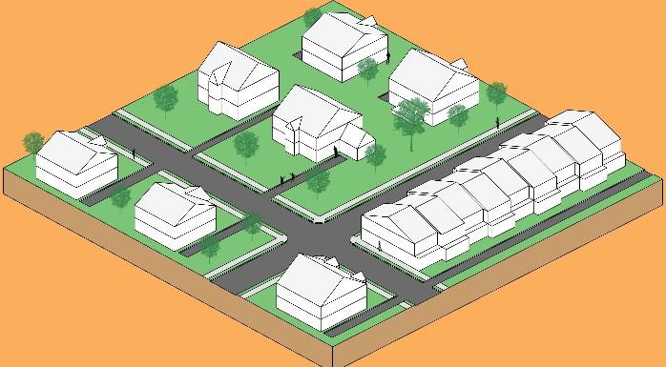
Transition
Transitions should be gradual, particularly where natural or man-made buffers are not available. New developments within Suburban Neighborhood areas adjacent to lower-density residential uses should create transitions in building scale and incorporate design elements that soften those transitions. Higher-density residential development can serve as a transitional land use between nonresidential uses and lower-density residential areas. Appropriate transitional techniques include variations in building orientation, height step down, and creative and extensive use of landscaping and natural features. Fencing or other barriers should not be used as the sole means of screening and buffering.

Suburban Compact Neighborhood
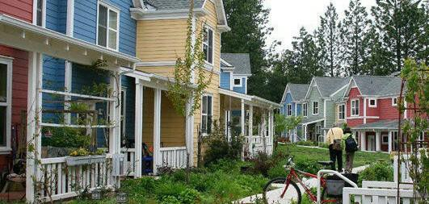
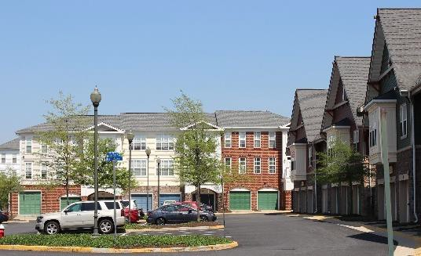
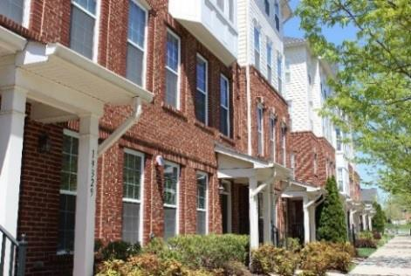
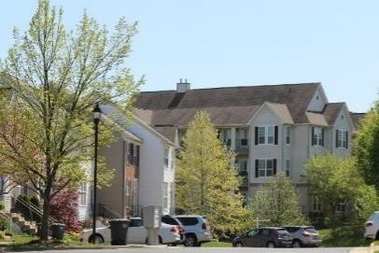
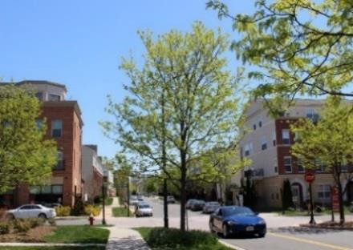

Suburban Compact Neighborhood areas provide opportunities to develop neighborhoods that can take advantage of small infill parcels near traditional suburban neighborhoods or high-density walkable urban neighborhoods, depending on the context of their location. They provide opportunities for a mix of housing types including small-lot patio homes, townhomes, duplexes, and multifamily residences. Accessory residential units are also appropriate for these areas and may consist of apartments in the principal structure, garage apartments, or other outbuildings approved by the County. Open space areas such as parks, trails, community courtyards, and small public plazas should be integrated into individual site plans. Small-scale offices as well as retail and service uses serving the immediate or routine shopping needs of the immediate neighborhood (e.g., grocery, drycleaners, etc.) could be integrated into these neighborhoods. Development within this Place Type should include a public and civic component or be located within walking distance of public and civic amenities.

Predominant Uses | Secondary Uses | Ideal Mix of Uses
- Single Family Attached Residential  - Single Family Detached Residential  - Multi-Family Residential | - Office  - Retail & Service Commercial  - Active Adult Retirement Communities  - Civic, Cultural, & Community  - Public Facilities  - Accessory Residential Units | Non Residential 10%  Residential 90%  Possible Ranges: Res: 90-100%  Non-Res: 0-10%  Public/Civic: 0%+

DESIGN CHARACTERISTICS

Context
Compact residential development providing opportunities for a variety of unit types that can be designed to fit within or adjacent to surrounding neighborhoods.

Street Pattern: Rectilinear Grid Block Length: 200-660 feet Building Setback: Shallow setbacks Parking:
On-street, accessory, alley-oriented parking
Design Amenities:
Sidewalks, street and shade trees, lighting, street furniture, bike racks, crosswalks
Open Space:
15% of the site

Place Type Rendering
An oblique projection of development within a Place Type to showcase the qualitative characteristics of how buildings within the Place Type should interact to create activity.

Residential Density: 8-24 du/ac Total Nonresidential FAR: Up to 1.0 Building Height: Up to 4 stories
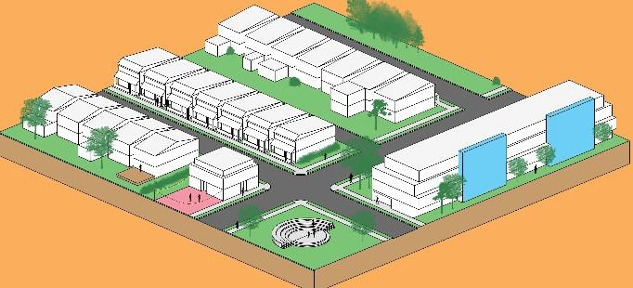

Transition
Appropriate transitional methods should be implemented where new development abuts more intensive nonresidential uses or less intensive residential uses. New high-density and large-scale infill within Suburban Compact Neighborhood areas adjacent to lower density residential uses should create transitions in building scale and incorporate design elements that soften those transitions. Appropriate transitional techniques include variations in building orientation, height step down, and creative and extensive use of landscaping and natural features.

Suburban Mixed Use
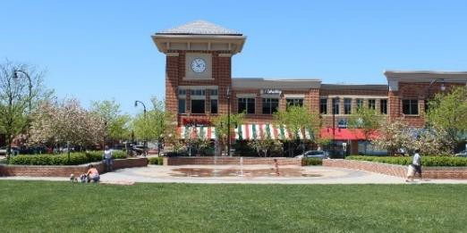
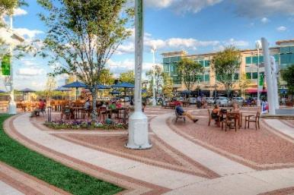
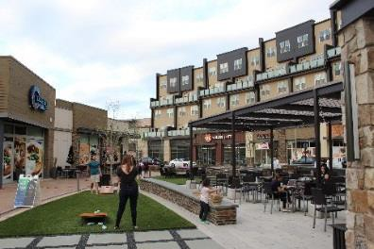
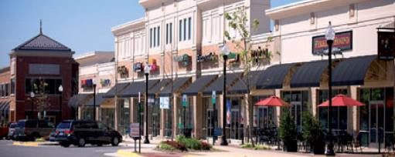
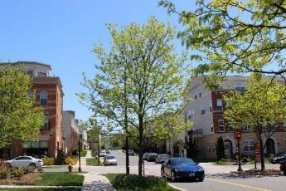

Suburban Mixed Use areas provide compact, pedestrian-oriented environments with opportunities for a mix of residential, commercial, entertainment, cultural, and recreational amenities. Although this area provides for residential uses, commercial and entertainment uses are the primary draw to the mixed-use center. Reducing the distance between home, work, and entertainment/retail destinations, Suburban Mixed Use areas serve as logical locations for transit stops. Accessory residential units are also appropriate for the area and may consist of apartments in the principal structure, garage apartments, or other outbuildings approved by the County. Within this Place Type, mixed-use developments with increased densities and greater ranges of uses than otherwise allowed for Suburban Mixed Use may be appropriate on sites 150 or more acres in area.
Over time, existing commercial developments within Suburban Mixed Use areas should be redeveloped with a vertically integrated mix of uses on the site. Multi-family residential can also be introduced into the design of existing suburban-style commercial developments as an initial step toward creating vibrant, walkable mixed-use communities.

Predominant Uses | Secondary Uses | Ideal Mix of Uses
- Retail & Service Commercial  - Office  - Entertainment Commercial  - Multi-Family Residential  - Institutional | - Small-Lot Single Family Residential (Attached and Detached)  - Active Adult Retirement Communities  - Civic, Cultural, & Community  - Accessory Residential Units  - Public Facilities  - Hotel | Public/Civic 5%  Non Residential  35% Residential  60%  Possible Ranges: Res: Up to 60%  Non-Res: Up to 80% Public/Civic: 5%+

DESIGN CHARACTERISTICS

Context
Vertically mixed-use buildings as well as multi-story single-use buildings that are integrated in a walkable street pattern.
Street Pattern: Arterial and local; grid Block Length:
200-660 feet
Building Setback:
Shallow setbacks at sidewalks
Parking:
Structured, on-street, accessory, short-term, and/or alley-oriented
Design Amenities:
Sidewalks, street trees, street furniture, shade trees, bike racks, lighting, crosswalks, plazas, pedestrian malls, network of green space, public art
Open Space:
10% of the site

Place Type Rendering
An oblique projection of development within a Place Type to showcase the qualitative characteristics of how buildings within the Place Type should interact to create activity.

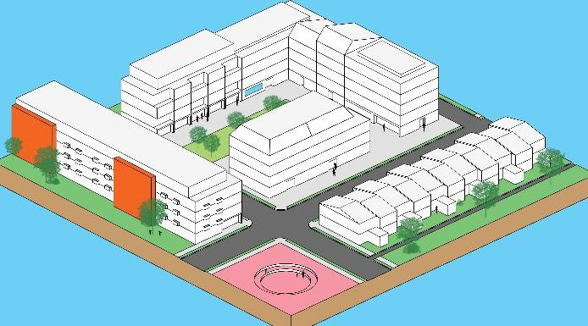
Total FAR: Up to 1.0 Building Height: Up to 5 stories
Transition
Small block sizes and a mix of different uses make transitions between uses and developments important in the Suburban Mixed Use Place Type. Changes in height or building character, where allowed, should occur mid-block to promote balanced streetwalls where both sides of the street appear similar in height. Larger developments near smaller residential dwellings should step down appropriately to respect these neighbors. Developments should be transitioned from taller buildings at the center to heights generally no more than a story taller than adjoining adjacent development consisting of less intensive uses. The predominant residential use type is multi- family; however, a very limited portion of the development within the Suburban Mixed Use Place Type may be developed with small-lot single family residential as a transitional use between Place Types.

Suburban Employment
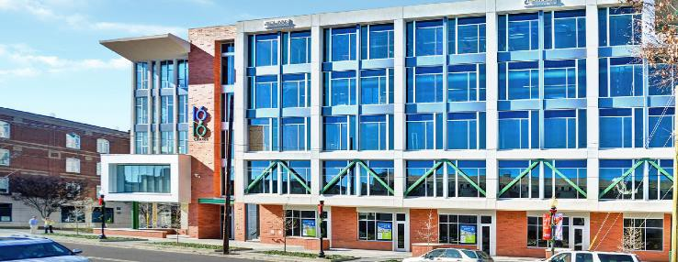
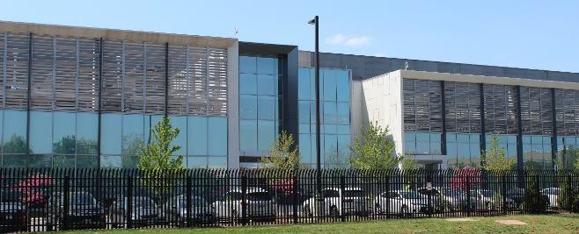

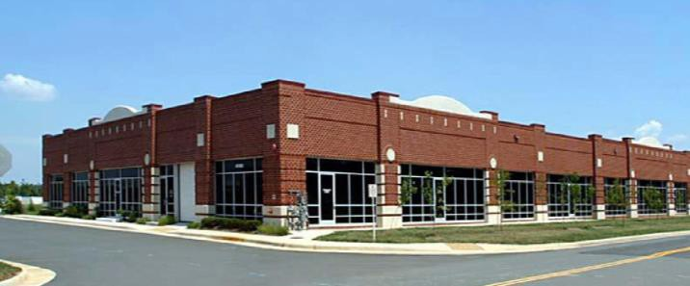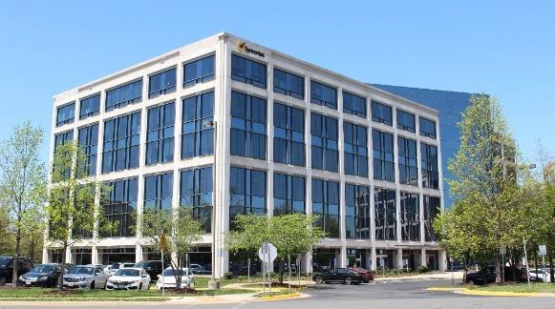
Suburban Employment areas provide opportunities for a broad array of employment uses within an environment that provides gathering spaces and opportunities for synergies among businesses. These offer prime locations for office, production, flex space, and warehousing uses as well as startups and established businesses. Appropriate uses do not generate excessive noise or air pollutants or require outdoor storage. Limited first floor retail that supports predominant uses is appropriate.
Parking should generally be located behind the building to ensure the buildings are the predominant feature when viewed from roadways and adjacent properties.
Although civic or recreation space is not expected, required open space in Suburban Employment developments should include areas for use by customers and employees.

Predominant Uses | Secondary Uses | Ideal Mix of Uses
- Light Production  - Office  - Research & Development  - Warehousing  - Contractor without Outdoor Storage  - Data Centers  - Flex Space | - Retail & Service Commercial  - Institutional  - Civic, Cultural & Community  - Public Facilities | Non Residential, 100%  Possible Ranges: Res: 0%  Non-Res: Up to 100% Public/Civic: 0%+

DESIGN CHARACTERISTICS

Context:
Separate employment uses that are integrated within a walkable, employment-based environment.
Street Pattern:
Rectilinear Grid or Fragmented Parallel
Block Length: 300-1,000 feet Building Setback:
Short to medium; greater if flex use
Parking:
Structured, on-street, accessory, or short-term
Design Amenities:
Sidewalks, street trees, shade trees, bike racks
Open Space:
30% of the site

Place Type Rendering
An oblique projection of development within a Place Type to showcase the qualitative characteristics of how buildings within the Place Type should interact to create activity.

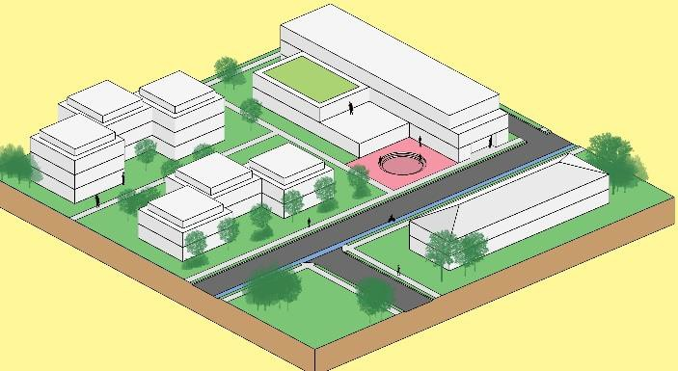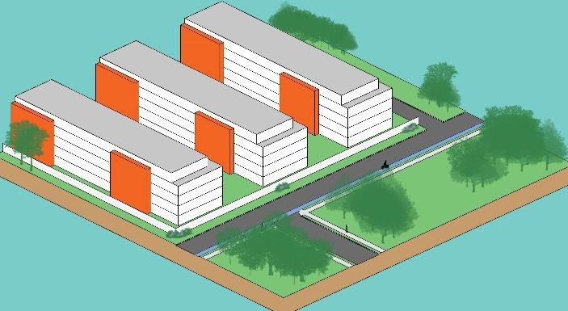Total FAR: Up to 1.0 Building Height: 2 to 8 stories

Transition
Transitions between Suburban Employment uses and other developments, in particular adjacent residential neighborhoods, are vitally important. Building heights should step down appropriately to less intense residential uses. In developments adjoining less intensive uses, building heights should decrease moving outward from the center of the development, stepping down to heights generally within one story of adjacent structures.
Certain employment uses that may not be compatible with adjacent residential uses, such as data centers, should have transitional uses located in between.

Suburban Industrial/Mineral Extraction
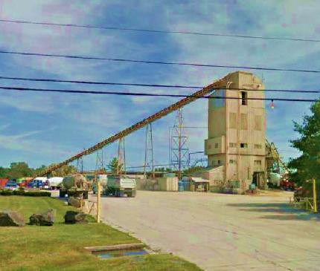
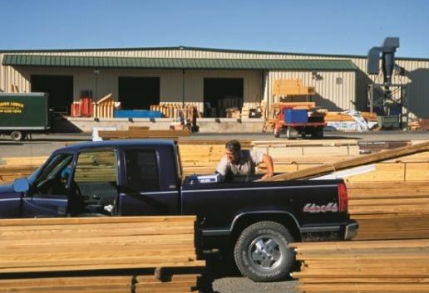
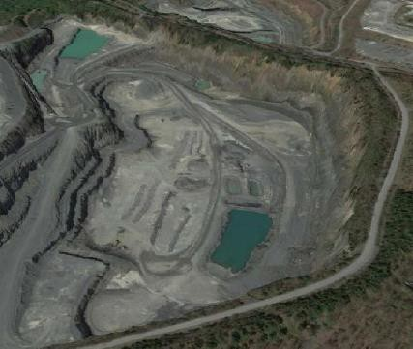

Suburban Industrial/Mineral Extraction areas consist of large manufacturing, contractor with outdoor storage, and other productive uses. Streets in this district are typically designed to accommodate freight ingress and egress. This Place Type also includes mineral extraction areas such as quarries and mines. Industrial and mineral extraction uses are incompatible with residential uses due to the prevalence of outdoor storage and the emissions of noise, odor, and vibrations. Buffers between these uses and residential uses are necessary to ensure compatibility and maintain commercial viability.

Predominant Uses | Secondary Uses | Ideal Mix of Uses
- General and Heavy Manufacturing and Assembly  - Warehousing  - Contractor with Outdoor Storage  - Data Centers  - Fleet & Equipment Sales & Service  - Research and Development  - Outdoor Storage  - Public Utilities  - Quarry  - Outdoor Manufacturing | - Office  - Retail & Service Commercial  - Flex Space  - Light Production  - Public Facilities | Non Residential, 100%  Possible Ranges: Res: 0%  Non-Res: Up to 100%  Public/Civic: 0%+

DESIGN CHARACTERISTICS

Context
Primarily one-to-two-story buildings used for warehousing, data centers, contractor services, or manufacturing.
Street Pattern: Irregular layouts Block Length: 300-1,000 feet Building Setback:
Deep, varying with use
Parking:
Surface lot
Design Amenities:
Sidewalks, street trees, shade trees
Open Space:
30% of the site

Place Type Rendering
An oblique projection of development within a Place Type to showcase the qualitative characteristics of how buildings within the Place Type should interact to create activity.

Total FAR: Up to 0.6 Building Height: Up to 4 stories
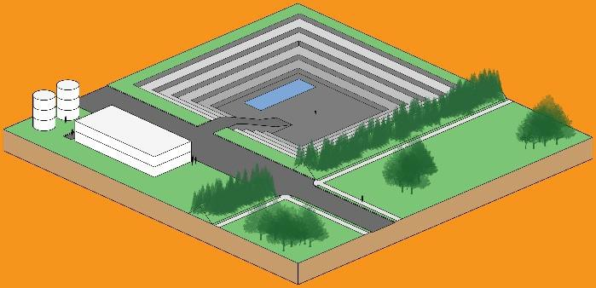

Transition
Transitions between Suburban Industrial/Mineral Extractive uses and other developments, in particular adjacent residential neighborhoods, are critically important to the viability of long-term industrial operations. Setbacks, buffering, and natural open space can reduce impacts by blending the edges of Industrial/Mineral Extraction developments with surrounding developments, providing softer transitions than structural buffers. Storage and loading areas are to be oriented away from and screened from streets and adjacent uses.

Policies, Strategies, and Actions
Unless otherwise specified, the following Policies, Strategies, and Actions apply only within the SPA.

SPA Policy 1: Foster community identity within the Suburban Policy Area.

Strategy
  - Build upon and enhance the sense of place in the Suburban Policy Area and its communities.
Actions
    - Update the County’s adopted Small Area Plans and create new Community Plans and other appropriate plans which address the particular needs and guide the remaining build-out and/or redevelopment of specific areas within the Suburban Policy Area.
    - Establish design principles for individual communities within the Suburban Policy Area which ensure a high quality of development and redevelopment is achieved.
    - Ensure development and redevelopment proposals conform to the applicable Design Guidelines of this plan.
Strategy
  - Enable residents to become more involved in their neighborhoods.
Actions
    - Develop a public outreach program to educate neighborhood residents regarding County programs available to them.
    - Expand civic outreach to involve underserved individuals.
    - Support citizen organizations in their efforts to improve their communities.
    - Foster the development of community partnerships to improve community character, maintenance, and safety.
    - Invest in programs that allow residents to formulate and assume stewardship of neighborhood values, standards, and goals.
Strategy
  - Integrate new development within the Suburban Policy Area with the existing development pattern that surrounds it.
Action
    - Evaluate the appropriateness of a proposed use or development with the surrounding community.
Strategy
  - Design and develop Suburban Policy Area communities as walkable and interconnected places.

Actions
    - The County, in collaboration with other governmental agencies and the private sector, will ensure through a variety of measures that all public spaces in residential and commercial areas are accessible by pedestrians.
    - 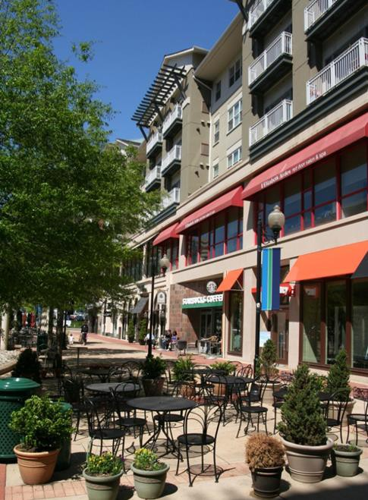Retail and office development proposals will combine open and civic space in features such as pedestrian promenades and plazas, public art, entrance features, linear parks and trails, outdoor seating, lawns and greens, and similar design features that invite pedestrian activity.
    - Require convenient access by foot and bicycle for residential, office, institutional, civic, and retail areas.
    - The Loudoun 2040 Countywide Transportation Plan will provide additional transportation policy direction for the transportation network (walkability, multimodal, connectivity) in the Suburban Policy Area.

SPA Policy 2: Create environments where individuals can work, live, and have convenient access to services, shops, and recreation.

Strategy
  - Allow a mix of uses or uses that complement and complete existing communities.
Actions
    - Provide incentives for redevelopment, infill development, and adaptive reuse projects that will enhance quality of life and neighborhood character, fulfill community needs, and improve economic opportunities (see Infill and Redevelopment section).
    - Allow new multi-family residential units to be located within existing commercial centers to allow for more walkable, mixed use communities
    - Promote residential and office uses above first floor retail.
    - Allow flexibility in the development phasing
for mixed-use projects while establishing a build-out relationship between the residential and non-residential components that ensures a mix of uses is achieved and to best balance the fiscal costs and benefits of the project.

    - Promote high quality site and building design, landscape design and buffering in employment areas that reflect their function as a gateway to the Urban Policy Areas and location along major vehicular thoroughfares (see Quality Development section).
    - Accommodate transit infrastructure in Employment and Mixed Use Areas (see
Loudoun 2040 Countywide Transportation Plan).
    - Provide pedestrian and bicycle connectivity to surrounding networks and transit nodes within employment areas.

SPA Policy 3: Support the Route 28 Highway Transportation Improvement District, established by the State as a means of providing additional local revenue to pay for improvements to Route 28.

Strategy
  - Ensure protection of the Route 28 Highway Transportation Improvement District as an important economic key of attracting major national and international corporations, and ensuring the long-term viability of Washington Dulles International Airport.
Actions
    - Limit residential development in the Route 28 Highway Transportation Improvement District except when allowing residential units will directly catalyze the office development potential of land in the District and result in an overall positive fiscal impact to the County’s Route 28 Highway Transportation Improvement District debt obligations.
    - Consider residential development on a case by case basis that results in a net positive impact to the County.

Design Guidelines
The Design Guidelines are to build upon our current development patterns in a manner that allows innovative design and new responses to the market. While the Design Guidelines are not regulatory requirements, the County prefers that all future developments comply with these guidelines. The Design Guidelines do not supersede or otherwise limit the application of adopted zoning regulations, ordinances, building codes, or any other design standards or regulations administered by Loudoun County.

The goals of the SPA Design Guidelines are to:
- Create visually interesting and compatible buildings and site designs that use building forms, materials, fenestration, repetition, rhythm, color, and architectural variety resulting in delightful blends of form, volumes, textures, and colors in the various neighborhoods;
- Create inviting spaces for varied activity; and
- Create a sense of place and uniqueness.
When using the guidelines make sure to analyze the impact a potential development may have on the urbanizing landscape, considering not only appearance, but practical considerations - such as

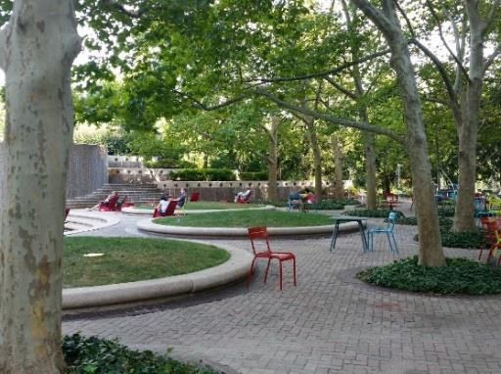proximity and quality of connections to community amenities, jobs, and housing to maximize the use of existing infrastructure and limit travel distances. Development should contribute to creating unique places within the Suburban Policy Area by working with existing topography and site features, responding to the local context, and reinforcing the regional character. Sustainability requires maximum consideration for using the landscape for benefits like solar heat gain or shelter from wind, as well as building designs that incorporate energy efficient and green building technologies. Dense areas of buildings should contribute to a hospitable microclimate. Development should locate close to the road and avoid isolating itself on the site in order to “maximize presentation.” The bulk of the design should be appropriate to the function of the development. Unless otherwise specified, the following guidelines apply only within the SPA:
Development Criteria:
- Ensure that the use contributes to and complements the existing development pattern;
- Consider innovative uses that contribute to the surrounding community;
- Provide consistency with the desired form, character and land uses of the underlying Place Type;
- Differences between the height, scale, bulk, setback from the street, or other physical features of the proposed development, and existing development in the immediate area;
- Presence and quality of a spatial or physical transition between uses;
- Availability of adequate roads, services and infrastructure; and
- Relationship and incorporation of existing Natural and Heritage resources.

Building Orientation and Setbacks
- All development should include a site design that is compact and makes buildings the prominent feature of the site as viewed from adjoining/adjacent roads, especially along major thoroughfares. Site design and
development will strive to minimize site disturbance and minimize removal of existing, viable vegetation.
- It is desirable to have civic, open spaces, green spaces, and vegetation to separate parking lots from buildings and areas for human activity. Civic spaces and green spaces are encouraged to have public art enhancements.

Building Design and Façades
- Buildings within larger multi-building developments should exhibit a unity of design through the use of similar elements such as rooflines, exterior materials, facade treatments, window/fenestration arrangements, sign location, and architectural styles and details.
- Large freestanding stores, retail centers, commercial centers, and restaurants will be encouraged to provide usable outdoor civic or public spaces.
- Required drainage and stormwater management facilities, such as holding basins, drainage swales, and culverts should be incorporated as features into the site design of the project, to the extent possible. Natural drainage features should be conserved to the

greatest extent possible, minimizing impervious facilities to the extent technically feasible.
- Building massing and walls must be varied to avoid long, flat facades and break down the scale of large buildings and commercial/retail centers. It is desirable that building facades should incorporate wall relief, recesses, off-sets, angular forms, or other features to avoid presenting a "blank side" to neighboring properties.
- Pitched, mansard, and other distinctive roof forms are strongly encouraged.
- Rooftop mechanical equipment will be screened with materials that blend with the architecture and will be perceived as an intergral part of the principal building. Ground mounted mechanical equipment will also be screened either by incorporating it in the building architecture or by landscaping.
- Buildings will incorporate covered entrances to provide weather protection for shoppers and create a pedestrian-oriented environment.

Sidewalks, Streets Trees, and Plantings
- Large parking areas will be landscaped with trees and shrubs throughout to reduce the visual impact, provide shade, and reduce the heat island effect or heat absorption of the parking area.
- The street frontage of development will be landscaped with trees to help create a green edge on both sides of the street.
- Existing environmental features such as natural topography, hedgerows, mature trees, and berms will be integrated into the landscape plan for non-residential centers, when feasible.
- Non-residential buildings and parking areas will be sufficiently screened and buffered from adjoining residential areas by distance, transitional uses, landscaping, and/or natural vegetation to mitigate the effects of noise, lighting, and traffic on the surrounding residences.
- Residential areas will be buffered from adjacent non-residential uses by trees, fences, and hedges.
- Sidewalks will be provided to all development to accommodate benches, bikes, strollers, trees, and planters.

Street Furnishings and Lighting
- Provide usable space and amenities when planning sidewalks, including street furnishings such as benches, trash cans, kiosks, street gardens, bike racks, outdoor sitting spaces, and public art.
- Signs for development will be developed as an integral part of the overall design. A unified graphic design scheme is strongly encouraged that is in conformance with an appropriate regulatory framework.
- Site and building lighting will reduce glare and spillage of light onto adjoining properties and streets. Fixtures should be attractive site elements that are compatible with the architecture of the development.
- Both lighting and signs will be designed for pedestrians, bicyclists, and vehicles.

Parking, Circulation, and Loading
- All development should strive to create inter-parcel connectivity for pedestrian and vehicular circulation to increase pedestrian activity and decrease vehicular traffic on roadways necessitated by broken inter-parcel connections.
- Pedestrian traffic, internal to non-residential centers, should be provided with a safe travel route from the parking area to the building with a demarcated pathway and clear directional signage. Trees and other plantings should be provided along the walkway.
- Parking areas will be visually screened from adjacent streets and residential areas by heavy landscaping, depressing the parking area, constructing earthen berms, and/or other means.
- All loading and storage areas must comply with Zoning Ordinance regulations and must be screened from adjacent residential areas by earthen berms, masonry walls, permanent wooden fencing, or dense landscaping.

