Urban Policy Areas

Vision
The Urban Policy Areas (UPA) will be complete communities that accommodate living, working, shopping, learning, and playing in dense urban environments of walkable mixed-use and transit- oriented development. These areas will possess high-quality public environments with accessible and connected spaces, and a rich mix of uses that establish a distinctive sense of place. UPA communities are envisioned to support development types, patterns, and densities that will create jobs, grow the tax base, and be fiscally sustainable.

Introduction
The new UPAs are planned and designed to be strong, diverse regional activity centers and economic drivers. As such, UPAs will provide new opportunities for regional employers to locate near complete urban communities with multiple transit options and access to Washington Dulles International Airport. The UPA has been in the making since the Toll Road Plan, with transit- oriented nodes and then building upon them in the Revised General Plan with Transit-Oriented Development areas in the Suburban Policy Area. The UPAs encompass areas around three Metrorail Stations: Innovation Center (in Fairfax County), Loudoun Gateway, and Ashburn (for reference, see Urban Policy Areas Place Types map). The areas around the Metrorail Stations are envisioned as transit-oriented communities with a dense urban core consisting of the greatest intensity of development in the County. These areas emphasize mixed-use development throughout and are the highest priority growth areas in the County. Due to their current suburban nature, the process of transitioning these areas to walkable communities may involve partial infill and redevelopment as described in the Infill and Redevelopment section of this chapter.
The expansion of Metrorail service into Loudoun County presents an unprecedented opportunity to create dynamic urban places that respond to the community’s evolving needs and demands. The Loudoun 2040 Comprehensive Plan integrates multimodal transit options with high quality urban and environmental design guidelines to shape livable, vibrant, and active UPA neighborhoods with a balance of business, commercial, and residential uses. The UPA communities will provide a variety of housing choices that offer diverse options for families, empty-nesters, individuals, couples without children, and seniors across socioeconomic groups, helping to provide the housing continuum described in Chapter 4. They will be communities that are rich in amenities including networks of publicly accessible green spaces, such as the Broad Run Stream Valley Park and Trail, that simultaneously protect valuable environmental resources.
The Loudoun 2040 General Plan’s design policies and guidelines recognize that urban form is essential to creating spaces that are functional and attractive to a diversity of users. Urban design characteristics in the UPA speak to the design of individual structures and spaces, the spatial relationship among structures, the relationship of buildings to the streetscape and other public spaces, and transitions between areas of differing densities or intensities. Building façades set at the back of the sidewalk and ground floor retail uses with transparent façades will help activate the streetscape. The guidelines also encourage the development of distinctive public spaces that

promote culture and the arts. Street furniture, public art, water features, and distinctive landscaping will create visually appealing streetscapes that encourage street-level activity and public interaction.
All UPA communities will include transportation hubs that offer a wide array of transportation mode choices including walking, biking, driving, and transit. The UPA is a place where walking and bicycling can be convenient travel modes, diversity of use is nurtured, and public spaces are aesthetically pleasing, safe, and accessible. Attractive grid-form street networks will prevent traffic congestion, maximize travel choices, and safely and efficiently move individuals throughout the area. Small, tree-lined blocks will enhance the pedestrian experience and encourage non-vehicular travel. Contiguous, linear green spaces accommodating both passive and active recreational uses will encourage alternative means and paths of travel.
Loudoun 2040 envisions a certain level of activity and intensity of development in the UPAs, which is necessary not only to create vibrant, viable transit-oriented communities but also to protect their long-term tax revenue generation potential. Therefore, land uses that do not meet the minimum bulk and/or density guidelines envisioned in the UPA Place Types should be avoided. Interim uses may be appropriate, if it can be demonstrated that they will evolve to an ultimate desired use that aligns with the long-term vision of the Loudoun 2040 General Plan.
The county's ongoing collaboration with the Metropolitan Washington Airports Authority (MWAA) regarding future land use planning around Washington Dulles International Airport’s northern border is essential to the success and economic viability of the Loudoun Gateway Metrorail Station. The County will continue its partnership with MWAA and explore mutually beneficial land use alternatives that realize greater tax revenue while supporting current and planned airport operations. This collaborative planning will ensure that the Loudoun Gateway Metrorail Station develops as a walkable place with job opportunities, amenities, pocket parks, transit options, and nearby housing without compromising Washington Dulles International Airport’s long-term viability.

Place Types
As described in the beginning of this chapter, the following Place Types have been designated for specific locations as displayed on the accompanying map. The Place Types will work in concert with the Design Guidelines and Policies, Strategies, and Actions of the UPA to fulfill the land use patterns and community characteristics intended for the area.

Loudoun County
Urban Po l ic y A reas Plac e T ypes
2040 General Plan

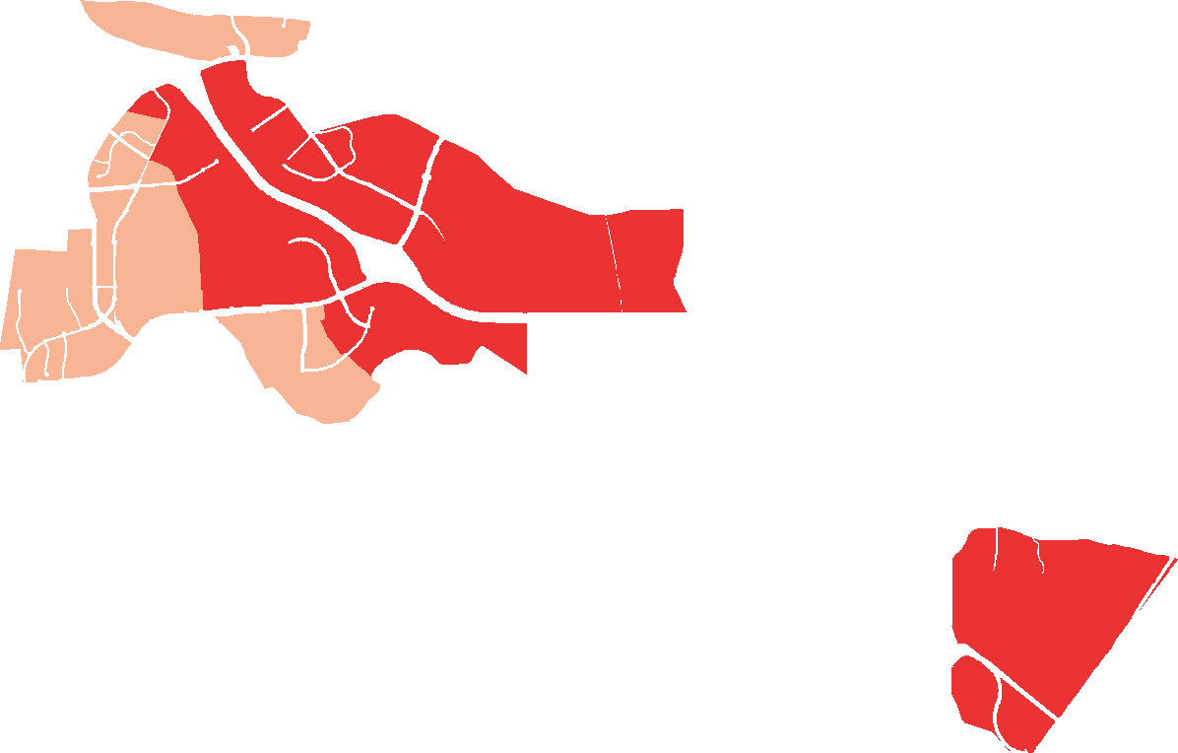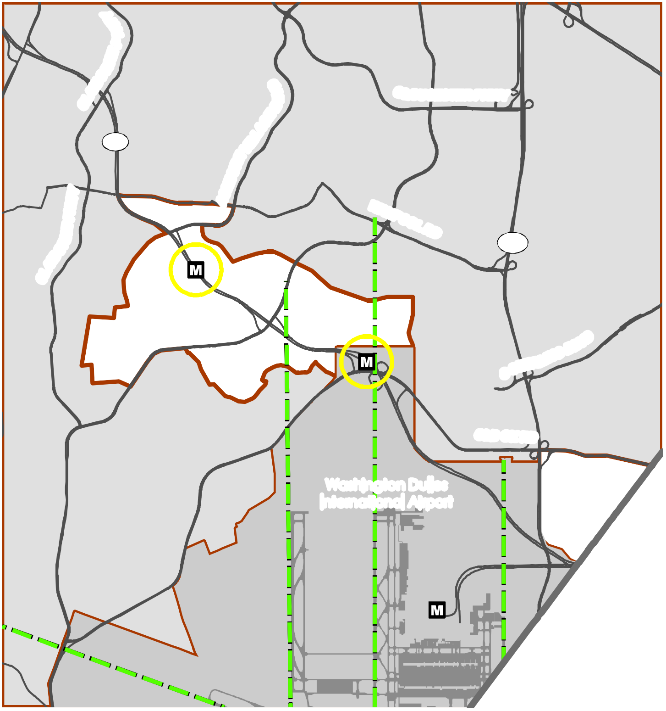Policy Areas Metro Station
YW
K P
E N R BO
AI
CL
1/4 Mile Metro Station Buffer Extended Runway Centerline Airport Runways
Place Types
Urban Mixed Use Urban Transit Center

UCESTER PKWY

267
L

28

Washington Dulles International Airport

Loudoun County IS NOT LIABLE for any use
of or reliance upon this map or any information contained herein. While reasonable efforts have been made to obtain accurate data, the County makes no warranty, expressed or implied, as to its
accuracy, completeness, or fitness for use of any purpose.

0 0.25

0.5 1 1.5 2
Miles
D R A F T
Map N um be r 2 01 8 - 1 5 0

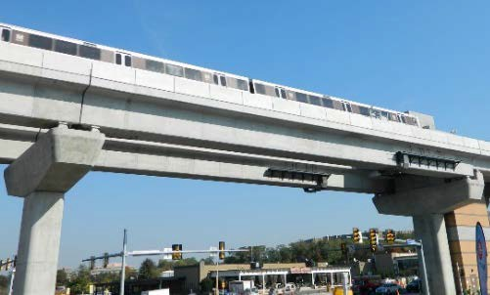
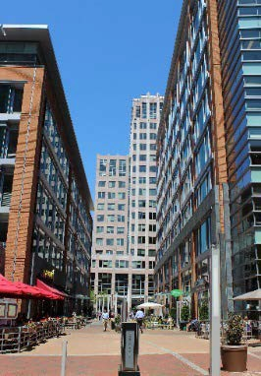
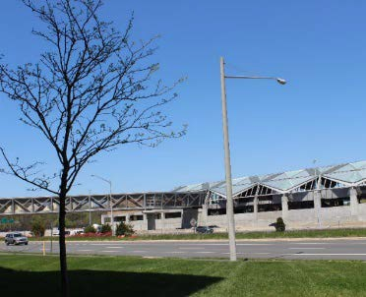
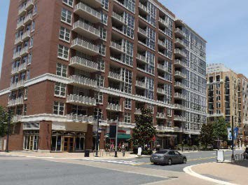
Urban Transit Center

Urban Transit Center areas take advantage of proximity to transit to provide opportunities for dense urban development and a host of economic, entertainment, and community activities. Each area serves as a gateway to the county from the greater region and a major destination in its own right. The Urban Transit Center has two focus areas: within a ¼ mile of the Metrorail Station and outside of the ¼ mile. Development within a ¼ mile of the station will have smaller average unit sizes, a higher minimum FAR, and a more equal mix of residential and non-residential development.

Predominant Uses | Secondary Uses | Ideal Mix of Uses
- Multi-Family Residential  - Office  - Retail & Service Commercial | - Public Facilities  - Sports Arena/Training Facility  - Entertainment Commercial  - Conference Center  - Full Service Hotel  - Institutional  - Civic, Cultural, & Community | Within  ¼ Mile  Public/Civic  5%  Non Residential Residential 50%  45%  Outside  ¼ Mile  Public/Civic  5%  Non Residential 25%  Residential 70%

DESIGN CHARACTERISTICS

Context
Vertically mixed-use buildings that are integrated in a walkable street pattern around the Metro station.
Street Pattern:
Gridiron
Block Length:
Within ¼ Mile: 200-400 feet Outside ¼ Mile: 200-660 feet Building Setback:
None to shallow
Parking:
Structured, on-street, accessory, short-term, alley-oriented
Design Amenities:
Sidewalks, street trees, street furniture, shade trees, bike racks, lighting, crosswalks, plazas, pedestrian malls, network of green space, public art Open Space:
10% of the site

Place Type Rendering
An oblique projection of development within a Place Type to showcase the qualitative characteristics of how buildings within the Place Type should interact to create activity.

Within ¼ Mile Total FAR: Minimum 2.0
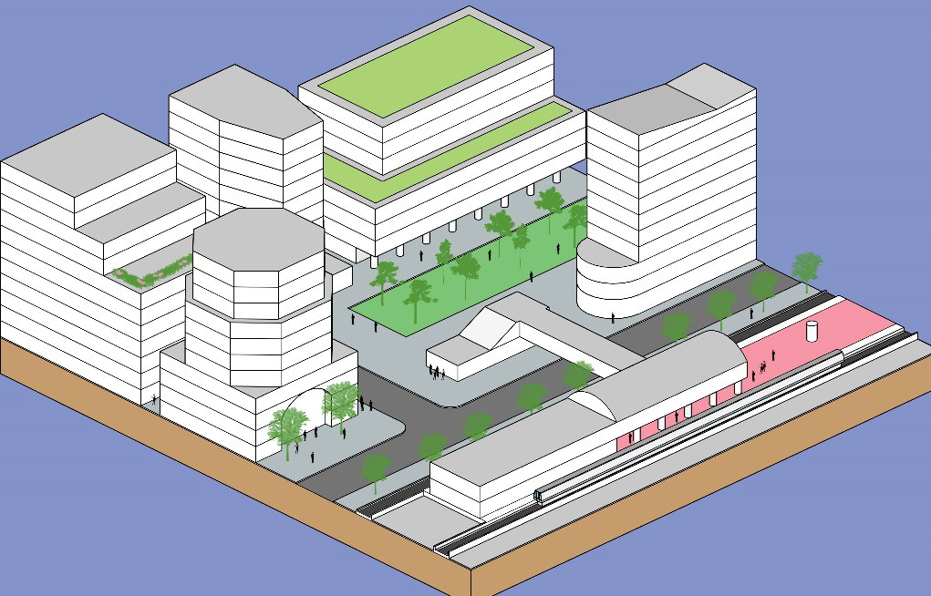
USE | Number  of Stories
Multi- Family  Residential | 8+
Office | 8+
Retail & Service Commercial | 8+

Outside ¼ Mile Total FAR: Minimum 1.4
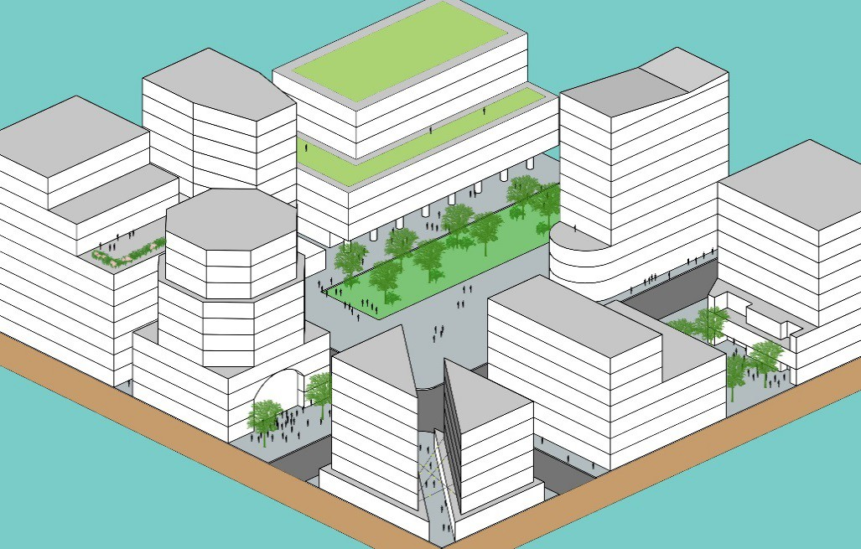
USE | Number  of Stories
Multi- Family  Residential | 6+
Office | 6+
Retail & Service Commercial | 6+

Transition
Given the small block sizes and mix of different uses, transitions between uses and developments are critically important in the Urban Transit Center Place Type. Development should transition from eight stories or more near the Metrorail Station to six or more stories outside of the ¼ mile. Changes in height or building character, where allowed, should occur mid-block to promote balanced streetwalls where both sides of the street appear similar in height. Larger developments near smaller residential dwellings should step down appropriately to respect these neighbors.

Urban Mixed Use
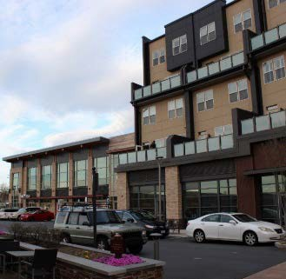
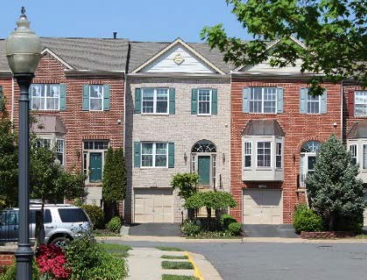
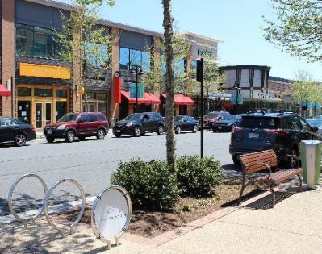
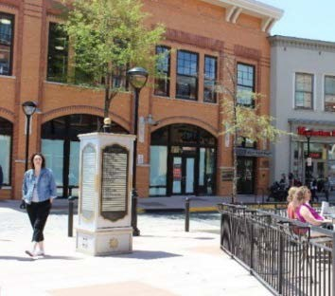
Urban Mixed Use areas take advantage of their fringe proximity to the Metro stations to provide opportunities for dense urban residential development including a mix of commercial uses. The Urban Mixed Use areas will develop as high-density walkable urban neighborhoods that encourage social connections because their mix of uses, multimodal infrastructure, and public spaces create vibrant public realms.
Urban Mixed Use areas provide opportunities for a mix of housing types that meet the housing needs for all ages, abilities, and socioeconomic groups. The small-lot patio homes, townhomes, rowhouses, duplexes, quadruplexes, and multifamily residences are designed to fit within or adjacent to a traditional single-family style neighborhood. Accessory residential units are also appropriate for the area and may consist of apartments in the principal structure, garage apartments, or other outbuildings approved by the County. Development will have slightly larger average unit sizes than in the Urban Transit Center and a large amount of residential development. Small scale office, retail and service uses should be integrated into the neighborhood.
This Place Type encompasses a wide array of commercial designs that create a unique sense of place and complement surrounding developments. Urban Mixed Use developments are oriented to the street, and those including larger format retail commercial establishments should also include smaller commercial establishments without substantial surface parking lots. These developments should be designed to provide direct access to adjacent neighborhoods with which they should blend seamlessly. Parking should be predominantly structured with accommodations for on-street parking and limited surface lots.

Predominant Uses | Secondary Uses | Ideal Mix of Uses
- Multi-Family Residential  - Single Family Attached Residential | - Office  - Retail & Service Commercial  - Active Adult Retirement Communities  - Civic, Cultural, & Community  - Public Facilities  - Accessory Residential Units  - Small Lot Single Family Detached Residential | Public/Civic  Non 5%  Residential 15%  Residential 80%

DESIGN CHARACTERISTICS

Context
Vertically mixed use buildings as well as multi-story single-use buildings that are integrated in a walkable street pattern in the fringe of the Metro station area.
Street Pattern: Rectilinear Grid Block Length: 200-660 feet Building Setback:
Shallow setbacks at sidewalks, Residential can be setback near sidewalk
Parking:
Structured, on-street, accessory, short-term, alley-oriented parking
Design Amenities:
Sidewalks, street trees, street furniture, shade trees, bike racks, lighting, crosswalks, plazas, pedestrian malls, network of green space, public art Open Space:
10% of the site

Place Type Rendering
An oblique projection of development within a Place Type to showcase the qualitative characteristics of how buildings within the Place Type should interact to create activity.

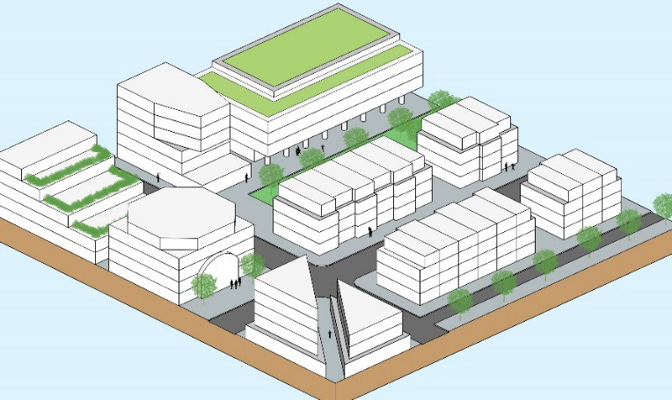
Total FAR: Maximum 1.5
USE | Number of  Stories
Multi-Family  Residential | 4-8
Single Family  Attached | 2-4
Office | 4-8
Retail & Service  Commercial | 4-8

Transition
Small block sizes and a mix of different uses make transitions between uses and developments important in the Urban Mixed Use Place Type. Changes in height or building character, where allowed, should occur mid-block to promote balanced streetwalls where both sides of the street appear similar in height. Larger developments near smaller residential dwellings should step down appropriately to respect these neighbors. Developments should transition from taller buildings at the center to heights generally no more than a story taller than adjoining adjacent development consisting of less intensive uses. The predominant residential use type is multi-family and single family attached; however, a very limited portion of the development within the Urban Mixed Use Place Type may be developed with small-lot single family detached residential as a transitional use between Place Types.

Policies, Strategies, and Actions
Unless otherwise specified, the following Policies, Strategies, and Actions apply only within the UPA.

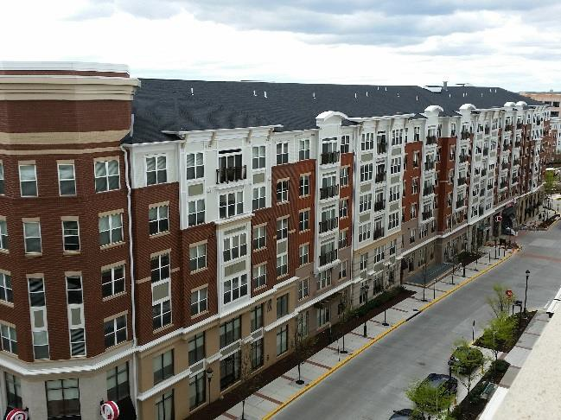UPA Policy 1: Ensure walkable development and connectivity to the community throughout the UPA as it is important to foster the urban character found in the Place Types.

Strategy
  - Development designed to provide for a walkable mixed-use environment that supports multi-modal transportation choices and fosters substantial pedestrian activity within the half-mile area and to surrounding areas.
Strategy
  - Emphasize walkability in the half-mile buffer area by providing pedestrian and bicycle commuter connectivity to the core of the Metrorail stations and surrounding neighborhoods as well as enabling future connections from undeveloped parcels.
Strategy
  - Support a high level of pedestrian connectivity including connected street grid patterns with sidewalks, short block lengths, and connected trails and pathways providing connections to surrounding neighborhoods.
Strategy
  - The Ashburn and Loudoun Gateway Metrorail Stations will serve as transit and commuter hubs while providing an urban walkable environment. Development proposals provide a balance between the needs of commuters with the desire to create a walkable urban environment.
Strategy
  - Accommodate a long-term vision with an appropriate mix of residential and non- residential uses that fulfill daily and convenience needs of its residents and employees.
Actions
    - Mixed-use neighborhoods accommodate infrastructure plans for near-term and long- term transit circulator service.
    - Community facilities like schools, community centers, and libraries are located to allow as many residents as possible to be within a short walking distance.

    - Larger developments provide pedestrian access within their development and possible shuttles to connect to the Metrorail stations.

Strategy
  - Discourage single-story buildings exceeding 2,000 square feet in the UPA to promote compact, pedestrian-oriented spaces.
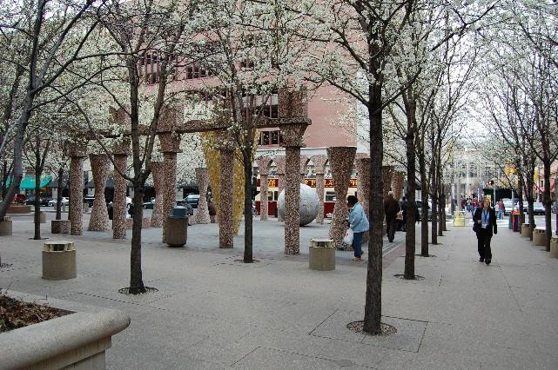Strategy
  - Ensure that any drive-through retail uses are incorporated within mixed-use buildings.

UPA Policy 2: Provide dynamic and diverse public spaces and amenities within proposed UPA communities.

Strategy
  - Densities in the area are expected to sustain an urban development pattern with pedestrian activity.
Strategy
  - The County promotes concepts like outdoor dining, event space, street fairs, and public art within compact, walkable non-residential areas.
Action
    - Accommodate walkable features and amenities like centralized activity areas such as shopping and dining areas with wide sidewalks, more narrow pedestrian-oriented streets, transit stops, and community gathering places (e.g., parks and plazas).

UPA Policy 3: Provide a diverse mix of choices in all development.
Strategy
  - Accommodate office developments and/or high-employment generating uses that conform to the overall vision for a walkable urban development pattern.
Action
    - Create partnerships with universities and private sector companies to foster growth of an Innovation District at the Loudoun Gateway Metrorail Station that supports workers and students in the advanced technology and science industries.
Strategy
  - Ensure that development within half-mile of the Loudoun Gateway Metrorail Station reflect the station area’s long-term vision of a global destination, activity center, and leader in innovation and entrepreneurship.

Strategy
  - Accommodate diverse housing options in all development.

Design Guidelines
The Design Guidelines are to build upon our current high standard of development in a manner that allows innovative design and new responses to the market. While the Design Guidelines are not regulatory requirements, the County prefers that all future developments comply with these guidelines. The Design Guidelines do not supersede or otherwise limit the application of adopted zoning regulations, ordinances, building codes, or any other design standards or regulations administered by Loudoun County.
All applications for development in the UPA are expected to include project specific design guidelines, site plans, illustrative, landscape plans, building elevations, and other similar graphics that demonstrate consistency with the UPA Design Guidelines and planning principles in this document.
When using the guidelines make sure to analyze the impact a potential development may have on the landscape, considering not only appearance, but practical considerations such as proximity to utilities, community amenities, jobs, and housing to maximize the use of existing infrastructure and limit travel distances. Development should contribute to creating unique places within the Urban Policy Area by working with existing topography and site features, responding to the local context, and reinforcing the compact walkable character, rather than simply attempting to place suburban design onto the urban landscape. Unless otherwise specified, the following guidelines apply only to UPA.
The goals of the UPA Design Guidelines are to:
- Promote accessibility and establish links to transit,
- Promote walkability,
- Encourage human activity between buildings and streets,
- Establish human scale of buildings at street level (first floor of a multi-story building),
- Create visually interesting and compatible buildings and site designs that use building forms, materials, fenestration, repetition, rhythm, color and architectural variety resulting in delightful blends of form, volumes, textures and colors in the various neighborhoods,
- Create inviting spaces for varied activities, and
- Create a sense of place and uniqueness.

Building Orientation and Setbacks
Buildings in the UPA, particularly along urban-type streets and “main streets”, should have common design strategies that promote walkability, accessibility, and activity in the ‘outdoor room’ or ‘outdoor hallway’ between streets and buildings.
- Locate buildings at the front property line or at the minimum required setback to create a strong pedestrian pathway framed by adequate spaces for sidewalks, plantings, street furnishings, and lighting along buildings. Where additional setback is necessary adjacent

to the street, that area can be used to create a plaza, pocket parks, or other public gathering spaces that incorporate activity space, outdoor seating, landscape features, and/or water features.
- Design grade level entrances providing direct access to building entrances from sidewalks and streets.
- Make primary entrances to buildings visible from the street and sidewalk.
- 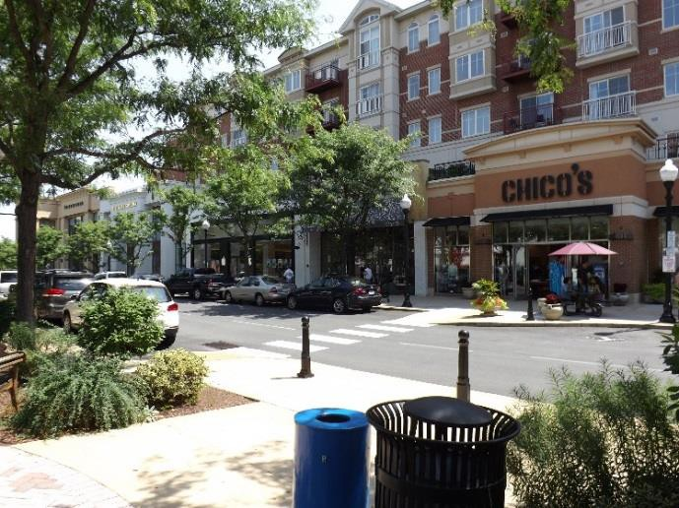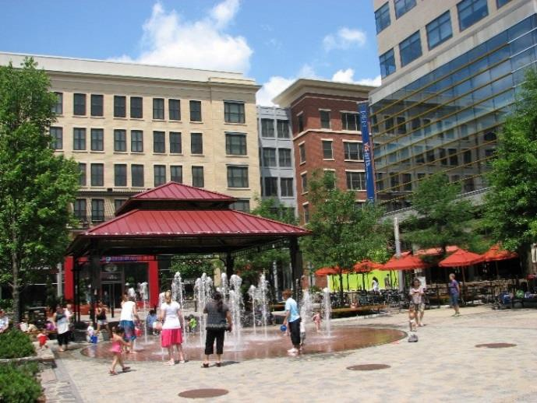Create primary entrances for pedestrians that are easily identified and accessible with as direct a path as possible to transit amenities.
- Maintain at least one entrance from the public way at retail and restaurant establishments.
- Incorporate transitions from the sidewalk to the front door such as landscaping, overhead cover (canopies, awnings or trellises) and/or porches at individual entrances to businesses and residences.
- Comply with the Americans with Disabilities Act (ADA), Universal Design, and International WELL Building Institute guidelines at primary pedestrian entrances. Alternate approaches for persons with mobility limitations, such as a ramp next to the main path to the primary entry, should not be necessary.
- Incorporate passageways or alleys into mid-block developments, particularly on long blocks, that facilitate safe pedestrian movement through the depth of the block to the front of the next parallel block. Ensure that pedestrians do not have to walk the circumference of a block in order to access the middle of the next parallel block or alley or parking behind the block.
- Activate use of mid-block passageways or alleys so that they are visually interesting, functional, well-lit, and safe spaces.

Building Design and Façades
Addressing architectural features of buildings is an important component of creating the ‘sense of place’ that Loudoun County desires for the UPA, particularly with respect to the denser and more intensely used areas.
- Incorporate different façade treatments such as forms, textures, colors, materials, and distinctive architectural features that add visual distinctiveness throughout the UPA, while

building consistency in their application within individual developments to create uniqueness and identifiable character of each new development.
- Add scale and interest to the building façade by articulated massing. Blank or long expansive walls with no detail or variation in form, color, texture, openings or material are undesirable, particularly in activity centers and along pedestrian pathways or linkages.
- Use of architectural features, enhanced materials, fenestration, planting, lighting, and signage should contribute to a more pedestrian friendly streetscape.
- Reinforce the existing façade rhythm along the street with architectural elements, landscaping, signage, street lighting, and street furnishings.
- Include overhead architectural features, such as awnings, canopies, trellises or cornice treatments that provide identifiable entries, shade, and reduce heat gain.
- Contribute to visual interest, human activity along streets and neighborhood safety by providing pedestrian scaled windows and fenestrations at the street level that act as pathways to activity inside buildings and “eyes on the street”.
- For ground floor retail, restaurants, and professional office uses within mixed-use environments, along main streets, and other activity centers, devote a minimum of 65 percent to 75 percent of the façade to pedestrian entrances and pedestrian-level display windows.

Sidewalks, Streets Trees, and Plantings
Sidewalks, in conjunction with street design and building placement, support ease of pedestrian movement and link people from their homes to community amenities such as parks, public spaces, retail and commercial areas, transit stops, nodes, landmarks, and the Metrorail stations. Sidewalks also enrich the quality of the public realm by providing appropriate connections and street furnishings in the public right of way. They create the basis for the concept of the ‘outdoor rooms’ and ‘outdoor hallways’ which support human activity at planned centers and along linkages.
Planting street trees and ground cover plantings has proven over time and across urban development to improve the human experience between building and streets. Along with creating inviting spaces, comfort for human activity, and positive impacts to the natural environment, street trees and ground level plantings contribute greatly to the visual appeal of building façades and outdoor spaces.
- Create a continuous and predominantly straight sidewalk to support two-way pedestrian traffic with enough space for streetscape amenities such as street furnishings, street trees, ground cover plantings areas, street lighting, signage, and utilities.
- Create amenities that act as a buffer between pedestrians and moving vehicles by the use of landscape and street furniture (benches, newspaper racks, pedestrian information kiosks, bicycle racks, bus shelters, and pedestrian lighting, etc.).
- Use street furnishings to create a consistent rhythm (i.e., consistent height of light standards or consistent shade pattern of trees) and encourage the activity and use of the sidewalk area between buildings and streets.
- Incorporate closely planted shade-producing street trees to encourage pedestrian activity along streets and promote comfort in the outdoor activity spaces. They may be interspersed

with existing or proposed street trees. Select native trees and plantings with low maintenance requirements. Plant outdoor spaces with ground cover, low-growing vegetation or permeable materials that accommodate both pedestrian movement and car door swings where on street parking is designed and planned. Incorporate stormwater bioswales with native plantings into the streetscape to serve both visual interest and stormwater management function.

Street Furnishings and Lighting
Street furnishings and lighting should be designed to strengthen the pedestrian experience and encourage outdoor use and activity in activity centers and spaces between buildings and streets. These amenities should also serve to create neighborhood identity and visual coherence with the use of building and street lighting.
- Provide usable space in the sidewalk areas which should include street furnishings such as benches, trash cans, kiosks, street gardens, bike racks, outdoor sitting spaces, and public art.
- Provide adequate lighting levels to safely light the pedestrian path.
- Use adequate, uniform, human-scaled, and glare-free lighting to avoid uneven light distribution, harsh shadows, and light spillage.
- Use poles, standards, fixtures, and lighting types that achieve “dark sky” compliant goals and objectives, such as lighting when necessary, reducing glare, use of energy efficient lighting systems, lighting enough to promote safety and security, and considers ecological impacts to the natural environment and humans.

On-street Parking
On-street parking provides numerous benefits in urban environments such as reducing the need for parking decks and parking lots, buffering pedestrians, moving vehicle traffic, vehicle traffic calming, and providing parking near community amenities, businesses, and retail uses shaping the ‘outdoor rooms’.
- Provide parallel or angled on-street parking wherever possible.
- Eliminate street parking within pedestrian crossings.
- Create traffic calming along streets designed for low speeds.

Public Spaces
Public spaces are areas that serve as centers for human activity, which could be a destination, a space to pass through, or a linkage. These spaces should provide a focal point for gathering, communicate community or neighborhood identity, and help make for complete neighborhoods. These spaces could include plazas, promenades, courtyards, park spaces that are landscaped and/or hardscaped, and should include trees and ground cover vegetation to create inviting spaces for activity and gathering.
- Orient buildings so that public spaces receive sunlight as well as provision for high quality, safe, night lighting.
- Balance sunlight accessibility with shade producing trees and overhead cover.

- Provide a variety of on-site features to maximize use and enjoyment of public spaces, including but not limited to:
  - Water features / public art,
  - Recreational features,
  - Outdoor furnishings,
  - Vegetative ground cover, gardens and shade tree plantings/reforestation,
  - Use of stormwater management best practice features to create year round open space amenities with walking paths and benches,
  - Open spaces for gathering large groups of people, and/or
  - Variety of ground cover materials such as permeable and impermeable surfaces as well as natural ground cover.

