DRAFT Loudoun 2040
Comprehensive Plan

DRAFT Loudoun 2040 General Plan

Chapter 1 - Introduction
Table of Contents
Purpose and Definition 3
Loudoun County’s Planning Approach 3
Loudoun County: Trends and Influences 6
Elements of Loudoun 2040 8
Policy and Regulatory Context 9
Reference Maps 10

Chapter 1 - Introduction
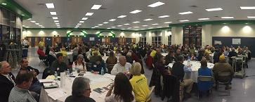The Loudoun 2040 Comprehensive Plan (Loudoun 2040) is the culmination of a collaborative multiyear effort and an unprecedented public outreach campaign that brought together Loudoun’s citizens, elected and appointed officials, stakeholders, and County staff to create a new comprehensive plan for the County. This planning process, known as Envision Loudoun, identified the community’s desires for the future of Loudoun County as they relate to growth management, land use, transportation, natural and heritage resources, community facilities and amenities, economic development, and fiscal management.

Vision:
Loudoun County continues to flourish as a prosperous and inclusive community with a well- deserved reputation for great places – natural and built, as well as, historic and new – in a variety of settings. The County will foster economic innovation, fiscal strength, and sustainability.

The Envision Loudoun planning process began with a Charter adopted by the Board of Supervisors in April 2016. The Charter identified key issues to be addressed in the new comprehensive plan: Growth Management, Land Use, Transportation, Natural and Heritage Resources, Community Facilities and Amenities, Economic Development, and Fiscal Management. The Charter called for the formation of a 26-member committee of community stakeholders, convened a staff technical advisory committee from regional public agencies, and set forth a community engagement strategy to allow for multiple opportunities for public outreach throughout the process. To ensure the community was kept informed, a communications plan was deployed that utilized internet, social media, radio advertising, and print materials.

Envision Loudoun proved to be an unprecedented public engagement effort for the County. Between summer 2016 and spring 2018, the stakeholders committee and County staff held over 40 worksessions. The public participated in three sets of public outreach sessions – totaling 17 meetings – each at various locations throughout the county. An Envision Loudoun website was established and kept up-to-date with maps, process updates, and project documents. The website also provided a web interface for citizens to provide input regarding the key issues to be addressed in the new comprehensive plan. All told, approximately 3,000 people participated in the Envision Loudoun process.

Purpose and Definition
Loudoun 2040 includes this General Plan and the Countywide Transportation Plan, a standalone document developed in close coordination with this plan. Loudoun 2040 is not a development ordinance, but is instead a “blueprint” document that provides guidance for elected officials and other governmental decision-makers as to where and how the community will grow in the long- term.
Comprehensive plans provide an opportunity for communities to think collectively about the future of their community and to develop a shared set of values and strategies intended to achieve a unified vision. They are critical tools for managing growth, the provision of capital facilities, and the fiscal health of communities. They are especially important for high growth communities like Loudoun County, where change can happen quickly, and a comprehensive plan is needed to guide that change. A comprehensive plan is not a static document and, as required by the Commonwealth of Virginia, must be reviewed at least every five years.

Loudoun County’s Planning Approach
Loudoun 2040 builds upon the County’s strong foundation of growth management practices. The Loudoun County Board of Supervisors adopted the County’s first zoning ordinance in 1942 and its first comprehensive plan in 1959. The County’s 1991 General Plan, Choices and Changes, was written when the County was largely undeveloped with an abundance of greenfield development opportunity in the eastern part of the County. By 2001, when the Revised General Plan was adopted, the County was feeling the effects of a 97 percent population increase since the adoption of Choices and Changes.
For decades, the County has supported the protection of its rural and agricultural areas to the west and focused development in suburban areas to the east. The County has accommodated growth near existing infrastructure to support development in a fiscally sound manner, and in close proximity to Washington Dulles International Airport and Washington, D.C. where the market forces have been strongest for new residential and employment development. Loudoun’s growth management policies have resulted in some of the most highly valued residential communities in the region, while also encouraging new business development.
The framework for land planning in Loudoun County consists of four types of Policy Areas – Urban, Suburban, Transition, and Rural – and several smaller planning areas designated as Joint Land Management Areas and Rural Villages. These Areas represent distinct planning communities with specific policies, strategies, and actions tailored to address the unique needs of each area.

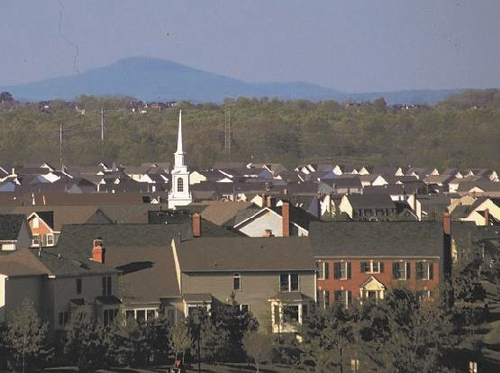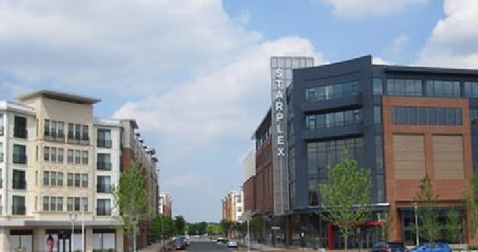Urban Policy Areas
The Urban Policy Areas represent a new planning area concept in Loudoun, encompassing approximately 2,600 acres in areas around the Silver Line Metrorail Stations. The two Urban Policy Areas represent major growth opportunities for the County with mixed-use and transit- oriented land uses and development intensity not previously contemplated in Loudoun. Loudoun 2040 calls for complete urban communities that accommodate
Loudoun Station, a mixed-use town center development adjacent to the Silver Line Ashburn Station, is within one of the new Urban Policy Areas.
housing, employment, retail, education, and entertainment in close proximity to Metrorail. These areas will facilitate opportunities for significant job creation and expansion of the County’s tax base.

Suburban Policy Area
The 48,000-acre Suburban Policy Area comprises the eastern third of the County and is where most of the residential and commercial growth has occurred since the 1960’s. The Suburban Policy Area developed in a traditional suburban pattern with predominantly single-family neighborhoods. Route 28 and Loudoun County Parkway (Route 607) form the County’s “data center alley,” having evolved into an international leader for global data management, technology, and communications industries. More than 70 percent of all internet traffic is routed through data centers in this Policy Area. The area around Washington Dulles
Much of Loudoun's residential growth has occurred in the easternmost part of the County. With decreasing undeveloped areas, the Loudoun 2040 General Plan anticipates a more integrated mix of uses in this part of the County over the next two decades.
International Airport is also expected to continue to be a major factor as a key location for industrial uses, airport-related businesses, and data center development.

Transition Policy Area
The Transition Policy Area is a 24,000-acre area along the western edge of the Suburban Policy Area and is intended to be visually distinct from the Suburban and Rural Policy Areas. The area is planned for a diversity of clustered housing with limited commercial uses to support residents and some industrial spaces focused on quarry activity and energy infrastructure. Public utilities are available in the Transition Policy Area, though the transportation network is limited in certain places. Large amounts of open space, trails, and parks provide recreational opportunities for
The Transition Policy Area is planned for a diversity of housing options in clustered patterns with substantial open space areas that provide recreational amenities and protect natural and heritage resources.
residents of the entire County and help to maintain a visual transition between the more densely populated east and the rural west.

Rural Policy Area
The western 230,000-acre Rural Policy Area comprises nearly two-thirds of Loudoun’s land area and contains twelve historic Rural Villages. This area is planned for limited residential development and supports a robust rural economy. Loudoun 2040 includes policies that protect the landscape, economy, and the existing community character of the Rural Policy Area, emphasizing the preservation of farmland,

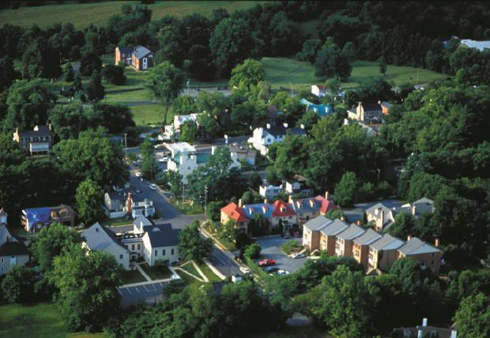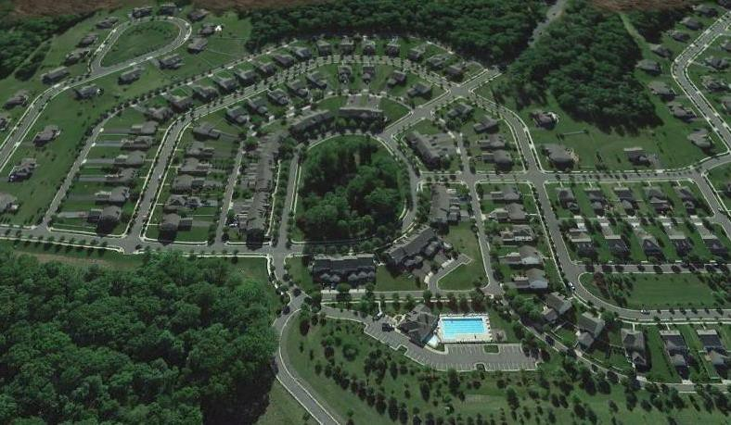natural and heritage resources, open space, and vistas that are vital aspects of Loudoun’s identity.
The Loudoun 2040 General Plan recognizes the importance of protecting the pastoral landscapes and agricultural character of Loudoun's Rural Policy Area.

Towns and Joint Land Management Areas
Loudoun County’s seven towns exercise planning and zoning controls within their corporate limits. In addition to the four Policy Areas, the County has partnered with several of its towns to develop Joint Land Management Areas (JLMA) around the edges of the towns. A JLMA is a planning area where Loudoun and each respective town set the limits for municipal water and sewer extension. These JLMA planning areas effectively serve as a growth
Loudoun County’s western landscape is dotted with historic towns that serve as hubs for the rural community.

boundary for each town and are intended to manage new growth and expansion outward from the towns.

Loudoun County: Trends and Influences
Loudoun County has rapidly transformed from a farming community to one of the fastest growing counties in the nation, ranking fifth in the country for growth between 2000 and 2010. This growth has slowed somewhat as the eastern part of the County has approached build out, but the County’s proximity to Washington, D.C. will continue to drive market demand. Loudoun 2040 identifies a number of trends and influences, including population diversity, housing affordability, and land availability that will affect future demand for both residential and nonresidential products.
Loudoun by the Numbers
- 362,400: Loudoun County’s population.
- 117,100: Number of households.
- $125,672: Median annual household income.
- 39: Percent of households with annual income above $150,000.
- 3: Percent of households with annual income below $15,000.
- 35.5: Loudoun County’s median age
- 29: Percent of population under 18 years of age.
- 8: Percent of population 65 years and older.
- 31: Percent of population that speaks a language other than English at home.
- 93: Percent of population 25 years and over graduated from high school.
- 59: Percent of population with a bachelor's degree or higher.
- 34: Average number of minutes it takes commuters to get to work.
Source: U.S. Census, 2012-2016 American Community Survey 5-Year Estimates

People
Loudoun County’s population has risen over the decades as the Washington, D.C. Metropolitan Area has grown and as Loudoun County has captured more of this regional growth. In 1940, the County’s population was just over 20,000 people. Fifty years later, the population had quadrupled, totaling just over 86,000 people in 1990. Since 1990, the population quadrupled again with an estimated 373,000 people in 2016. However, this exponential growth is projected to slow as Loudoun continues to mature, a trend that may already be occurring. From 2000-2010, Loudoun was the 5th fastest growing county in the nation, but dropped to the 20th fastest growing county from 2010-2015. Even with this slowdown, Loudoun’s population is projected to increase to almost 489,000 by 2040.1
As Loudoun’s population has grown, the community has also diversified. Between 2000 and 2016, the percentage of Loudoun’s population identifying as Hispanic or Latino increased from 6.0 percent to 13.7 percent. During the same time period, the percentage of people identifying as Asian

grew from 5.6 percent to 18.7 percent. The percentage of residents identifying as Black or African American is also growing, though at a much slower rate, increasing from 7.0 percent to 7.7 percent. Overall, Loudoun’s foreign-born population has increased from 11.3 percent in 2000 to 23.9 percent in 2016.2 This growth has led to greater diversity in service demands, expanded retail and entertainment opportunities, changes in housing needs, and overall expanded economic growth of the community.

Housing
As of 2017, Loudoun ranked number one in the country for the highest median household income for the tenth straight year, yet housing affordability and attainability remain a significant challenge in the County and the region. Limited housing supply and high demand presents difficulties for employers in attracting employees and contributes to workforce instability, especially in lower paying industries.
Over 82 percent of Loudoun’s existing housing stock consists of traditional suburban single-family detached and single-family attached dwellings. Most of the housing stock is also considered large, with 80 percent of all dwellings containing three or more bedrooms. Conversely, studio and one- bedroom housing makes up less than six percent of all housing in Loudoun. National trends show that smaller households, such as aging seniors, couples without children, and single persons, may demand different housing types, public services, and lifestyle options than provided in the past.
There is also a general national trend toward more people living in multigenerational households, where extended family lives together. This trend can be attributed to a number of factors including housing affordability and cultural traditions as more foreign-born residents settle in the region. Multigenerational households may require different types of housing options, with larger common areas, accessory apartments, in-law suites, or other attributes that help accommodate the needs of multiple generations living together.
The amount of land available for new residential development also affects housing affordability and availability. The Suburban Policy Area, where land use policy has concentrated most residential development, is approaching buildout with less than 1,200 vacant acres remaining for residential uses. With limited land available for development in the Suburban Policy Area and the County’s desire to protect the unique character of the Rural Policy Area, Loudoun 2040 includes a more targeted approach regarding infill development and revitalization of aging areas. Loudoun 2040 seeks to address these competing factors of limited land supply and increasing residential demand by encouraging a greater diversity of housing types, including affordable and workforce housing, near jobs, schools, and transportation facilities.

Transit
The County’s connection to the regional Metrorail network through the Silver Line extension signals a new era for Loudoun, with significant impacts on transit options available to Loudoun’s residents, workers, and visitors. Two Metrorail stations in Loudoun provide a gateway to Loudoun County from Washington, D.C., while also providing Loudoun’s residents with an alternative

method of commuting to the east. Access to the Silver Line creates the opportunity to develop vibrant, transit-oriented, mixed-use, urban environments around the Metrorail stations, where people can live and work in close proximity to regional transit.
The Washington Dulles International Airport will also continue to serve as a major transportation gateway to the country and the world. It provides a critical economic engine for leisure and business travel as well as cargo transport for the County and the larger Washington, D.C. region. In 2017, 265,025 flights operated out of Washington Dulles International Airport, serving nearly 22,800,000 passengers, including 7,744,586 international travelers.3 With its close proximity to the Metrorail stations and Urban Policy Areas, Washington Dulles International Airport is well positioned to grow moving into the future, operating at approximately one-third of its ultimate capacity.

Economy
The Loudoun 2040 General Plan acknowledges that local, regional, and national economic factors have changed significantly in the last two decades, and includes new policies and strategies to continue Loudoun’s remarkable success as an economic leader in the region. Employment in Loudoun County increased nearly 77 percent from 2000 to 2015, adding over 67,000 new jobs in a 15-year period.4 Momentum in Loudoun’s job base is influenced by activity in the surrounding region, proximity to Washington Dulles International Airport, a growing information and communications sector, agritourism, and a robust increase in households requiring a wide array of services.
Loudoun’s economy continues to diversify and Loudoun 2040 provides growth opportunities for this evolving economy. Employment uses adjacent to the future Metrorail Stations will also present new opportunities to attract employers who seek to locate in dynamic, urban communities with access to mass transit.

Elements of Loudoun 2040
The Loudoun 2040 General Plan begins with overarching vision and goals; then sets forth policies, strategies, and actions for five elements: Land Use; Natural and Heritage Resources; Housing; Economic Development; and Fiscal Management and Public Infrastructure. An Implementation matrix is provided to prioritize and track the execution of the Loudoun 2040 General Plan action items. In addition to this Introduction, the Loudoun 2040 General Plan includes chapters associated with each of the five elements and the Implementation matrix:
- Land Use. Chapter 2 lays out the vision for Loudoun’s future land use, growth management, and built environment. It includes specific policy guidance for Quality Development, Infill and Redevelopment, and each geographic policy area. Place Types guide the intent, form, character, and anticipated land uses within each policy area.
- Natural and Heritage Resources. Chapter 3 provides guidance for the protection, maintenance, and enhancement of the County’s abundant natural and heritage resources.

3 Metropolitan Washington Airport Authority, 2018
4 Loudoun County Department of Economic Development, 2018

The policy approach is applicable at multiple geographic scales, from initiatives that may affect these resources countywide, to management of specific watersheds and waterways, to site-level development considerations.
- Housing. Chapter 4 analyzes the current and anticipated housing environment in Loudoun County and includes policies aimed at ensuring the provision of a full housing continuum for the varied lifestyles, households, ages, cultures, market preferences, and abilities of Loudoun’s residents.
- Economic Development. Chapter 5 examines the many challenges and opportunities facing Loudoun County in maintaining and advancing the County’s diverse and globally competitive economy. The policies focus on targeted industries, investments, and County initiatives that contribute to Loudoun’s world-class business environment and ties in land use considerations to sustain a diverse, adaptable, and dynamic County economy.
- Fiscal Management and Public Infrastructure. Chapter 6 acknowledges the interrelatedness of land use, growth management, fiscal management, and facilities planning. The policy approach ensures the provision of public facilities and utilities, high- quality telecommunications networks, and passive and active recreational amenities in accordance with the County’s larger land use and fiscal policies.
- Implementation. Chapter 7 compiles the individual Policies, Strategies, and Actions described throughout the Loudoun 2040 General Plan and provides an Implementation matrix that prioritizes, assigns responsibility, and tracks progress for each action item.
In addition to the Place Types in Chapter 2, Loudoun 2040’s guidance is established through:
- Policy statements for each element that provide the approach to decision-making for specific topics or issues,
- Strategies providing more focused, measurable guidance for decision-making relative to each policy, and
- Actions that target specific steps to realize the Policies and Strategies and intent of the
Loudoun 2040 General Plan.
The five elements of the Loudoun 2040 General Plan are interrelated and complementary, and Policies, Strategies, and Actions from multiple elements may apply when evaluating individual proposals or initiatives. The Policies, Strategies, and Actions are organized hierarchically; however, each category carries equal weight. As such, Strategies may apply to different Policies and Actions to different Strategies than those under which they are nested.

Policy and Regulatory Context

Statutory Basis for the Comprehensive Plan
The basis for the Loudoun 2040 Comprehensive Plan is rooted in the Code of Virginia §15.2-2223. The County’s Planning Commission is responsible for preparing and recommending elements of the County’s Comprehensive Plan to the Board of Supervisors, which adopts the Comprehensive Plan. Within statutory limitations afforded by the Dillon Rule, the County can manage development in accordance with the policies of its Comprehensive Plan.

Relationship to Other Planning Documents
The Loudoun 2040 Comprehensive Plan serves as the “umbrella” document for the County’s planning efforts and consists of the Loudoun 2040 General Plan and the Loudoun 2040 Countywide Transportation Plan. The Loudoun 2040 Comprehensive Plan supersedes the previous Revised General Plan (2001), the Revised Countywide Transportation Plan (2010), the Bicycle and Pedestrian Mobility Master Plan (2003), Greenways and Trails Plan (1994), the Toll Road Plan (1995), and the Countywide Retail Policy Plan Amendment (1997). Loudoun 2040 also supersedes area management plans for Dulles North (1993), Dulles South (1993), Cub Run (1989), and Eastern Loudoun (1980).
The County will continue to apply the adopted area plans for the communities of Hamilton (1995), Leesburg (1982), Round Hill (1990), and Waterford (1988). The Heritage Preservation Plan (2009), Route 50 Corridor Design Guidelines (2007), and Strategic Land Use Plan for Telecommunication Facilities (1996) as amended, also remain in effect. The policies and guidelines in the Loudoun 2040 Comprehensive Plan will supersede any conflicting policies and/or guidelines contained in any of the plans mentioned above. Additional information regarding the relationship between the Loudoun 2040 Comprehensive Plan and other planning documents can be found in [a future Appendix].
The Loudoun 2040 Comprehensive Plan anticipates the need for additional detailed planning efforts, such as small area plans and village plans, to address the County’s complex and evolving planning challenges and to better realize the County’s long-range community development goals.

Relationship to Regulatory Documents
The Loudoun 2040 General Plan sets forth the community-based vision for Loudoun’s future and is a policy document that provides guidance to the County’s decision-makers regarding land development, capital improvements, and public programs. The Loudoun County Zoning Ordinance (Zoning Ordinance) is a regulatory document that establishes the rules governing the use of land. The Zoning Ordinance’s regulations specify permitted uses on properties, establish the density and intensity of development, and establish design parameters for developments. These regulations also provide “entitlements” or certain rights of property owners to develop their property.
Many of the Policies, Strategies, and Actions described in the Loudoun 2040 General Plan are intended to be implemented through revisions and amendments to various sections of the Zoning Ordinance. Parts of the Loudoun 2040 General Plan also refer to other documents that regulate the County’s land use, land management, and development patterns, including the Loudoun County Facilities Standards Manual and the Loudoun County Land Subdivision and Development Ordinance. Although Loudoun 2040 provides guidance for potential revisions and amendments to various regulations, it does not replace or supersede the County’s existing codes and ordinances, all of which will continue to apply as standalone regulatory documents.

Reference Maps
Loudoun County and Surrounding Area (Map #2018-153)

Loudoun County
Ü

Loudoun County and Surrounding Area
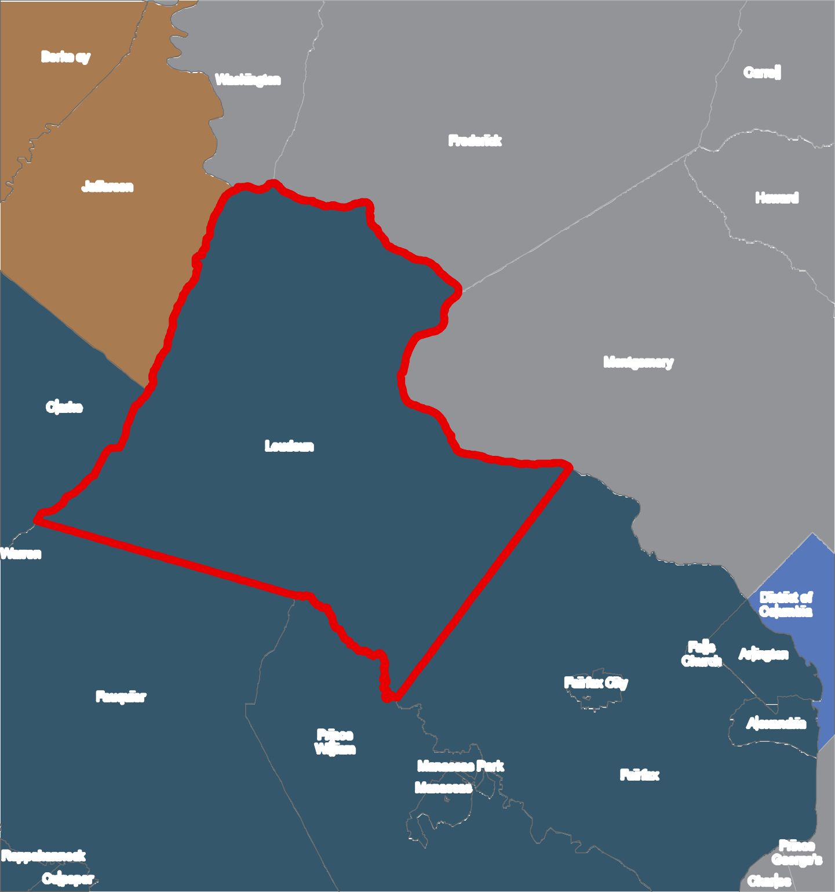2040 General Plan
Berkeley

^_ County Seats  Loudoun County District of Columbia Maryland  Virginia  West Virginia |  | Washington |  |  |  | ^_  Frederick |  |  | Carroll
Jefferson  _^  ^_  Clarke  Warren  Fauquier  Rappahannock  Culpeper | ^_ |  | Loudoun | Prince William | _^ | Manassas Park Man_^assas | Montgomery  Fa^_irfax City  Fairfax | ^_  Falls Church | Howard  District of Columbia  Ar_^lington Alexandria  Prince George's  Charles

Loudoun County IS NOT LIABLE for any use
of or reliance upon this map or any information contained herein. While reasonable efforts have been made to obtain accurate data, the County makes no warranty, expressed or implied, as to its
accuracy, completeness, or fitness for use of any purpose.

0 1.5

3 6 9 12
Miles
Ma p N u m b er 2 018 -1 53

D R A F T
CHAPTER 1-11
Map N um b er ## ## -## ##

